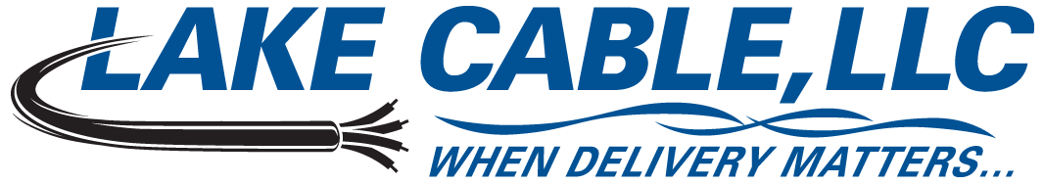
529 Thomas Drive, Bensenville, IL 60106 USA – Ph: 847-238-3000 Toll Free: 888-518-8086 Fax: 630-860-5944

18 AWG 8 Conductor Shielded 600V Control Tray Cable Specification – Quad Rated

Lake Cable Part #: V188S-QR

Description: 18 AWG, 8 conductor shielded 600V control tray cable constructed with stranded bare copper, polyvinylchloride and nylon insulation, an aluminum/mylar shield with a stranded tinned copper drain wire and an overall polyvinylchloride jacket. Individual conductors are manufactured in accordance with UL Standard 62, Type TFN/TFFN/VW-1. Cable is manufactured in the USA in accordance with UL Standard 1277 and NEC listed Type TC, suitable for use in Class I Division II hazardous locations and approved for installation in cable trays per Article 336 and for use as fire protective signaling cable per Article 760 of the National Electric Code. Cable may be installed in open air, in ducts or conduits, in trays or troughs and is approved for direct burial and outdoor applications. Jacket is sunlight resistant and cable is (UL) TC-ER approved for 600V, 75°C Wet or 90°C Dry, quad rated TC, PLTC, NPLF and FPL and meets or exceeds the requirements of IEEE 383 and UL 1581 (1685) 70,000 BTU/HR flame tests.

1. Conductor
1.1 AWG Size & Stranding: 18 AWG, Class B 7 Strands
1.2 Material: Annealed Bare Copper
2. Insulation
2.1 Material: Polyvinylchloride & Nylon per UL Standard 62, Type TFN/TFFN/VW-1
2.2 Wall Thickness: 0.015” PVC & 0.005” Nylon - The minimum at any point shall not be less than 90%
of the specified wall thickness
3. Color Code
3.1 Code: Method 1, Table E-2
4. Assembly
4.1 Lay Length: Per UL Standard 1277
4.2 Fillers: N/A
4.3 Binder: N/A
4.4 Shield: Aluminum/Mylar Tape - 100% coverage
4.5 Drain Wire: 20 AWG, 7 Strand Tinned Copper
5. Jacket
5.1 Material: Polyvinylchloride per UL Standard 1277
5.2 Wall Thickness: 0.045” - The minimum at any point shall not be less than 80% of the specified
wall thickness
5.3 Diameter: 0.408”
5.4 Color: Black
5.5 Weight: 102 lbs./Mft.
6. Markings
6.1 Type: Cable shall be permanently identified via surface inkjet print
6.2 Legend: LAKE CABLE E208309 18AWG 8C SHIELDED (UL) TC-ER 600V PLTC NPLF FPL PVC/NYLON
90’C DRY 75’C WET PVC JACKET SUN RES DIR BUR “ROHS”
7. Standards
7.1 UL listed as Type TC-ER per UL Standard 1277 and Quad Rated TC, PLTC, NPLF & FPL
7.2 UL approved for Sunlight Resistant & Direct Burial applications
7.3 Individual conductors pass UL VW-1 flame test, rated TFN/TFFN/VW-1
7.4 Cable meets IEEE 383 & UL 1581 (1685) 70,000 BTU/HR flame test requirements
7.5 Meets ICEA S-95-658, where applicable
7.6 All materials used in the manufacture of this cable are RoHS compliant

ALL SPECIFIED PARAMETERS ARE NOMINAL AND SUBJECT TO VERIFICATION

