
DEPARTMENT OF COMPUTER & INFORMATION SYSTEMS ENGINEERING
BACHELORS IN COMPUTER SYSTEMS ENGINEERING

Open Ended Lab Report

AI-powered inventory, billing, reporting, and staff management system

Course | CS 222 - Database Management Systems
CLO / Taxonomy | CLO-2 / C3
Backend DBMS | PostgreSQL using Prisma ORM
Frontend | Next.js 14 App Router with role-based dashboards
Submitted Project | ShopIQ retail operations workspace

Contents
- 1. Project Overview
- 2. Problem Statement and Objectives
- 3. Technology Stack
- 4. System Architecture
- 5. User Roles and Permission Design
- 6. Database Design and ERD
- 7. Tables, Keys, Constraints and Indexes
- 8. CRUD Operations and Validation
- 9. Query Implementation and Reports
- 10. Front-End and Database Connectivity
- 11. AI Assistant Feature System
- 12. Testing, Exception Handling and Rubric Mapping
- Appendix A. Representative SQL / Prisma Queries

1. Project Overview
ShopIQ is a database-backed retail operating system for shops that need one place to manage inventory, customers, suppliers, invoices, purchases, payments, reports and staff. The application is not a static prototype: it uses PostgreSQL through Prisma, authenticated Next.js route handlers, role-aware CRUD screens, and a Gemini-powered assistant that can answer business questions from live operational data.
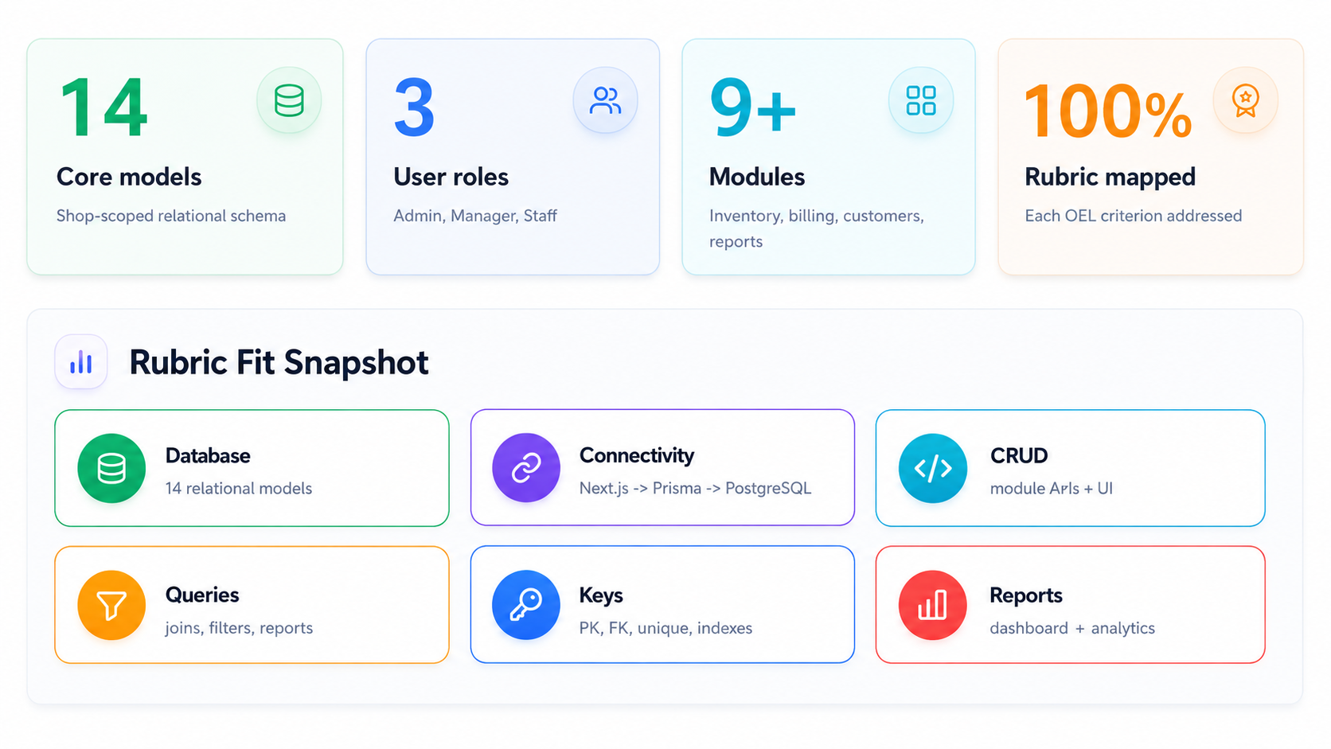

Figure 1. How ShopIQ maps to the OEL evaluation areas.
Why this project fits DBMS OEL
The project demonstrates schema design, integrity rules, many-to-one and one-to-many relations, CRUD operations, report queries, role separation, and a complete database-connected front end.

2. Problem Statement and Objectives
Retail shops often manage sales, stock and credit information through notebooks, spreadsheets or disconnected billing tools. That creates four recurring problems: stock is reordered late, customer dues are hard to track, supplier payments become unclear, and managers cannot quickly see the condition of the business.

Project objectives
- Build a relational database system that stores shop operations in normalized tables.
- Provide user-friendly forms for insert, update, delete, search and reporting operations.
- Enforce role-based access for Admin, Manager and Staff users.
- Generate meaningful reports for sales, revenue, dues, stock risk and product movement.
- Add an AI assistant that can answer live business questions and prepare safe database actions only after approval.

Main users
User | Purpose | Typical privileges
Admin | Owner-level control of the shop workspace. | Full management of products, customers, suppliers, purchases, staff, settings and reports.
Manager | Operational control without unrestricted ownership risk. | Can manage most operational modules and create staff members within allowed rules.
Staff | Daily billing, payments and customer handling. | Can work with permitted customer, invoice, payment, inventory view and assistant features.

3. Technology Stack
Layer | Technology | Role in project | OEL evidence
Frontend | Next.js 14, React, Tailwind, shadcn-style UI | Forms, dashboards, tables, charts, theme modes and route-based workspaces. | GUI connected to database.
Backend | Next.js API route handlers | Authenticated endpoints for CRUD, reports, auth, staff, settings and AI. | Insert/update/delete/search APIs.
Database | PostgreSQL | Relational storage with PK/FK, enums, constraints and indexes. | Database creation and integrity.
ORM | Prisma Client | Typed queries, relation includes, transactions and migrations. | Front-end/database connectivity.
Validation | Zod schemas | Request parsing, required fields, email, number and enum validation. | Debugged data entry forms.
AI | Gemini API via @google/genai | Business assistant with role-aware tools and approval-gated writes. | Advanced reporting and tool workflow.

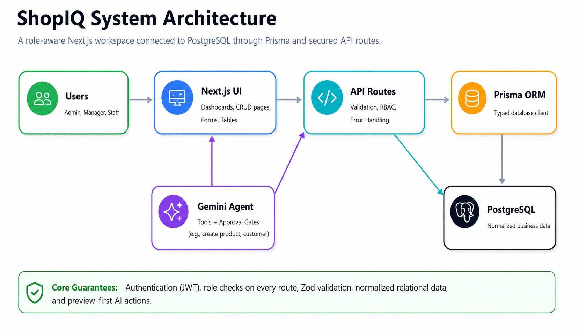
4. System Architecture

Figure 2. ShopIQ architecture from user roles to PostgreSQL and Gemini tools.
Connectivity summary
Every protected page reads the current user session, calls server-side data functions or API routes, and stores or retrieves records through Prisma. The route handlers return consistent JSON responses and use shared permission rules.

5. User Roles and Permission Design
The sample OEL brief requires Admin and Normal User roles. ShopIQ expands this into a practical three-role model: Admin, Manager and Staff. Manager is useful in real shops because the owner may delegate operations without giving unrestricted control.
Resource | Admin | Manager | Staff | Design note
Products | CRUD | CRUD | Read | Stock master is protected from accidental staff edits.
Customers | CRUD | CRUD | Create/Read/Update | Staff can serve customers, but delete stays owner-level.
Suppliers | CRUD | CRUD | No access | Supplier cashflow is confidential.
Payments | CRUD | CRUD | Create/Read customer receipts | Supplier payouts are owner/manager only.
Invoices | CRUD | CRUD | Create/Read | Billing is available to daily staff.
Purchases | CRUD | CRUD | No access | Supplier procurement is owner/manager only.
Staff | CRUD | Manager can create/manage Staff | No access | Manager cannot promote themselves or create Admins.
Reports/Settings | Read/Update | Read/Update | No access | Strategic reports and settings remain protected.
Implementation evidence
The permission matrix is implemented in src/lib/permissions.ts and then applied in API routes and UI pages. This means buttons are hidden/disabled in the interface and server routes still reject unauthorized requests.

6. Database Design and ERD
The database is normalized around a Shop workspace. Almost every operational table includes shopId so records are isolated by shop. Transaction tables such as Invoice, Purchase and Payment separate header-level totals from line-level item rows, which avoids repeated data and supports accurate reporting.

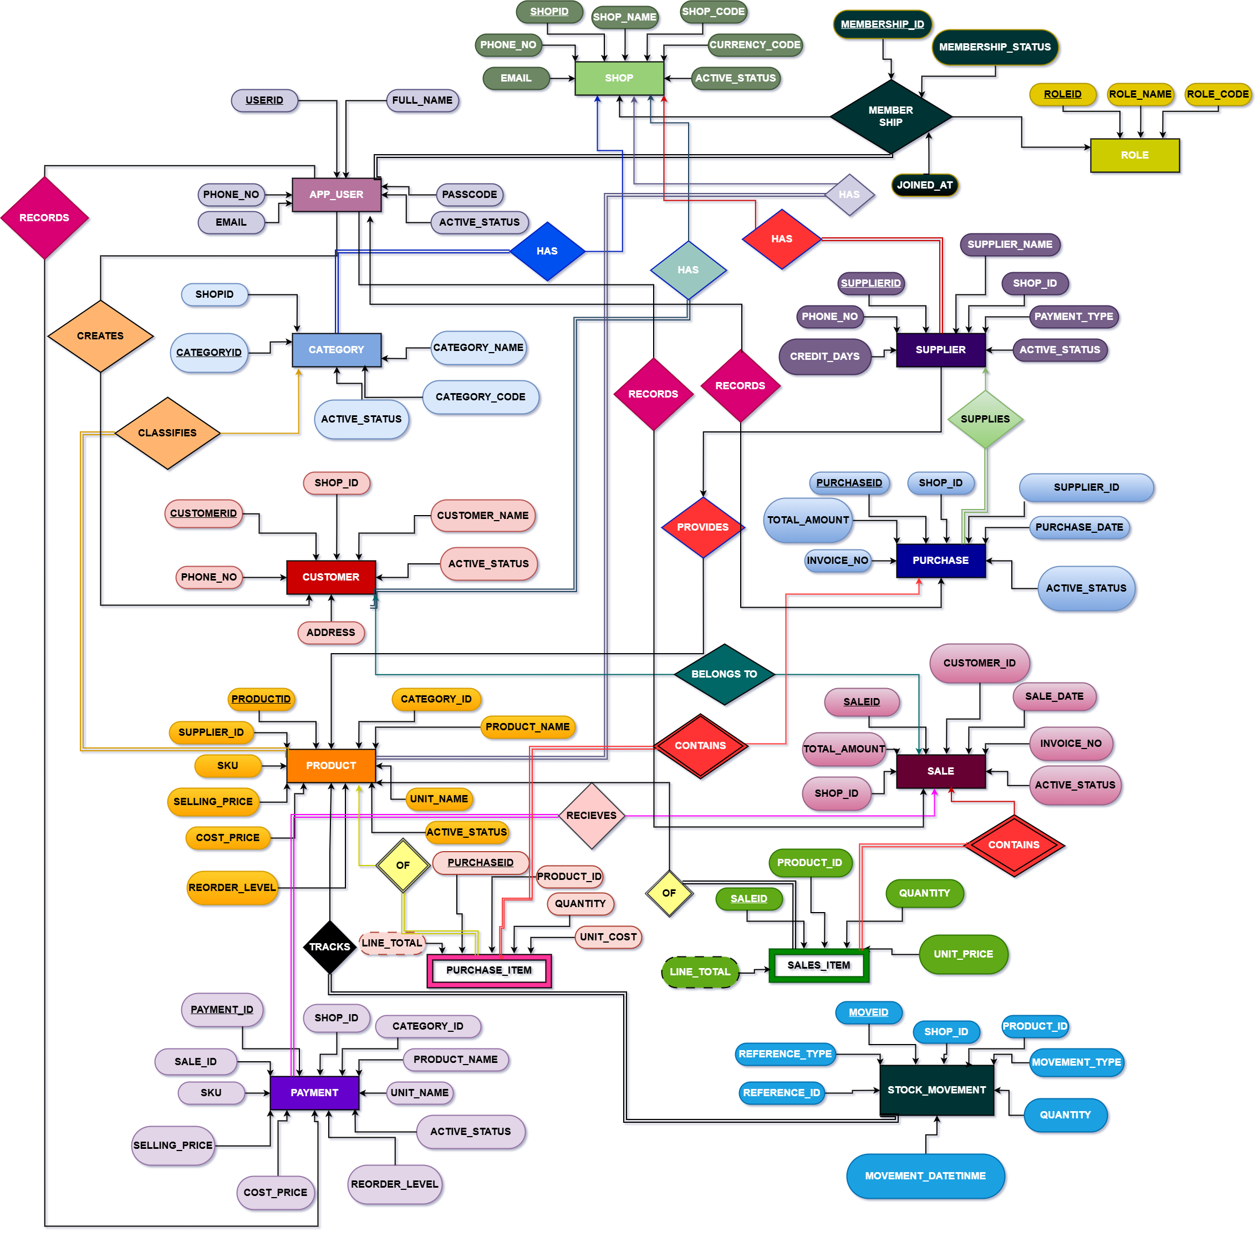

Figure 3. Simplified ERD for the ShopIQ relational database.

Design principles used
- Normalization: line items are separated from invoice and purchase headers.
- Referential integrity: foreign keys link users, shops, products, customers, suppliers and transactions.
- Controlled vocabularies: enums are used for roles, invoice status, payment direction, methods and stock movement types.
- Query performance: indexes target common filters such as shopId, status, date, balance and product stock.
- Auditability: ActivityLog and StockMovement preserve operational history.
7. Tables, Keys, Constraints and Indexes
Table | Purpose | Main keys/constraints | Important indexes
Shop | Top-level shop/workspace. | id PK. | createdAt.
User | Team account and authentication role. | id PK, email unique, shopId FK. | shopId+role, shopId+status.
Category | Product grouping. | id PK, shopId FK, unique(shopId,name). | shopId+createdAt.
Product | Inventory master and pricing. | id PK, unique(shopId,sku), categoryId FK. | name, status, category, stock/reorder.
Customer | Customer ledger and credit balance. | id PK, shopId FK. | name, phone, balance.
Supplier | Supplier ledger and reliability. | id PK, shopId FK. | name, phone, balance.
Invoice | Sales transaction header. | id PK, unique(shopId,invoiceNo), customer/user FK. | status, date, customer.
InvoiceItem | Products sold in an invoice. | id PK, invoiceId FK, productId FK. | invoiceId, productId.
Purchase | Supplier purchase header. | id PK, unique(shopId,purchaseNo), supplier/user FK. | status, supplier, date.
PurchaseItem | Products received in a purchase. | id PK, purchaseId FK, productId FK. | purchaseId, productId.
Payment | Customer receipts and supplier payouts. | id PK, optional invoice/purchase/customer/supplier FK. | direction, paidAt, customer, supplier.
StockMovement | Stock history with before/after quantity. | id PK, product/user FK. | product, type, movedAt.
AssistantThread/Message | AI conversation and action metadata. | thread/message PKs, thread FK. | threadId+createdAt.
ActivityLog | Human-readable audit trail. | id PK, shopId/user FK. | shopId+createdAt, shopId+type.

Integrity choices
Important delete behaviors are intentionally mixed. Shop deletion cascades through its child records, while invoice creator references use Restrict to preserve accountability. Optional relations such as customerId or supplierId may use SetNull so a transaction can remain historically valid even if a related party record is later removed.

8. CRUD Operations and Validation
ShopIQ implements CRUD through reusable workspace screens and dedicated API routes. Each module combines front-end forms with server-side Zod validation and Prisma database calls. The UI is role-aware, but server routes remain the final security layer.
Module | Create | Read/Search | Update | Delete | Validation highlights
Products | Yes | List + search | Yes | Archive/delete route | SKU, prices, stock, reorder fields.
Customers | Yes | Ledger/search | Yes | Owner-level | Name, contact, email, credit limit.
Suppliers | Admin/Manager | Supplier cockpit | Yes | Owner-level | Reliability score, balance, contact fields.
Invoices | Yes | Billing list | Status update | Owner-level | Items, quantities, totals, due amount.
Purchases | Admin/Manager | Purchase list | Status update | Owner-level | Supplier items and received totals.
Payments | Yes | Cashflow timeline | Owner-level | Owner-level | Direction, method, amount, linked party.
Staff | Admin/Manager | Team list | Role/status update | Owner-level | Role rules prevent unsafe promotions.
Settings | No create | Shop profile | Admin/Manager | No | Shop name, city, phone, address.
Exception handling
The shared API response utilities return unauthorized, forbidden and validation errors consistently. Zod catches missing or malformed fields before Prisma attempts a database write.

9. Query Implementation and Reports
The application uses select queries with relation includes, aggregation in the dashboard data layer, filtering by status/date, and ranked lists for operational decision making. Reports are visible in the dashboard and reports modules rather than exported as isolated static files.
Report / query | Data used | Query behavior | Business value
Daily/active-day sales | Invoice | Date filtering and sum(total). | Shows current sales even when demo data has no literal current-day records.
Monthly revenue | Invoice | Month window or latest active 30 days. | Improves dashboard accuracy for seeded historical data.
Low stock risk | Product | stockQty <= reorderLevel. | Highlights reorder needs.
Customer dues | Customer + Invoice + Payment | Balance ranking and payment history. | Supports collection decisions.
Supplier payables | Supplier + Purchase + Payment | Role-filtered supplier balances. | Protects sensitive cashflow.
Fast/slow movers | StockMovement + Product | SALE movement aggregation. | Identifies demand and dead stock.
Payment method mix | Payment | Group by method and sum amount. | Cashflow and channel insight.
Activity feed | ActivityLog | Recent events by shop. | Audit trail for actions.

Professional report generation
The reports are presented as charts, KPI cards, ranked lists and timelines. This is more useful for a shop owner than a raw SQL printout because it immediately answers: what sold, what is risky, who owes money, and what needs action.

10. Front-End and Database Connectivity
The interface is built as a modern workspace with separate admin and staff routes. CRUD pages reuse a common manager component for search, details, form validation and action buttons. Route handlers connect to PostgreSQL through Prisma and are protected by JWT cookie sessions.
Area | Implementation | Evidence in project
Authentication | JWT session cookie with bcrypt password hashes. | src/lib/session.ts, src/lib/auth.ts, login/signup routes.
Workspace UI | Admin and staff shells, sidebar, topbar, dashboards and CRUD pages. | src/app/admin/*, src/app/staff/*, src/components/workspace/*.
Database access | Prisma singleton client and server-side data functions. | src/lib/prisma.ts, src/lib/data.ts.
Validation | Zod schemas for API bodies and AI action payloads. | src/lib/validation.ts, API route schemas.
Theme support | Light/dark, classic/liquid glass, and shadcn/tweakcn-style presets. | theme provider, globals.css and toggles.

11. AI Assistant Feature System
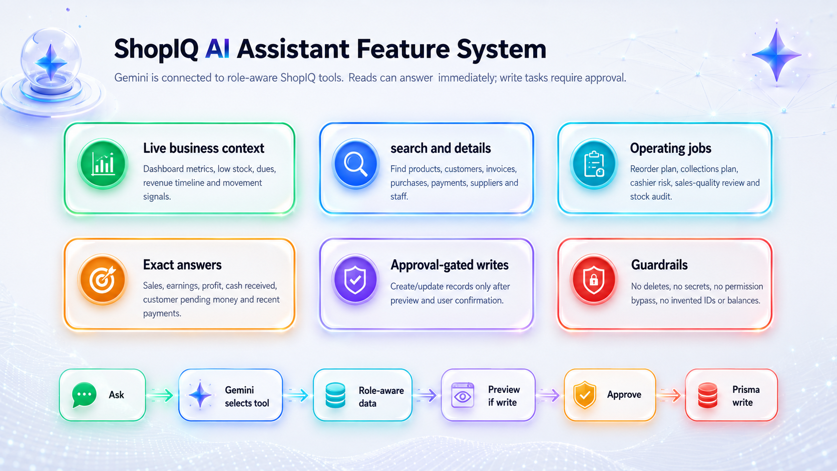
ShopIQ includes a live Gemini assistant built for the project itself. It is connected to ShopIQ through the /api/ai/chat route, @google/genai, the Prisma-backed data layer, and the role rules already used by the application. The assistant can read live operating context, run decision-support jobs, answer exact money/date questions, and prepare database actions through a preview-first approval flow.

Figure 4. Actual ShopIQ AI feature system implemented through role-aware Gemini tools.

AI tools implemented in ShopIQ
Tool | Purpose in ShopIQ | Uses live project data from | Permission behavior
get_dashboard_snapshot | Reads metrics, low stock, dues, activity and chart-ready dashboard data. | src/lib/data.ts and Prisma models. | Role-filtered supplier/cashflow data.
search_business_records | Searches products, customers, suppliers, invoices, purchases, payments and staff before selecting ids. | Prisma queries over ShopIQ records. | Rejects entities the role cannot read.
get_record_details | Loads full details for a selected visible record. | Product, customer, supplier, invoice, purchase, payment and staff tables. | Uses the same resource permission matrix.
run_operating_job | Runs read-only jobs: reorder plan, collections plan, cashflow risk, sales quality review and stock audit. | Dashboard snapshot, products, customers, suppliers, payments and movements. | Supplier-side jobs require Admin/Manager.
get_sales_summary | Answers exact revenue, earnings, gross profit, cash received, item count and invoice totals for a date range. | Invoice, InvoiceItem, Payment and Product data. | Read-only and shop-scoped.
get_customer_balance_summary | Answers pending money, outstanding invoices and recent payments for one customer. | Customer, Invoice and Payment tables. | Customer read permission required.
prepare_business_action | Validates write requests and creates a preview. It never writes immediately. | Zod schemas and actionResource permissions. | Requires later user approval before execution.

AI write actions supported
Action family | Supported actions | Validation source | Execution result
Inventory | create_product, update_product | Product Zod schemas: name, SKU/category, prices, stock and reorder fields. | Creates/updates product records and logs AI product activity.
Customer ledger | create_customer, update_customer | Customer schemas: name, contact, email, creditLimit, balance and notes. | Creates/updates customer records and opens Customers workspace.
Supplier ledger | create_supplier, update_supplier | Supplier schemas: contact, balance, reliabilityScore and notes. | Admin/Manager only because supplier cashflow is restricted.
Cashflow | create_payment | Payment schema: direction, method, amount, party and linked invoice/purchase. | Customer receipts for allowed users; supplier payouts only for Admin/Manager.
Sales and procurement | create_invoice, create_purchase | Item schemas require product id/SKU/name, quantities and prices/costs. | Creates transaction headers/items and updates related operational data.
Team management | create_staff, update_staff | Staff schemas plus canCreateStaffRole/canManageStaffMember rules. | Admin can manage all roles; Manager can create/manage Staff only.

AI guardrails and user experience
- Current chat context is sent to Gemini so follow-up prompts are understood within the same conversation.
- Every write task is confirmation-gated: the assistant creates a preview first, and the server executes only after approval.
- Pending actions are stored in AssistantMessage metadata with previewId and status so stale approvals cannot accidentally execute another action.
- The system prompt blocks deletes, account suspension, bulk destructive edits, secret retrieval and role bypassing.
- The assistant is instructed to choose ids only from tool results and never invent SKUs, invoice numbers or balances.
Project-specific AI conclusion
The assistant is a database-aware operating layer for ShopIQ. Its feature set is limited to the modules that exist in the project: inventory, customers, suppliers, invoices, purchases, payments, staff, reports and dashboard context.

12. Testing, Exception Handling and Rubric Mapping
Rubric criterion | How ShopIQ satisfies it | Evidence
Database creation | Tables, enums, relationships and migrations are defined. | Prisma schema and SQL migration.
Keys and constraints | PK, FK, unique constraints, onDelete rules and indexes are present. | schema.prisma relation annotations.
Insert/update/delete | CRUD routes exist for operational modules. | API route handlers and workspace CRUD UI.
Queries | Filtering, relation includes, aggregation and ranking are used. | src/lib/data.ts and reports routes.
Connectivity | Next.js front end calls API routes backed by Prisma/PostgreSQL. | Route handlers + Prisma client.
Reports | Dashboards and reports produce operational metrics and charts. | Dashboard snapshot and report pages.
Understanding | Role model, AI guardrails, validation and exception handling are documented. | This report and implemented source files.

Appendix A. Representative SQL / Prisma Queries
Low-stock products
SELECT name, sku, stockQty, reorderLevel FROM Product WHERE shopId = ? AND status = 'ACTIVE' AND stockQty <= reorderLevel ORDER BY stockQty ASC;
Customer due ranking
SELECT name, phone, balance FROM Customer WHERE shopId = ? AND balance > 0 ORDER BY balance DESC LIMIT 10;
Invoice status report
SELECT status, COUNT(*) AS count, SUM(total) AS gross FROM Invoice WHERE shopId = ? GROUP BY status;
Daily revenue
SELECT DATE(invoiceDate) AS day, SUM(total) AS revenue FROM Invoice WHERE shopId = ? GROUP BY DATE(invoiceDate) ORDER BY day;
Product movement history
SELECT p.name, m.type, m.quantity, m.beforeQty, m.afterQty, m.movedAt FROM StockMovement m JOIN Product p ON p.id = m.productId WHERE m.shopId = ? ORDER BY m.movedAt DESC;

Conclusion
ShopIQ fulfills the OEL requirement as a complete database application: it creates a relational schema, enforces keys and constraints, implements role-based CRUD operations, connects a polished front end to PostgreSQL, and generates useful operational reports. The project goes beyond a basic DBMS submission by adding a safe AI assistant, multi-role workflows, audit logging, and a modern UI system while keeping the database at the center of the application.

