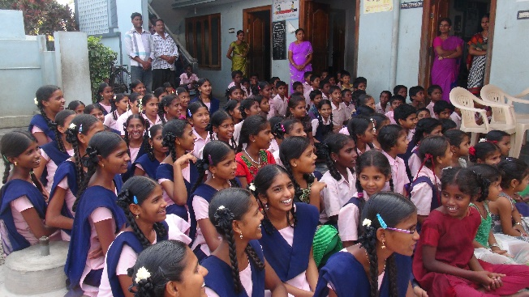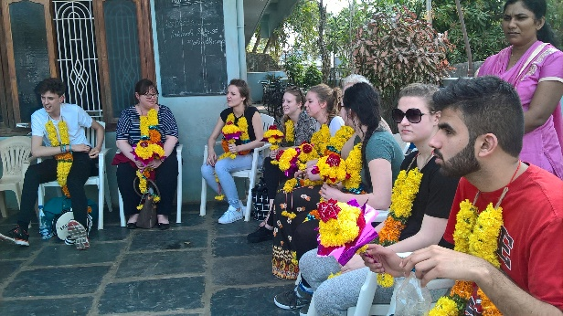I would like to thank-you for allowing me and my fellow students to travel to India and help out at an orphanage. Because of your generosity I was able to help out at the orphanage for a week and got to experience something that is best described as a ‘once in a life time opportunity’. I had such an amazing time, so much so that I wish to return again in the near future. On the way there we were all full with such adrenaline due to the fact that we could only imagine of what was to come and what we could discover about ourselves, in some cases something we didn’t even know existed. We were greeted with many friendly faces and got presented with some flowers and were sat down all in a row and were to explain shortly about who we are and a bit about ourselves. After the ice was broken we all mingled and got to know some of the children and about their lives in the orphanage, an issue that I thought there might be was the language difference but to my surprise a lot of the children could speak basic English.

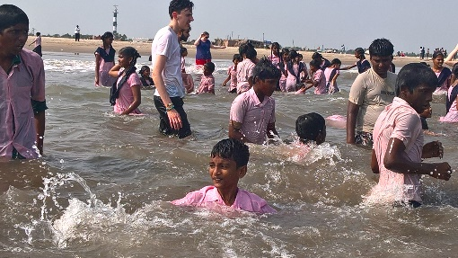I have two main highlights of the trip, one of which was the trip to the near-by beach. To say the orphanage is maybe twenty minutes away from the beach, they only ever go to visit when Quarrydale School pupils come during their year visit, so as you can imagine on arrival the children ran to the sea and even dragged us along. To see their faces light up just made the day travel worth it. The children and even the teachers went into the sea and played volleyball and splashed us all, even picking us up and dunking us in the water. We must have spent an hour in the water before we decided to play some beach games, this included duck-duck-goose, cricket and kabaddi. We were at the beach for around six hours maybe, but it felt like we were frozen in time due to just being able to experience something with the children that they rarely ever get the chance to do, it was breath-taking.

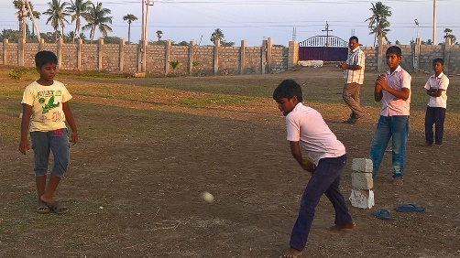My second main highlight was when we got the chance to visit the land in which Emmanuel is building the new, bigger orphanage which again gave the children a chance to play in a bigger spaced area due to the original orphanage’s space to be very limited, this included games of cricket again and gave us all to mingle with some children that we have not yet had the chance to speak to as in-depth as others. As the day disappeared into night, some of the ex-orphanage children, that now work there, set off some fireworks and so on, we all sat together and watched in a daze, and to look around at all the faces being lit up by things that we take advantage for made me open my eyes and see things from another perspective and made 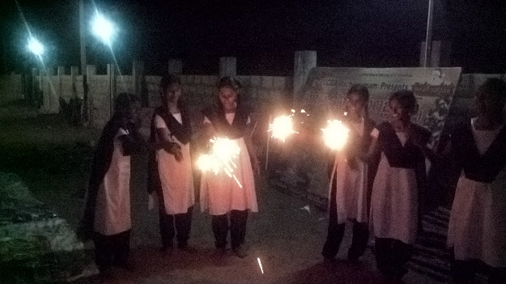me appreciate things even more so than before I got the chance to visit Emmanuel’s orphanage. To realise how little an individual can have and for them to be always smiling makes us look quite selfish, in England we could be perceived as quite materialistic as we expect expensive gifts and are never happy, whereas the children were happy just because of our presence.

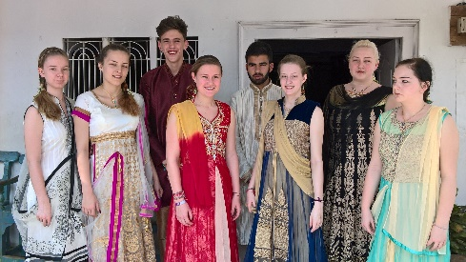I would like to deeply thank-you for allowing us to visit Emmanuel’s orphanage and to get the opportunity to experience things that we will probably never get to experience again. Because of my visit I would actually like to visit again after my exams in 2017 and I will hopefully continue to visit this orphanage and to try and give the children the chance to do things that they may never get to do throughout the rest of the year. Because of your constant support and help you have been able to give eight students to see things in India that we could only ever see on television previously.

Thank-you again,

Yours,

Emma Smith.

