Reality runs on both [osx] and [wos] (32 and 64-bit versions). The installation is automated by the Reality installer and most of the times all you will have to do is to simply click on the **Install** button and everything will be done in a few seconds.

In this section you can find detailed information on every aspect of the installation process, just in case you might need more information.

##Distribution files
When you download Reality the program is distributed as a DMG file for [osx] or as a self-extracting zip file for [wos].

##[osx]
To start the installation on [osx] double-click on the DMG file, which will mount it in the Finder.

{$SCRImageLink[w:298;h:156]=/Users/paolo/devel/Reality/documentation/images/UI/OSX-Installer-DMG.png} "Installing Reality on Mac OS"

From the DMG folder double-click on the RealityInstaller app and follow the instructions. See below for more details.

##[wos]
The distribution file for installing Reality on Windows, as a self extracting zip file. This means that the file that you downloaded is an actual executable, a file with the .exe extension.

On Windows, double-clicking on the executable will show a window to select the destination folder for expanding the archive. Select a folder and confirm the operation. The result will be a folder with the name starting with "Reality". Open that folder and from there double-click on the RealityInstaller program to start the installation.

Figure <!--\ref{wos-installer-zip.png}--> shows the window that prompts for the destination folder for the archive extraction. The result of this operations will be to have, in this specific case, a folder called Reality_DS_w64 created in the same location where the self-extracting zip file is stored.

{$SCRImageLink[w:250;h:101]=/Users/paolo/devel/Reality/documentation/images/UI/WOS-installer-zip.png} "Uncompressing Reality on Windows"

After a few seconds you will get a folder on disk, and that folder includes the RealityInstaller.exe file. Double-click on RealityInstaller and the installation program will start.

Please note of that [PS] and [DS] **must be closed** before running the Reality Installer.

##Installing [rpe]
The Reality installer automatically searches the hard disk of the computer to locate the right version of [PS]. The installer also verifies that the bitness of Reality matches the one of [PS]. In case you have multiple version of [PS] installed and the Reality installer selects the wrong one, you can change the selection by clicking on the **Change** button. Navigate to the folder when the desired version of [PS] is installed and select that folder.

If you need to install Reality for multiple versions of [PS], for example for [PS] 9 and [PS] 10, you will need to repeat the installation for each version of [PS].

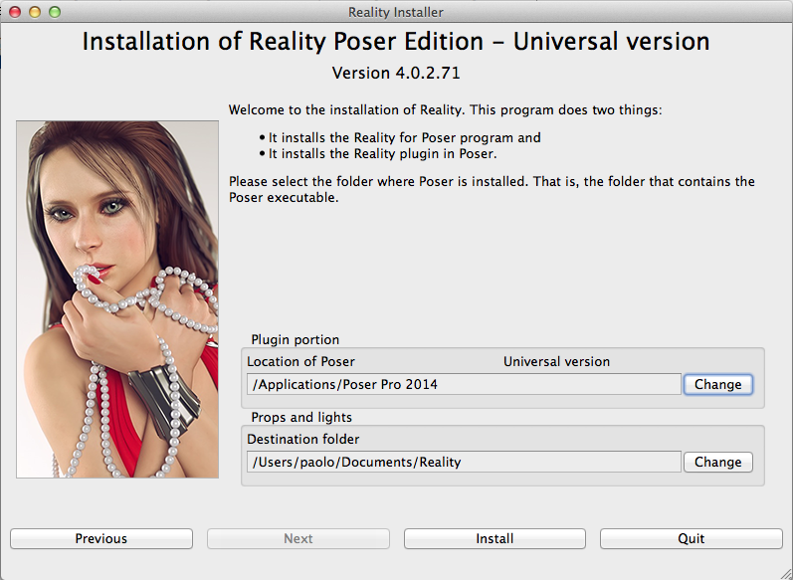 "[PS] Installer, [osx] version"

The installer provides some valuable information in the main screen. For the [osx] version the program confirms that this is a Universal binary, which means that it works both on 32 and 64-bit versions of [osx]. The second line from the top lists the full version number of the program.

###Matching the bitness

The following only applies to [wos]; the [osx] version of Reality ships as a universal binary capable of running at both 32 and 64 bits.

With [wos] it's important that you select the installer that matches the bitness of [PS]. Please note that this is not the bitness of your OS. For example, [PS] 10 is a 32-bit program even if you install it on a 64-bit version of [osx] or [wos]. In addition, even the Pro version of [PS] will run at 32 bits if the computer and the OS are running at 32 bits.

Every plugin must match the bitness of the host. If you use 32-bit [PS] then you must install the 32-bit version of Reality. If you use a 64-bit[PS] then you must install the 64-bit version of Reality.

You can easily verify what is the bitness of [PS] by running the program and then selecting the **Scripts | Python Shell** menu option. The Python interpreter's window will appear , and the first message includes the hint on what bitness is used:

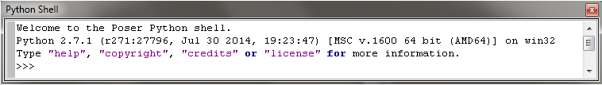 "[PS] Python Shell on [wos]"

In there we can see that [PS] is running at 64 bits because of the `[MSC v.1600 64 bit (AMD64)]` message. Please don't let the `win32` portion confuse you, the portion between square brackets is what matters. On a 32-bit installation that message will show as `[MSC v.1600 32 bit (Intel)]`.

Figure <!--\ref{poserinstaller-w64.png}--> shows the Reality installer running on 64-bit Windows for 64-bit [PS].

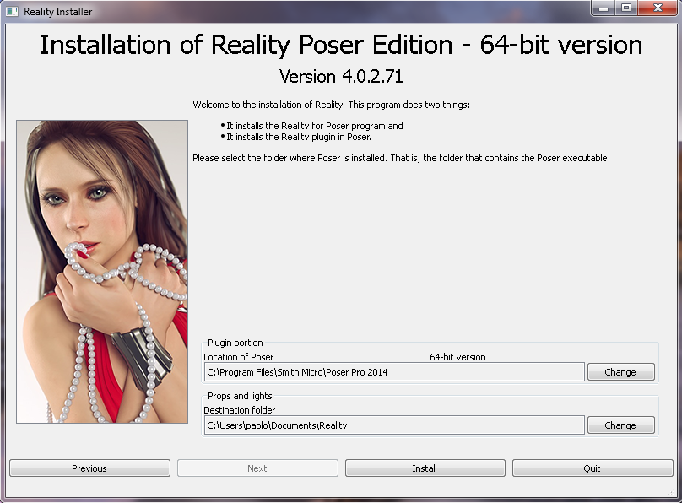 "[PS] Installer, [wos] version"

###Props and Lights

Reality [PS] Edition includes the plugin itself, the Reality program, and a series of Props and Lights, which can be installed in any Runtime of your choice. The installer selects a suitable default location but that can be changed to any folder of your liking. Regardless of what folder is selected, the Reality Installer will automatically update [PS]'s configuration to include that Runtime, so that the Reality Props and Lights will appear in the [PS] Library.

When everything is set as desired, simply click on **Install** and the installation will start. In a few seconds the process will be completed and you will be able to use Reality.

##Installing [rse]

The Reality installer automatically searches the hard disk of the computer to locate the right version of [DS]. The installer also verifies that the bitness of Reality matches the one of [DS]. In case you have multiple version of [DS] installed, and the Reality installer selects the wrong one, you can change the selection by clicking on the **Change** button. Navigate to the folder when the desired version of [DS] is installed and select that folder.
Please note that if you select a version of [DS] that does not match the bitness of Reality, the **Install** button will not become enabled.

Figure <!--\ref{dsinstaller-osx.png}--> shows the Reality installer running on [osx].

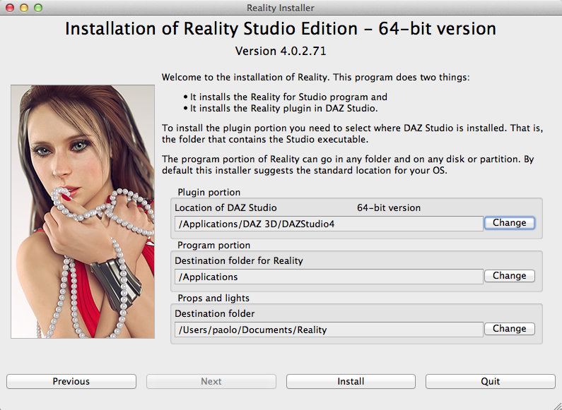 "The [rse] installer on [osx]"

The installer provides some valuable information in the main screen. The first line confirms what version you are installing and the second line provides the complete version number.

Reality is composed of a plugin, which runs as an extension of [DS], and the Reality program itself, which provides the User Interface with which you configure the rendering of your scene.

The installer shows the locations for the plugin portion, the program portion and the props and light of Reality. The plugin portion must be installed where [DS] is installed.

The program portion can be installed anywhere. The installer suggest a location that is appropriate for your system but you can change that directory.

The same is true for the Props and Lights. The installer selects a suitable default location for those but it that can be changed to any folder of your liking. Regardless of what folder is selected, the Reality Installer will automatically update [DS]'s configuration to include that Runtime, so that the Reality Lights and Props will appear in the [DS] Content Library.

