Reality comes with a set of lights and props to help you get the most out of your scenes. See figure <!--\ref{rug_realitylights.png}--> or figure <!--\ref{dazstudio_reality_lights.png}-->.

<!-- \index{Reality add-ons} -->
###Mesh Lights
<!-- \index{[ML]} -->
[MLs] are the most flattering and flexible lights that you can use with LuxRender. For this reason Reality includes a great [ML] prop that is designed to give you excellent control on the quality and position of the light.

In the Reality Lights folder you can find the Reality lights. There are two [MLs]: one that is positioned by default in a position suitable for portraits. The other is automatically placed above the default location for figures.

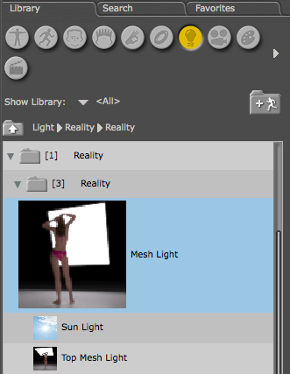 "The Reality lights in [PS]"

{$SCRImageLink[w:250;h:229]=/Users/paolo/devel/Reality/documentation/images/UI/DAZStudio_Reality_lights.png} "The Reality lights in [DS]"

The Reality [ML] has controls to set its softness with ease. Simply select the light in the scene and look in the Parameters tab, you will find a **Shadow Control** group. You can turn the light sharp by enabling the Sharp parameter. Or you can make the light very soft with the, aptly named, VerySoft parameter. The light comes in the scene by default set as Soft. This gives you a very pleasant light that has visible soft shadows.

The Reality [MLs] work well with the "Point at" function of [PS] or [DS].

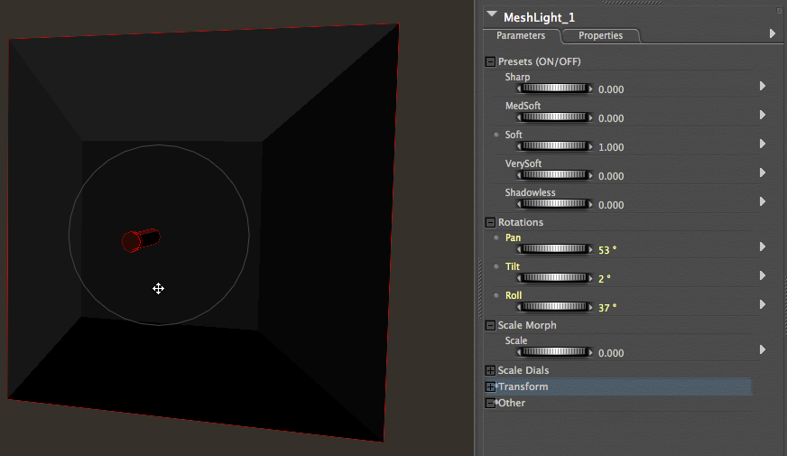 "[ML] adjustments in [PS]"

{$SCRImageLink[w:349;h:229]=/Users/paolo/devel/Reality/documentation/images/UI/DAZStudio_ML_shadow_controls.png} "[ML] shadow control in [DS]"

####Gobo and Snoot
<!-- \index{Snoot} -->
<!-- \index{Gobo} -->
The [ML] offers also a great degree of control. The light includes a snoot that can be extended to prevent the spill of light. This allows you to focus the light on a limited area of the scene and can be a valuable tool in complex lighting situations. Extend the snoot using the Snoot parameter, which can be found in the Morphs group of the light.
Here is a 4-minute video that shows how to use the snoot in both [PS] and [DS], and what effects it has on the light:

[{$SCRImageLink[w:300;h:168]=/Users/paolo/devel/Reality/documentation/images/UI/Using-the-snoot.png}](http://youtu.be/wriLFRzn9mQ)

The gobo is a panel that *goes between* the light and the rest of the scene, hence the name "gobo." The panel can be decorated with a transparency map for shadow effects or turned to glass and set with a transmission texture for creating colorful light effects.

###Sun light
<!-- \index{Sun} -->
Reality also includes a Sun light. The Sun Light is a physically-accurate Sun light that also produces a sky. Reality exports the Sun and the sky as separate lights that can be adjusted in LuxRender while rendering the image.

Note for [PS] users: unlike the [MLs], when you add the Sun light it will replace all the [PS] lights in the scene, if you _double-click_ on the icon. The exceptions are the Reality [MLs] since they are actual props and not [PS] lights. If you want to add the sun without removing previous lights drag and drop the Sun Light into your scene, instead of double-clicking on it.

###Single IBL Sets
Reality includes a set of 200 IBL lights prepared by Lee Furssedonn (Fuzzy70) and available for both [PS] and [DS]. These are great for quickly making portraits that use different shapes of light fixtures, circle, line, ring and so on, while taking advantage of the simplicity of set up of IBL.

Each light has a well-made thumbnail that shows the expected result. See figure <!--\ref{singleibls.png}--> for an example of how they appear in the content library.

{$SCRImageLink[w:214;h:400]=/Users/paolo/devel/Reality/documentation/images/UI/SingleIBLs.png} "Single IBL lights in [DS]"

###Studio Cubed
<!-- \index{Props!Studio Cubed} -->
Studio Cubed is a model that simulates a photographer's studio. This model has been developed by John Hinton, aka Dumor3d at [Dumor3D.com](Dumor3D.com) and kindly provided to Reality artists for free.

The advantage of using Studio Cubed is that it provides an enclosed environment an for which the walls are UV-mapped and identified by separate materials so you can apply any photo or image to create great backgrounds with ease.

Please note that the [PS] Main camera is by default placed outside the Studio Cubed but it is configured in a way to see inside the prop. For this reason it might happen that, when you render with LuxRender, the scene will be come out black. Make sure to move the camera inside the Studio Cubed space.

There are several materials presets that can be used to hide or show sections of Studio Cubed.

