Thank you for purchasing Reality; we hope that you will have fun using it. <!-- \index{loop|see{infinite}} -->

Reality gives you a new way of rendering your [PS] or [DS] scenes by using physics-based rendering, the best way of creating realistic images from 3D geometry.

Reality is designed to enhance and simplify the conversion of the [PS] or [DS] materials and lights in several ways.

Reality has intelligent conversion of skin <!-- \index{Material!Skin} -->materials to provide a zero-click SubSurface Scattering (SSS) <!-- \index{SSS} -->configuration even for [PS] and [DS] materials that don't include SSS.

Reality includes a fully-featured Material Editor that gives you the power of creating and modifying materials without the complexity of a node system. The Reality Material Editor is based on a modern User Interface design that promotes productivity and artist-oriented workflow.

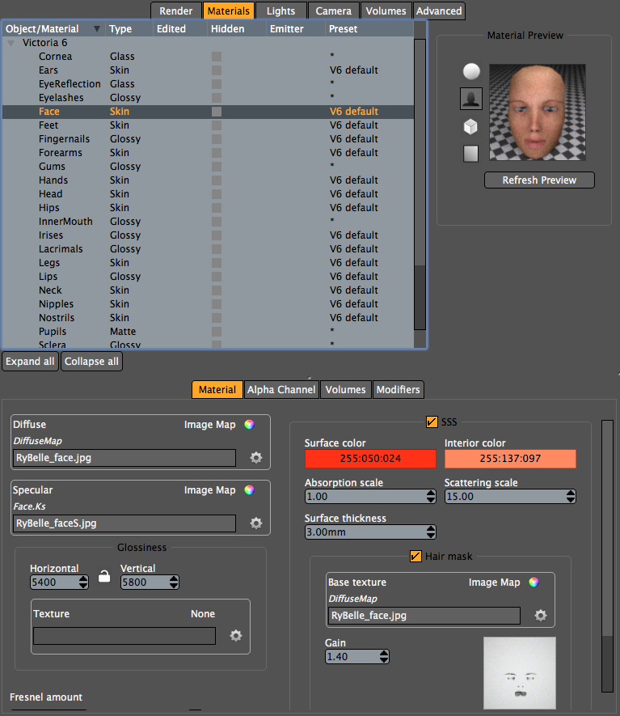 "The Reality Material Editor in action"

Reality [version] features at a glance:

- A wide selection of physically-based materials:
- Skin, with SSS
- Water
- Glass
- Metal
- Velvet
- Glossy
- Fog
- Mirror
- Cloth
- Matte
- A large selection of texture types that can be mixed in any material:
- Image Maps
- Texture mixing
- Bricks
- Marble
- Procedural noise
- Cloud noise
- Texture Combine
- Distorted noise
- Checkers
- Wood
- Texture math
- Automatic presets for popular skins and figures.
- Material preset library.
- Image Based Lighting with support of HDR images and the SmartIBL (sIBL) format.
- Single-light, physically-based Sun light with indirect lighting, caustics, etc.
- Mesh-based lights, Spotlights, and point lights that can be used to simulate any real-life lighting fixture.
- Lighting can be changed while the image is rendering. Render status is saved automatically and can be stopped and resumed at a later time.
- Material preview right inside the Reality UI.
- Automatic conversion of [DS] and [PS] materials to Reality's physics-based versions, including nodes and procedural textures from Poser.
- Volumetric fog.
- Stop and restart of the rendering.
- Network rendering. Render nodes can be running Mac OS, Windows or Linux, making it possible to create low-cost renderfarms.
- Rendering runs independently of the host. You can continue working on your scene while the rendering runs.
- Multi-core support, 32 and 64 bit support for Mac OS and Windows.

