After you play with LuxRender a little bit you will notice some controls in the main render window. The topmost is called *Tonemapping.* <!--\index{Tonemapper}--> Tonemapping is very important in making things work the way you want, and in achieving the look that you desire.

{$SCRImageLink[w:250;h:220]=/Users/paolo/devel/Reality/documentation/images/UI/LuxRender-tonemapper.png} "The tonemapper selector in LuxRender"

Unlike [hrenderer] and many other renderers, LuxRender calculates the light values using full light spectral values. This means that when it calculates the light amount for a given pixel LuxRender has the real value and not some number that has been clamped down to stay in the RGB limits of what our monitors can show. Light in the real world has wavelengths that go beyond what the human eye can see. Photographic film has a more limited ability to capture light values than what our eyes can see. Computer monitors have an even more limited range of light values that they can display.

If LuxRender was going to render a light value that was based on what your monitor can "see" then the fidelity of the information would be seriously compromised. Instead, LuxRender uses the full spectrum of light, and the tonemapper uses an algorithm to convert those internal light values to what we can see on the computer. As it turns out there are a few different tonemapping possibilities, but for Reality we will focus on just two: AutoLinear and Linear.

## AutoLinear ##
<!-- \index{Tonemapper!Autolinear} -->
Think of your scene as something that you can capture with a photographic camera. As you decide which [hrenderer] camera you should use you have two choices: point-and-shoot "all automatic," or state-of-the-art DSLR (Digital Single-Lens Reflex) with full manual control.

Point-and-shoot cameras nowadays are pretty good and deliver nice pictures. You point the camera at the scene, click the button, and you get a nice picture that is correctly exposed, in focus, and with good colors. However, if you tried to take a picture of somebody in front of a window you know that there are limitations to what those cameras can do. Nevertheless they get the job done in a very good way and without your involvement in things like shutter speed, film ISO and aperture.

AutoLinear is your point-and-shoot camera. It works well for many situations, including scenes that have sun and spotlights, but it averages the light intensity in the scene in order to find a good balance, and consequently things are not always exposed correctly. If a light is visible in the scene, Autolinear will seriously underexpose the scene and you might even end up with a pitch black image with a bright spot, the light, in it. If that happens then it's time to switch to Linear.

## Linear ##
<!-- \index{Tonemapper!Linear} -->
Linear is the best tonemapper and it gives you full control over the final aspect of the image. You can dynamically change the exposure <!-- \index{Exposure} -->to achieve overexposed/underexposed effects without re-rendering your scene, and the result is usually shown in a second or less.
Linear works like a manual camera. The parameters to adjust are:

- Film ISO. This is also known as film speed. Higher values mean faster film, faster film means that the "film" is more sensitive to light. If your scene looks dark then change this parameter first and see if you gain some definition.
- Exposure. <!-- \index{Exposure} -->This is equivalent to the speed of the "shutter" of a camera, and is usually expressed in a fraction of a second. 1/60, 1/125 or 1/250 of a second are normal values. For a night scene with very faint light you might want to try an exposure of 1 full second.
- f-stop. This is the aperture of the "iris" in your camera. Lower numbers mean wider aperture and more light hitting the "film." Generally each f-stop number, in increasing order, means that the lens acquires half the light than with the previous f-stop. For example, f4.0 gives us an aperture that is half of f2.8. f5.6 is half the aperture of f4.0. When we use smaller apertures we let less light pass through the lens and that gives us a darker image.

You can press the `Estimate settings` button in LuxRender to have the program quickly estimate a reasonable exposure. From there you can adjust the setting more.

###Video tutorial

See the following video or a demonstration on how to adjust the exposure while rendering.

[{$SCRImageLink[w:298;h:165]=/Users/paolo/devel/Reality/documentation/images/RUG_Video-Controlling-Lights.png}](http://www.youtube.com/watch?v=Evw2yjC4sa4)

## Converting from AutoLinear to Linear ##

When you change a tonemapper from AutoLinear to Linear, it can sometimes seem that you have done something wrong because the image turns completely white.

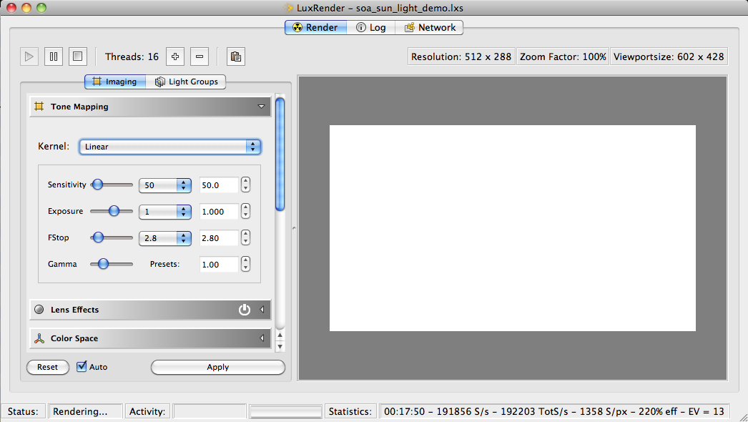 "Conversion to Linear without exposure adjustment"

If you look at the tonemapper parameters in figure <!--\ref{linear_tm_f2_8_iso50_ss_1.png}--> you'll see that we have a full exposure of 1 second and the iris wide open at f2.8. The scene that I'm trying to render is a daylight scene and if you used that kind of aperture and exposure with a real camera you would end up with something overexposed like that as well.
So, lets first change the exposure to something more reasonable like 1/250 of a second. Even with the aperture at f2.8 we can immediately see the difference. See figure 4.8.

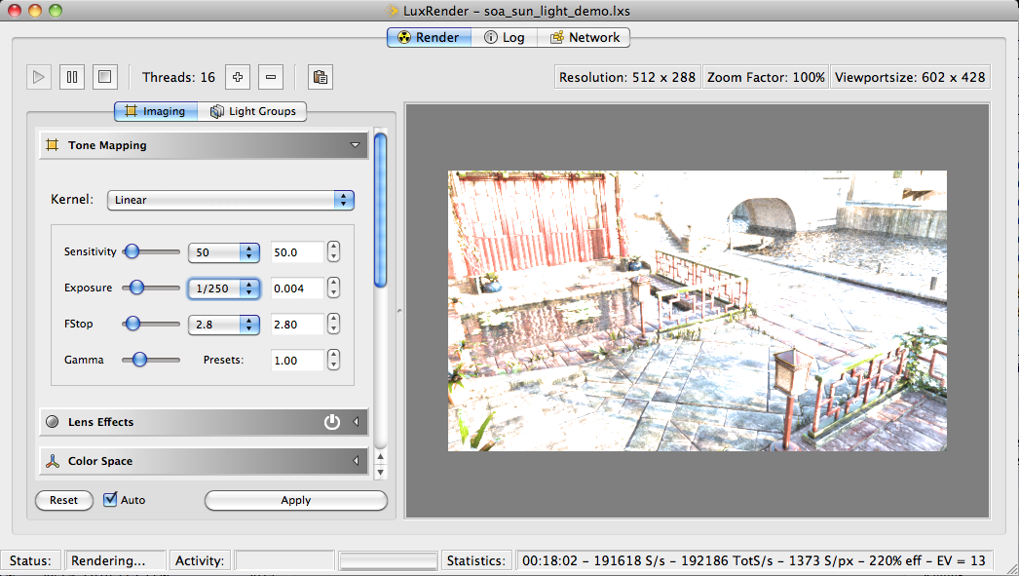 "Reducing the shutter time"

OK, we are on the right path. Next let's change the aperture (f/stop) to something a little more appropriate. Figure <!--\ref{linear_tm_f2_8_iso50.png}--> shows the result.

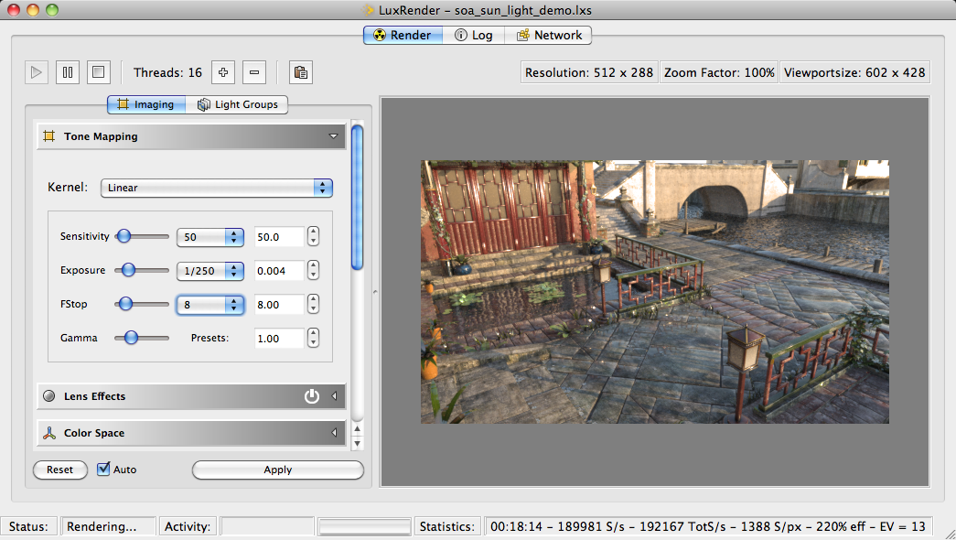 "Closing the iris"

At f8.0 we have 1/8 of the light that we were getting before and now almost everything is exposed correctly. Just for the heck of it, let's see what happens when we increase the sensitivity to 80. See figure <!--\ref{linear_tm_f8_iso50.png}-->.

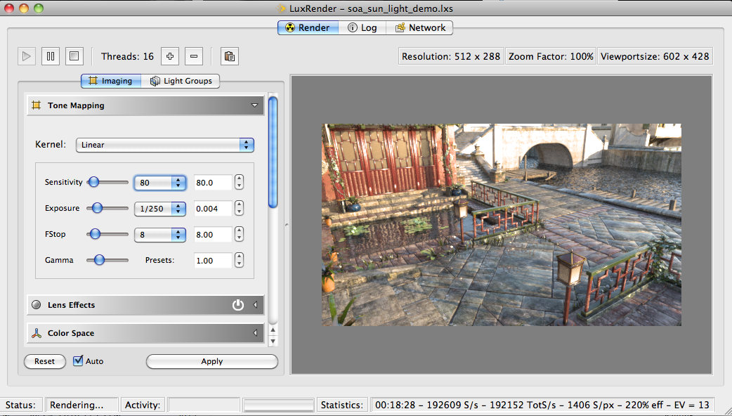 "Adjusting the film sensitivity"

That looks good. Even though a couple of spots might be a tad overexposed, we can adjust the textures to compensate for that. Figure <!--\ref{linear_tm_f8_iso80.png}--> shows us the result of a perfectly exposed image.

