The first time that you run Reality the program will ask you for the registration.
This process is simple, quick, and it will take just a minute of your time. Once it's done the program will work without further requirements.

You call Reality from inside [PS] or [DS], using the Render menu. Click on the **Render | Reality Render Editor** menu to call the program.

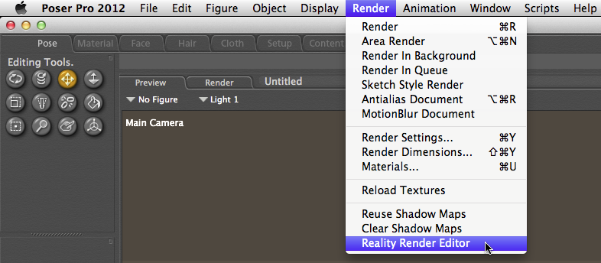 "Calling Reality from [PS]"

{$SCRImageLink[w:245;h:90]=/Users/paolo/devel/Reality/documentation/images/UI/DAZStudio_render_menu.png} "Calling Reality from [DS]"

We have done our best to make the registration system as easy as possible. Here's how it works.

The first time that you run Reality you will be prompted to register the program. The registration requires four elements to be entered:

- Your first name
- Your last name
- Your order number
- Your serial number

Some of our distributors might call the serial number a "license code." It's the same thing. If you have purchased Reality via the Prêt-à-3D website you will need to enter the same name as reported in the email that you received after the purchase.

##Automatic Registration
The easiest way to complete the registration is to use the **Automatic** mode, which sends the registration data via Internet. Please note that there is no requirement for Reality to have an Internet connection in order to work normally. The Internet connection is just for your convenience, to make the registration simple and quick.

So, with your Internet-connected computer you can enter the four pieces of data described above plus your email address. At this point you can decide to receive notifications from Prêt-à-3D about updates for Reality or other relevant information. Please note that we don't spam our customers and we keep our mailing list strictly confidential.

The registration window is shown in <!--\ref{registrationdialog.png}-->.

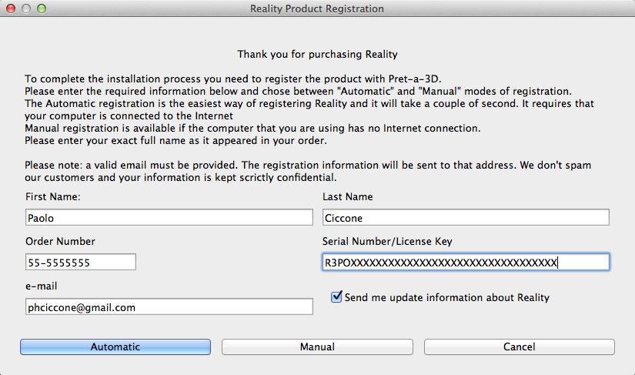 "The Registration window"

Please note that the name must appear exactly how it appears in your invoice or the registration process will fail. Rest assured that the information given is kept strictly confidential and is not shared with anybody.

##Manual registration
If, for any reason, you cannot use a computer with an Internet connection available, then there is an alternative system for registering your copy of Reality. You need to fill out the form above as usual and then press the **Manual** button. Another page will show you the instructions on how to complete the registration manually.

You will need to go to a web page using another computer, smartphone or tablet. The URL for the page is shown on the screen. The page provides a form to enter **exactly** the same data that you have in the registration window of Reality. Once that is done you will receive an activation code via email. Enter the activation code in the window shown in figure <!--\ref{registrationdialog2.png}-->.

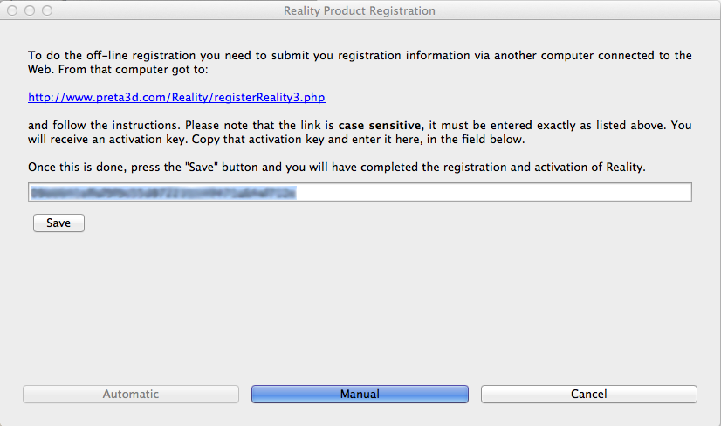 "The Manual registration window"

After that you just need to press the **Save** button and you will get a confirmation message about the registration.
If anything happens that prevents the registration from finishing successfully please send an email to `reality@preta3d.com` with a screenshot of your registration window.

##Unregistering Reality

If, for any reason, you need to remove the registration for your copy of Reality you can do that from the Help menu. This is how it's done:

- Run Reality
- From the Help menu of the program select "Unregister Reality"
- You will be asked to confirm the operation
- If you confirm the unregistering of Reality the program will erase its registration information and then close

