The heart of Reality is its material editor. With it you can modify the type and definition of all materials recognized by Reality. This can be used to optimize the desired result or to create new materials from scratch.

The Reality material editor has been designed to be flexible, powerful and easy to use. It provides the same power that you can have from a node-based editor, but without the complexity of using nodes.

##Material types

Every material in Reality has a specific type. The types available are:

- Skin <!-- \index{Material!Skin} -->
- Glossy <!-- \index{Material!Glossy} -->
- Matte <!-- \index{Material!Matte} -->
- Glass <!-- \index{Material!Glass} -->
- Metal <!-- \index{Material!Metal} -->
- Velvet <!-- \index{Material!Velvet} -->
- Cloth <!-- \index{Material!Cloth} -->
- Null <!-- \index{Material!Null} -->
- Mirror <!-- \index{Material!Mirror} -->
- Water <!-- \index{Material!Water} -->

Right at this point we can see already how Reality makes things easier from the start. When materials are of a given type there is no confusion about what to expect. A Metal material cannot have settings related to skin. A glass material will not have parameters that belong to metal or velvet.

Materials with types make it much easier to work and find the relevant parameters.

###Channels
Each material is defined by channels and properties. A channel is where we attach textures. For example, the Glossy material has a Diffuse channel which defines the surface of the material. If we attach an image map to that channel then the surface of that material will show that image.

{$SCRImageLink[w:350;h:345]=/Users/paolo/devel/Reality/documentation/images/UI/RealityMatEditor.png} "The Material Editor"

In figure <!--\ref{realitymateditor.png}--> we can see the Diffuse, Specular, Top Coat, and Translucency channels. Each channel has, in this example, a texture of type Color. The groups of three numbers are the RGB values for the color selected in each texture.

{$SCRImageLink[w:250;h:101]=/Users/paolo/devel/Reality/documentation/images/UI/Reality-texture-preview.png} "Detail of the material editor"

###Textures
In the [PS] and [DS] world the word "texture" is frequently used as a synonym for "image" but that is an oversimplification. In the 3D world a texture is any pattern that is applied to a surface. A solid color is a texture for which all pixels have the same value. In Reality we have fourteen types of textures. One of them is the Image Map, which paints an image file onto the selected surface.

We can edit the value of the texture or we can change the type of the texture altogether. For example, if we want to have an image for the diffuse channel, instead of a solid color, here is the simple procedure to do that:

Alt/Opt-Click on the color swatch in the Diffuse channel. The Texture Editor will show in the right side of the window, see figure <!--\ref{reality-texture_editor1.png}-->. We can also click on the gear menu for the Diffuse textures and select **Edit** from it.

{$SCRImageLink[w:300;h:127]=/Users/paolo/devel/Reality/documentation/images/UI/Reality-texture_editor1.png} "The Texture Editor"

From the drop-down list labelled "Texture type" select **Image Map**. See figure <!--\ref{reality_texture-selector.png}-->

{$SCRImageLink[w:250;h:272]=/Users/paolo/devel/Reality/documentation/images/UI/Reality_texture-selector.png} "Changing the type of texture"

The texture has been changed from Color to Image Map. Now we can select an image of our liking. Let's click on the gear menu to show a menu that gives us the choice to **Select a new file**. Figure <!--\ref{reality-gearmenu-image.png}--> shows what happens.

{$SCRImageLink[w:249;h:425]=/Users/paolo/devel/Reality/documentation/images/UI/Reality-gearmenu-image.png} "The Gear menu"

Navigate to an image file of your choice and confirm the selection. Once you do that you will see the file in the preview field, below the name. You can also see the dimension, in pixels, of the file just below its preview. See figure <!--\ref{te-grainy-rock.png}-->.

{$SCRImageLink[w:299;h:510]=/Users/paolo/devel/Reality/documentation/images/UI/TE-grainy-rock.png} "Image map loaded"

If we run a render now we will see the the object attached to that material, in this case the standard host's sphere primitive, renders with a rocky surface. It's not very credible but this is just to show the workflow in modifying materials. See figure <!--\ref{rug_rocktexture.png}-->.

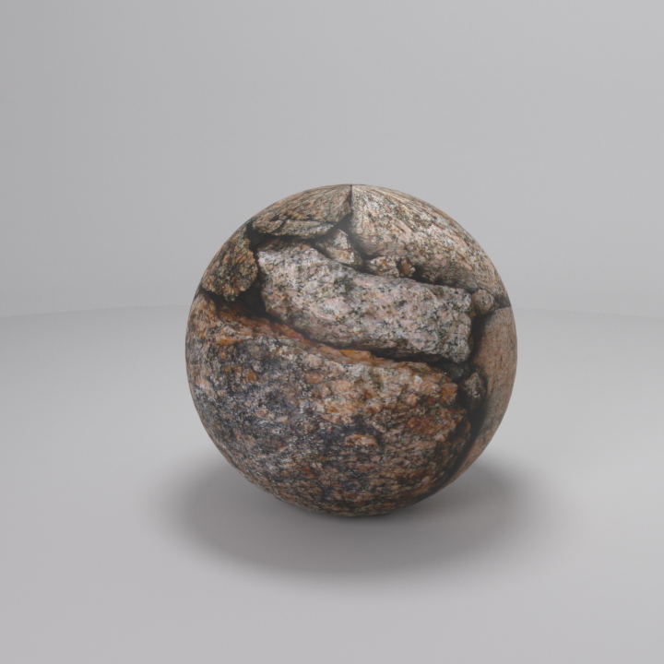 "Rock texture applied to the sphere"

###A nodeless system
It is common for 3D programs to represents materials using "nodes," entities that represent a certain function and that can be connected together. Nodes are very powerful but they are also very hard to use. Reality doesn't use nodes but it has a system of creating textures that is as powerful.

In Reality, to change how a texture works, you don't disconnect/reconnect nodes, you simply convert from one texture type to another and Reality will carry over the relevant information.

##Reality materials are independent

One of the great advantages of Reality is that it creates its own copies of materials distinct from the host's versions. In this way you can change types of material, and you can completely change the properties of that material, without having to worry how that will affect your base materials in the host. This level of freedom, coupled with the simpler material editor, is very conducive to creativity and experimentation.

For example, let's say that you see some buttons on a garment and you are wondering if those would look good if they were turned to glass. You can convert the material to Reality's Glass and do a quick render. If the result is not satisfactory then you can simply right-click on the material and select **Revert to original**. Like it never happened!

