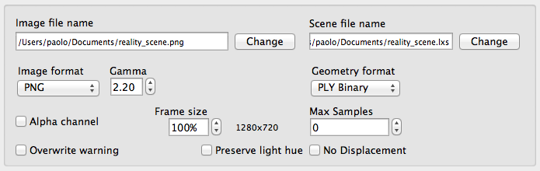 "The Output group"

A LuxRender scene is generally composed of a few files. The way Reality exports your host scene to LuxRender is via two main files:

- **reality_scene.lxs** This base file contains the general scene definition, including the resolution, format, and name used for the rendered image.
- **reality_scene.lxi** This file contains the definition of the objects in the scene.

The Render tab allows us to change the name of the base file, which will also determine the name for the .lxi include file. These files and their purposes are mentioned here purely to provide all the information necessary to back up and transfer your scene files. Copying the .lxs file alone is not enough. We have to get the corresponding .lxi file as well.

The options in the Output group are: <!-- \index{Output options} -->

**Image file name**
In this field we specify the name and folder of the image file that we want to obtain when we render. By default a PNG file is generated. <!-- \index{PNG} -->

**Image format**
The output file formats supported for your render are PNG, EXR, and Targa.

**Gamma** <!-- \index{Gamma} -->
The Gamma Correction used to generate the image file. Gamma correction is applied to determine the treatment of midtones when an image is converted from the internal, full spectrum, light representation of LuxRender to the RGB color space. Usually this value doesn't need to be changed. Reality knows what is the appropriate Gamma value for the Operating System.

**Geometry format** <!-- \index{PLY} -->
Exporting a scene to LuxRender involves writing a very long series of vertex and polygon data. There are two main file formats that we can use: the native LuxRender text file and the PLY file format. PLY can be written in either text or binary format. Even with the text variant PLY is generally more compact than the LuxRender native format. Binary PLY format is less than half the size of the LuxRender native format. Smaller files not only require less disc space but they take much less time to be written by Reality and much less time to be read by LuxRender. By default Reality sets the file format to PLY Binary. Reality 3.0 only supported the LuxRender native file format. If you re-render a scene that was created with Reality 3.0 Reality will automatically set the file format to binary PLY.

**Alpha Channel** <!-- \index{Alpha channel!rendered image} -->
The Alpha Channel checkbox allows you to create an alpha channel for your scene in case you want to do background replacement in graphic packages like Adobe Photoshop. When this option is selected, any part of the scene that is not covered by some object will be set to be transparent.

**Frame size**
The size of the render is taken directly from the host but you can also select to have the final render at 100%, 75%, 50% or 25% of the size, or at 200%, 300% and 400% of the size. This is a great way of making test renders that take a fraction of the time of the final scene. The "% of frame rendered" parameter is persistent, and it's remembered across invocations of Reality for the same scene.

**Max samples** <!-- \index{Samples!Maximum} -->
The "Max Samples" value is used to force LuxRender to stop rendering after a given number of samples per pixel is reached. Leave it at zero for no limit. This value is also necessary for the rendering of animations. Setting it, for example, at a value of 500 will stop the rendering of a frame when that number of samples has been reached, and will cause LuxRender to start rendering the following frame. Otherwise, if left at zero, LuxRender would never move past the first frame in the series.

**Overwrite Warning** <!-- \index{Overwrite warning} -->
When this checkbox is enabled Reality will warn us if the scene file (.lxs) that we are creating for the export already exists on disk. We can then decide to overwrite it or not. This flag is saved for each scene. The default for new scenes, on or off, is decided by the setting in the Advanced tab.

**Preserve Light hue** <!-- \index{Light hue} -->
When the camera faces a light, and that light has a certain color, or hue, the objects lit by that light will take the hue but the light source itself will render almost pure white. If we enable this option then the light hue will be preserved.

**No Displacement**
This option globally turns off the use of displacement maps for all materials. It can be useful to create quick test renders since displacement can add quite a bit of time during rendering. By turning it off we can obtain a test render without modifying the materials. Once the test render is done the option can be disabled to return to full-quality rendering.

