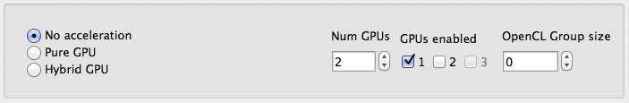 "Acceleration options"

If our computer has a OpenCL-compatible video card (note, this is different from OpenGL) we can now take advantage of that additional computing power by selecting this option. <!-- \index{OpenCL} -->

There are currently two types of acceleration possible: *Pure GPU* and *Hybrid GPU*. <!-- \index{Pure GPU} --><!-- \index{Hybrid GPU} -->

See [GPU-based Rendering][] for more details on how to use GPU acceleration.

The other options available are:

- Num GPUs. This options must be set to the number of GPUs installed in your machine, regardless if they will be used or not during the renderer. Reality has no way of gaining this information from the OS so this value must be configured manually.
- GPUs enabled. In some cases, if there are more than one GPU installed, we might desire to not include one or more GPUs in the rendering process. This series of checkboxes allows us to do so. For example, if the second GPU needs to be excluded from rendering, then checkbox marked *2* must be disabled. Reality supports up to a maximum of three GPUs.
- OpenCL group size. For certain video cards it is necessary to set this value. It's generally best to start rendering with this value set at zero. If the image, while using GPU acceleration, is completely, solid black then try changing this value to 64.

