<!-- \index{Textures} -->
A texture is a pattern that is projected on a surface. At the very simplest the "pattern" can be a solid color.

Traditionally, in the [PS] and [DS] world the term texture has been equated to an image. That is actually not correct. This book uses the term "texture" to indicate a generic pattern projected on a surface. We will use the expression "image map" to indicate a texture based on an image.

Textures are divided into a few different subcategories. There are, for example, procedural textures, which are patterns generated by the software based on some input parameters. Procedural textures are very powerful and flexible. For example, the Bricks texture generates brick patterns that can be adjusted by the artist.

Some textures generate RGB values that are suitable for input for the Diffuse channel. Other textures generate numeric data, values between 0.0 and 1.0, for each "pixel." Numeric textures are useful to drive things like displacement and transparency. Although some programs, like [PS], allow us to mix color and numeric textures together, LuxRender doesn't allow it. This is the reason why some textures are not accessible for certain channels.

Reality provides access to a few different types of textures. They are:

- Color. A color texture paints the surface with a solid color chosen by the user. See figure <!--\ref{rug_tex_color.png}-->.
- Image map. This texture uses an image to paint the surface. See figure <!--\ref{rug_tex-image-map.png}-->.
- Texture Combine. This image mixes two textures together. The mixing can be selected to be one of:
- Add. The RGB values from texture 1 are added to the RGB values of texture 2.
- Subtract. The RGB values from texture 1 are subtracted from the RGB values of texture 2.
- Multiply. The RGB values from texture 1 are multiplied with the RGB values of texture 2. This is the most common use.
- None. This "function" allows us to use the Texture Combine texture without an input for the second texture. This situation is useful when we want to mix a color with a texture because each input in the Texture Combine texture includes a texture and a color that is multiplied. By using None we simply multiply a color with the texture in the first slot.
- Math. This operation is reserved for numeric textures. It's similar to Texture Combine but it acts on floating point values instead
- Band. This is a gradient texture based on four color points. See figure <!--\ref{rug-tex-band.png}-->
- Bricks. This procedural texture generates a brick pattern based on several parameters. See figure <!--\ref{rug_tex-bricks.png}-->
- Checkers. This procedural texture generates a checker pattern based on several parameters. See figure <!--\ref{rug_tex-checkers.png}-->
- Clouds. This texture generates semi-random noise that takes the shape of clouds. If scaled down it can be used for bump mapping and other applications where random noise is useful. This is a numeric texture. See figure <!--\ref{rug_tex-clouds.png}-->
- Fractal noise. This texture generates great pseudo-random noise that is excellent for bump mapping. This is a numeric texture. See figure <!--\ref{rug_tex-fractal-noise.png}-->
- Marble. Another numeric texture. This one generates patterns that resemble types of marble, depending on the parameters entered. See figure <!--\ref{rug_tex-marble.png}-->
- Mix. This texture allows us to mix two textures together. Each input texture can be a Mix texture itself, allowing endless nesting of the mix.
- Distorted noise. This texture generates a noise pattern and then it distorts it using another noise pattern. It's a great tool for creating interesting patterns. This is a numeric texture. See figure <!--\ref{rug_tex-distorted-noise.png}-->
- Wood. This texture generates patterns that resemble the grain of wood. This is a numeric texture. See figure <!--\ref{rug_tex-wood.png}-->

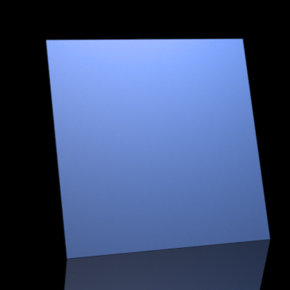 "Color texture"

<!-- \index{Textures!color} -->
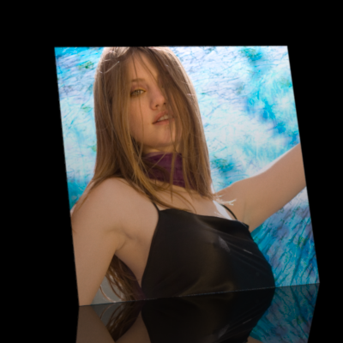 "Image Map texture"

<!-- \index{Textures!image map} -->
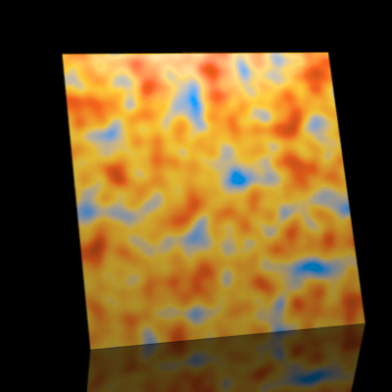 "Band texture"

<!-- \index{Textures!band} -->
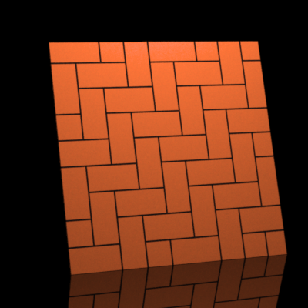 "Bricks texture"

<!-- \index{Textures!bricks} -->
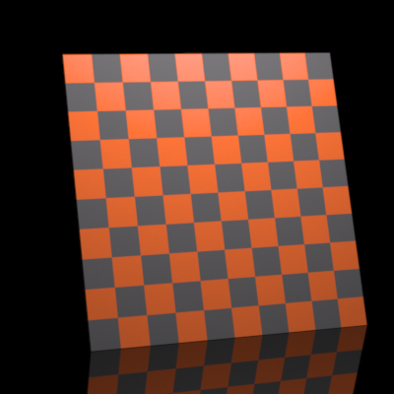 "Checkers texture"

<!-- \index{Textures!checkers} -->
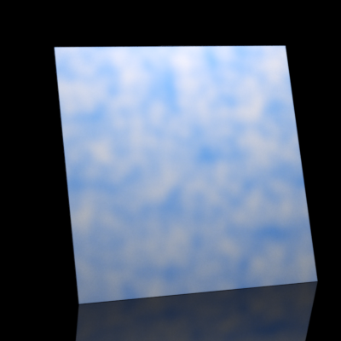 "Clouds texture"

<!-- \index{Textures!clouds} -->
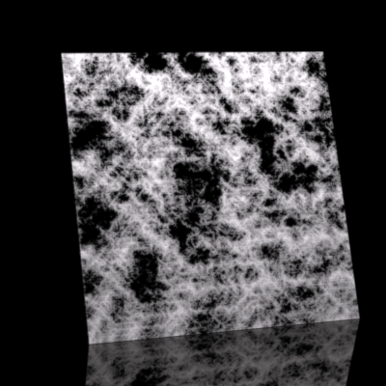 "Fractal noise texture"

<!-- \index{Textures!fractal noise} -->
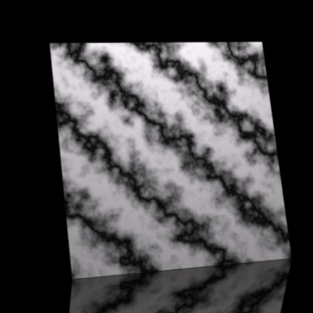 "Marble texture"

<!-- \index{Textures!marble} -->
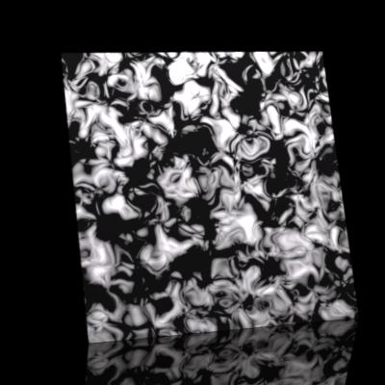 "Distorted noise texture"

<!-- \index{Textures!distorted noise} -->
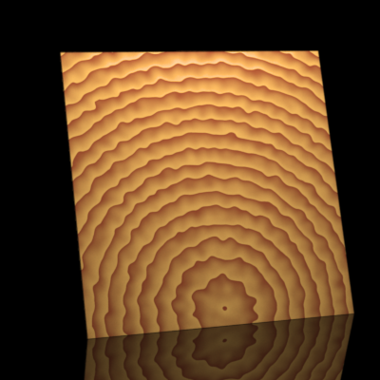 "Wood texture"

<!-- \index{Textures!wood} -->

