<!-- \index{Material!Glass} -->
Glass is a simulation of real glass and it can create near-photographic results. Glass is mainly defined by the Tint and Reflection parameters and the Index Of Refraction (IOR). Reality includes dozens of IOR presets measured from real materials. For example, if you want to render an emerald you can find the exact IOR for it, 1.56, under the Gemstones preset group. The IOR does not change the color of the material, which needs to be modified manually. Glass has three tabs: Glass, which defines the glass characteristics, and the usual Alpha Channel and Modifiers tabs. <!-- \index{Alpha channel} -->

The parameters for Glass are:

- Reflection. The color or texture of the reflections on the surface of the material. The specular color from the host's material is imported in this channel but it's usually best to change it to an off-white (250, 250, 250 for example). The higher this number is, the more reflective the glass is. If you want to create the effects of a glass pane that has been coated with an anti-glare treatment, use a low Reflection value, like 42, 42, 42.
- Tint. The color or texture that the glass will have and consequently the amount of light that will pass through the material. The host's diffuse color is applied to this channel.
If you want to create a green glass bottle this is where the green will be configured. This is the color that the light will pick up when traversing the glass. For neutral glass, like windows or car windshields, it should set it to white. For Lara Croft's sunglasses a nice shade of orange will do. If you convert the texture to use an Image Map you can achieve a plethora of stunning effects, including stained glass and light gels. If the texture washes out because of the light going through it, mix it with a dark gray color, like 20, 20, 20.
- Architectural. <!-- \index{Glass!Architectural} -->Glass is computationally expensive so if the object is small and at a distance, or if you don't need absolute accuracy for it, enabling this parameter will speed things up while maintaining the basic characteristics of glass like being reflective and transparent. The refraction deformation will be not visible.
- Volumetric. <!--\index{Glass!Volumetric}--> LuxRender 0.7 introduced volumetric glass, a material that transforms light based on its volume. What this means is that the thickness of the glass in the model affects the final result of how it's painted on the image. Also, light is affected when passing through the glass and it creates colored shadows. In Reality 2 this was called "Hyper-realistic."
- Frosted. <!-- \index{Glass!Frosted} -->This flag creates Frosted Glass, or rough glass. When enabled, the Roughness slider will be activated. Higher values of roughness make the glass appear more and more as if it was sand blasted.
- Thin film thickness. <!-- \index{Thin film} -->This value allows you to define a glass material with a film coat that is expressed in nanometers. Optical instruments, like a camera lens, are often coated with a thin film to reduce the glare caused by direct bright light like the sun. This coat can show as an iridescent "film" when seen at a certain angle. A good starting value for this parameter can be 200nm.

The images below show what a glass sphere looks like without and with thin-film coating.

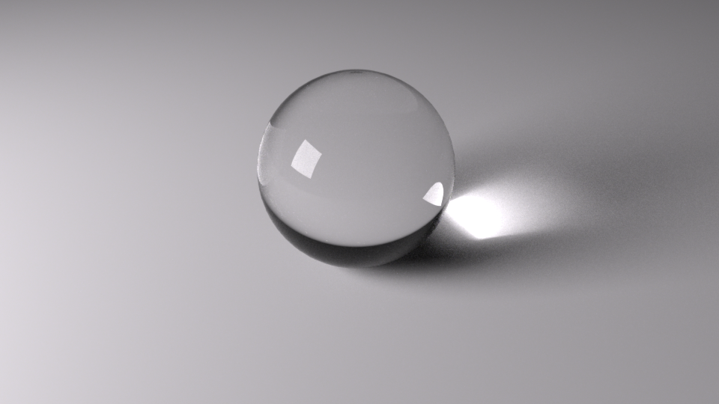 "A glass sphere without thin-film coating"

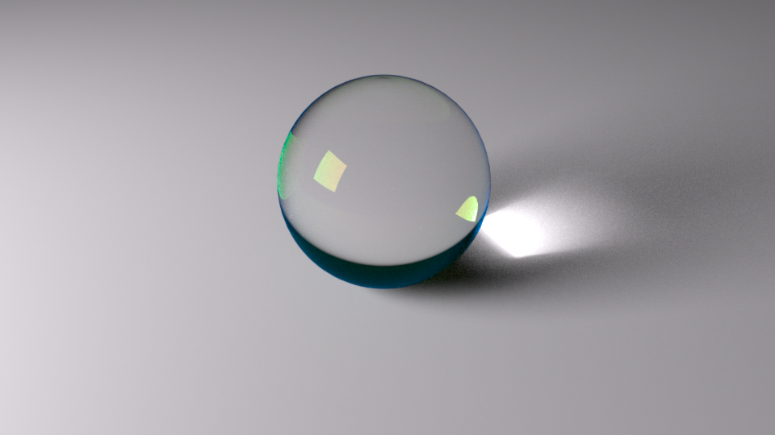 "Glass sphere with thin film coating. Thickness at 200nm, IOR at 1.5"

- Thin film IOR. This is the Index Of Refraction of the thin film. Different IORs will create different colors in the film. For this IOR you can try 1.0 and move from there to see the shift of iridescence in the coat.
When converting glass from a the host material you need to keep an eye on a couple of issues. Both [PS] and [DS] simulate glass via a transparency map or opacity value. Both these options should be avoided in Reality. If you convert a material to Glass check immediately if it has an alpha map. If so, remove it by using the Unlink option of the gear menu or the resulting material will be too transparent to be visible. We also need check that the Opacity value is set to 1.0.

The texture in the Tint channel of the Glass material is a crucial factor. Some textures in the host are designed to create a certain coloration in the simulated material. Unless the transmission texture has a real image, we are better off by using a solid color instead. This can be easily done by converting the Image Map texture to a Color one in the Texture Editor. If the texture has a sort of painting, like the images found on stained glass, then it will be OK to leave it in place.

- Dispersion. This flag allows you to create real glass effects like when a light is split into its basic colors by a prism. The Cauchy <!-- \index{Cauchy} -->coefficient can be used to control the result, together with the Clarity at depth. This option is best used with Volumetric or Standard Glass.

