Reality provides several options for rendering your images with optimal balance between quality and speed. Let's see all the options in detail.

{$SCRImageLink[w:400;h:255]=/Users/paolo/devel/Reality/documentation/images/UI/R4-1-Render-Options.png} "Scene Configuration Options"

By default Reality renders using CPU acceleration. This mode gives you an excellent quality of image, while rendering as fast as possible when using the CPU and preserving the unbiased nature of the image. Compared to the previous version of Reality, this accelerated mode is between seven and ten times faster.

We can make the CPU rendering even faster by enabling the **Extra Boost** option. As the name implies, this option can deliver an image in even a shorter time. The trade-off is that Extra Boost can introduce bias. Nevertheless, this is an excellent option when in a hurry or when rendering animations. Compared to the previous version of Reality, CPU acceleration with **Extra Boost** can be up to twenty times faster.

##OpenCL rendering

If your computer has an OpenCL device then the **OpenCL rendering** option will be enabled. Reality automatically detects all the OpenCL devices in your computer and it lists them in the **Scene Configuration** page. When you enable the OpenCL rendering option you have the possibility to enable or disable any of the devices detected. For example, you can decide to render using both the CPU and the GPU, or exclude the CPU from the rendering process and use the GPU alone.

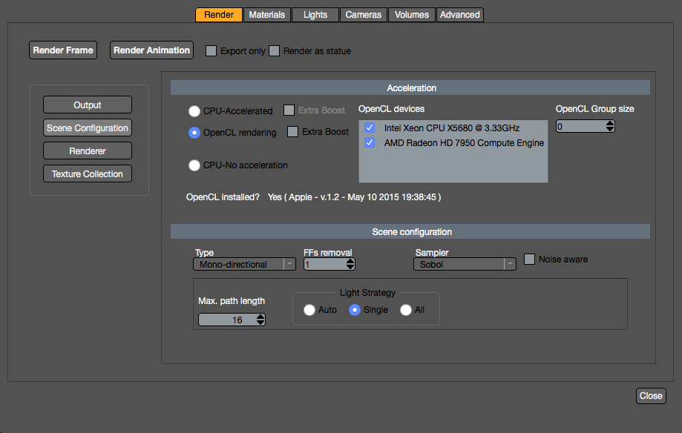 "OpenCL Rendering options"

As with the CPU acceleration, the OpenCL rendering has an **Extra Boost** variant. The same considerations outlined for the CPU version are valid in this case; enabling the Extra Boost option can introduce bias in your final image.

Please note that when enabling Extra Boost for OpenCL, Reality automatically excludes the CPU from participating in the rendering. This is because Extra Boost for OpenCL devices is valid only for GPUs.

GPU-based rendering also suffers from limited RAM. GPUs generally have small amounts of on-board RAM, typically in the range of 2GB. On the other hand computers nowadays can have in excess of 20 or 30 GB and the CPU is able to address all that memory. For complex scenes having that amount of memory is a crucial factor.

To help contain a scene inside the GPU's RAM, Reality automatically enables texture collection and scaling when selecting to render with OpenCL.

##Starting up
If you want to try OpenCL rendering we suggest that you start without the Extra Boost option. Gain some experience in using this mode and then experiment with the Extra Boost option.

##Shader compilation
Whenever you use OpenCL, the materials, a.k.a. shaders, need to be compiled before the rendering can begin. During this time LuxRender will show a black rectangle in the area where the image is expected to show.

While LuxRender is compiling the shaders it will report that there are zero devices present. The information is shown in the status bar:

{$SCRImageLink[w:226;h:35]=/Users/paolo/devel/Reality/documentation/images/UI/Luxrender_0_devices.png} "LuxRender compiling the shaders"

Once the compilation is done the number of devices will be displayed. For example, if you enabled one GPU then LuxRender will report 1 device. If you enabled both the GPU and CPU then LuxRender will report two devices.

Depending on the type of hardware and the device driver installed, the compilation time could vary from a few seconds to several minutes. This compilation phase is necessary only the first time a given material is rendered. If you do successive renders, without changing any of the materials, then the rendering will start almost immediately.

It has been noticed that OpenCL with Extra Boost might take longer to compile on some nVidia hardware. We are aware of this and hope to provide a solution soon.

It is worth noting that in the case of an animation the compilation time will be needed only for the first frame, while all the other frames would be a rendered right away.

Once all the materials are compiled you will find that changing camera view, changing poses and doing any other operation in the scene that does not involve changing materials will not affect the render startup time.

##OpenCL technical information

<!-- \index{OpenCL} --> <!-- \index{OpenGL} -->
Please note that OpenCL is not related to OpenGL. Please also note that OpenCL is not CUDA. OpenCL is an open standard that provides computer programmers with an interface to use the computing power available in the GPU. OpenCL is platform-independent and so it works, and it's supported by, graphic cards from different brands, including nVidia, AMD and Intel. CUDA is a proprietary API, similar in scope to OpenCL, but only supported by nVidia.

With OpenCL you can have multiple devices, GPUs, your machine and those devices can come from different vendors, and Reality and LuxRender will be able to use them at the same time.

####Important notes for OS X users
While Reality provides full support for OpenCL on both OS X and Windows, unfortunately the OpenCL drivers for OS X 10.10 and 10.11, up to September 2015, are broken. This means that it's not possible to render using OpenCL on OS X.

If and when Apple will fix its OpenCL drivers, then Reality will automatically be able to render your images with OpenCL.

