<!-- \index{Material!Metal} -->
This material defines metallic objects that can have anisotropic reflections (see the Polish parameter, below, for a definition). There are several presets:

- Aluminum
- Chrome
- Cobalt
- Copper
- Gold
- Lead
- Mercury
- Nickel
- Platinum
- Silver
- Titanium
- Zinc

These presets can be configured to have variable levels of shininess and they can be used to create other types of metal. For example, very shiny silver can be used in place of stainless steel. We can also select *Custom metal* and use a simple color channel to create materials like anodized aluminum in seconds. Or use an image for more sophisticated effects.

The Polish value sets how shiny the metal is. Higher values bring more shine. The Horizontal and Vertical sliders are linked together by default to give uniform reflection. When the "Synchronized" option is deselected the two sliders can move independently, allowing you to create a polish that has different values for the vertical and horizontal directions, called "anisotropic reflection."

See the figure <!--\ref{rug_metal_reference.jpg}--> for an example of how the Metal material renders.

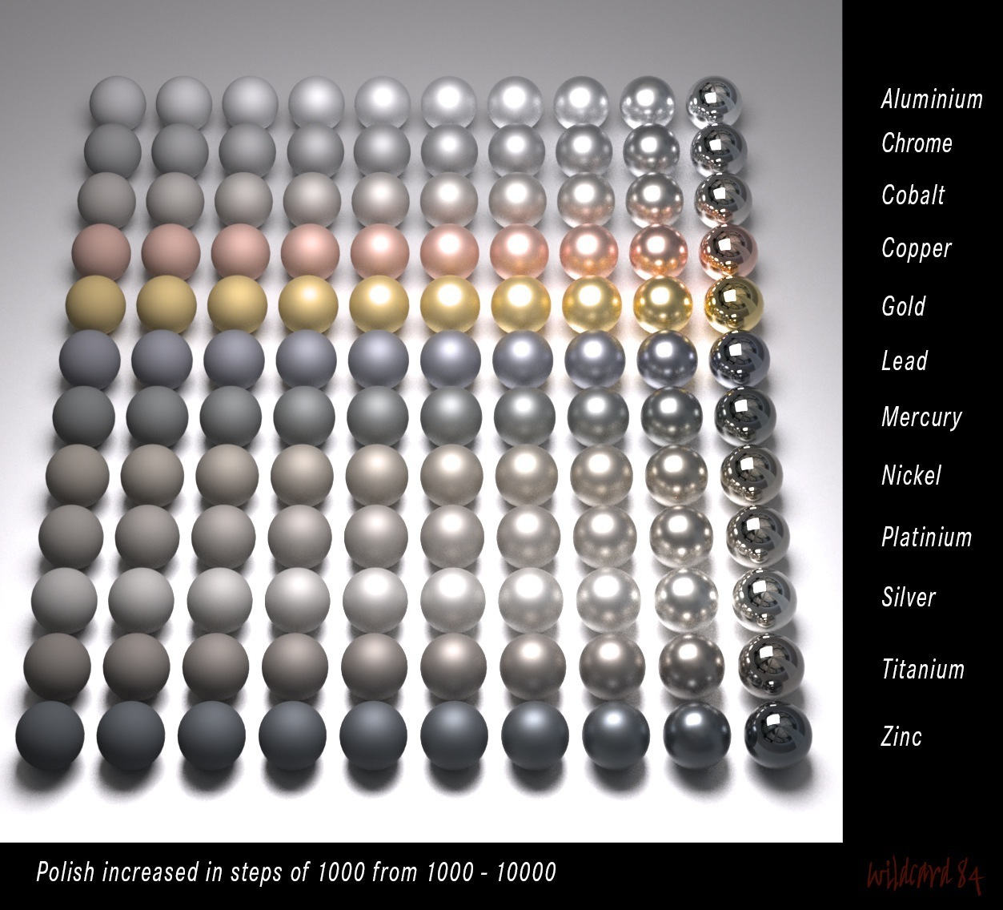 "Metal reference card - Courtesy of Michael Wladarsch"

<!--\pagebreak[4] -->

