Realism is achieved by careful use of lights. What Reality and LuxRender allow you to do is to avoid using the usual "cheats" of traditional 3D lighting and start applying lighting solutions that work in real life. If you have experience in photography then the way LuxRender handles lights will be immediately familiar. For example, if you need to fill a part of your scene with some soft diffuse light you can set a plane on the opposite side of the subject, facing the light source, and you have a beautiful "fill" without using an additional light.
The following pictures show this principle in action. In figure <!--\ref{rug_car.png}--> we see a car lit by a single large mesh light suspended above it at an angle. Notice that the front of the car and its side are dark and we can't quite see the detail in those areas.

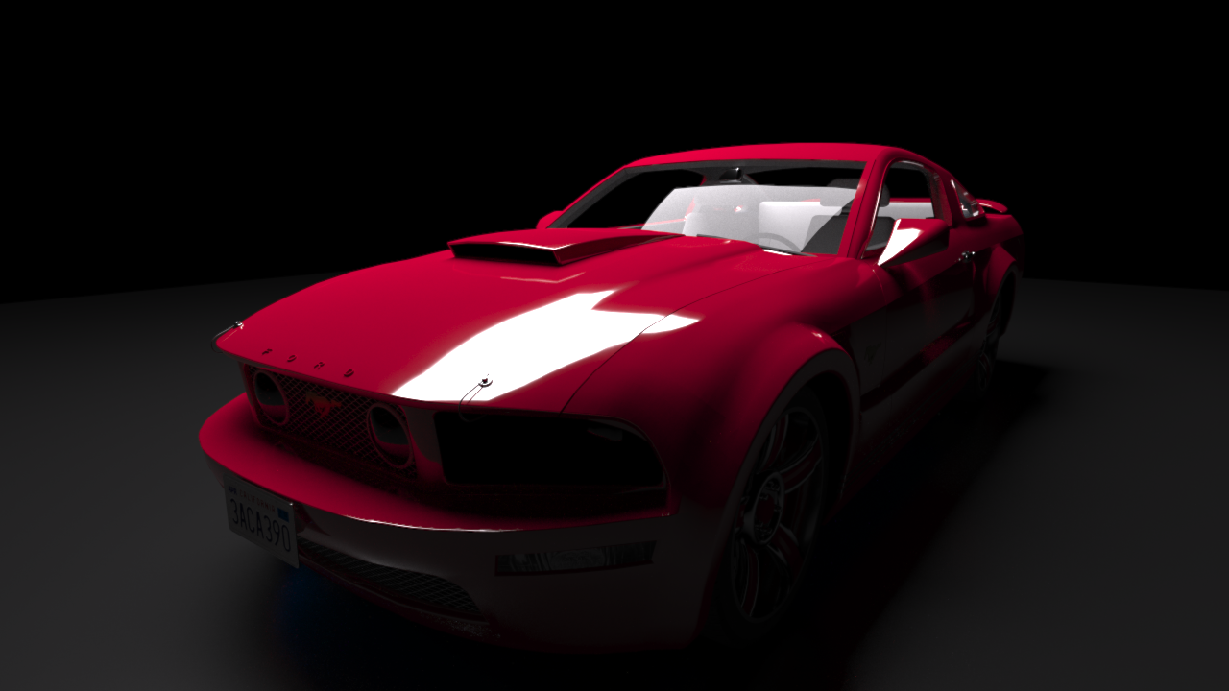 "Simple lighting with top mesh light"

Instead of adding lights we can add a couple of planes, one in front and one on to the side of the car, to reflect the light from the top fixture. See figure <!--\ref{rug_car_with_planes.png}-->.

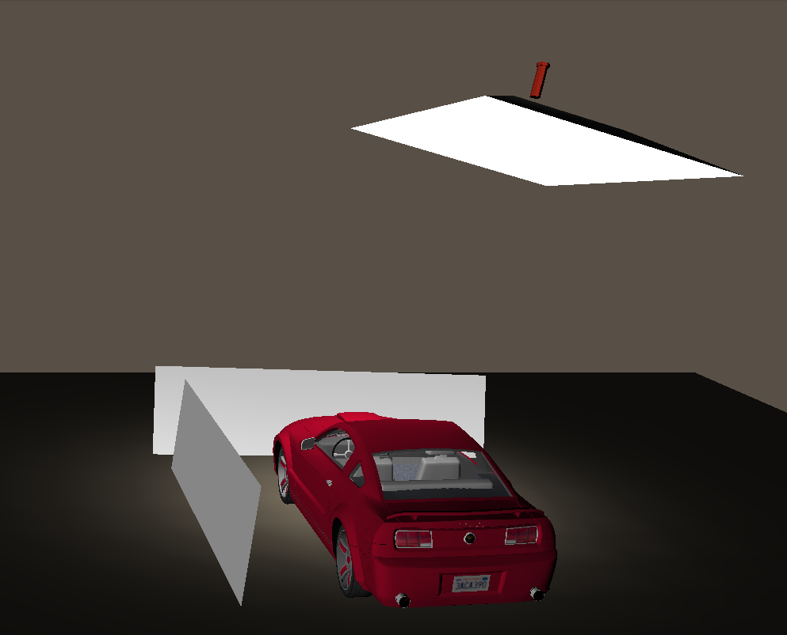 "Adding reflectors to bounce the light"

Now the exact same scene, with no added lights, shows more details of the car. See figure <!--\ref{rug_car2.png}-->

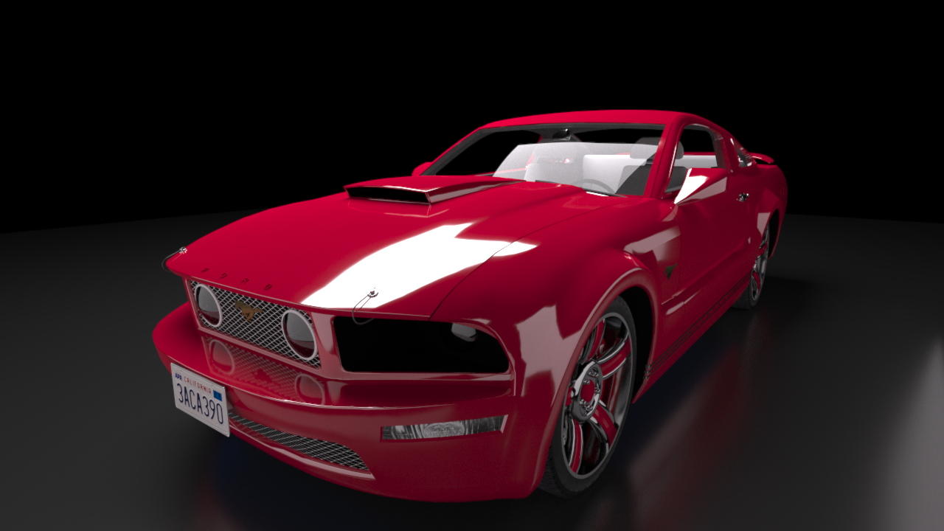 "More details visible without adding lights"

On a similar note, if the Sun light is too harsh we can place a plane between the Sun and your subject, then configure the plane to use the translucent Matte material which gives us a diffuser. A diffuser turns a harsh light, the Sun, into a soft light. Think like a photographer and the software will react as expected. The sooner we get start thinking in terms of real light the sooner we start getting the right results.

We also need to remember that LuxRender requires fewer lights than [PS] or [DS]. In fact the number of lights needed is dramatically smaller. This is because LuxRender employes a physics-based lighting model and so light bounces around the environment in a natural way. It's a good thing, while you get used to the way LuxRender works, to do some tests with only one [ML] and see how that source reacts. You will be surprised at how much you can obtain from one single light source.

