Reality supports the following types of lights:

- [ML] <!-- \index{[ML]} -->
- Spotlight <!-- \index{Spotlight} -->
- Projector <!-- \index{Projector} -->
- Point light <!-- \index{Pointlight} -->
- Sun light <!-- \index{Sun} -->
- [IL] <!-- \index{[IL]} -->
- IBL <!-- \index{IBL} \index{Image Based Lighting} -->

##[MLs]
<!-- \index{[ML]} -->
These are also known as Area Lights and they are geometric meshes that emit lights. These are generally the best choice for creating good lighting and for achieving realism. Reality includes two ready-to-use Meshlights:

- MeshLight: this is a simple light fixture with a front panel that is preconfigured to work as a light-emitting object. It provided beautiful lighting and it has very few polygons so it doesn't require much memory.
- Top Mesh light: a mesh light that is conveniently positioned to shine from top to bottom.

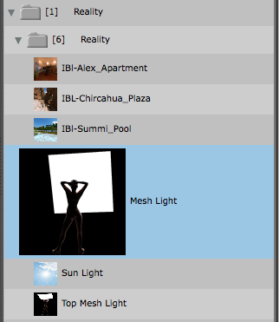 "Reality lights in [PS]"

{$SCRImageLink[w:216;h:197]=/Users/paolo/devel/Reality/documentation/images/UI/DAZStudio_Reality_lights.png} "Reality lights in [DS]"

We can also create a mesh light by simply adding a plane or any other primitive, and rename it "RealityLight." After that we simply orient it in the direction we want it to spread light. A cube will emit light from all six sides, and a plane will emit light from the direction pointed by its surface normals. If we need more light sources we can simply create more primitives and add a suffix to the name: RealityLight_1, RealityLight_fill, RealityLight_hair, etc. The important thing is that the object's name starts with "RealityLight." Capitalization has to be exactly as in the examples given. In general it's just simpler to use the [MLs] provided.

The Reality [MLs] have controls made to help in both positioning them and setting the type of light that they generate. In the real world the quality of a light is determined by the size of the light. For example, a large light generates a very diffuse light with soft shadows. A small light generates a harsh light with sharp shadows. The brightness of a light has nothing to do with its sharpness. It's the size that affects the quality of the shadow. For this reason the Reality [ML] has controls to change its softness and those controls achieve the effect desired by changing the size of the light. See the Parameters panel in [PS] or [DS].

When we add a [ML] to the scene it is set to use the *Soft* preset, which provides a visible soft shadow. We can enable the other settings, for example, *VerySoft*. In that case we need to remember to disable the previous preset. In this example we need to set the *Soft* preset to 0 after we set the *VerySoft* preset to 1.

##Sun Light
<!-- \index{Sun} -->
This is an [IL] that is named Sun. With this light Reality will export to LuxRender a Sun plus atmosphere which will be rendered beautifully. The angle of the Sun will also determine the type of light. If the sun light is horizontal it will look yellow-orange. On the other hand, vertical sunlight sun will look cooler and more on the blue side of the spectrum. **The position of the Sun in the scene is not relevant, only the angle is.** You can place the Sun wherever it is convenient for you. Of particular use is the *Sun size* control. With that you can make the sun, if it's visible by the camera, appear larger than the default size determined by LuxRender. The turbidity parameters can be used to create a more visible atmosphere. The default of 2.2 is what is normally used by Reality.

Reality generates a separate light group for both the Sun and the Sky so that you can adjust their balance in LuxRender while rendering. Look in the "Light groups" tab of LuxRender and you will find a "sun" and "sky" group that you can adjust independently from each other. For this effect to work we need to use the "Linear" tonemapper.

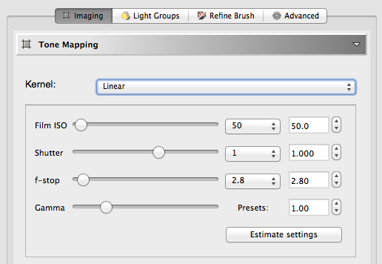 "Selecting the Linear tonemapper in LuxRender"

##Spotlights
<!-- \index{Spotlight} -->
A spotlight from the host is converted to use the exact same orientation, position, and cone angle in LuxRender. The color of the spotlight is also preserved. If the light's color is any shade of gray then the standard color temperature of 6,500 Kelvin is used. This can be changed dynamically in LuxRender when the scene renders. Spotlights usually have a soft area around the edges, where the light is "feathered." [PS] or [DS] don't have that control and so Reality sets the edge feather at 5 degrees. It can be adjusted to other values in order to make the edge as soft or as sharp as we need. We can also set a texture for the Spotlight. This turns the spotlight into a projector.

##Projectors
<!-- \index{Projector} -->
A projector light acts as expected: it projects an image map similarly to what a physical image projector does. This is obtained by applying an image map to a Spotlight. The width of the spotlight, the angle of the light and the shape of the receiving surface will affect the final result. The following video shows how to create projectors using Reality [PS] Edition. It shows version 3 but it's still current.

[{$SCRImageLink[w:298;h:165]=/Users/paolo/devel/Reality/documentation/images/RUG_Projector-video.png}](http://youtu.be/lozfDq33J4U)

The following video shows how to create projects with [DS]:

[<$img:../images/RUG_DSprojector.png;w=298>](http://youtu.be/kmfH1qc0nRc)

##Point lights
<!-- \index{Pointlight} -->
Reality supports point lights, which are light source that emit light in all directions. Point lights are also enabled to use IES profiles. See the description about IES lights below. Keep in mind that point lights are possibly one of the least desirable lights to be used in a scene. Artistic lighting is all about control and point lights are the hardest to control because they emit light in all directions (360 degrees) . There are legitimate uses of point lights but they are much less used with LuxRender than with [PS] or [DS].

##[ILs]
<!-- \index{[IL]} -->
- This kind of light is used to simulate the sun and ambient light with biased renderers. They have little or no use with LuxRender and should not be used whenever you plan to render your scene with LuxRender. If you use one for seeing the objects in the scene you can then disable it in the Reality light editor so that it has no influence in the final render. **[ILs] generally produce the worst type of light and detract from the overall realism.**

- ##Image Based Lighting (IBL)
<!-- \index{IBL} -->
- Image Based Lighting provides some the highest levels of realism and it is fully supported in Reality. Reality also supports the Smart IBL (sIBL) format pioneered by HDRLabs.com. With sIBL you can set up a full IBL scene with preview in the host with one click of the mouse.

