

**OCHRe: Operant Conditioning Headset for focus Reinforcement**

**Tommy Kearns**

G00320978

**BEng(H) in Software & Electronic Engineering**

**Project Engineering**

Supervisor: TBD

Atlantic Technological University

2022/2023

# Introduction

As someone with Attention Deficit Hyperactivity Disorder (ADHD), I can sometimes struggle with inattention. I can often be slow to think and formulate ideas due to distractions – both internal and external. Nor can ‘hyperfocus’ – intensely focusing on an activity for potentially hours and ‘zoning out’ from all outside stimuli – always be controlled. One solution I found useful was neurofeedback training, using real-time brain activity to allow the brain to train itself via operant conditioning.

With that in mind, I wish to base this project upon a potential solution for directing my concentration and to help me stay focused on the task at hand.

# Project Description

This project will a Brain-Computer Interface (BCI), composed of both hardware and software elements. An electroencephalography (EEG) device covers the hardware, which will read and transmit brainwave data to be interfaced with a software application that will act upon the data given.

The software application will monitor and record brainwave data; tracking when the user is attentive, attention duration, and how attentive they are. The user will be able to graphically view historical data and view their progress over time. Should the user exhibit poor focus for an extended period of time, the application will disable audio – preventing the user from listening to music while working (negative punishment). Once the user returns to a more focused state, the application will re-enable audio (positive reinforcement).

## Feature Goals

* An EEG device, preferably a headset, capable of measuring and processing brainwaves between 8 – 32Hz at the microvolt scale.
* The EEG data should then be transmitted to the user’s computer wirelessly for ease-of-use. Bluetooth should suffice for this, especially since most laptops have combined WiFi and Bluetooth Network Interface Cards (NICs).
* A software application to analyse and act upon the received EEG data.
* A Graphical User Interface (GUI) front-end for the application where preferences and tolerances can be easily managed, and personal statistics can be viewed.

# Complexity

On the hardware side of things, the Mindwave Mobile 2 EEG headset from NeuroSky (which I already own) looks to be a complete package. However, a major caveat is its singular EEG electrode when EEG caps can have up to 19 electrodes. While a single electrode on the forehead is indeed enough for our purposes, time will tell how this will affect accuracy.

Controlling system audio may be more troublesome than it’s worth, since most audio APIs (Application Programming Interfaces) are platform specific and/or do not provide access at the device level. Windows Device Console (DevCon) is a command line tool that shows promise, but this would be more of a workaround than a solution. Alternate solutions to audio control for positive reinforcement and negative punishment may be preferred.

As for the program itself, the aforementioned audio question may well rule out the use of Java while the necessity of a GUI personally pushes me away from C++ as the primary language. Ideally, historical data is backed up to the cloud for safekeeping, inviting the use of Amazon Web Services (AWS). I hope to make the app using Flutter to take advantage of its multi-platform capabilities. I am more familiar with it than I am with React, but this and AWS will still take some time to get to grips with.

# Architecture Diagram

Electroencephalography (EEG) Headset

EEG Electrode



NeuroSky EEG Chip

Bluetooth Module

Workstation/Operating System

OCHRe Application

Data Processing

Workflows

GUI

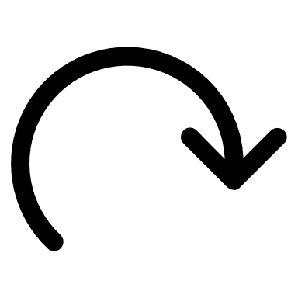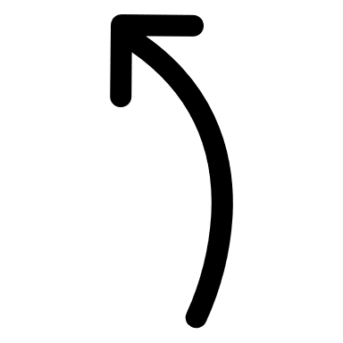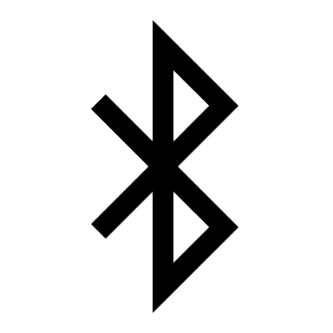

Brainwave data sent to computer via Bluetooth Low Energy (BLE)

# Proposed Timeline

