System Overview and Architecture
Status date: April 29, 2026 Audience: the next developer who picks up Omnilore Scheduler from Team 34 Prerequisites: familiarity with Flutter/Dart and basic AWS EC2 concepts

1. Problem and Audience
Omnilore is a member-led lifelong-learning organization in Rancho Palos Verdes, CA. Every term, members rank course preferences (first choices and backups), declare their availability across twenty time slots, and request a specific number of classes (0–6). A small administrative team then has to compute a term schedule that:
- drops courses that fall under a minimum class size,
- splits oversize courses into two or more sections,
- assigns each surviving course to one of twenty time slots,
- assigns one main coordinator and a co-coordinator (or two equal co-coordinators) to each course, and
- exposes four export actions: an early roster in phone-roster style, a final roster with coordinator labels, a mail-merge file, and an unmet-wants report.
The previous (pre-2026) implementation was a Flutter desktop application that depended on dart:io, native window sizing, and OS file dialogs. Onboarding a new admin meant installing Flutter and the desktop runtime. Several stakeholder-reported defects (the "Co-Coordinator" assignment bug and the "Show Splits" bug) and a missing intermediate-state save/load capability remained outstanding.
Team 34's mandate (CSCI 401, Spring 2026) was to migrate the application to a web-based delivery model, fix the two defects, add intermediate state save/load aligned with admin expectations, expand regression testing, and stand up automated cloud deployment. An optional AI-assisted scheduling feature was scoped out by the stakeholder in favor of stability.

2. Features Delivered (D1 → D7)
- Browser-deployable build. The same Dart codebase compiles for desktop and web. Conditional imports route file I/O, downloads, autosave, and window sizing to platform-appropriate implementations. A static check (scripts/check_platform_gating.sh) prevents dart:io and other desktop-only imports from leaking into shared code.
- Two-file load. Tab-delimited course and people text files are parsed in-browser via file_picker and validated against fifteen-plus exception types defined in lib/model/exceptions.dart.
- Drop/Split/Schedule/Coordinator pipeline. The original desktop pipeline is preserved end-to-end; oversize courses now expose a non-destructive Show Splits preview with manual rebalancing and explicit Cancel / Implement controls.
- Coordinator UX rebuild. Both Set C and CC and Set CC1 and CC2 now reset selection state on re-entry so admins can fully reassign coordinators; tapping a highlighted name on a coordinator-assigned course clears the assignment.
- Time-slot deselection. Clicking the same slot a second time unschedules the course; downstream availability counts recompute.
- Save / Save As / Load / Autosave / Restore. lib/io/bundled_state.dart produces a single text bundle containing the original course file, the original people file, and the scheduler state grammar — restoring everything from one file. Web autosave uses six localStorage keys with timestamped restore-prompts.
- Four export menu actions. Early roster (phone-roster style), final roster (with (C) / (CC) labels), tab-delimited mail-merge, and unmet-wants report. All exports route through a unified helper (lib/io/export_text_file.dart) with timestamped filenames from lib/io/default_filename.dart; web exports use showSaveFilePicker where the browser supports it and fall back to a normal browser download.
- Cloud deployment. .github/workflows/deploy.yml builds the Flutter web target, briefly whitelists the runner IP in an EC2 security group, copies build/web/* to /var/www/html over SCP, and revokes the IP — reachable today at http://scheduler.omnilore.org.
- Continuous validation. .github/workflows/test.yml runs the gating check, flutter analyze, and flutter test on every push and PR to main.

3. Architecture
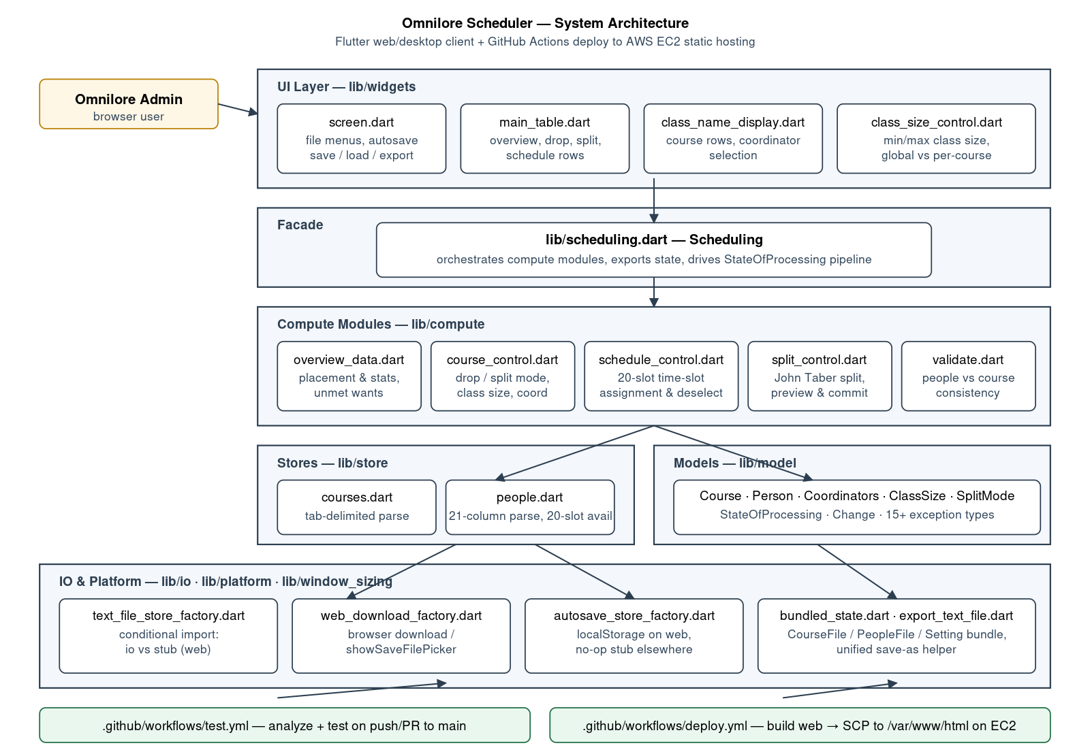
A high-level view of how the layers fit together:
flowchart TD
User["Omnilore admin (browser)"] --> UI["UI layer<br/>lib/widgets"]
UI --> Facade["Scheduling facade<br/>lib/scheduling.dart"]
Facade --> Compute["Compute modules<br/>lib/compute/*"]
Facade --> Stores["Stores<br/>lib/store/*"]
Facade --> Models["Models<br/>lib/model/*"]
UI --> IO["I/O abstractions<br/>lib/io · lib/platform · lib/window_sizing"]
IO --> Web["Browser: file_picker, showSaveFilePicker, localStorage"]
IO --> Desktop["Desktop: dart:io paths, desktop_window"]
GitHub["GitHub Actions"] --> CI["test.yml: gating + analyze + test"]
GitHub --> Deploy["deploy.yml: build web → SCP to EC2"]
Deploy --> EC2["AWS EC2<br/>/var/www/html"]
EC2 --> User

Layer responsibilities
Layer | Path | Job
UI | lib/widgets/ | Owns Flutter state and renders the main table; hands user actions to Scheduling and reacts to its callback. The most active widget files are screen.dart, class_name_display.dart, class_size_control.dart, and widgets/table/*.
Facade | lib/scheduling.dart | The only object the UI talks to. Loads files, delegates compute to the modules below, computes StateOfProcessing after every change, and produces all exports. ~809 LOC.
Compute | lib/compute/ | Pure scheduling logic (overview_data.dart, course_control.dart, schedule_control.dart, split_control.dart, validate.dart). No Flutter, no dart:io.
Models | lib/model/ | Plain-Dart data carriers: Course, Person, Coordinators, ClassSize, SplitMode, Change, StateOfProcessing, exceptions.dart.
Stores | lib/store/ | Tab-delimited parsers for the course and people files. Throw the exception types in lib/model/exceptions.dart on malformed input.
IO | lib/io/, lib/platform/, lib/window_sizing/ | Conditional-import factories that pick a desktop or browser implementation at compile time.

Conditional-import pattern (platform gating)
Every desktop-only API is hidden behind a three-file factory:
// text_file_store_factory.dart
export 'text_file_store_stub.dart'
if (dart.library.io) 'package:omnilore_scheduler/io/text_file_store_io.dart';
scripts/check_platform_gating.sh greps the entire lib/ tree and fails the build if import 'dart:io'; or import 'package:desktop_window/...'; appears anywhere outside the explicit allowlist. This is also enforced by test/platform_gating_test.dart. Whenever you add a new platform-touching feature, follow the same triple of _factory.dart + _stub.dart + _io.dart (or _web.dart) and update the gating script.

4. Data Flow
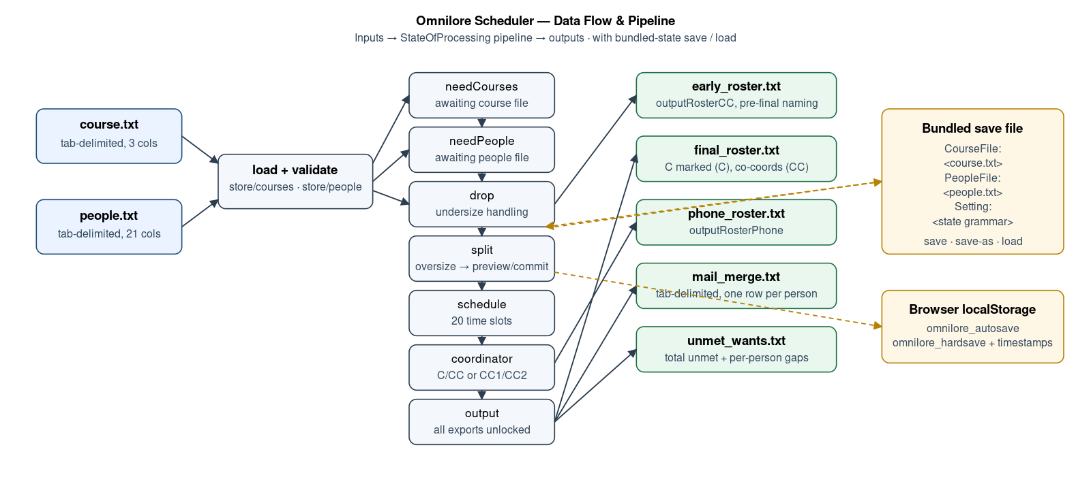
flowchart LR
Course["course.txt<br/>tab-delimited, 3 cols"] --> Stores
People["people.txt<br/>tab-delimited, 21 cols"] --> Stores
Stores --> Facade["Scheduling"]
Facade --> Drop["drop"] --> Split["split"] --> Sched["schedule"] --> Coord["coordinator"] --> Out["output"]
Out --> Early["early_roster_YYYY-MM-DD_HHMM.txt"]
Out --> Roster["final_roster_YYYY-MM-DD_HHMM.txt"]
Out --> MM["mail_merge_YYYY-MM-DD_HHMM.txt"]
Out --> Unmet["unmet_wants_YYYY-MM-DD_HHMM.txt"]
Facade --> Bundle["Bundled save:<br/>CourseFile + PeopleFile + Setting"]
Bundle --> Auto["Browser localStorage<br/>(autosave + hardsave)"]
Bundle --> File["User-saved .txt"]

5. Pipeline State Machine
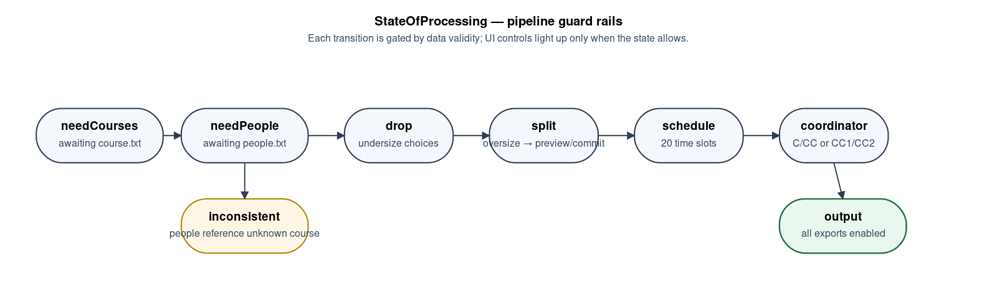
Scheduling._updateStateOfProcessing() evaluates the eight StateOfProcessing values in order after every UI-driven compute(Change) call:
needCourses → needPeople → inconsistent | drop | split | schedule | coordinator → output
State | Entered when | UI hint
needCourses | course store is empty | "Load courses."
needPeople | course OK, people store is empty | "Load people."
inconsistent | a person references an unknown course code | Inline error; admin must fix the input file.
drop | at least one course is below its minimum class size | Drop / split-mode controls light up.
split | at least one course is over its maximum size | Show Splits preview is required.
schedule | all classes sized; some unscheduled | Twenty-slot table is live.
coordinator | all scheduled; coordinators incomplete | C/CC and CC1/CC2 controls light up.
output | everything assigned | All exports are unlocked.
The pipeline is monotonic forward but reactive backward: dropping a course or rebalancing a split rewinds downstream stages and the UI greys out their controls until the upstream constraint is satisfied again.

6. Key Design Choices
- Single Dart engine for desktop and web. The compute and model layers are pure Dart with no Flutter or dart:io dependencies. This keeps the desktop-vs-web fork to the I/O surface only, which is the smallest possible blast radius.
- Bundled save format. A single text file (CourseFile: + PeopleFile: + Setting: sections) restores the entire working session. This was chosen over JSON because (a) it remains diff-friendly and human-readable for stakeholder review, (b) it allows admins to hand-edit a snapshot if needed, and (c) it preserves the original tab-delimited input bytes — useful for traceability and re-running.
- Autosave is convenience, not durability. Web autosave writes to browser localStorage and is therefore tied to that browser profile and device. The user-facing message and the runbook treat Save As to a real file as the only operational backup.
- No backend. The application is entirely client-side. There is no database, no auth, no API, and no PII server-side. PII (names, phone numbers) lives only in the admin's browser session and in the files they choose to save.
- Static-asset deploy. The web build is just static files. EC2 + nginx/Apache was the path of least resistance because Omnilore already has an AWS account; the doc includes a recommendation to migrate to S3 + CloudFront in the long term (see Backlog_Known_Issues_Roadmap.md, P2).
- Aggressive platform gating. Catching a desktop-only import at CI time is cheap; debugging a runtime dart:io failure in a stakeholder's browser is not. The grep-based gating script and matching test prevent that.

7. Known Limits
- The app is a single-user, client-side scheduling tool. There is no shared state, multi-user collaboration, audit log, or user identity.
- Browser autosave is browser-profile-scoped. Switching browsers, profiles, or devices loses the autosave; admins must Save As to a portable bundle.
- showSaveFilePicker support varies by browser. On unsupported browsers (notably Firefox at the time of writing) the save flow falls back to a normal download.
- AWS deployment currently overwrites /var/www/html on EC2 in place. There is no automated rollback artifact; rollback is "redeploy a known-good commit" (see Operations_Runbook.md).
- Performance under unusually large datasets (well beyond the 24-course / 267-person fixture) is not separately profiled.
- The optional AI-assisted scheduling enhancement from D1 was deferred by stakeholder agreement and is not delivered.

8. Where to extend the system
Need | Touch this | Watch out for
Add a new export | New outputXyzToString() on Scheduling; route through exportTextFile() | Keep the gate check on StateOfProcessing so disabled actions stay disabled.
Add a new pipeline stage | New StateOfProcessing enum value + branch in _updateStateOfProcessing(); new compute module under lib/compute/ | Update the bundled-state grammar and the legacy state loader (Scheduling.loadState).
Add CSV exports | Wrap the existing string-builders with a CSV serializer alongside the tab-delimited form | Mail-merge already produces tab-delimited rows; adding a CSV output is mostly a header + escaping pass.
Move off EC2 to S3 + CloudFront | Replace deploy.yml with aws s3 sync build/web s3://… + an invalidation step | Update Operations_Runbook.md and the rotation table; archive the EC2 host config.
Add a backend (e.g., shared term schedules) | A new lib/api/ package with conditional Web/desktop transport; gate it the same way as I/O | Introduces auth and PII at rest — re-evaluate Security_Privacy_Accessibility_UX_Notes.md before implementing.

9. Repository inventory (for the next developer)
lib/
scheduling.dart # facade — start here
main.dart # Flutter entry + theme
widgets/ # UI
screen.dart # main screen, file menus, autosave
class_name_display.dart # course rows + coordinator selection
class_size_control.dart # min/max class-size controls
overview_data.dart # overview/stats panel
table/{main_table, drop_row, schedule_row, class_name_row, overview_row}.dart
names_display_mode.dart, utils.dart
compute/
overview_data.dart # placement + unmet wants
course_control.dart # drop, split mode, class size, coordinators
schedule_control.dart # 20-slot scheduling state
split_control.dart # split preview/commit (John Taber's algorithm)
validate.dart # people vs courses consistency
model/
course.dart, person.dart, coordinators.dart, class_size.dart
state_of_processing.dart, change.dart, exceptions.dart
store/
courses.dart, people.dart, list_item.dart
io/
text_file_store_factory.dart # conditional import gate
text_file_store_stub.dart, text_file_store_io.dart, text_file_store.dart
web_download_factory.dart, web_download.dart, web_download_stub.dart, web_download_web.dart
autosave_store_factory.dart, autosave_store_stub.dart, autosave_store_web.dart
bundled_state.dart # Save / Save As / Load bundle
default_filename.dart # timestamped export/save filenames
export_text_file.dart # unified save-as helper
file_io_exceptions.dart
platform/
desktop_platform.dart, desktop_platform_stub.dart, desktop_platform_io.dart
window_sizing/
window_sizing.dart, window_sizing_desktop.dart, window_sizing_noop.dart
theme.dart
test/ # 21 .dart test files, 89 passing tests (see Testing_and_QA_Summary.md)
.github/workflows/
test.yml # CI
deploy.yml # build web → SCP to EC2
scripts/
check_platform_gating.sh # grep-based desktop-import gate
docs/ # earlier-deliverable working docs
Project_Docs_D7/ # D7 handoff source docs + rendered deliverables

