F0102 Pendataan Objek Pajak
SPOP
TableName:
DAT_OBJEK_PAJAK
DAT SUBJEK_PAJAK
DAT_OP_BUMI
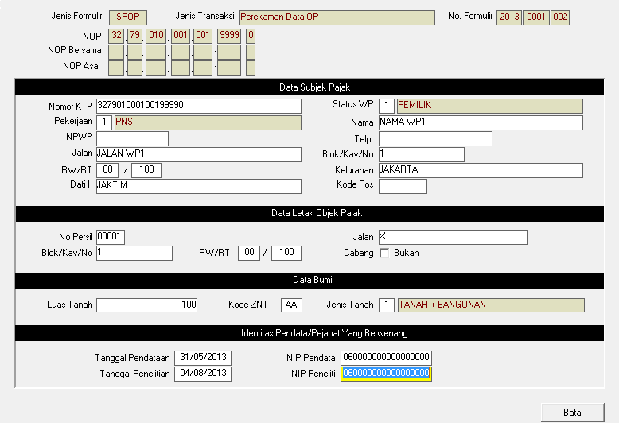
Tabel Referensi
ref_propinsi
ref_dati2
ref_kecamatan
ref_kelurahan
lookup_item
dat_znt
temp_max_bundle

Jenis Formulir:
S = SPOP
JenisTransaksi:
- Perekaman Data OP
- Pemutakhiran Data OP
- Penghapusan OP
- Penghapusan Status OP Bersama

No. Formulir Tahun(4) Bundle(4) Urut(3)
Tahun if null default Current Year
NOP, NOP Bersama, NOP Asal:
Propinsi, Dati2 ReadOnly Default gkd_propinsi, gkd_dati2
Kecamatan(3), Kelurahan(3), Blok(3), Urut(4) Jenis(1)
SUBJEK PAJAK
NO. Ktp(max 30) Default=NOP Required
Nama WP, Jln WP (Max 30) Required
Blok Kav (Max 15)
RW (2) If Null Default '00',
RT WP (3) If Null Default '000',
Kelurahan, Kecamatan, Kota, Propinsi WP (max 30)

Kode POS WP (5) If Null '00000'
Telp WP Max(20)
NPWP (15) Default If Null -> '000000000000000'

Pekerjaan WP:
SELECT ALL LOOKUP_ITEM.KD_LOOKUP_ITEM, LOOKUP_ITEM.NM_LOOKUP_ITEM
FROM LOOKUP_ITEM WHERE KD_LOOKUP_GROUP = '16'

Objek Pajak
No. Persil(5) LJUST Req:
Jalan OP (Max 30) Req:
Blok Kav (Max 15)
RW (2) If Null Default '00',
RT WP (3) If Null Default '000',
Status Cabang(1) Default 0

Status WP:
SELECT ALL LOOKUP_ITEM.KD_LOOKUP_ITEM, LOOKUP_ITEM.NM_LOOKUP_ITEM
FROM LOOKUP_ITEM WHERE KD_LOOKUP_GROUP = '10'

Total_Luas_Bumi (proses)
Total_Luas_Bng (proses)
NJOP_bumi (proses)
NJOP_BNG (proses)
Status_Peta_OP (SIG) default 0

Objek Bumi
no_bumi Default '01'
kd_znt(2) Req dat_znt
luas_bumi
jns_bumi
SELECT ALL LOOKUP_ITEM.KD_LOOKUP_ITEM, LOOKUP_ITEM.NM_LOOKUP_ITEM
FROM LOOKUP_ITEM WHERE KD_LOOKUP_GROUP = '20'

nilai_sistem_bumi (proses)

Identitas Pendataan (Dat_Objek_Pajak)

Tgl_Pendataan If Null Current Date
NIP Pendata If Null Session NIP
Tgl_Pemeriksaan If Null Current Date
Nip_Pemeriksaan If Null Session NIP

Tgl_Perekaman Default ToDay
Nip_Perekaman Default Session NIP

Proses
Validate No Form.
1. Python Proses
isform = Select Count(*) FROM temp_max_bundle
WHERE
kd_kanwil = gkd_kanwil
kd_kantor = gkd_kantor
temp_thn_bundel = :form.tahun
temp_no_bundel = :form.bundle
temp_urut_bundel = :form.no_urut

data=blank_row()

data['max_form']=dict(get_max_form)

if form:
data['found']=1
dop=dict(select from dat_objek_pajak
where no_formulir_spop = :no_formulir)
if dop:
data['SL']='S'
data.update(dop)
if not dop:
dopbumi = dict(SELECT * FROM dat_op_bumi
where no_formulir_lspop=:no_formulir)
if dopbumi:
data.update(dopbumi)
data['SL']='L'

if data['found']=1:
if JenisTransaksi=1:
data['fail']=1
elif JenisTransaksi>1:
if data['SL']='S':
data.update(data.dat_op_subjek_pajak):
data.update(data.dat_op_bumi):
else:
data['fail']=1:

2. Proses JQuery User Action

if result['found']
if (result['fail])
alert('Fail')
return false
elseif JenisTransaksi=2
if confirm('Gunakan Form?')==true
isi semua field dengan result
make readonly no_form s.d NOP Asal
else return false

else
if no_form<result['frm_max'] or abs(no_form-result['frm_max'])>1 alert
if confirm('No. Form Terakhir')==true
Next Field (NOP)
else
result false

Validate NOP
- Python Proses

Call Validasi Form
if data['found']==0:
isnop = get_dop_by_nop
if isnop:
if Jenis Transaksi=1
data['fail']=1
else
if Jenis Transaksi>1
data['fail']=1

todo: nop bersama dan nop asal

- JQuery Proses
if result['found']
if (result['fail])
alert('Fail')
return false
elseif JenisTransaksi=2
if confirm('Gunakan Form?')==true
isi semua field dengan result
make readonly no_form s.d NOP Asal
else return false

else
if no_form<result['frm_max'] or abs(no_form-result['frm_max'])>1 alert
if confirm('No. Form Terakhir')==true
make readonly no_form s.d NOP Asal
else
result false

LSPOP
Table:
DAT_OP_BANGUNAN
DAT_FASILITAS_BANGUNAN
FASILITAS
FAS_NON_DEP
FAS_DEP_JPB_KLS_BINTANG

REF_JPB

DAT_JPB_2
DAT_JPB_3
DAT_JPB_4
DAT_JPB_5
DAT_JPB_6
DAT_JPB_7
DAT_JPB_8
DAT_JPB_9
DAT_JPB_12
DAT_JPB_13
DAT_JPB_14
DAT_JPB_15
DAT_JPB_16

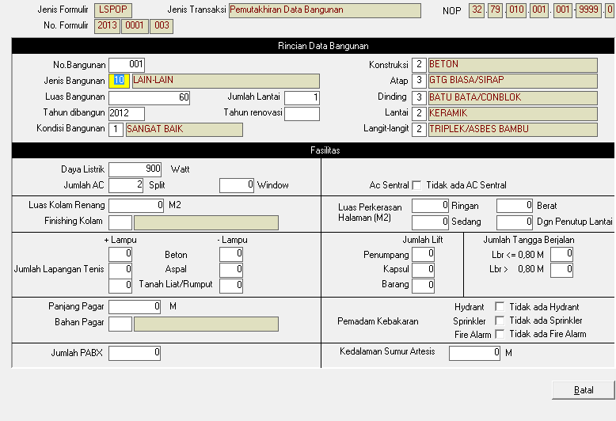

Jenis Transaksi:
- Perekaman Data Bangunan
- Pemutakhiran Data Bangunan
- Penghapusan Data Bangunan
DAT_OP_BANGUNAN

Jenis Bangunan= REF_JPB
Kondisi Bangunan=
SELECT KD_LOOKUP_GROUP, KD_LOOKUP_ITEM, NM_LOOKUP_ITEM
FROM LOOKUP_ITEM
WHERE KD_LOOKUP_GROUP = ''21'''

Konstruksi=
SELECT KD_LOOKUP_GROUP, KD_LOOKUP_ITEM, NM_LOOKUP_ITEM
FROM LOOKUP_ITEM
WHERE KD_LOOKUP_GROUP = ''22'''

Atap=
'SELECT KD_LOOKUP_GROUP, KD_LOOKUP_ITEM, NM_LOOKUP_ITEM
FROM LOOKUP_ITEM
WHERE KD_LOOKUP_GROUP = ''41'''))

Dinding=
'SELECT KD_LOOKUP_GROUP, KD_LOOKUP_ITEM, NM_LOOKUP_ITEM
FROM LOOKUP_ITEM
WHERE KD_LOOKUP_GROUP = ''42'''))

Lantai=
'SELECT KD_LOOKUP_GROUP, KD_LOOKUP_ITEM, NM_LOOKUP_ITEM
FROM LOOKUP_ITEM
WHERE KD_LOOKUP_GROUP = ''43'''))

Langit2
'SELECT KD_LOOKUP_GROUP, KD_LOOKUP_ITEM, NM_LOOKUP_ITEM
FROM LOOKUP_ITEM
WHERE KD_LOOKUP_GROUP = ''44'''))

Data Tambahan Apabila Jenis Bangunan Sesuai dengan Piihan
Table Terkait:
DAT_JPB_4
DAT_JPB_5
DAT_JPB_6
DAT_JPB_7
DAT_JPB_12
DAT_JPB_13
DAT_JPB_15
DAT_JPB_16
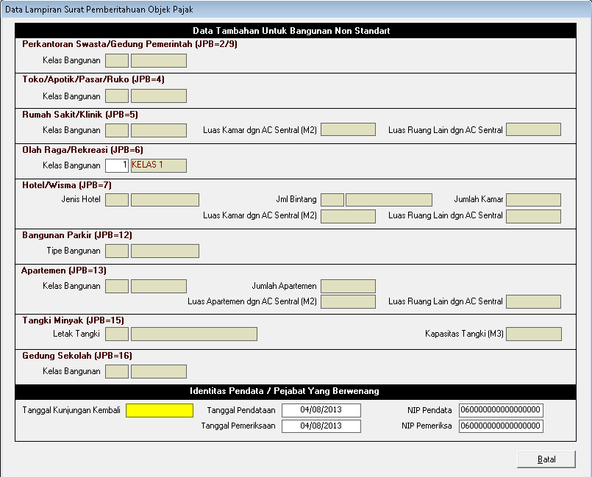

Penilaian Individu

