**ROLDA, Christine Mae B. Rolda**

BSIT-2 (BLOCK B)

**ACTIVITY: SUPERGLOBALS**

***SUPERGLOBALS (GET)***

* **Source Code (get.php):**

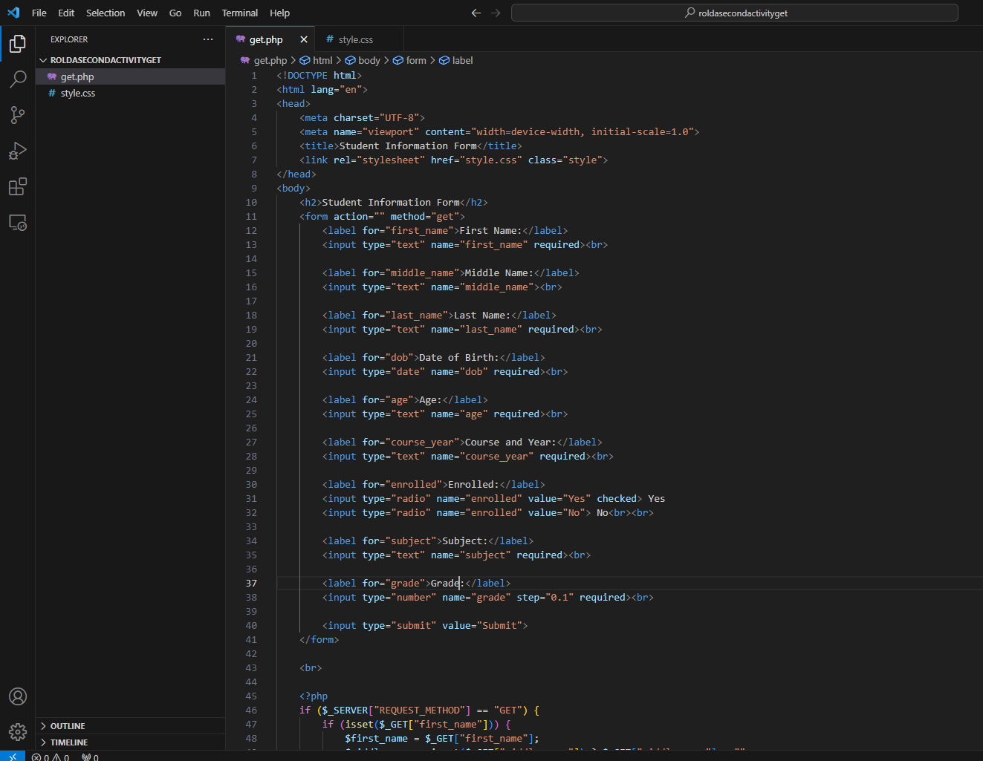

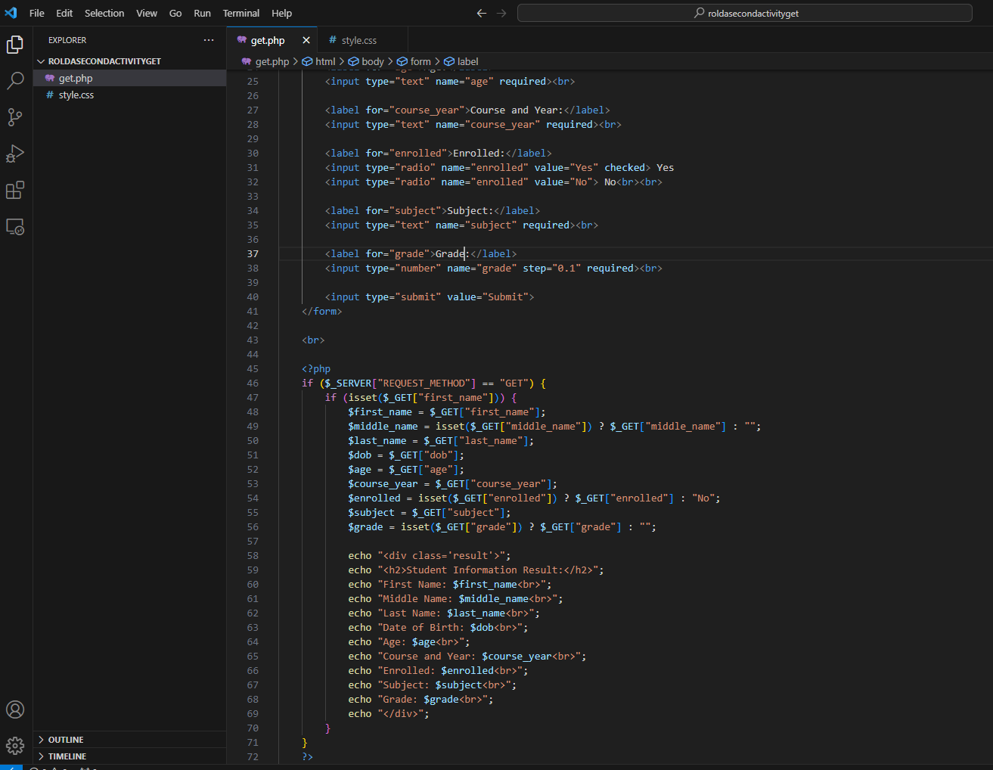

* **Source Code (style.css):**

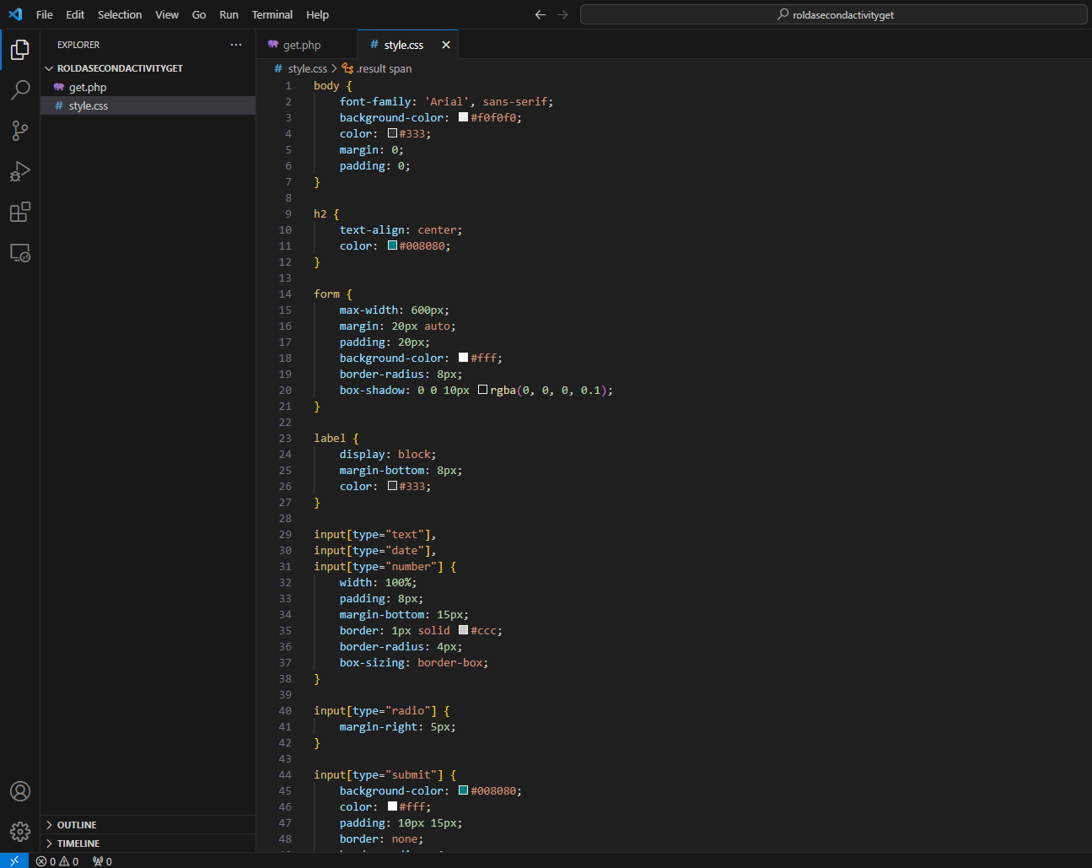

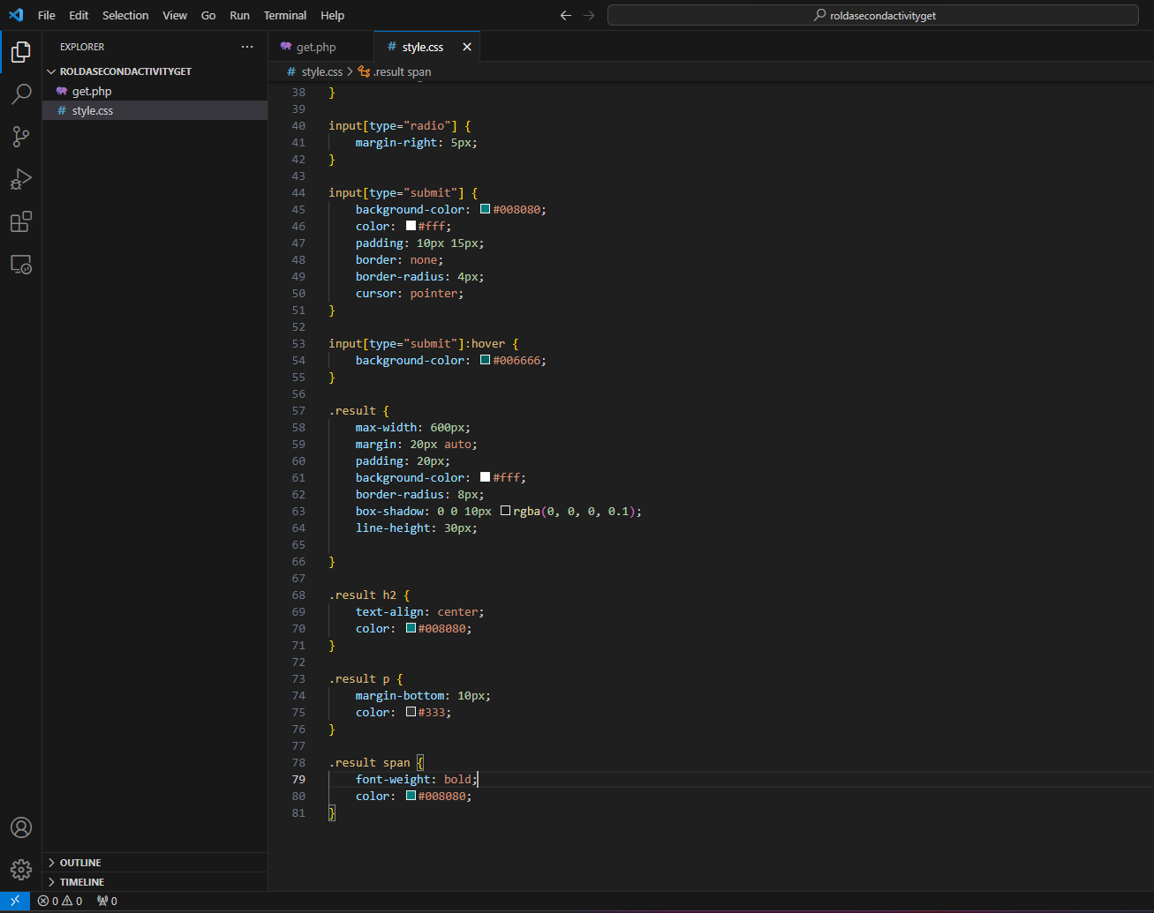

* **Output:**

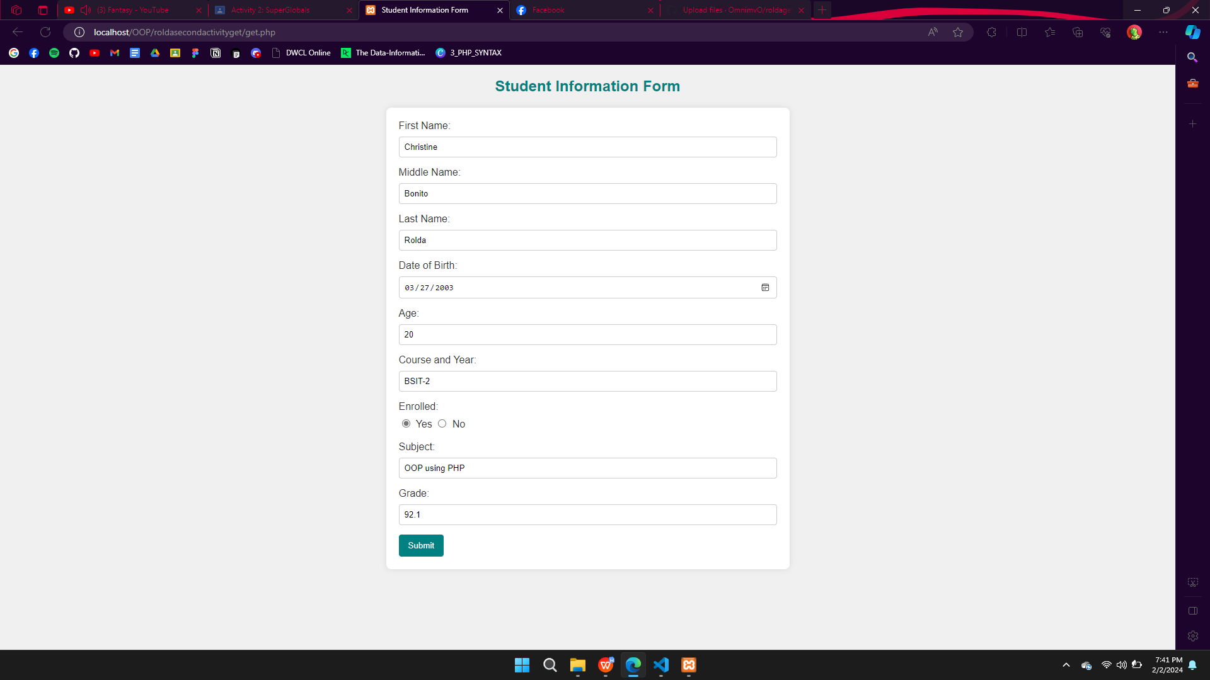

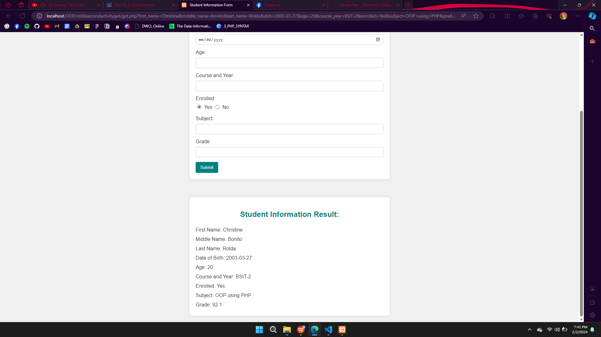

***SUPERGLOBALS (POST)***

* **Source Code (index.php):**

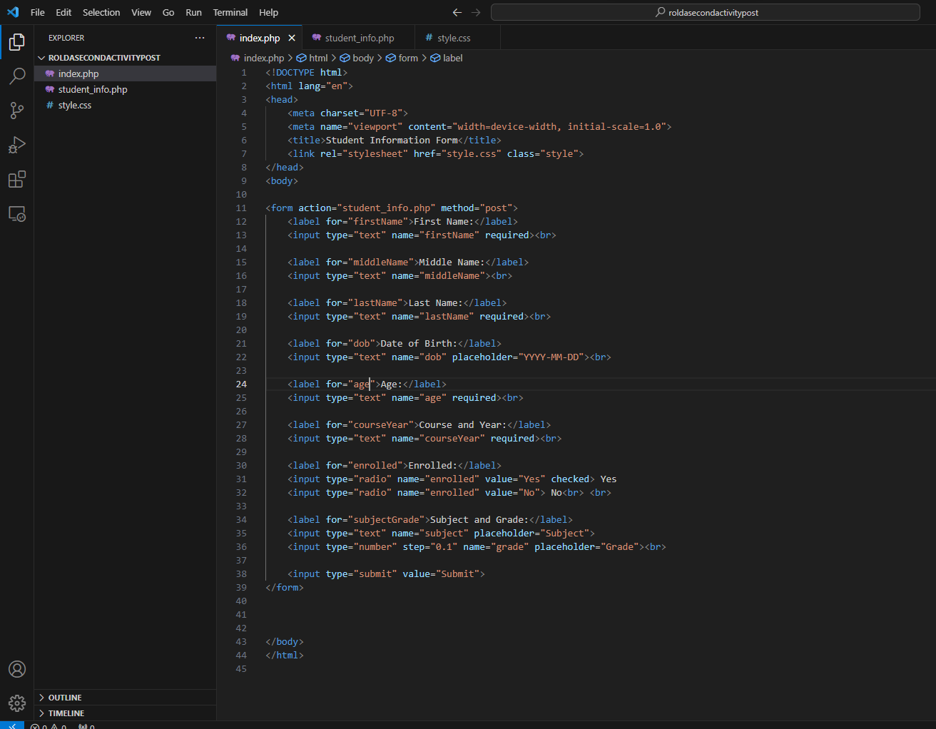

* **Source Code (student_info.php):**

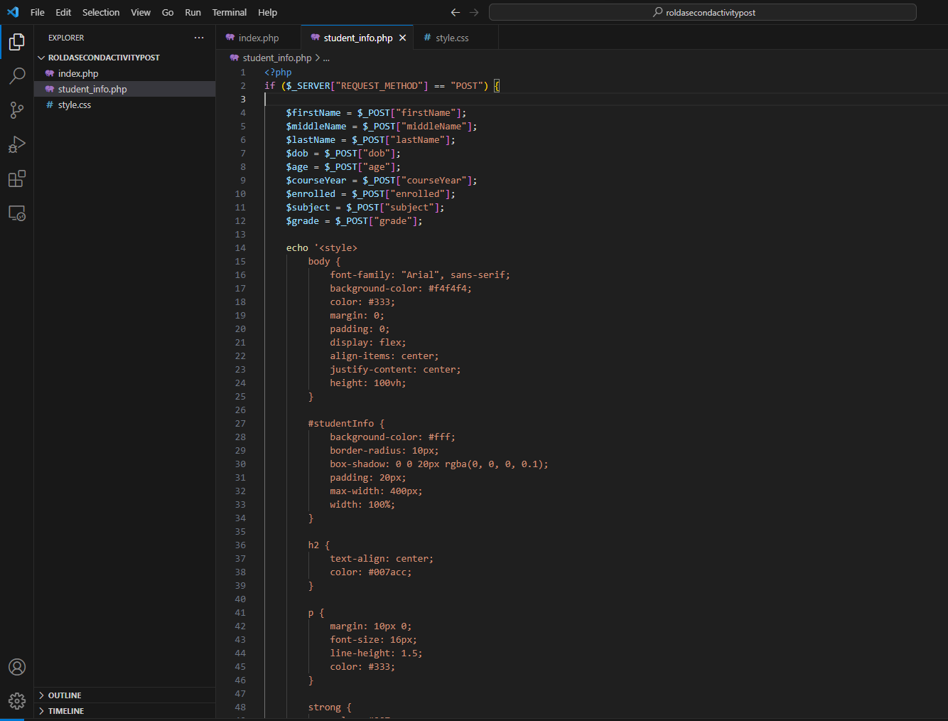

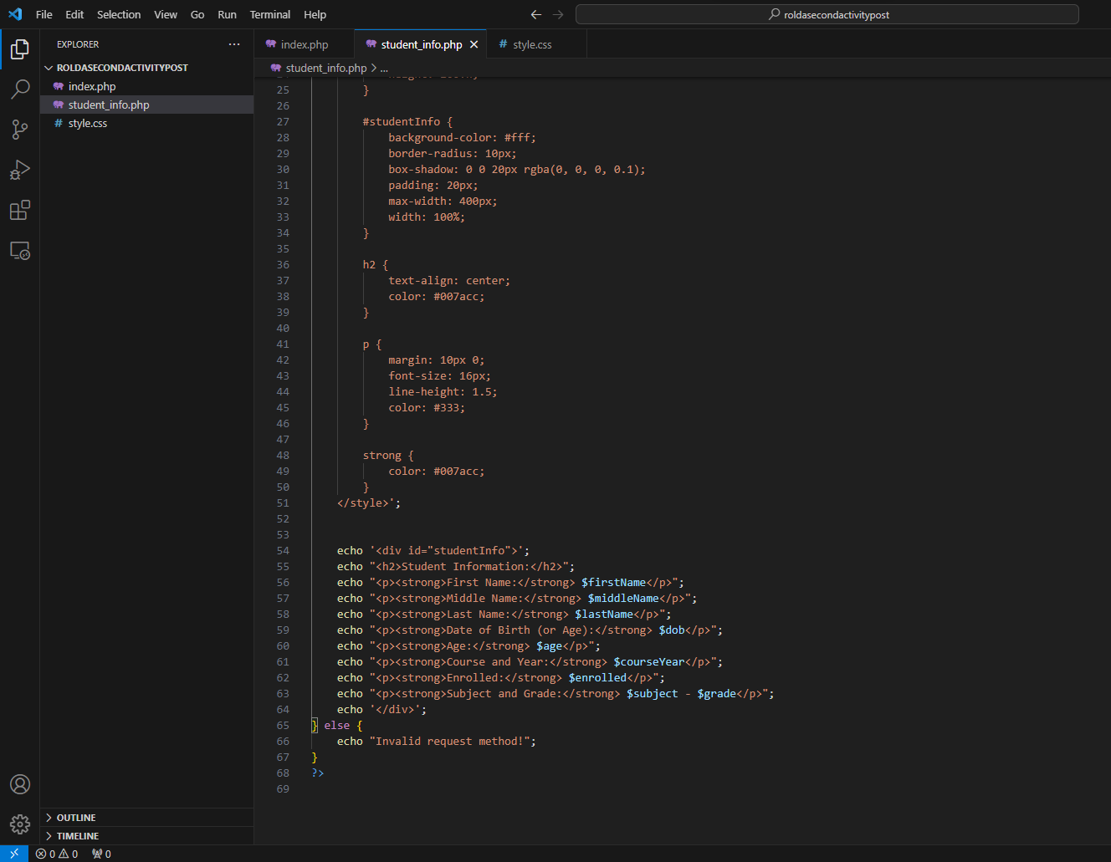

* **Source Code (style.css):**

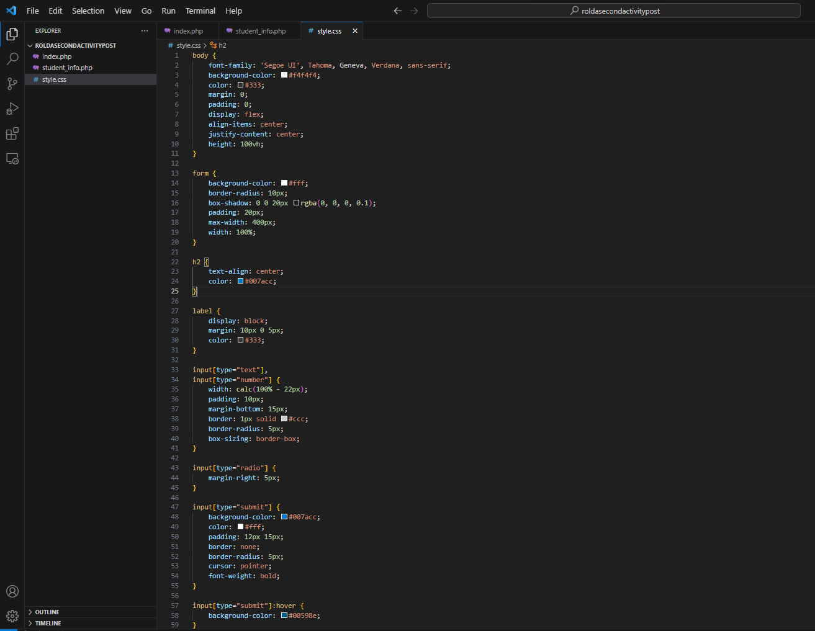

* **Output:**

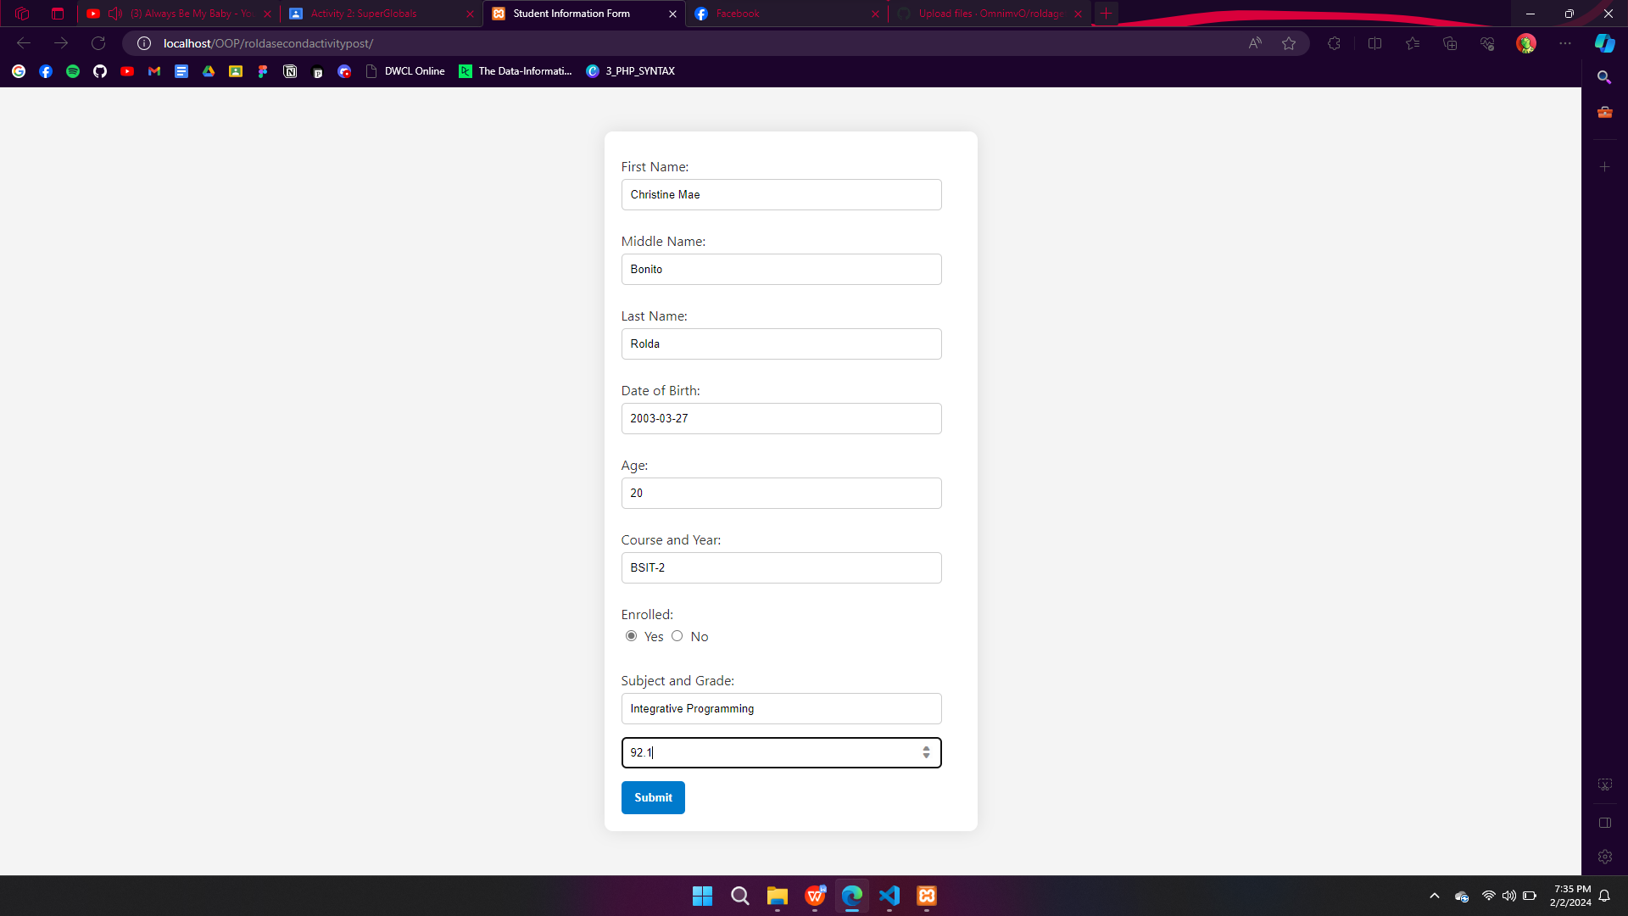

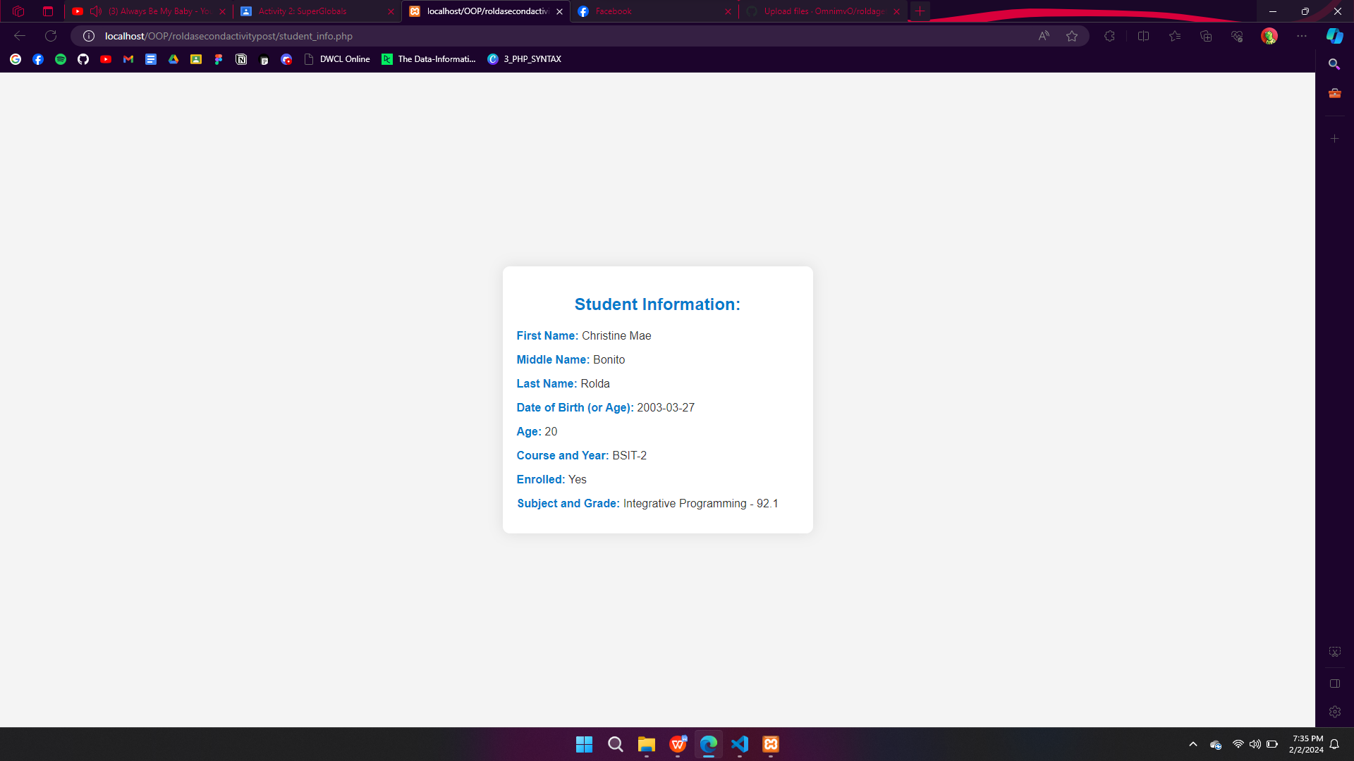

**ALL SOURCE CODES FOR SUPERGLOBALS (GET):**

* **Source Code (get.php):**

<!DOCTYPE html>

<html lang="en">

<head>

<meta charset="UTF-8">

<meta name="viewport" content="width=device-width, initial-scale=1.0">

<title>Student Information Form</title>

<link rel="stylesheet" href="style.css" class="style">

</head>

<body>

<h2>Student Information Form</h2>

<form action="" method="get">

<label for="first_name">First Name:</label>

<input type="text" name="first_name" required><br>

<label for="middle_name">Middle Name:</label>

<input type="text" name="middle_name"><br>

<label for="last_name">Last Name:</label>

<input type="text" name="last_name" required><br>

<label for="dob">Date of Birth:</label>

<input type="date" name="dob" required><br>

<label for="age">Age:</label>

<input type="text" name="age" required><br>

<label for="course_year">Course and Year:</label>

<input type="text" name="course_year" required><br>

<label for="enrolled">Enrolled:</label>

<input type="radio" name="enrolled" value="Yes" checked> Yes

<input type="radio" name="enrolled" value="No"> No<br><br>

<label for="subject">Subject:</label>

<input type="text" name="subject" required><br>

<label for="grade">Grade:</label>

<input type="number" name="grade" step="0.1" required><br>

<input type="submit" value="Submit">

</form>

<br>

<?php

if ($_SERVER["REQUEST_METHOD"] == "GET") {

if (isset($_GET["first_name"])) {

$first_name = $_GET["first_name"];

$middle_name = isset($_GET["middle_name"]) ? $_GET["middle_name"] : "";

$last_name = $_GET["last_name"];

$dob = $_GET["dob"];

$age = $_GET["age"];

$course_year = $_GET["course_year"];

$enrolled = isset($_GET["enrolled"]) ? $_GET["enrolled"] : "No";

$subject = $_GET["subject"];

$grade = isset($_GET["grade"]) ? $_GET["grade"] : "";

echo "<div class='result'>";

echo "<h2>Student Information Result:</h2>";

echo "First Name: $first_name<br>";

echo "Middle Name: $middle_name<br>";

echo "Last Name: $last_name<br>";

echo "Date of Birth: $dob<br>";

echo "Age: $age<br>";

echo "Course and Year: $course_year<br>";

echo "Enrolled: $enrolled<br>";

echo "Subject: $subject<br>";

echo "Grade: $grade<br>";

echo "</div>";

}

}

?>

</body>

</html>

* **Source Code (style.css):**

body {

font-family: 'Arial', sans-serif;

background-color: #f0f0f0;

color: #333;

margin: 0;

padding: 0;

}

h2 {

text-align: center;

color: #008080;

}

form {

max-width: 600px;

margin: 20px auto;

padding: 20px;

background-color: #fff;

border-radius: 8px;

box-shadow: 0 0 10px rgba(0, 0, 0, 0.1);

}

label {

display: block;

margin-bottom: 8px;

color: #333;

}

input[type="text"],

input[type="date"],

input[type="number"] {

width: 100%;

padding: 8px;

margin-bottom: 15px;

border: 1px solid #ccc;

border-radius: 4px;

box-sizing: border-box;

}

input[type="radio"] {

margin-right: 5px;

}

input[type="submit"] {

background-color: #008080;

color: #fff;

padding: 10px 15px;

border: none;

border-radius: 4px;

cursor: pointer;

}

input[type="submit"]:hover {

background-color: #006666;

}

.result {

max-width: 600px;

margin: 20px auto;

padding: 20px;

background-color: #fff;

border-radius: 8px;

box-shadow: 0 0 10px rgba(0, 0, 0, 0.1);

line-height: 30px;

}

.result h2 {

text-align: center;

color: #008080;

}

.result p {

margin-bottom: 10px;

color: #333;

}

.result span {

font-weight: bold;

color: #008080;

}

**ALL SOURCE CODES FOR SUPERGLOBALS (POST):**

* **Source Code (index.php):**

<!DOCTYPE html>

<html lang="en">

<head>

<meta charset="UTF-8">

<meta name="viewport" content="width=device-width, initial-scale=1.0">

<title>Student Information Form</title>

<link rel="stylesheet" href="style.css" class="style">

</head>

<body>

<form action="student_info.php" method="post">

<label for="firstName">First Name:</label>

<input type="text" name="firstName" required><br>

<label for="middleName">Middle Name:</label>

<input type="text" name="middleName"><br>

<label for="lastName">Last Name:</label>

<input type="text" name="lastName" required><br>

<label for="dob">Date of Birth:</label>

<input type="text" name="dob" placeholder="YYYY-MM-DD"><br>

<label for="age">Age:</label>

<input type="text" name="age" required><br>

<label for="courseYear">Course and Year:</label>

<input type="text" name="courseYear" required><br>

<label for="enrolled">Enrolled:</label>

<input type="radio" name="enrolled" value="Yes" checked> Yes

<input type="radio" name="enrolled" value="No"> No<br> <br>

<label for="subjectGrade">Subject and Grade:</label>

<input type="text" name="subject" placeholder="Subject">

<input type="number" step="0.1" name="grade" placeholder="Grade"><br>

<input type="submit" value="Submit">

</form>

</body>

</html>

* **Source Code (student_info.php):**

<?php

if ($_SERVER["REQUEST_METHOD"] == "POST") {

$firstName = $_POST["firstName"];

$middleName = $_POST["middleName"];

$lastName = $_POST["lastName"];

$dob = $_POST["dob"];

$age = $_POST["age"];

$courseYear = $_POST["courseYear"];

$enrolled = $_POST["enrolled"];

$subject = $_POST["subject"];

$grade = $_POST["grade"];

echo '<style>

body {

font-family: "Arial", sans-serif;

background-color: #f4f4f4;

color: #333;

margin: 0;

padding: 0;

display: flex;

align-items: center;

justify-content: center;

height: 100vh;

}

#studentInfo {

background-color: #fff;

border-radius: 10px;

box-shadow: 0 0 20px rgba(0, 0, 0, 0.1);

padding: 20px;

max-width: 400px;

width: 100%;

}

h2 {

text-align: center;

color: #007acc;

}

p {

margin: 10px 0;

font-size: 16px;

line-height: 1.5;

color: #333;

}

strong {

color: #007acc;

}

</style>';

echo '<div id="studentInfo">';

echo "<h2>Student Information:</h2>";

echo "<p><strong>First Name:</strong> $firstName</p>";

echo "<p><strong>Middle Name:</strong> $middleName</p>";

echo "<p><strong>Last Name:</strong> $lastName</p>";

echo "<p><strong>Date of Birth (or Age):</strong> $dob</p>";

echo "<p><strong>Age:</strong> $age</p>";

echo "<p><strong>Course and Year:</strong> $courseYear</p>";

echo "<p><strong>Enrolled:</strong> $enrolled</p>";

echo "<p><strong>Subject and Grade:</strong> $subject - $grade</p>";

echo '</div>';

} else {

echo "Invalid request method!";

}

?>

* **Source Code (style.css):**

body {

font-family: 'Segoe UI', Tahoma, Geneva, Verdana, sans-serif;

background-color: #f4f4f4;

color: #333;

margin: 0;

padding: 0;

display: flex;

align-items: center;

justify-content: center;

height: 100vh;

}

form {

background-color: #fff;

border-radius: 10px;

box-shadow: 0 0 20px rgba(0, 0, 0, 0.1);

padding: 20px;

max-width: 400px;

width: 100%;

}

h2 {

text-align: center;

color: #007acc;

}

label {

display: block;

margin: 10px 0 5px;

color: #333;

}

input[type="text"],

input[type="number"] {

width: calc(100% - 22px);

padding: 10px;

margin-bottom: 15px;

border: 1px solid #ccc;

border-radius: 5px;

box-sizing: border-box;

}

input[type="radio"] {

margin-right: 5px;

}

input[type="submit"] {

background-color: #007acc;

color: #fff;

padding: 12px 15px;

border: none;

border-radius: 5px;

cursor: pointer;

font-weight: bold;

}

input[type="submit"]:hover {

background-color: #00598e;

}