# Age, Gender and Expression Detection

## Intro to Deep Learning

* Fundamental of Neural Network (theory): <https://www.analyticsvidhya.com/blog/2016/03/introduction-deep-learning-fundamentals-neural-networks/>
* Optimising with Keras (practical): <https://www.analyticsvidhya.com/blog/2016/10/tutorial-optimizing-neural-networks-using-keras-with-image-recognition-case-study/>
* Building Neural Network with Python (practical): <https://www.analyticsvidhya.com/blog/2017/05/neural-network-from-scratch-in-python-and-r/>

## Age, Gender and Expression Detection Programmed Resources

* Tutorial in python: <https://www.analyticsvidhya.com/blog/2017/06/hands-on-with-deep-learning-solution-for-age-detection-practice-problem/>
* Preprogramed, requires data to train neural network to use: <https://github.com/dpressel/rude-carnie>
* OpenCV on Raspberry Pi: <https://www.youtube.com/watch?v=F0njE7D22SI>
* Python, OpenCV: <https://github.com/BoyuanJiang/Age-Gender-Estimate-TF>
* Python, OpenCV: <https://github.com/yu4u/age-gender-estimation>

**Note: Most data being used is 2GB or higher to train the neural network**

## Age, Gender and Expression Priced Solution

**Sightengine**: <https://sightengine.com/docs/face-attribute-model>

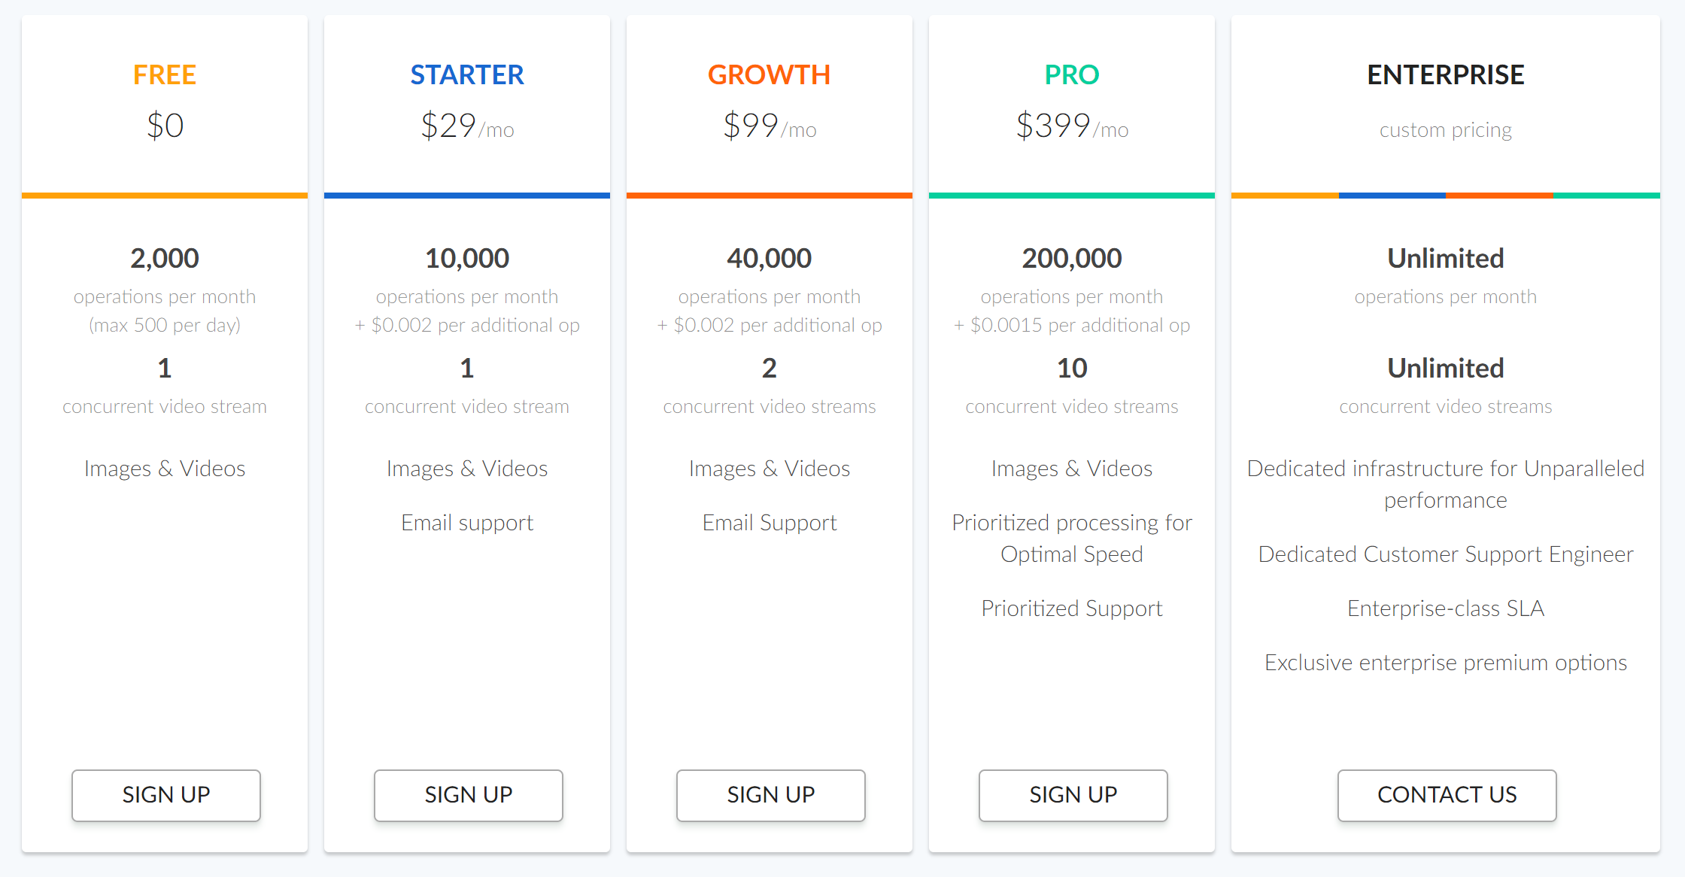

Figure 13 Pricing of Sightengine

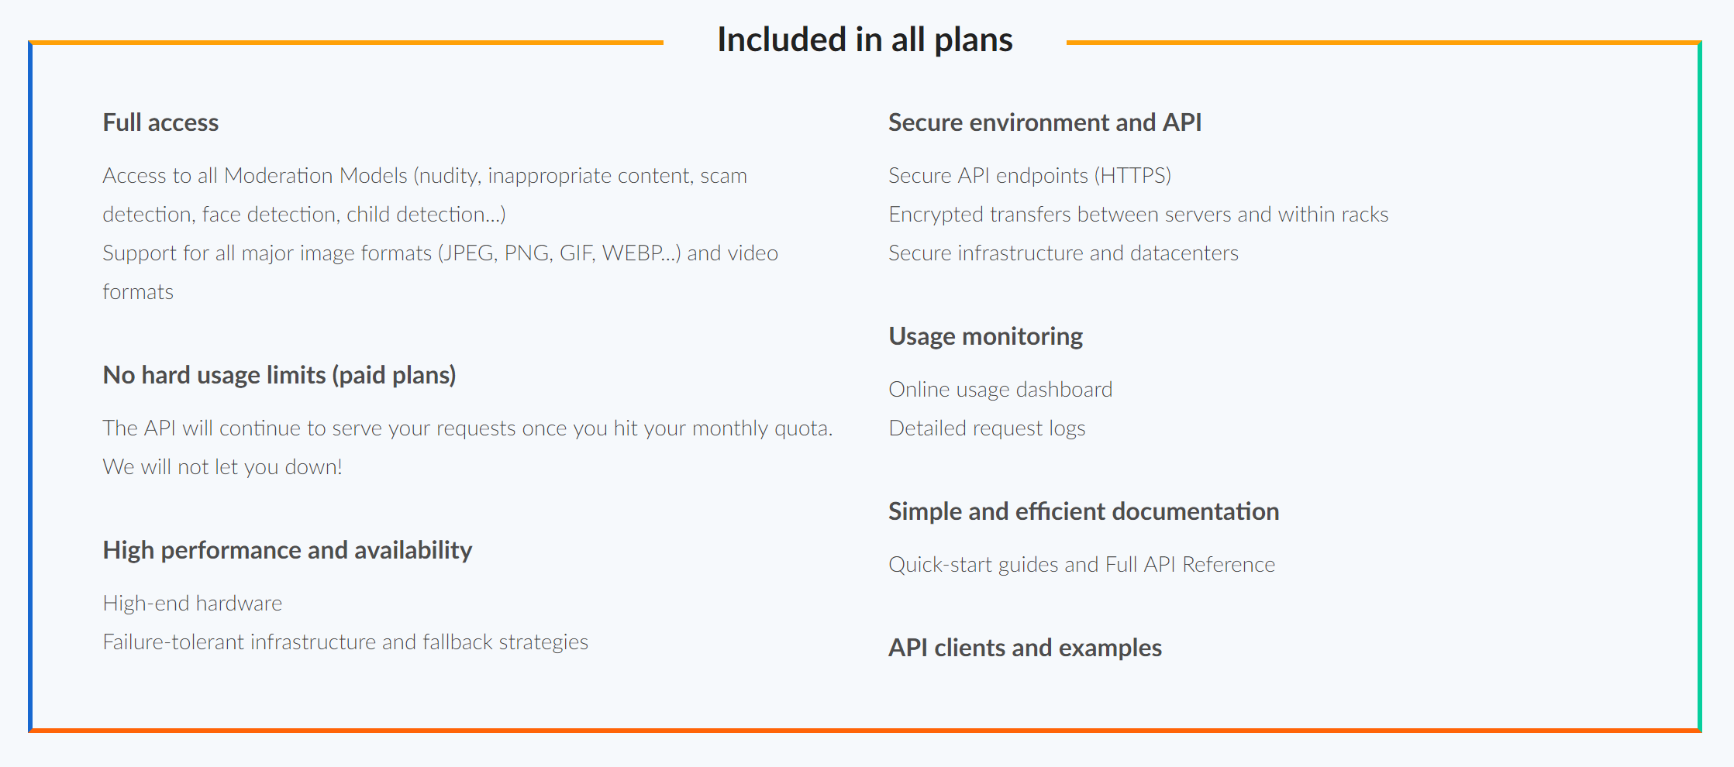

Figure 14 Features of Sightengine

Detection Available:

1. Nudity
   1. Raw
   2. Partial
2. Weapon Alcohol Drug
3. Text Detection
   1. Natural – on shirt, etc
   2. Artificial – title, logo, etc
4. Offensive
   1. Gesture
   2. Flags
   3. Symbols
5. Face
   1. Gender
   2. Age group
   3. Sunglasses
6. Celebrities
7. Image Quality
   1. Sharpness/Blurriness
   2. Brightness
   3. Contrast
8. Colour
9. Type – logo, drawing, clipart, painting, photography
10. Scammer – profiled used by scammer

Demonstration of the software: <https://sightengine.com/demo>

**ACTI**: <https://www.acti.com/technologies>

Contact for pricing.

Has ‘face analytics’ which does:

* Age (<https://www.acti.com/technologies/age-detection>)
* Gender (<https://www.acti.com/technologies/gender-detection>)
* Emotion (<https://www.acti.com/technologies/emotion-detection>)

**Visage** **Technologies**: <http://visagetechnologies.com/products-and-services/visagesdk/faceanalysis/age-detection/>

Contact for pricing

Has ‘FaceAnalytics’ which does:

* Age (<https://visagetechnologies.com/products-and-services/visagesdk/faceanalysis/age-detection/>)
* Gender (<https://visagetechnologies.com/products-and-services/visagesdk/faceanalysis/gender-detection/>)
* Emotion (<https://visagetechnologies.com/products-and-services/visagesdk/faceanalysis/emotion-recognition/>)

**FotoNation**: <https://www.fotonation.com/products/face-power/age-detection/>

Contact for pricing

* Age (<https://www.fotonation.com/products/face-power/age-detection/>)
* Face Feature (<https://www.fotonation.com/products/face-power/face-feature-detection/>) – can be used to develop facial expression or emotion tracking.

## How does age detection work?

By using the location of facial features such as pupils, eye corners, lip boundaries, etc, it can estimate the age. However, it is proven ineffective as the age can fluctuate easily as such, it is not a feasible detection currently.

## How does gender detection work?

Similarly, gender detection work by identify facial features – usually those present in male but not female, vice versa. Since it does not analyse the person’s attire, body, etc, but just the face, it can be very accurate to a certain extend.

## How does expression detection work?

Expression or emotion recognition detect the basic 6 emotions researched by Paul Ekman (1972). Like the previous detection, it works by identifying the facial features of landmarks.

## Feasibility

Based on the demonstration of these concept, developing the features would rely on good understanding of neural network and face landmarks. Self-developing these concepts would be proven inaccurate as demonstrated by a few github users – age being the most unreliable with fluctuating results whereas gender and expression can maintain a good accuracy.

There are a few providers that develop this concept, the recommended one is sightengine. Their demonstration shows that it is accuracy and proven effective while being able to test it out for free (limited processing) to custom pricing. Other providers have the concept as well but with less features added into it, which made sightengine the best choice to experiment with.

## Resources:

<http://visagetechnologies.com/products-and-services/visagesdk/faceanalysis/age-detection/>

<https://visagetechnologies.com/products-and-services/visagesdk/faceanalysis/emotion-recognition/>

<https://visagetechnologies.com/products-and-services/visagesdk/faceanalysis/gender-detection/>