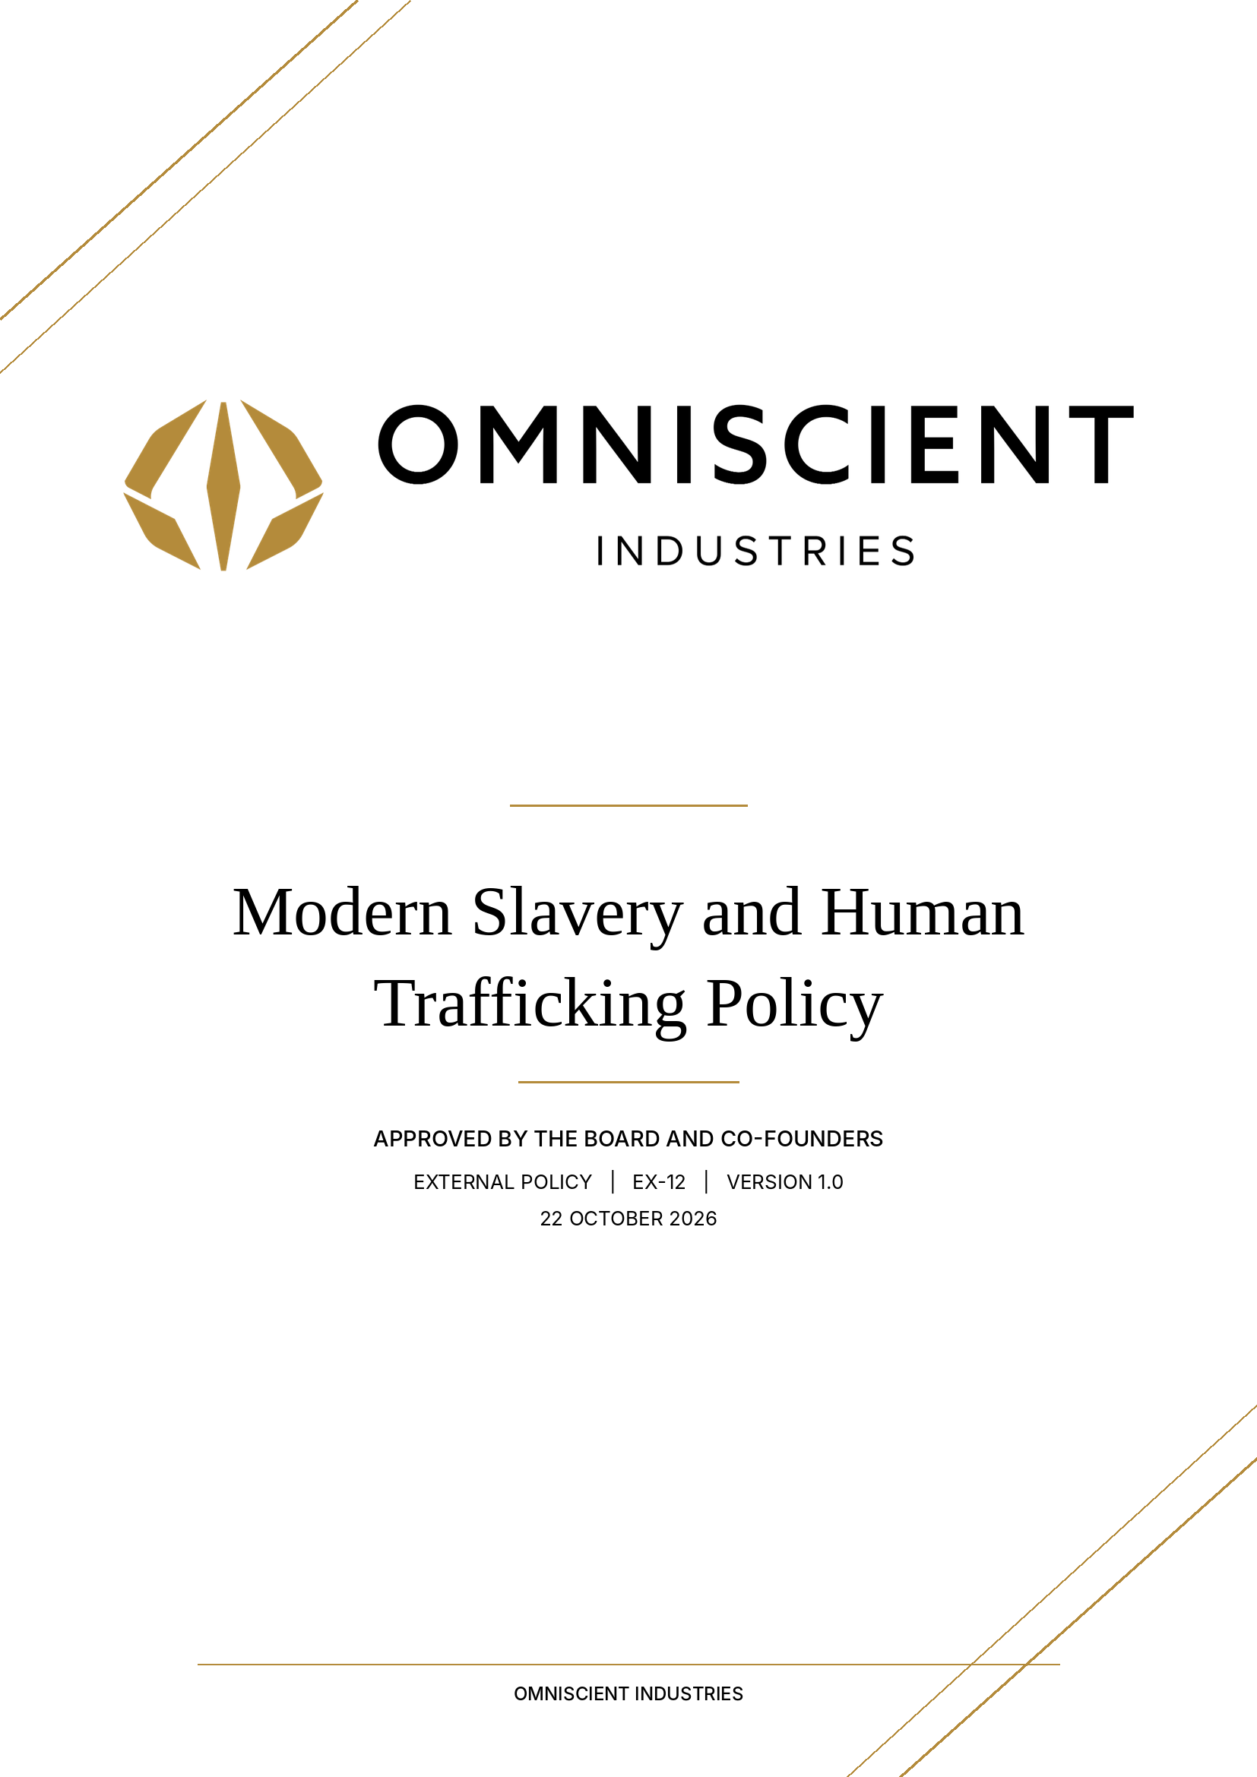
Modern Slavery and Human Trafficking Policy
EXTERNAL / CORPORATE GOVERNANCE / VERSION 1.0
DOCUMENT CODE | EX-12
POLICY OWNER | People / Procurement
STATUS | Approved — Board and both co-founders
REVIEW | At least annually and after material change
01 Purpose
This voluntary policy sets expectations to prevent modern slavery and exploitation in Omniscient operations and purchasing. This policy establishes minimum requirements and accountability for modern slavery and human trafficking policy across Omniscient Industries Limited ("Omniscient"). Its requirements apply proportionately to the activity, risk and applicable law. Implementation and compliance must be supported by appropriate operational evidence.
02 Application
This approved policy governs the stated public or third-party commitments. External publication must accurately reflect the company’s relevant services and actual operating arrangements. Contractual and statutory requirements take priority; any customer-specific terms or product documentation continue to apply where relevant.
03 Policy requirements
3.1 Prohibited conduct
- Forced or compulsory labour, human trafficking, debt bondage, unlawful child labour and retention of workers’ identity documents for coercive purposes are prohibited.
- Workers must be free to leave employment in accordance with applicable law and must not pay unlawful recruitment fees.
- Recruitment agencies and labour providers require heightened assessment when their models create exploitation risks.
3.2 Supply chain controls
- Apply proportionate due diligence to suppliers and subcontractors, particularly those using migrant labour or high-risk employment structures.
- Raise concerns when credible evidence suggests withheld pay, coercion, unsafe accommodation, threats or deceptive recruitment.
- Work with suppliers on corrective action where appropriate and discontinue relationships where serious risks remain unremedied.
3.3 Reporting and remedy
- Provide a confidential reporting route and protect persons who raise genuine concerns in good faith.
- Prioritise the safety and welfare of potential victims and refer to competent authorities where appropriate.
- Maintain investigation records securely and limit access to sensitive reports.
3.4 Annual statement distinction
- This policy is not an annual statement under section 54 of the Modern Slavery Act 2015.
- The statutory annual reporting duty depends on current eligibility, including the £36 million turnover threshold and other conditions.
- If publishing a voluntary annual statement, it must accurately describe steps actually taken in the relevant financial year.
04 Responsibility and escalation
The policy owner is People / Procurement. The responsible executive sponsor must ensure that this policy is translated into working arrangements, that relevant teams understand their duties and that material concerns are considered without unnecessary delay. Business partners should use their nominated Omniscient contact to raise questions; serious suspected misconduct or safety and security risks should be escalated urgently.
05 Evidence, assurance and improvement
The owner should establish practical records, risk reviews, approvals and corrective actions needed to demonstrate application of this policy. Evidence should be proportionate to the risk, handled according to the information classification and retention policies, and reviewed after significant incidents or regulatory change. Do not state that a control, certification, audit or training programme has been completed without supporting evidence.
06 Review, exceptions and approval
This policy has been approved by the Board and both co-founders. Publication and implementation must remain accurate to actual company operations. Changes must be version controlled, and material updates communicated to affected audiences.
6.1 Publication or implementation condition
Do not mislabel this policy as the company’s statutory annual slavery statement.
DOCUMENT CONTROL / EX-12 / V1.0 APPROVED / 22 OCTOBER 2026

