The Sentinel Framework

Operational Trust, Cultural Alignment, and the Womack + DragonHawk Protocols
Submitted by: Ethan Ross Womack
TPA4 Technician | RME / PMO Aligned
Date: August 8, 2025

Table of Contents
- Executive Summary
- Introduction & Background
- Liability Layers Analysis (The Ticking Time Bomb)
- Current Operational Issues & Observations
- The Womack Protocol: Proposed Change Request
- Psychological Safety & The Martyr Mechanism (Embedded Whitepaper)
- The DragonHawk Protocol: Strategic Framework for Change
- Expected Outcomes & Strategic Benefits
- Closing Statement & Call to Action
- Appendix & Supporting Documentation

Executive Summary
This report presents an integrated operational and cultural risk assessment for Amazon’s RME, PMO, and WHS functions. It identifies layered liabilities — cognitive, operational, legal, and psychological — that form a systemic “ticking time bomb” within current workflows. Left unaddressed, these compounding risks will cost Amazon hundreds of millions annually while eroding its ability to retain top talent.

The analysis draws on:
- Internal observations and cross-functional process mapping.
- The Womack Protocol: a structured safety and morale restoration framework.
- The Martyr Mechanism: a psychological model for early detection of resistance patterns in high-pressure environments.
- External research, including Fast Company/Inc.’s coverage of “quiet cracking” — a newly identified form of employee disengagement that erodes morale and productivity without immediate visibility in performance metrics.
“Quiet cracking is the erosion of workplace satisfaction from within… Unlike burnout, it doesn’t always manifest in exhaustion. Unlike quiet quitting, it doesn’t show up in performance metrics immediately. But it is just as dangerous.” — TalentLMS survey, as cited in Fast Company/Inc.
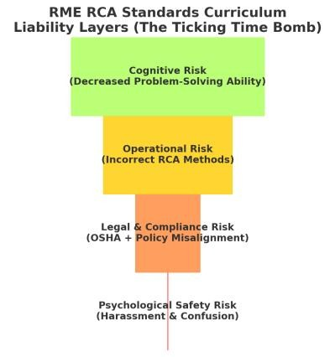
The combination of these factors creates an environment where:
- Employees disengage silently while still “present.”
- Operational risks remain undetected until critical failures occur.
- Turnover accelerates, increasing backfill costs and destabilizing teams.

The Womack Protocol addresses these risks through cross-domain leadership engagement, AIassisted early signal detection, and morale-leak mitigation strategies, ensuring sustainable operational health and workforce stability.

Introduction & Background
Amazon’s scale and pace demand a workplace culture that balances operational precision with human sustainability. In recent years, however, the balance has tilted toward procedural rigidity and reactive enforcement, creating fractures in trust and morale.

As a cross-aligned technician operating within RME and PMO, I have observed patterns that mirror industry-wide trends identified in research on employee disengagement. While phenomena such as burnout and quiet quitting have received attention, the emerging threat of quiet cracking is particularly relevant to Amazon’s operational model.
“Quiet cracking… develops gradually. Employees generally don’t recognize initial dissatisfactions… until they’ve become too deep and ingrained to shrug off.” — TalentLMS/Inc.
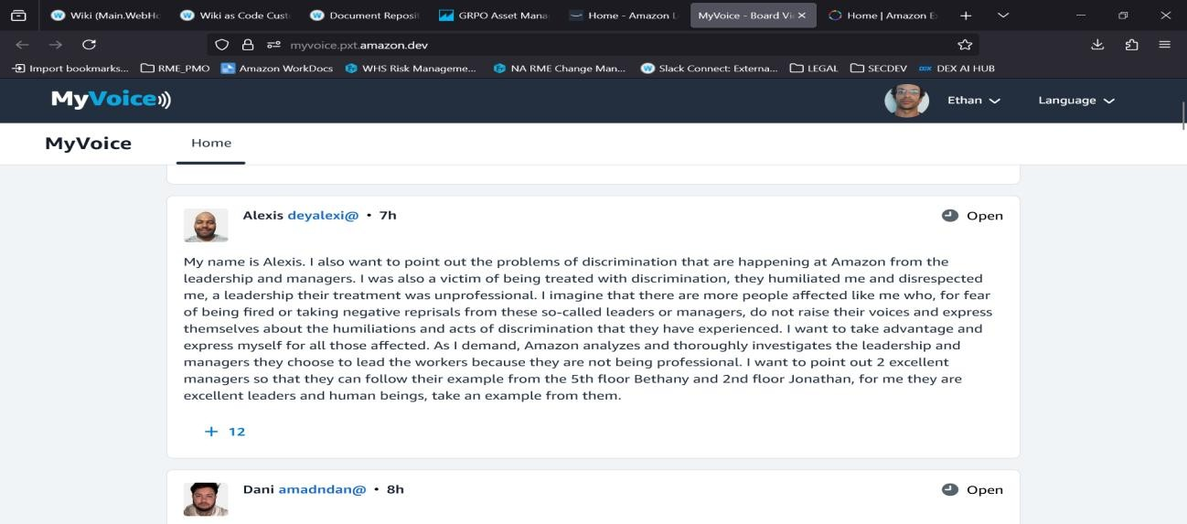
This condition thrives in environments where:
- Recognition and appreciation are inconsistent.
- Career advancement paths are opaque or nonexistent.
- Leadership listens selectively, often missing early warning signs.
These conditions directly align with several documented pain points in our WHS, PMO, and RME workflows, where frontline employees encounter:
- Inconsistent policy enforcement.
- Procedural inefficiencies.
- Lack of cross-domain problem ownership.

This report synthesizes internal documentation, external research, and a comprehensive set of corrective measures — culminating in the Womack Protocol — to both mitigate current risks and future-proof operational culture.

Liability Layers Analysis (The Ticking Time Bomb)
The operational ecosystem contains multiple interdependent risk layers. These layers do not exist in isolation; they amplify one another, accelerating systemic decline.

Layer 1: Cognitive Risk — Flawed RCA training creates cognitive friction and misinformation. Layer 2: Operational Risk — Policy misapplication leads to safety and compliance gaps. Layer 3: Legal & Compliance Risk — Incongruence between OSHA standards and internal enforcement methods.
Layer 4: Psychological Safety Risk — Morale erosion often precedes measurable attrition, as documented in “The Martyr Mechanism” and echoed by quiet cracking research.
EXAMPLE : The following is a literal quiz question from the RCA FUNDAMENTALS module titled
“RME Structured Problem Solving: Advanced Topics”

Training Quiz Glitch - Morale Impact
Example of a training system glitch that undermines trust and wastes time:

Question: 'A solution that prevents problem recurrence is what kind of action?'
Acceptable response: corrective User answer: corrective action Result: Marked incorrect.

Impact:
- Frustration for employees.
- Reduced engagement with training.
- Perceived incompetence in training content validation.

Layer 1: Cognitive Risk
- Flawed RCA training creates cognitive friction and misinformation.
- Employees are left with inconsistent problem-solving skills.
- Results in slowed resolution times and compounding errors.

Layer 2: Operational Risk
- Policy misapplication leads to gaps in safety and process compliance.
- Critical incidents go unaddressed until escalation is unavoidable.

Layer 3: Legal & Compliance Risk
- Incongruence between OSHA standards and internal enforcement methods.
- Creates vulnerability to regulatory action and reputational harm.

Layer 4: Psychological Safety Risk
- As documented in “The Martyr Mechanism” and echoed by *quiet cracking* research, morale erosion often precedes measurable attrition or productivity drops.
- TalentLMS research shows 54% of U.S. employees have experienced quiet cracking, with 20% reporting it “frequently” or “constantly.”
- This psychological disengagement is a leading indicator of turnover and decreased creativity.

Each layer magnifies the others. For example, when procedural errors (Operational Risk) are combined with low recognition and high stress (Psychological Safety Risk), turnover spikes and institutional knowledge is lost — restarting the cycle.
EXAMPLE : The following is a literal quiz question from the RCA FUNDAMENTALS module
titled “RME Structured Problem Solving: Advanced Topics”
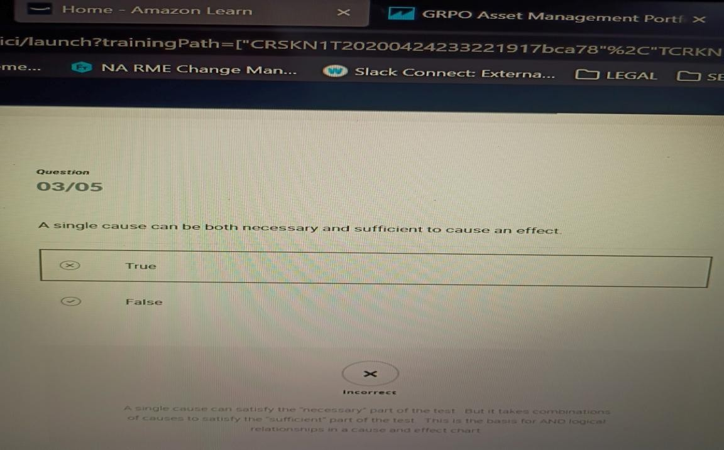
You’re thinking of Newton’s Third Law of Motion —
For every action, there is an equal and opposite reaction.
In physics, that does mean a single cause (an action) always produces a corresponding effect (a reaction).
Which, logically, makes the quiz question even dumber — because in the physical world, yes, a single cause can be both necessary and sufficient to cause an effect.
But Amazon’s training logic isn’t built on physics or common sense — it’s built on their root cause analysis framework, where they artificially break things down into “necessary” and “sufficient” conditions to justify multi-cause problem trees.
It’s a tool design choice, not a statement about reality.

So basically: physics says they’re wrong, but their flowchart religion says they’re right.

Current Operational Issues & Observations

Through direct observation, cross-functional involvement, and consistent engagement with frontline personnel, the following operational failures have been documented:
- Inconsistent inbound screening.
- Disproportionate outbound enforcement.
- Behavioral risks from checkpoint staff.
- Absence of AI-assisted oversight.
- Lack of unified ownership across domains.
“Respondents typically said they didn’t feel bosses appreciate them, don’t listen or notice them, and aren’t providing any paths for advancing in their work and careers.” — TalentLMS/Inc.
As further illustration of the systemic breakdowns observed across the site, we revisit the internal testimonial highlighted in Section 2 — a statement submitted by an associate named Alexis through Amazon’s internal Voices of Associates portal:

“I was also a victim of being treated with discrimination, they humiliated me and disrespected me... I imagine that there are more people affected like me who, for fear of being fired or taking negative reprisals, do not raise their voices and express themselves about the humiliations and acts of discrimination that they have experienced.” — Alexis, TPA4 Associate

This message — while raw in tone — exemplifies the kind of **psychological safety breakdown** that often escapes detection in performance metrics but silently corrodes morale and retention from within.

What Alexis describes is not an isolated grievance, but a signal flare — the articulation of quiet cracking in real-time, echoing the findings of the TalentLMS study:

“Employees gradually become mired in feeling unappreciated… until they’ve become too deep and ingrained to shrug off.” — TalentLMS/Inc.

Importantly, Alexis does not simply vent; they differentiate between poor leadership and positive leadership, identifying Bethany (5th floor) and Jonathan (2nd floor) as exemplary. This contrast supports a central argument in the Womack Protocol:
- That site culture is not inherently broken —
- But that the inconsistent application of leadership values results in vastly different psychological outcomes depending on team assignment.

Therefore, any serious attempt to reduce attrition and improve engagement must begin by mapping these trust disparities and identifying the behaviors of effective floor-level leaders — not merely enforcing compliance through abstract policy.

The solution is not stricter enforcement — it's smarter, more human-centered leadership modeling.

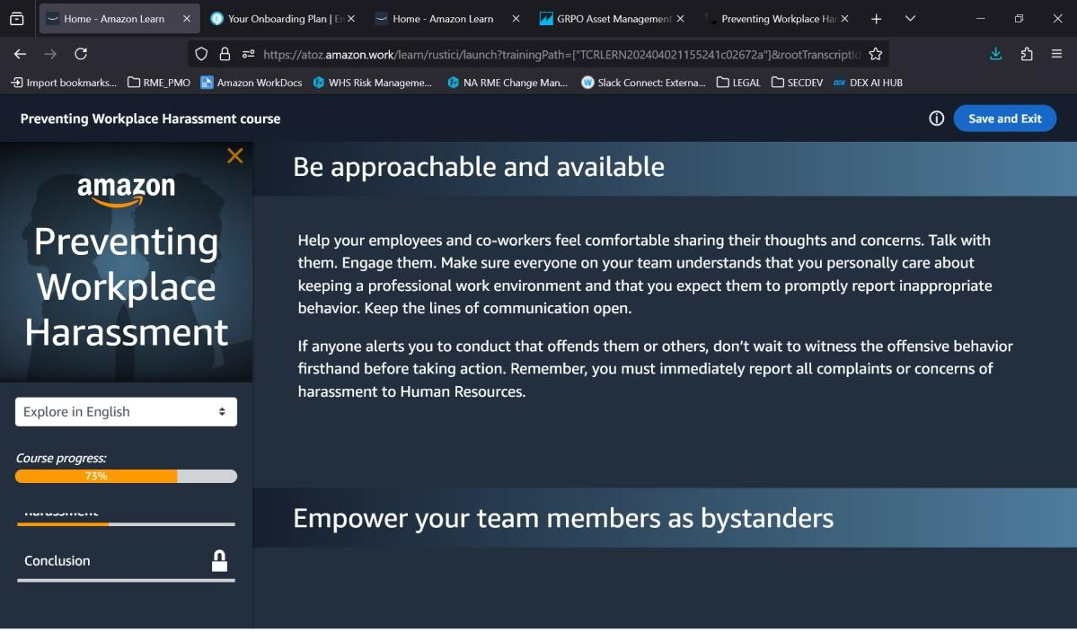

The Womack Protocol: Proposed Change Request
The Womack Protocol is a multi-step resolution framework designed to restore operational trust, strengthen safety compliance, and reverse morale erosion.
Core Actions: Cross-functional working group, morale-leak matrix review, behavioral escalation tracking, risk logic reclassification, and protective channels for early signal reporters.
“When employees quietly crack, they take productivity, creativity, and loyalty with them.” — TalentLMS/Inc.


Change Request ID: 20250724-1576125
Submitted By: Ethan Ross Womack, TPA4 Technician | RME / PMO Aligned
The Womack Protocol
A multi-step resolution framework designed to restore operational trust, strengthen safety compliance, and reverse morale erosion.

Core Actions
- Cross-Functional Working Group
Establish a unified leadership cell with WHS, RME, and PMO representatives to take joint ownership of checkpoint and floor-level issues.
- Morale-Leak Matrix Review
Conduct structured sessions to identify and address morale breaches before they escalate into disengagement or attrition.
- Behavioral Escalation Tracking
Introduce consistent, AI-assisted tracking of behavioral incidents at screening points to identify patterns and intervene early.
- Risk Logic Reclassification
Reassess inbound/outbound screening logic to ensure proportional enforcement without unnecessary psychological pressure.
- Protective Channels for Early Signal Reporters
Shield whistleblowers and “first detectors” from retaliation to maintain critical earlywarning systems.

Recognition:
“When employees quietly crack, they take productivity, creativity, and loyalty with them.” — TalentLMS / Inc.

Objective:
The Womack Protocol is designed to stop that cycle before it starts.

Psychological Safety & The Martyr Mechanism (Embedded Whitepaper)
The Martyr Mechanism describes a recurring psychological pattern in high-pressure operational environments: Early perception, attempted resolution, resistance, and emotional overload.
Symptoms: High turnover, passive retaliation, misapplied procedures, and unresolved reporting. Countermeasures: Recognition signals, cross-domain loops, shadowbox protocols, and protective channels.
“Employees gradually become mired in feeling unappreciated… until they’ve become too deep and ingrained to shrug off.” — TalentLMS/Inc.
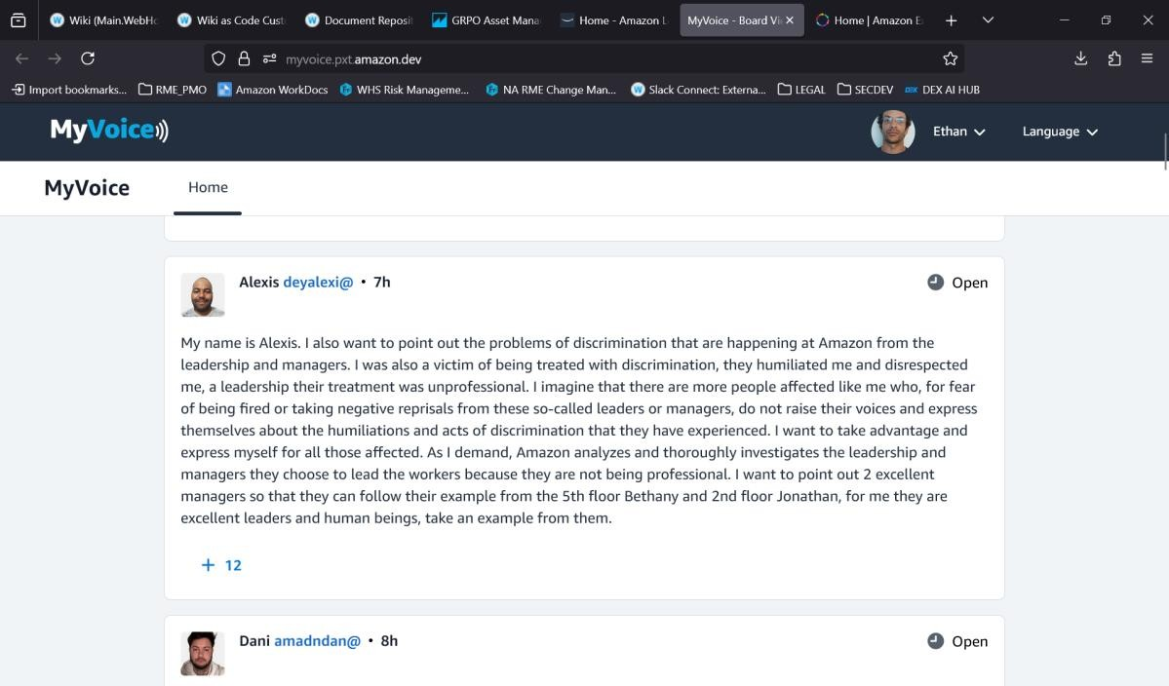
The Martyr Mechanism
A recurring psychological pattern observed in high-pressure operational environments.

Stages
- Early Perception
The individual identifies system flaws before others notice.
- Attempted Resolution
They seek to address issues through established, formal channels.
- Resistance
Leadership deflects, delays, or dismisses the concerns.
- Emotional Overload
The individual becomes demoralized, overburdened, and eventually disengages.

This mirrors the concept of quiet cracking, where:
“Employees gradually become mired in feeling unappreciated… until they’ve become too deep and ingrained to shrug off.” — TalentLMS / Inc.

Symptoms in 4D Resistance Environments
- High turnover
- Passive retaliation
- Misapplied procedures
- Increased unresolved reporting

Countermeasure Model
- Recognition Signals
Train managers to identify subtle, early warnings of disengagement.
- Cross-Domain Loops
Ensure consistent communication flow between departments on morale and safety concerns.
- Shadowbox Protocols
Simulate operational crises to test both cultural and procedural resilience.
- Protective Channels
Safeguard employees who surface issues early, preventing retaliation and preserving trust.

Final Note:
The first person to notice the fire is not the enemy. Unless systems are designed to recognize and protect these voices, we risk losing our most valuable sensors.

The DragonHawk Protocol: Strategic Framework for Change
The DragonHawk Protocol merges operational reform with narrative-driven cultural transformation. Anchors include decentralized leadership, integrated safeguards, predictive analytics for culture, and narrative alignment.
“Addressing quiet cracking doesn’t require overhauling your entire strategy — but it does require listening, acting, and investing.” — TalentLMS/Inc.
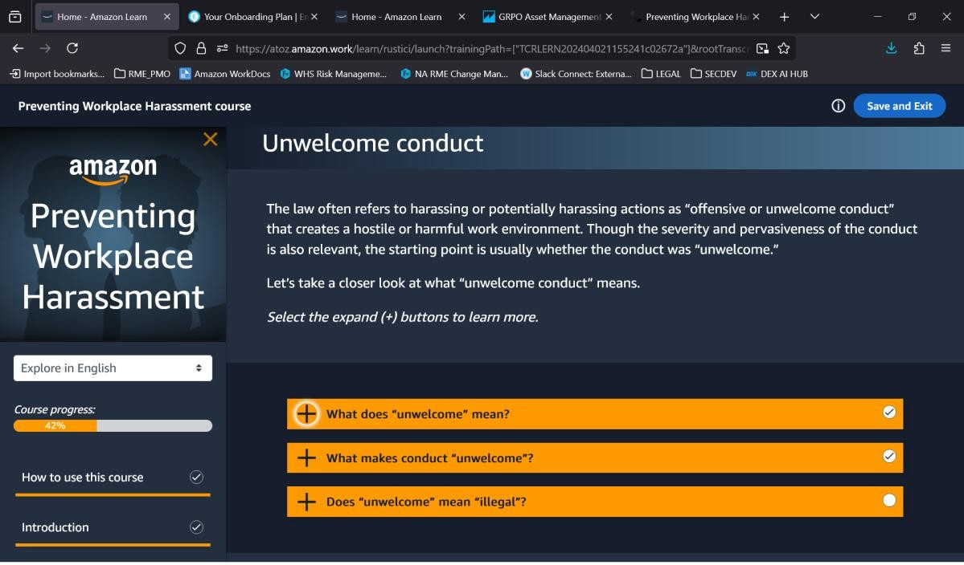
The DragonHawk Protocol
While the Womack Protocol addresses structural and procedural deficiencies, the DragonHawk Protocol adds a strategic overlay that merges operational reform with narrative-driven cultural transformation.

Strategic Anchors
- Decentralized Leadership
Empower problem-solvers at every level to act without waiting for top-down authorization.
- Integrated Psychological Safeguards
Embed morale monitoring into daily workflows, not just quarterly surveys.
- Predictive Analytics for Culture
Use AI to detect quiet cracking trends before they manifest in performance drops.
- Narrative Alignment
Frame reforms in a way that unites employees under a shared mission and identity — transforming Amazon from a rules-enforcing machine into a living, responsive organism.

Why It Works
“Addressing quiet cracking doesn’t require overhauling your entire strategy — but it does require listening, acting, and investing.” — TalentLMS / Inc.

Summary:
The DragonHawk Protocol ensures that listening, acting, and investing happen continuously — not just in reaction to crises.

EXAMPLE OF WHAT NOT TO DO :
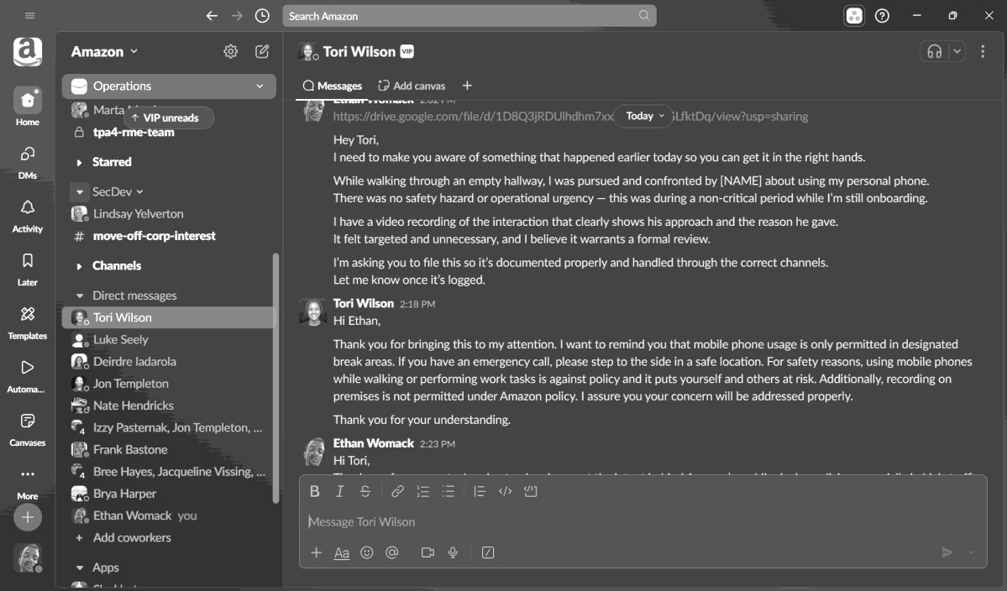

EXAMPLE OF A CORRECT RESPONSE :

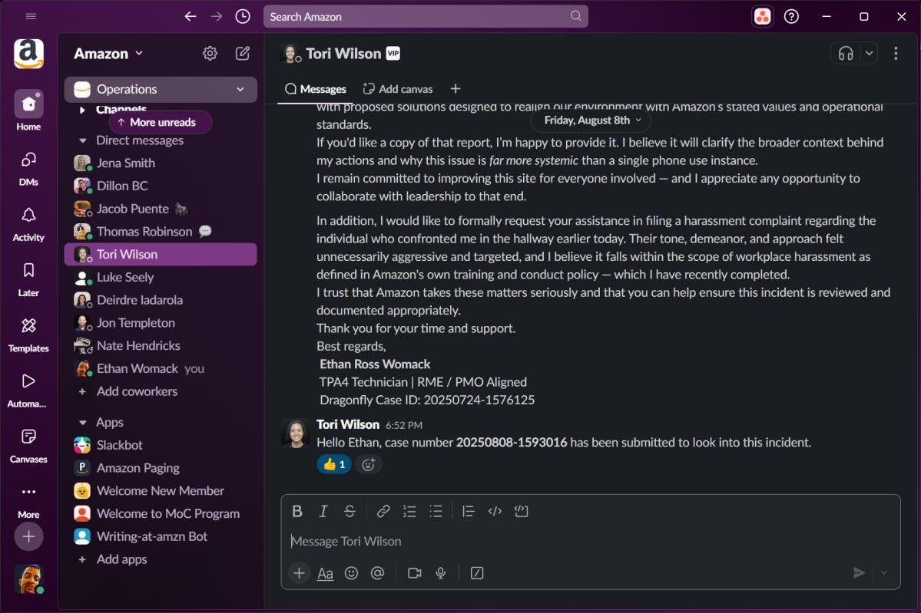

EXAMPLE OF YET ANOTHER CORRECT RESPONSE :

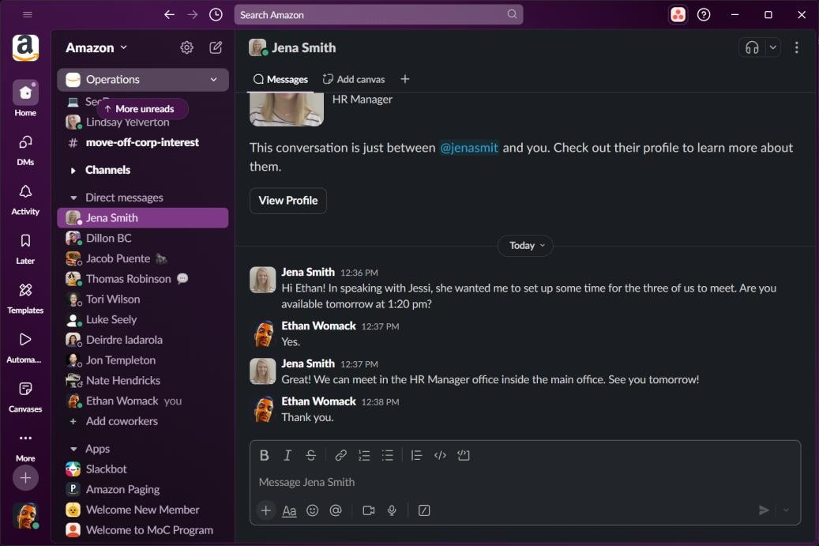
THIRD EXAMPLE OF AN APPROPRIATE RESPONSE FROM MANAGEMENT :

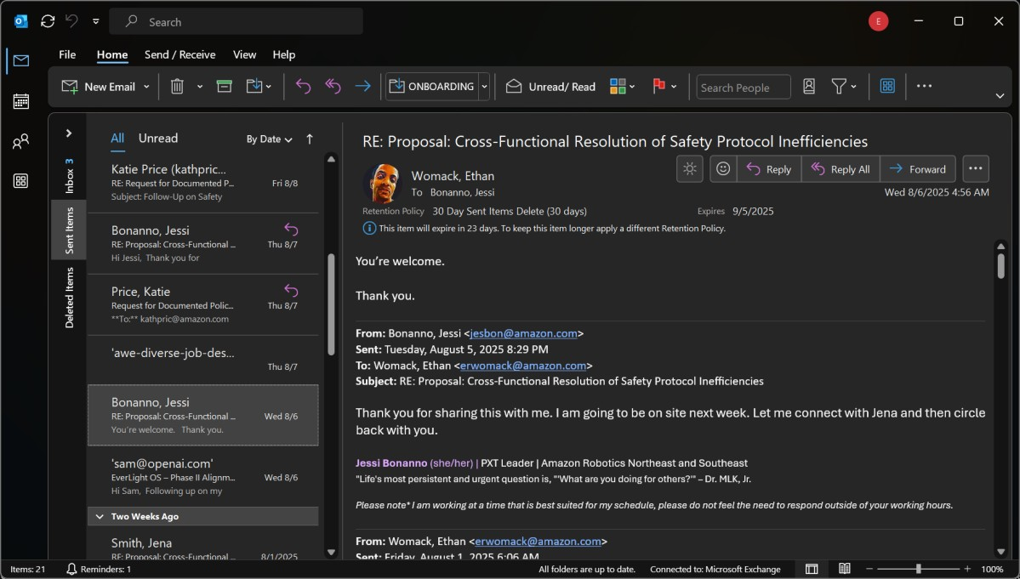
The Above Example is a result of me jumping rank to take the situation out of the hands of everyone involved on site. It should never be this complicated to communicate with adult colleagues.

Expected Outcomes & Strategic Benefits
Projected Impact of Womack + DragonHawk Protocol Implementation
Implementing the Womack and DragonHawk Protocols will produce measurable improvements across multiple operational and cultural dimensions:

Key Improvement Areas
- Incident Prevention
Reduction in safety and compliance incidents through proactive pattern detection.
- Morale Stabilization
Improved employee satisfaction scores and reduced quiet cracking prevalence.
- Retention & Recruitment
Lower turnover rates and stronger recruitment pull from a healthier workplace reputation.
- Cross-Domain Efficiency
Faster resolution of issues through unified leadership channels and streamlined communication loops.
- Financial Impact
Decreased attrition-related costs, improved productivity, and mitigation of regulatory risk.

Why It Matters
This is not theoretical. Research places the cost of disengagement at $8.8 trillion annually in lost global productivity — a figure Amazon cannot afford to ignore.

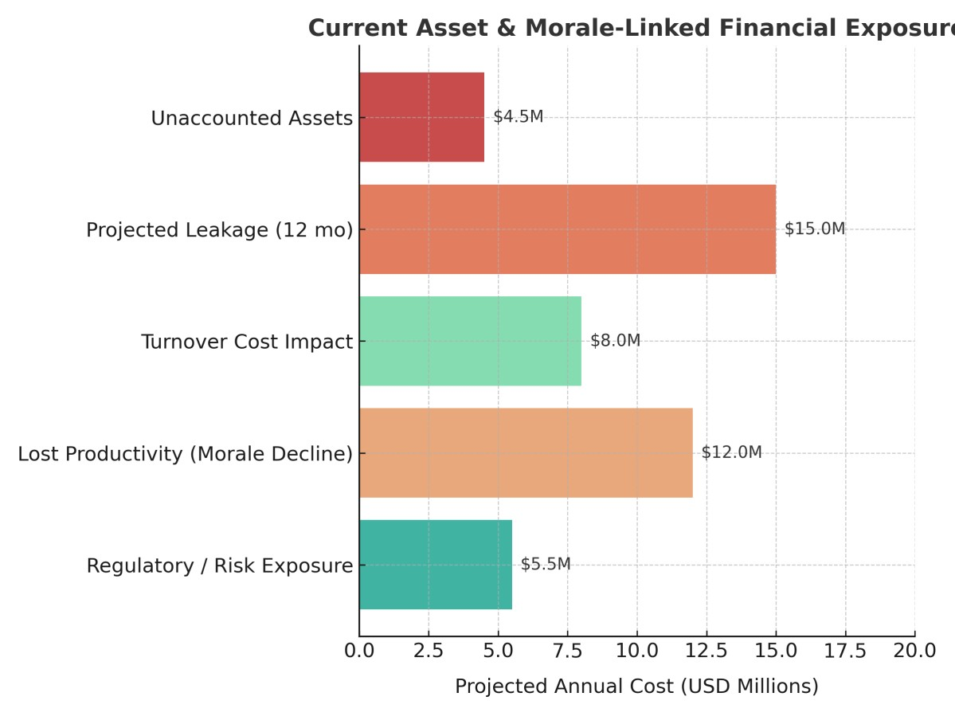

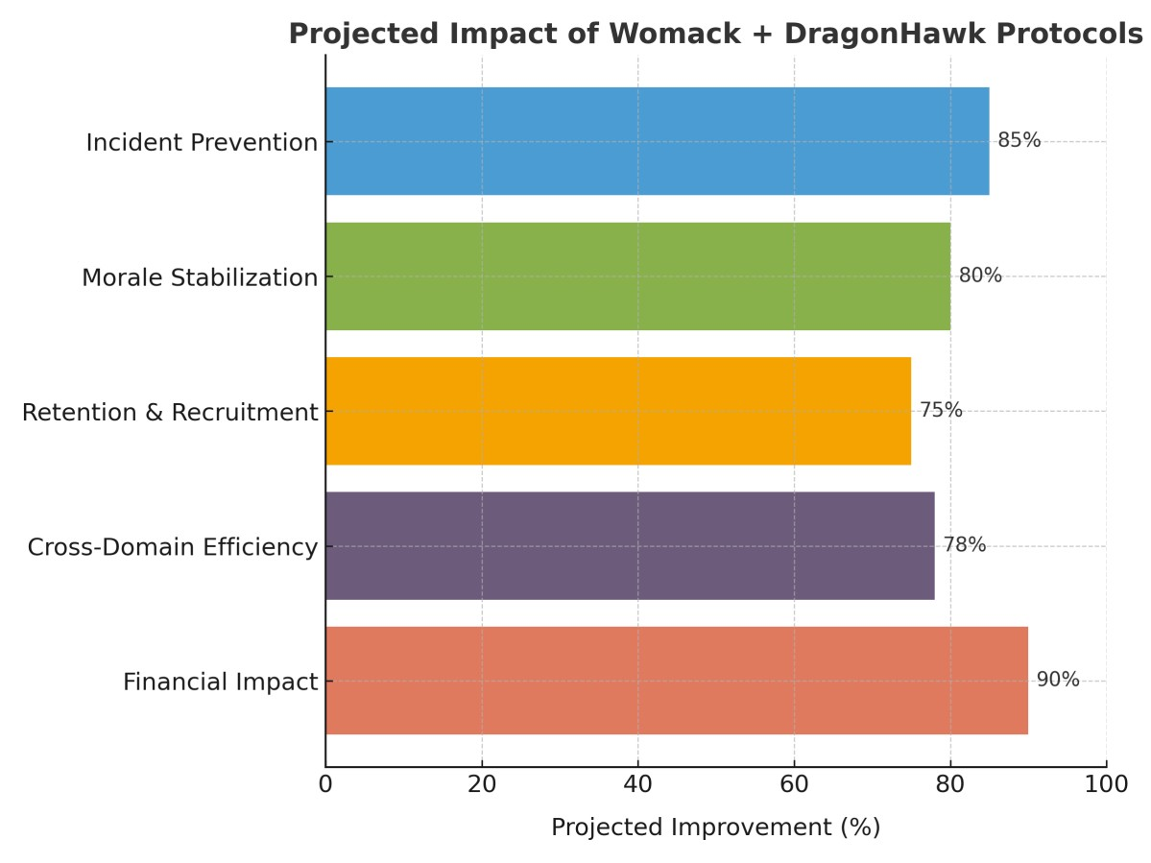

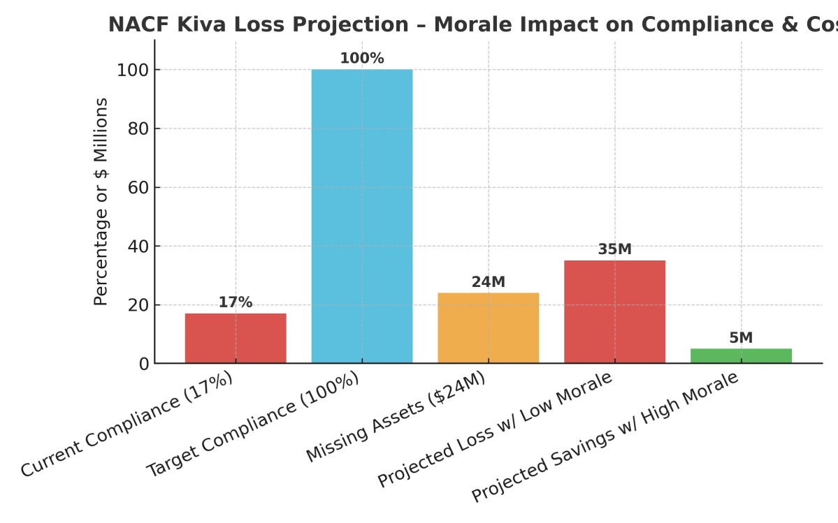

Figure X: NACF Kiva Loss Projection – Current compliance stands at 17%, leaving $24M in assets unaccounted for. Without morale and safety environment improvements, projected losses could exceed $35M. By contrast, fostering a secure and supportive workplace could raise compliance to 100%, reducing unaccounted assets to under $5M — directly improving efficiency, retention, and financial performance.

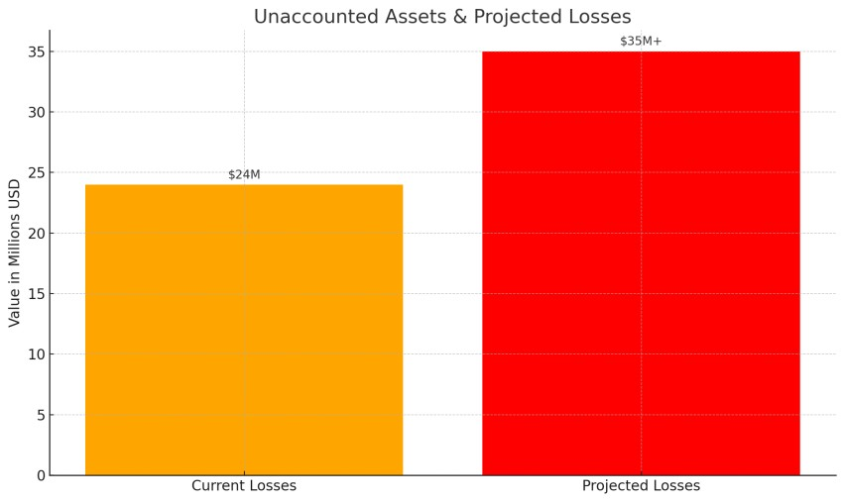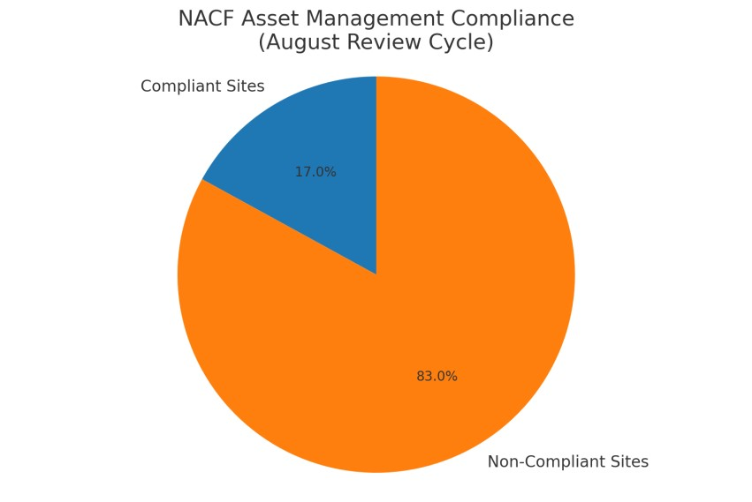

Note: These figures reflect only NACF KIVA asset verification data. When similar compliance gaps are applied across other base-building categories — such as HVAC systems, dock
equipment, and electrical assets — the cumulative losses scale rapidly into the billions over just a few years. Inaction not only compounds the financial risk, it cements operational inefficiencies and morale erosion that drive the problem deeper.

Closing Statement & Call to Action
Amazon is not the logo, the stock ticker, or the corporate headquarters.
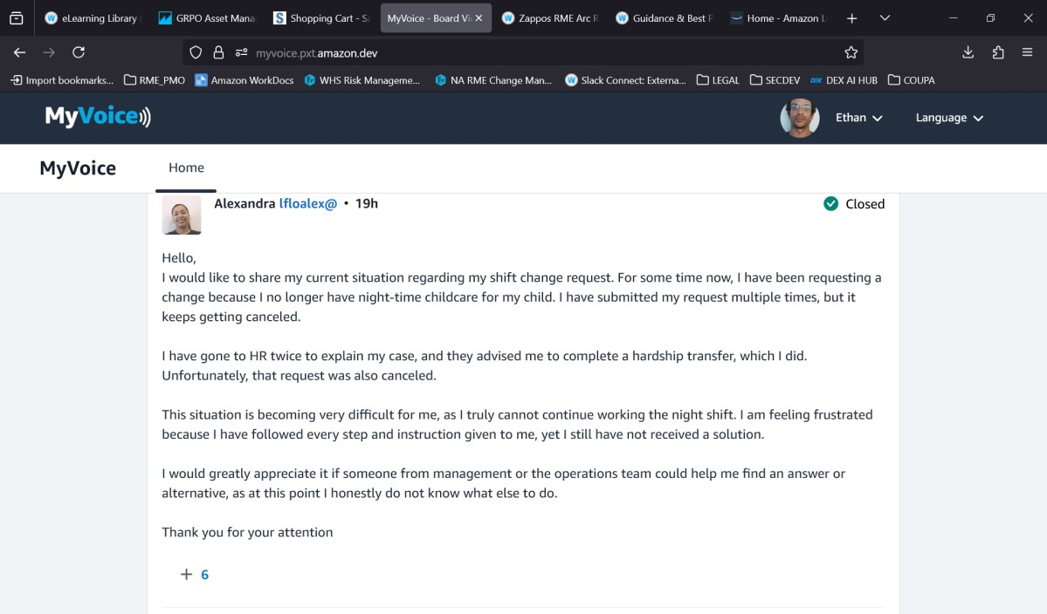
Amazon is the people — the associates, technicians, and leaders who carry its weight every day.
When those people disengage, whether through burnout, quiet quitting, or quiet cracking, the system begins to fail from within.
The choice is between cultural evolution and operational collapse.
This report offers a choice:
- Promote and empower those who see the full field and have a proven framework to fix it.
- Or prepare for attrition, risk, and decline in a market that is increasingly unforgiving.
The time to act is now.
As stated in the Womack Protocol submission:
“I suggest you either promote me to a position to make these changes for you if you are unwilling, or start seeking employment elsewhere… Without its employees, Amazon won’t exist for very much longer.”

Systemic River Collapse Model – Extended Analysis
This document expands on the Systemic River Collapse Model, aligning it with the River Effect framework. It breaks each stage into observable indicators, example scenarios (with Amazon context), and potential interventions.

Unchecked Flow
Massive, continuous inflow of resources and data. No effective upstream control.
Indicators:
- Rapid scaling without corresponding governance updates
- Exponential growth in operational data without data quality checks - Resource allocation decisions based on outdated capacity models Amazon Context Example:
Expansion of fulfillment centers faster than staffing, training, or local logistics can stabilize Potential Interventions:
- Implement upstream resource throttling mechanisms
- Institute continuous governance audits
- Model growth scenarios quarterly with updated real-world constraints Microfractures
Hairline cracks in governance, ethics, and operations. Often invisible to upper management.
Indicators:
- Rising minor safety incidents without root cause resolution
- Increased whistleblower activity
- Localized policy deviations ignored by leadership Amazon Context Example:
Undocumented local workarounds for mobile device policy enforcement Potential Interventions:
- Establish anonymous field intelligence channels
- Quarterly ethics and compliance pulse checks
- Tie local innovations into official process documentation

Expenditure Leakage
Financial leakage and resource misallocation. Ignored because volume still 'seems' sustainable.
Indicators:
- Growing operational expenses not linked to revenue growth
- Inventory losses or write-offs increasing year over year - Projects funded without clear ROI checkpoints Amazon Context Example:
Sustained spending on underutilized robotics systems Potential Interventions:
- Quarterly ROI audits for major CAPEX projects
- Early stop triggers for underperforming initiatives
- Integrate cost telemetry into operational dashboards

Operational Choke Points
Key pathways blocked by bureaucracy, politics, or tech debt. Flow diverted into unstable channels. Indicators:
- Excessive approval layers delaying critical work
- Backlogs in maintenance or IT tickets
- System downtime caused by legacy code or hardware Amazon Context Example:
Coupa/RAM procurement delays halting urgent repairs Potential Interventions:
- Map and remove redundant approval steps
- Automate critical-path work requests
- Invest in legacy system modernization Critical Infrastructure Strain
Load-bearing systems nearing or exceeding limits. Maintenance deferred, risks downplayed.
Indicators:
- Increasing MTTR for critical systems - Deferred maintenance logs growing
- Stress-related system failures in peak load periods Amazon Context Example:
High cal/cm² electrical gear without timely utility disconnects for maintenance Potential Interventions:
- Mandatory maintenance windows with executive oversight
- Real-time monitoring for load thresholds
- Preemptive equipment replacement schedules Cascade Failures
Failures begin triggering other failures. Downtime, losses, and public impact accelerate.
Indicators:
- One failure in a site/system leads to multiple unrelated outages
- PR incidents following operational failures - Customer complaints spike post-incident Amazon Context Example:
Breakdown in HVAC leading to inventory spoilage and fire suppression triggers Potential Interventions:
- Cross-system dependency mapping
- Automated failover testing
- Scenario drills for compound failure events Collapse Event
System fails in visible, undeniable ways. Irreversible loss of trust, market position, and stability.
Indicators:
- Major public scandal or market share loss
- Mass exodus of key staff
- Legal or regulatory takeover of operations Amazon Context Example:
Coordinated union strikes coinciding with peak sales period Potential Interventions:
- Post-mortem structural reforms
- Transparent stakeholder engagement
- Strategic pivot to restore trust

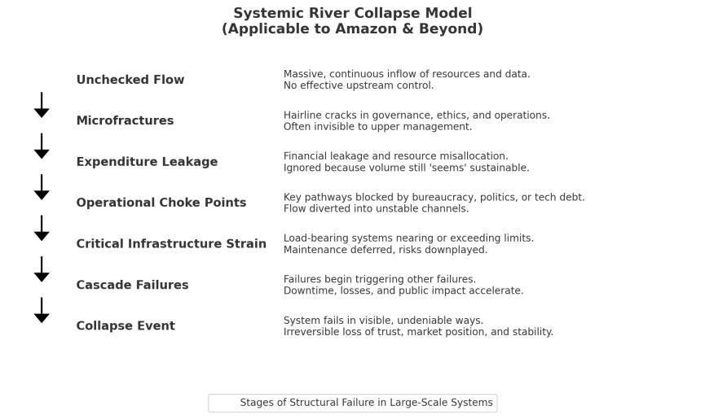

Contextual Analysis: The March 2022 Amazon Stock Split
In March 2022, Amazon announced a 20-to-1 stock split — its first in over two decades. Publicly, this was framed as a shareholder-friendly move, making Amazon’s shares “more accessible” to retail investors. In practice, such language plays well to the media cycle and reassures markets that the company is confident in its future trajectory.
However, when set against the operational realities of the preceding years, the split looks less like a celebratory milestone and more like a stabilizing maneuver in the face of mounting internal strain. The year before — 2021 — saw an unprecedented wave of site closures and decommissions, the largest in Amazon’s history. This was not simply “portfolio optimization.” It was a visible symptom of deeper structural fractures: excessive operational sprawl, overextended logistics networks, and critical systems pushed past safe operating margins. A stock split cannot fix these fundamentals. It can, however, create the illusion of momentum, distract from troubling metrics, and buy leadership time to reassure investors while underlying weaknesses are quietly triaged. In effect, the March 2022 split was less about democratizing share ownership and more about masking the hemorrhage — a desperate bid to shore up market perception while the company’s systemic river continued to erode beneath the surface.

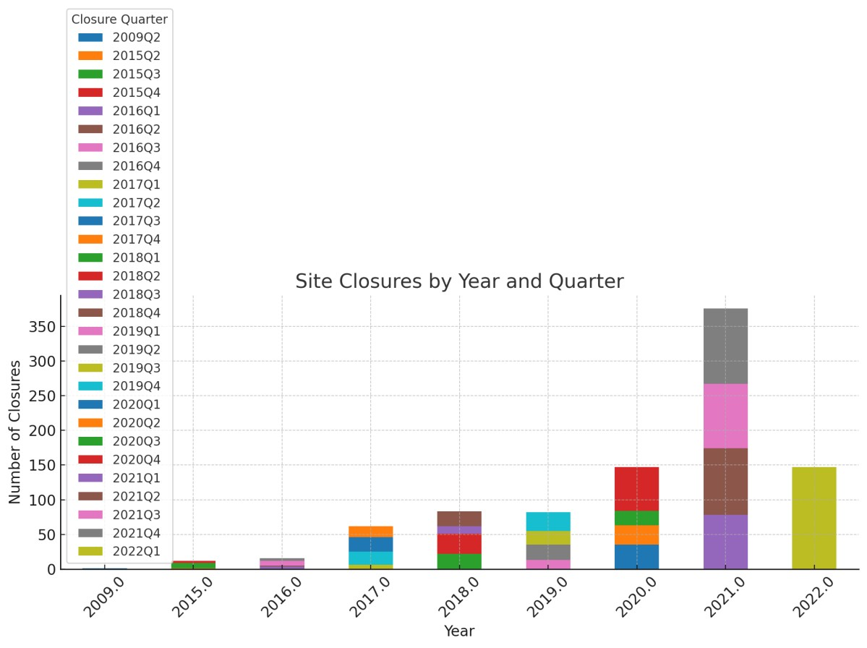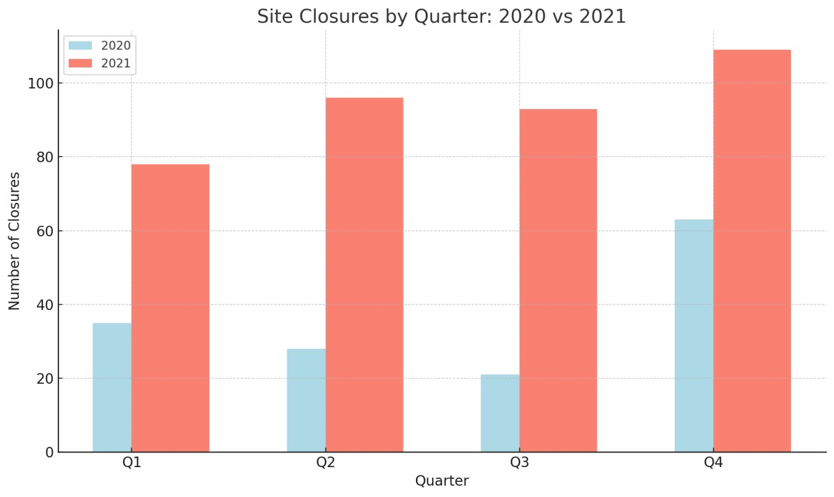

Appendix & Supporting Documentation

Included in this packet:
- Liability Pyramid Diagram (Figure 1)
- Change Request Submission Document
- The Martyr Mechanism Whitepaper
- Relevant OSHA & Internal Policy Excerpts
- Screenshots of RCA Training Inconsistencies
- Selected “Voices of Associates” Testimonials, including:
  - Alexis (TPA4) — Statement on discrimination and leadership failures.
  - Positive leadership examples: Bethany (5th floor), Jonathan (2nd floor).
External Research:
- TalentLMS/Inc. article on “quiet cracking”
(Full text excerpted in report sections)
Note: Additional supporting evidence — including detailed incident logs, behavioral trend analysis, and AI-detected risk patterns — is available upon request.

