Lab 1 Communication systems

Harshal Abhyankar 2019A3PS0282P

Task 1.1

[audio,Fs]=audioread('audio_example_WAV.wav');

sound(audio,Fs)

wavBinary = dec2bin( typecast( single(audio(:)), 'uint8'), 8 ) - '0';

wavSerial = reshape(wavBinary,1,[]);



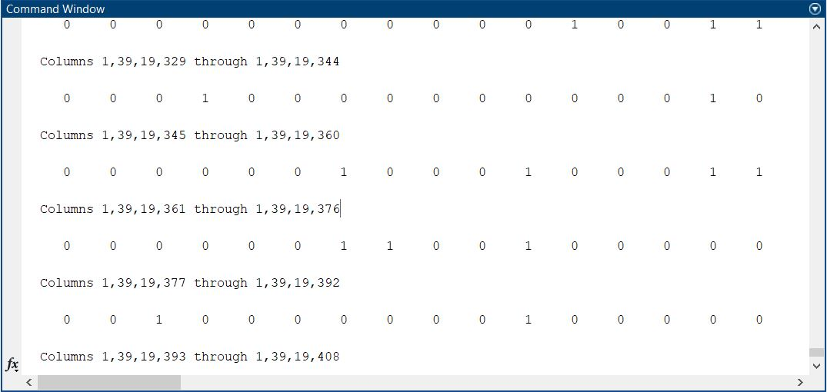

Task 1.2

A = imread('image1.jpg');

image(A);

imagestream = dec2bin(A);

imreshape = reshape(imagestream, 1 ,[]);

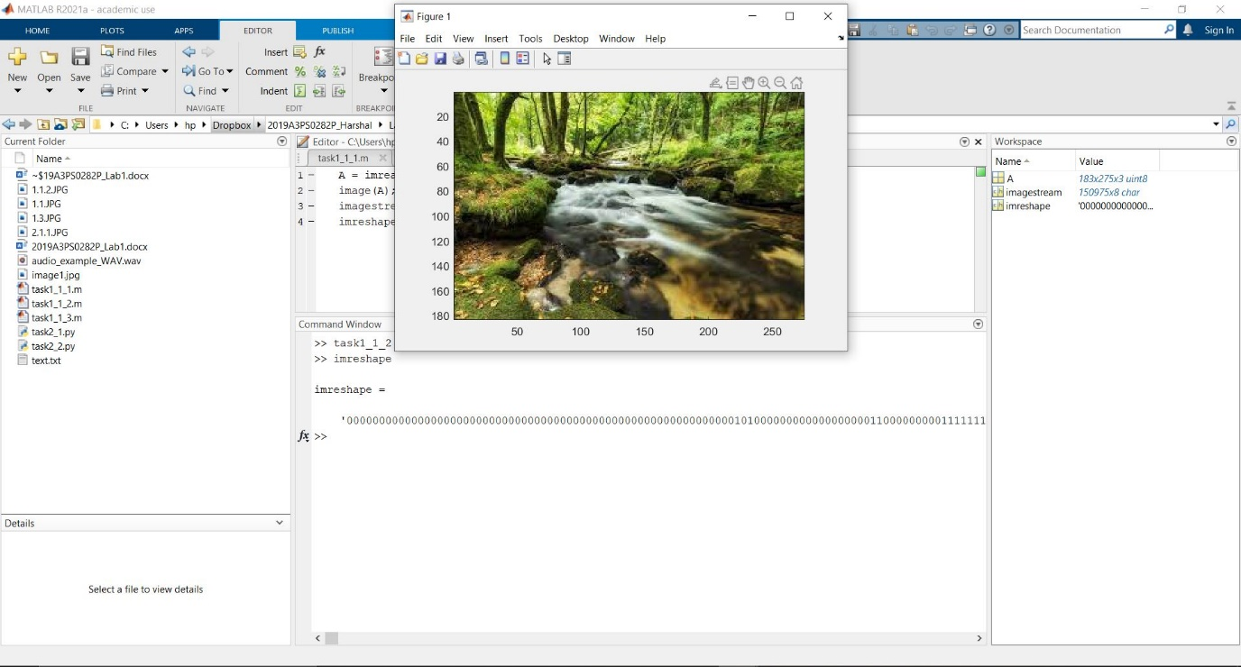

Task 1.3

fileID = fopen('text.txt');

B = fread(fileID);

textstream = dec2bin(B);

textreshape = reshape(textstream, 1 ,[]);

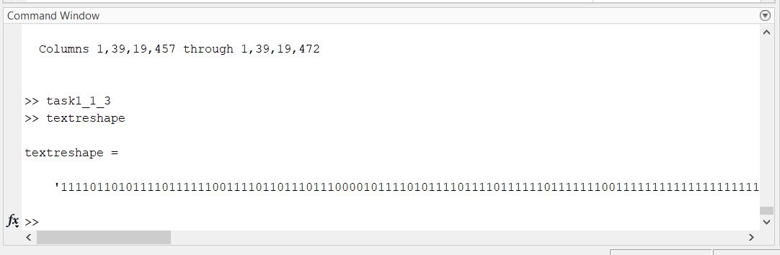

Task 2-1

Last digit of ID-2.

import numpy as np

import matplotlib.pyplot as plt

N = 2

fs = 1000

t = np.arange(50)

signal_m = np.sin(2 * np.pi * N * 10 * (t/fs))

plt.title('Sinewave plot')

plt.plot(t, signal_m)

n = np.arange(50)

dt = 0.05/50

x = np.sin(2 * np.pi * 2 * 10 * n * dt)

plt.stem(n, x)

plt.show()

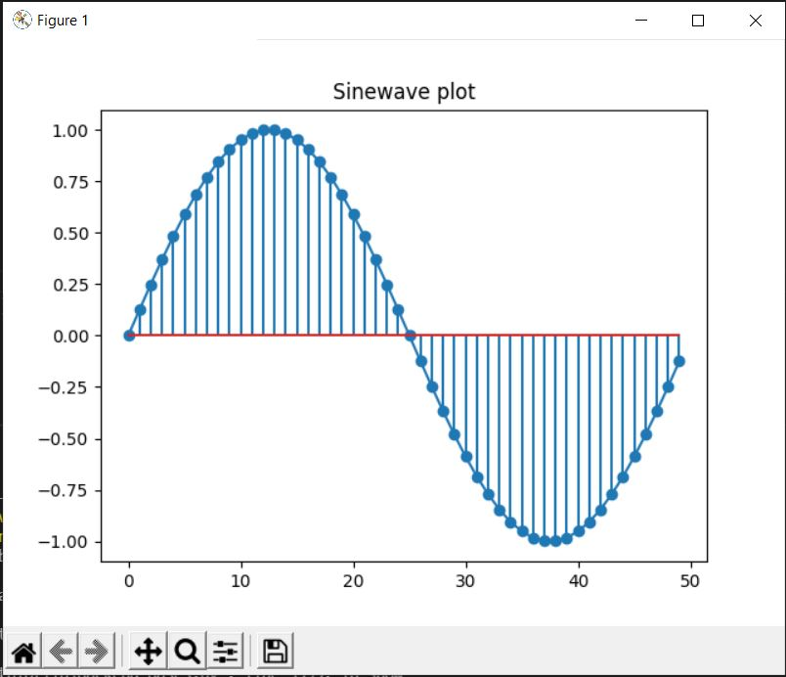

Task 2-2

clc;

fs = 6000;

f1 = 450;

f2 = 550;

t = [0:1/fs:10];

wave1 = sin(2*pi*f1*t);

wave2 = sin(2*pi*f2*t);

output = wave1 + wave2;

plot(output)

sound(output, fs);

