Lab 2

Name: Harshal Abhyankar

2019A3PS0282P

**Task 1**

Code:

N=2;

B=5+N;

fm=B;

fs = 6*fm;

t_start=0;

t_end=3;

t = [-3:1/fs:3];

mt= 2*B*sinc(2*B*t);

subplot(2,1,1); stem(t,mt)

subplot(2,1,2); plot(t,mt)

Figure:

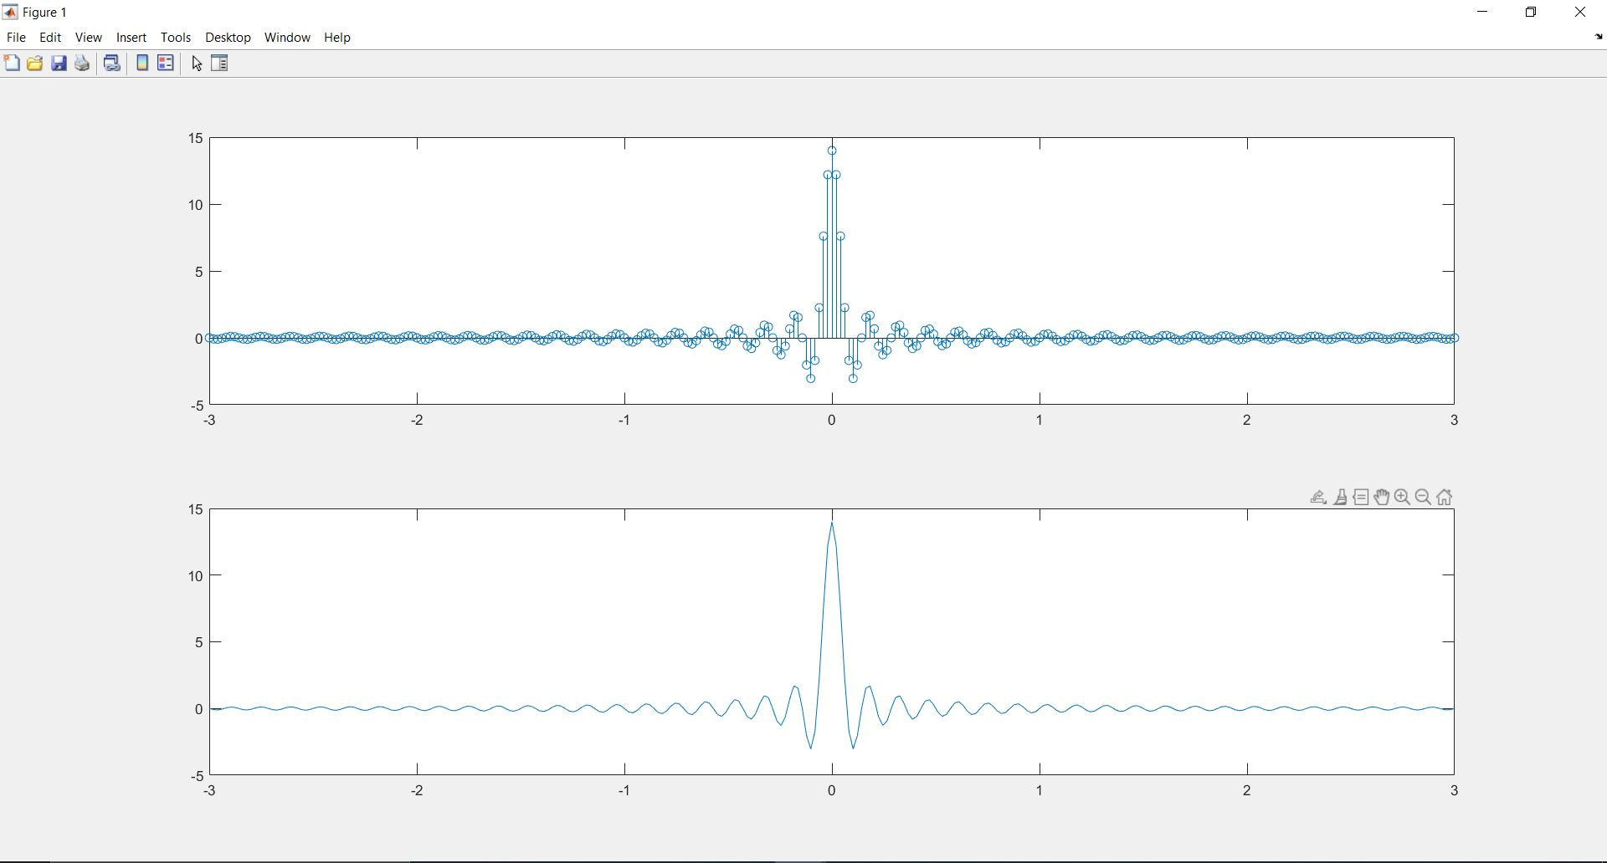

**Task 2:**

Code:

roc=280/(10^3);

ac=0.0969/(10^12);

Lo=587.3/(10^9);

Linf=426/(10^9);

b=1.385;

fm=745900;

Cinf=50/(10^12);

Co=0;

ce=1;

go=0;

ge=1;

f=4000; % this has to be changed for each graph

R=sqrt(sqrt((roc^4)+ac*(f^2)));

L=(Lo+Linf*((f/fm)^b))/(1+(f/fm)^b);

C=Cinf+Co*(f^(-ce));

G=go*f^ge;

w=2*pi*f;

gama=sqrt((R+1j*w*L)*(G+1j*w*C));

%H=exp(1)^(gama*d);

%H_mod=abs(H);

H_loop=[];

d_start=10;

d_end=5000;

for d=d_start:500:d_end

H=(exp(1))^(-1*gama*d);

H_mod_db=10*log10((abs(H)));

H_loop=[H_loop H_mod_db];

end

hold all

title('Graph for frequency = 4GHz'); %this has to change with f for each graph

xlabel('Distance (in m)');

ylabel('Channel Gain (in dB)');

d_axis=d_start:500:d_end;

plot(d_axis,H_loop)

For 4KHz:

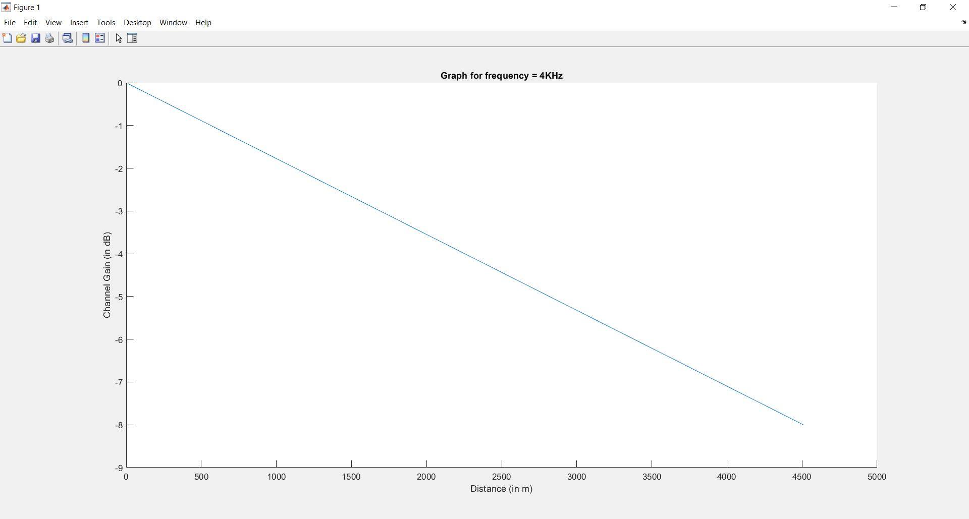

For 4Ghz:

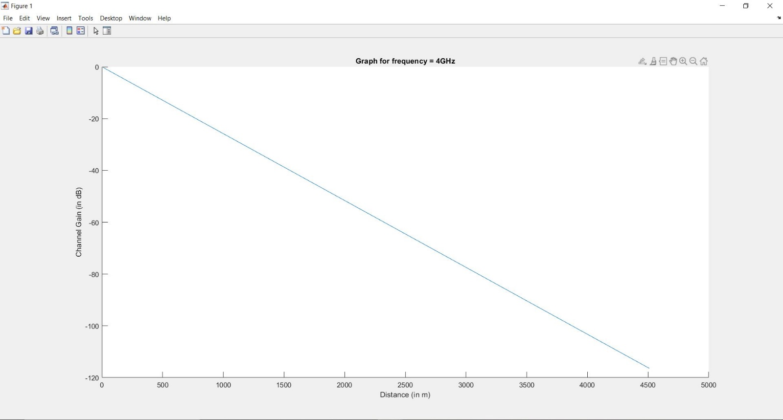

For 4MHz:

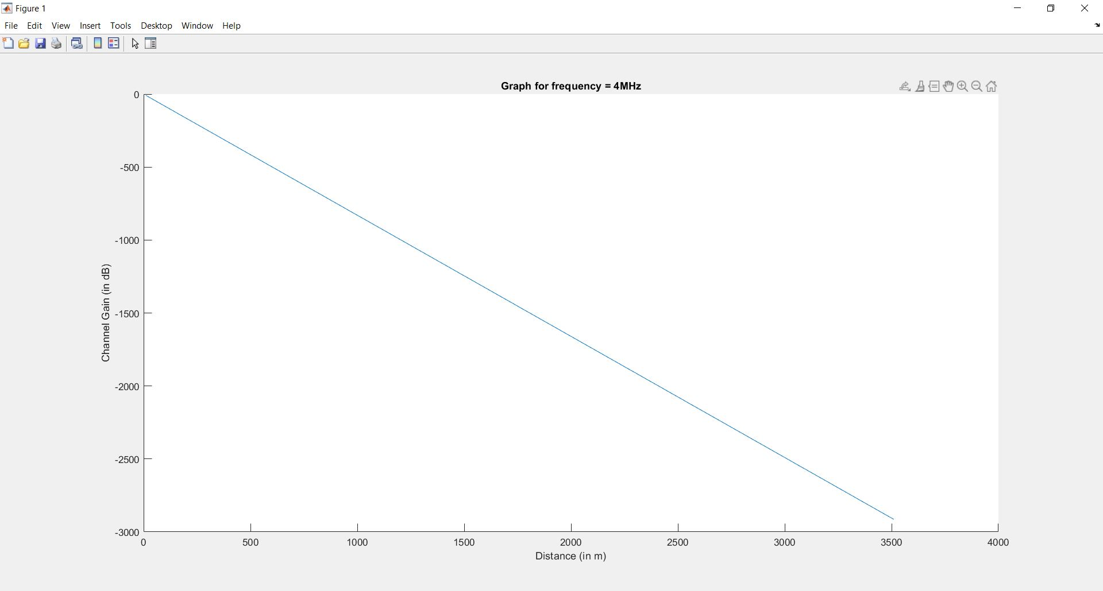

**Task 3:**

symbls={'H' 'A' 'R' 'S' 'L' 'B' 'Y' 'N' 'K'};

prob=[0.1875 0.3125 0.125 0.0625 0.0625 0.0625 0.0625 0.0625 0.0625];

% H 3/16 A 5/16 R 2/16 S 1/16 L 1/16 B 1/16 Y 1/16 N 1/16 K 1/16

[dict,avglen]=huffmandict(symbls,prob);

inpSig={'H' 'A' 'R' 'S' 'A' 'L' 'B' 'Y' 'N' 'K'};

code=huffmanenco(inpSig,dict);

sig=huffmandeco(code,dict);

Input:

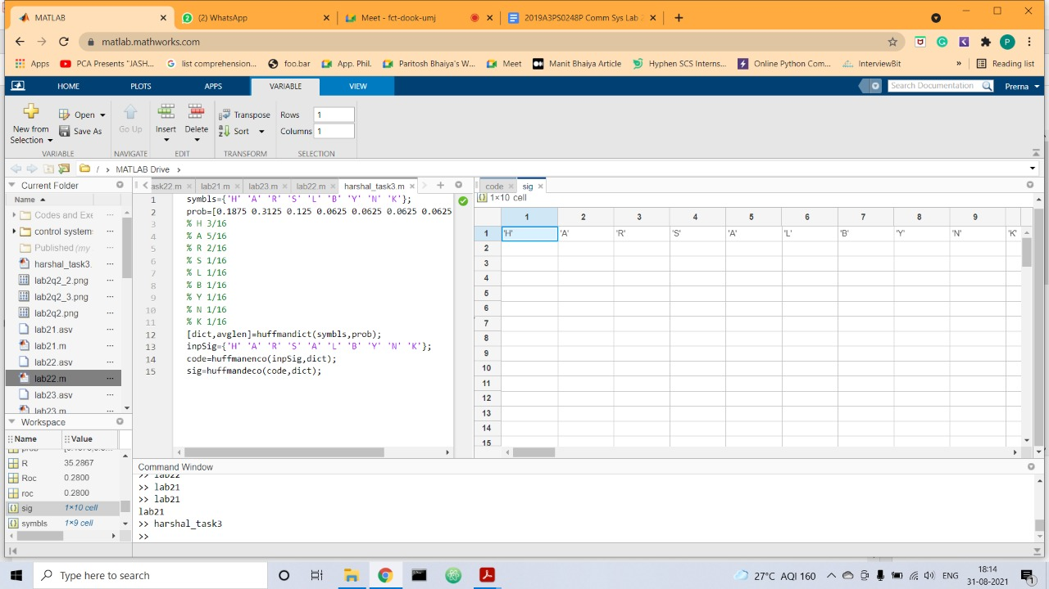

Coded:

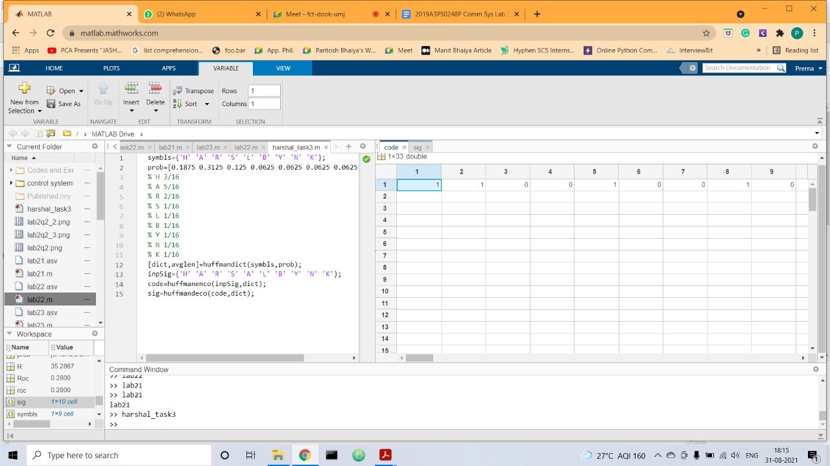

Average length:

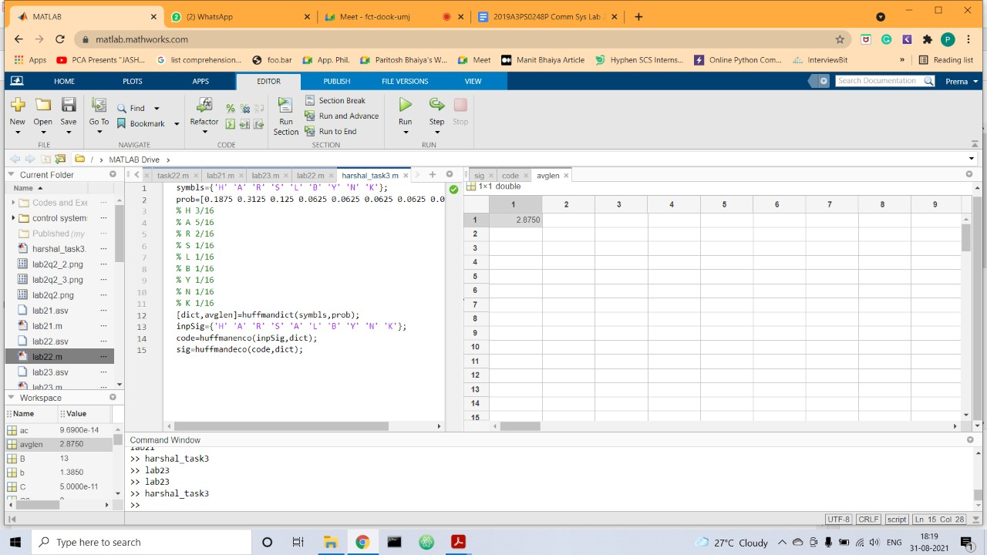

**Task 4**

Code:

clear all; close all; clc;  
f1 = 440;  
f2 = 480;  
time = 6;  
sample_rate = 1000;  
t = linspace(0,6,time*sample_rate);  
A = 0.1;  
y = A*(sin(2 * pi * f1 * t) + sin(2 * pi * f2 * t));  
s = square(t,33);  
s=s+1;  
s=s./2;  
sound_wave = s.*y;  
plot(t,sound_wave)  
sound(sound_wave,sample_rate)

