Communication systems Lab 6

Harshal Abhyankar 2019A3PS0282P

N=12.

**Task 1**

**Code:**

clear all

close all

duration_signal=29;

for T = 0:duration_signal %%%% Duration 30 seconds with interval of 1 sec.

if T==0

display('Transmission Started')

display (T)

elseif (T==duration_signal)

display('Transmission ends: see the final result')

display (T)

else

display('Transmission in progress: please wait')

display (T)

end

N=12;

fm=N;

fc = 1000;

fs=10*fc;

ts=1/fs;

t=0:ts:1;

i=randi(1);

display(i)

m1_t=cos(2*pi*fm*t);

m2_t=2*fm*sinc(2*fm*t);

Nsym = 200; %filter span in symbol durations

L=10;

alpha=1;

t2=-10:ts:10;

m3_t = 200*(cos(200*pi*t)./(1-40000*t.*t)).*sinc(200*t);

switch i

case 1

m_t=m1_t;

case 2

m_t=m2_t;

case 3

m_t=m3_t;

end

Ac = 2;%Amplitude of carrier signal.

carrier = Ac*cos(2*pi*fc*t);%carrier signal.

dsb_sc = m_t.*carrier; %dsb sc modulated wave

t2=-0.5:ts:0.5;

h_t = 2*100*sinc(2*100*t2);

y_t = conv(dsb_sc, h_t, 'same');

n_t = 0.01*randn(size(t));

y_t = y_t + n_t;

%y_t = dsb_sc + n_t;

%=====DSB SC IN FREQUENCY DOMAIN============

ld=length(dsb_sc);

f=linspace(-fs/2,fs/2,ld);

DSB_SC=fftshift(fft(dsb_sc,ld)/ld); %frequency spectrum of dsb_sc modulated signal.

%=====DSB SC DEMODULATION TIME DOMAIN============

pmo = y_t.*carrier;

pmo = pmo/(Ac*Ac);

t1=-5:ts:5;

lpf=2*fm*sinc(2*fm*t1);

msg_r = conv(pmo, lpf, 'same');

%=====DSB SC DEMODULATION FREQUENCY DOMAIN============

lr=length(msg_r);

fr=linspace(-fs/2,fs/2,lr); %frequency bins

MSG_R=fftshift(fft(msg_r,lr)/lr); %frequency spectrum of demodulated signal

%================ PLOTTING =========================

figure(1)

hold all;

subplot(4,1,1);

plot(t+T, m_t);

title("MESSAGE SIGNAL (TIME DOMAIN)");

xlabel('time (sec)');

ylabel('amplitude');

grid on;

hold on;

subplot(4,1,2);

plot(t+T, carrier);

title("CARRIER SIGNAL (TIME DOMAIN)");

xlabel('time (sec)');

ylabel('amplitude');

grid on;

hold on;

subplot(4,1,3);

plot(t+T, dsb_sc);

title("MODULATED DSB SC SIGNAL (TIME DOMAIN)");

xlabel('time (sec)');

ylabel('amplitude');

grid on;

hold on;

subplot(4,1,4);

plot(t+T, msg_r);

title("DEMODULATED DSB SC SIGNAL (TIME DOMAIN)");

xlabel('time (sec)');

ylabel('amplitude');

grid on;

hold on;

figure(2)

hold all

subplot(2,1,1);

plot(f, abs(DSB_SC));

xlim([-15 15]);

title('DSB SC MODULATION IN FREQUENCY DOMAIN');

xlabel('frequency(hz)');

ylabel('amplitude');

grid on;

hold on;

subplot(2,1,2);

plot(fr, abs(MSG_R));

xlim([-6 6]);

title('DSB SC DE MODULATION IN FREQUENCY DOMAIN');

xlabel('frequency(hz)');

ylabel('amplitude');

grid on;

%pause(2) %%%%% pauses for 2 seconds and then go for next loop increment.

end

**If considering only cos message signal (for better graph analysis):**

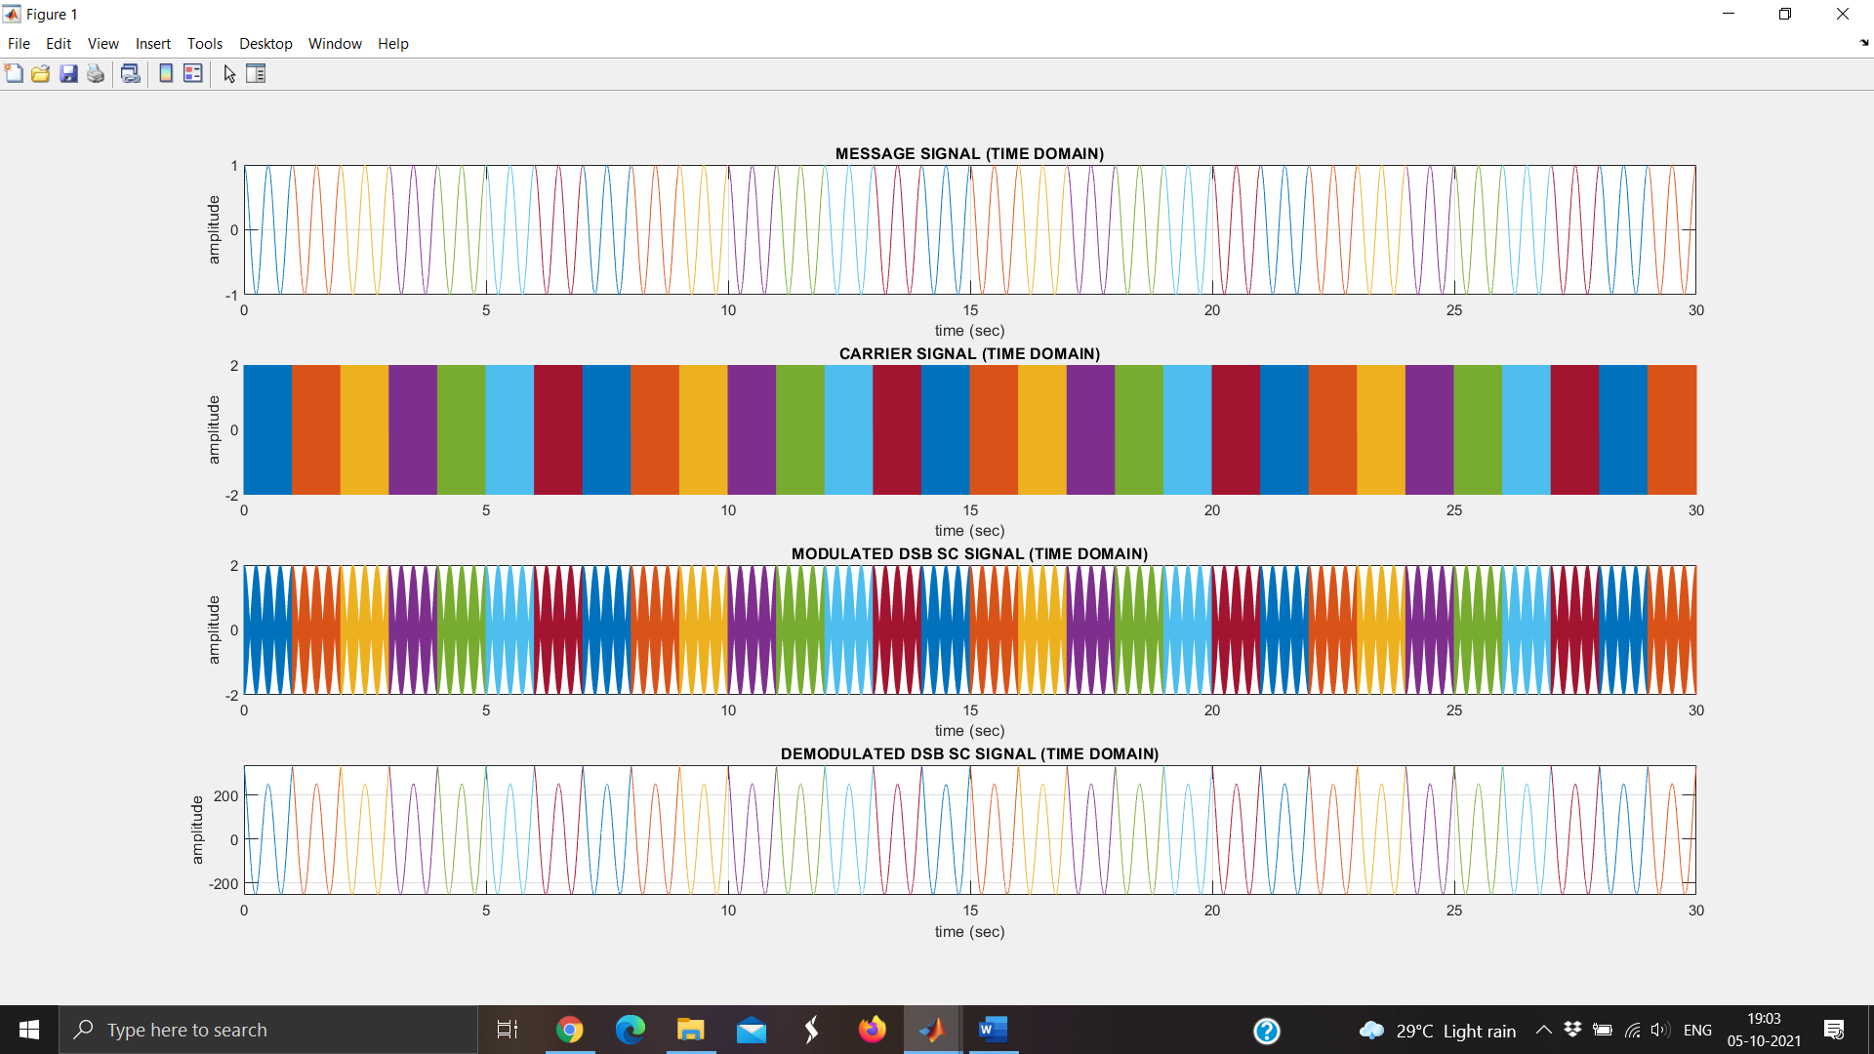

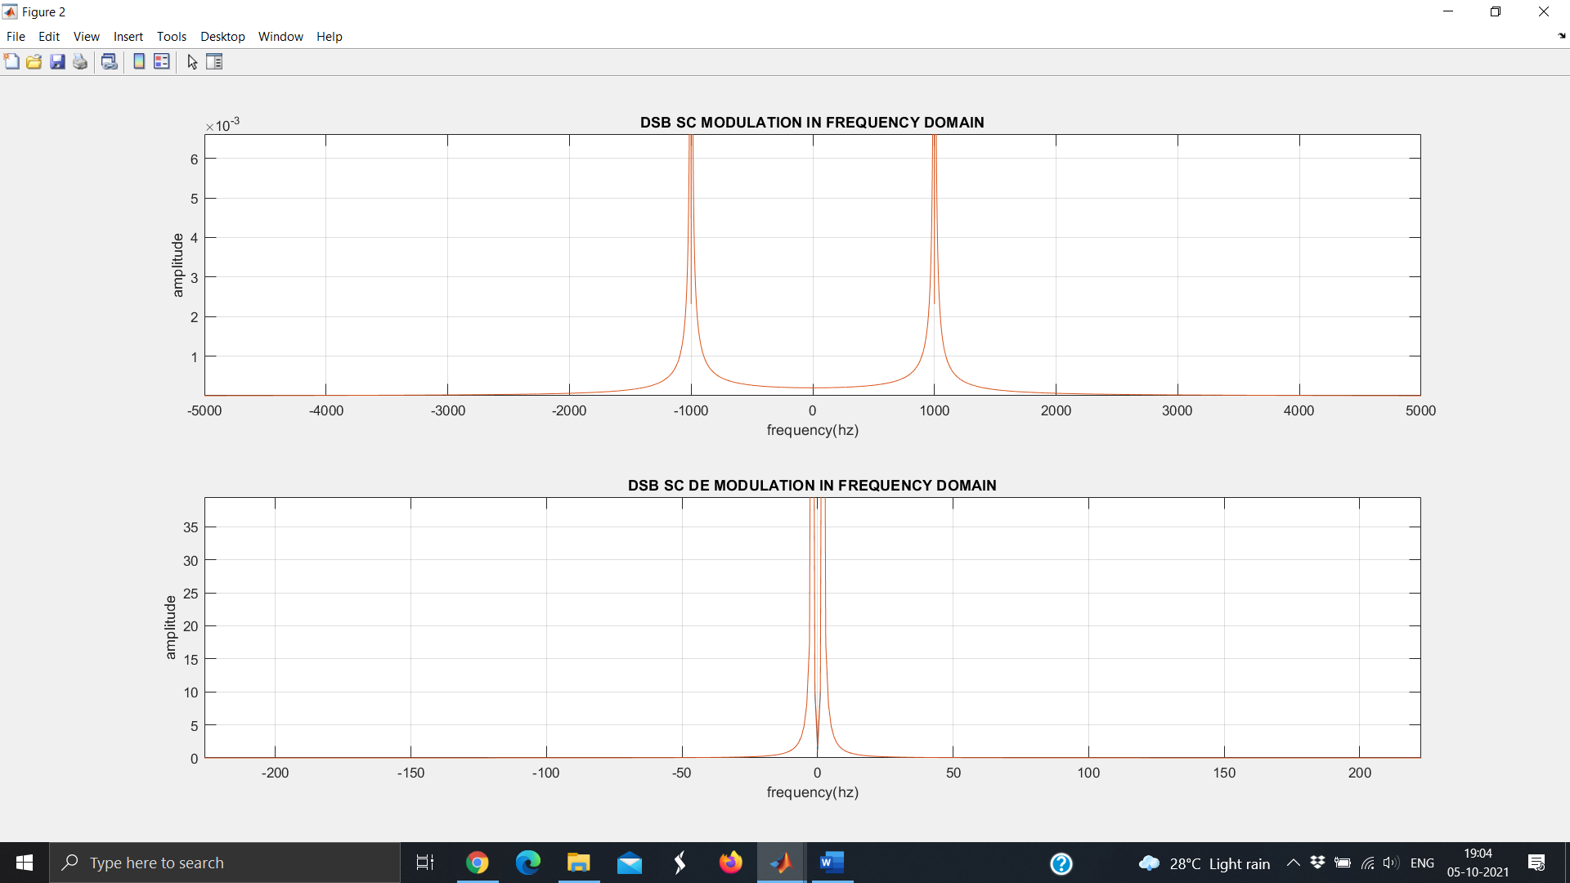

For random selection:

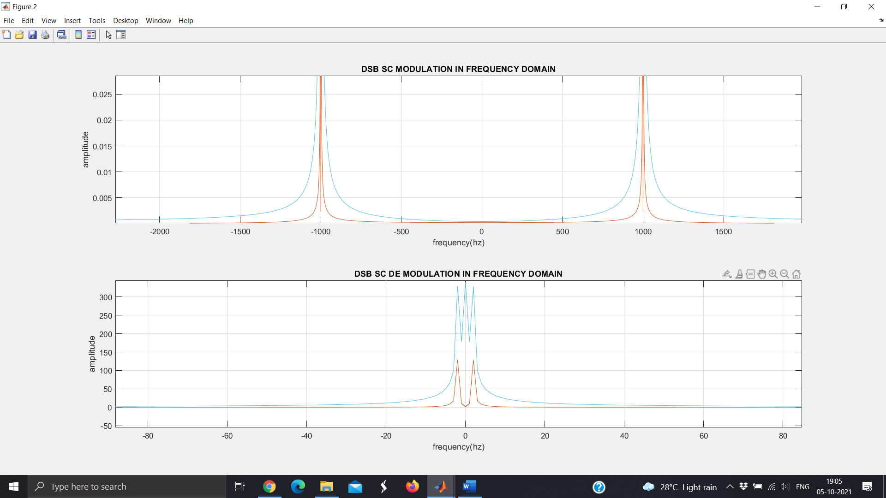

**Conclusion:**  For better visualization of modulation and demodulation of message signal I have added screenshots of only cosine signal first.

Due to multiple multiplication the orders of magnitude message signal and demodulated signals vary which can be corrected by reducing the magnitude at the receiver and the shape of the received and demodulated signal can be seen to be very close to our original message signal.

The received signal is demodulated by multiplying with carrier signal and then passing through a low pass filter of sinc pulse(synchronous detector) to get back the transmitted signal through channel with noise n_t.

**Task 2**

**Code:**

clear all;close all;clc;

N = 12;

fc = 1000;

fs = 4*fc;

mu = 0;sigma = sqrt(0.01);

duration_signal = 29;amp_carrier = 2;

BW_lpf = 1.5*N;BW_chanl = 0.5*N;

for T = 0:duration_signal

t = -0.5:1/fs:0.5;

m1t = cos(2*pi*N*t);

m2t = 2*N*sinc(2*N*t);

m3t = 200*(cos(200*pi*t)./(1-40000*t.*t)).*sinc(200*t);

noise = mu + sigma*randn(1,length(t));

chanl = 2*BW_chanl*sinc(2*BW_chanl*t).*(2*cos(2*pi*fc*t));

carrier = amp_carrier*cos(2*pi*fc*t);

signals = {m1t;m2t;m3t}; take = randi(3);

m_t = cell2mat(signals(take));

modulated = (m_t + 44).*carrier;

modulated = modulated + noise;

modulated = conv(modulated,chanl,'same');

demodulated = hilbert(modulated).*exp(-1i*2*pi*fc*t);

% Modulated signal plot

nfft = length(modulated);m_f = fft(modulated,nfft)/fs;

freqaxis = linspace(-fs/2, fs/2, nfft);

figure(1);hold all ;

subplot(2,1,1), plot(t+0.5+T,modulated);

title('Modulated Signal');xlabel('Time(sec)');

ylabel('Amplitude(volts)');grid on;hold on;

subplot(2,1,2), plot(freqaxis,fftshift(abs(m_f)));

xlabel('Freq(Hz)');ylabel('Magnitude');grid on;

% Demodulated signal plot

nfft = length(demodulated);

m_f = fft(demodulated,nfft)/fs;

freqaxis = linspace(-fs/2, fs/2, nfft);

figure(2);hold all ;subplot(2,1,1), plot(t+0.5+T,demodulated);

title('Demodulated signal');xlabel('Time(sec)');ylabel('Amplitude(volts)');

grid on;hold on;subplot(2,1,2), plot(freqaxis,fftshift(abs(m_f)));

xlabel('Freq(Hz)');ylabel('Magnitude');grid on;

pause(0.5);

end

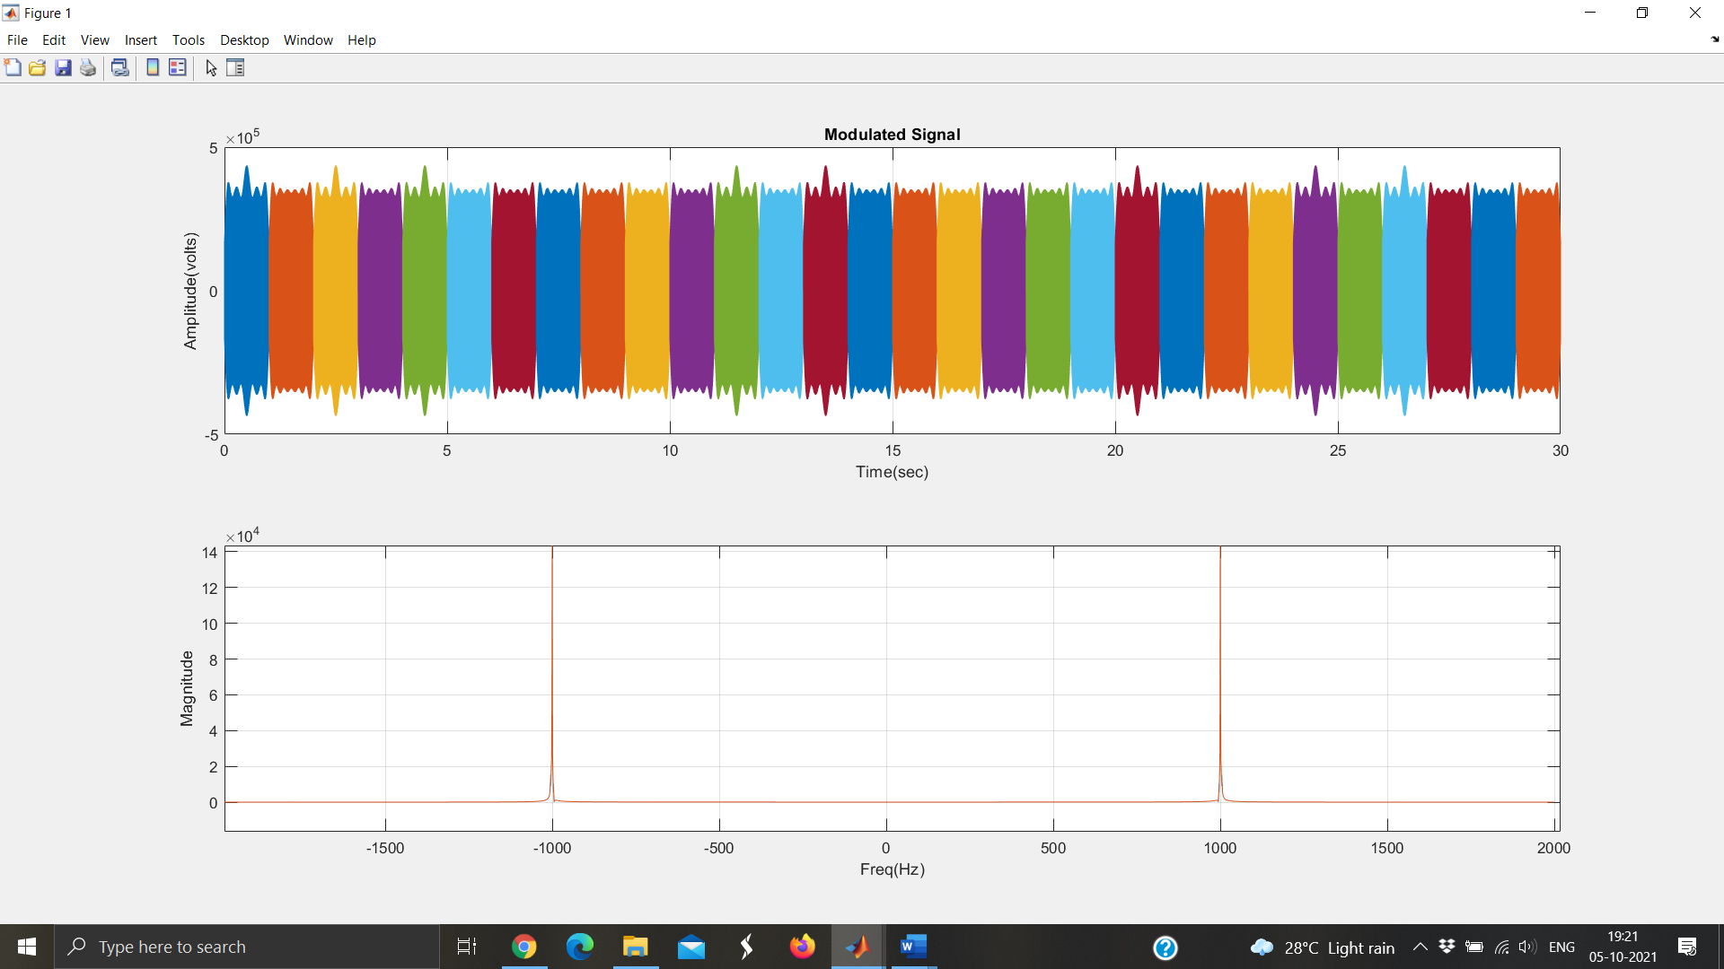

**Conclusion:** In this task we demodulate the signal using Hilbert transform of the received signal and then shift it from band pass to low pass by multiplying it with the exponential term to get our original signal back.

By using the Hilbert transform we demodulate the signal using basic geometrical conversions of sine and cosines indirectly and this is known as the envelop detector.