Communication systems Lab 7

Harshal Abhyankar 2019A3PS0282P

N=10.

**Task 1.1**

**Code:**

import numpy as np

import matplotlib.pyplot as plt

from numpy.fft import fft

import random

from scipy.signal import hilbert

N = 10

signal_duration = 10

fc = 100

fs = 10*fc

for T in range(signal_duration):

 t_signal = np.arange(-0.5,0.5,1/fs)

 Am = random.randint(1,10)

 m_t = Am*np.cos(2*np.pi*N*t_signal)

 c_t = np.cos(2*np.pi*fc*t_signal)

 USSB = m_t*c_t - np.imag(hilbert(m_t))*np.sin(2*np.pi*fc*t_signal)

 LSSB = m_t*c_t + np.imag(hilbert(m_t))*np.sin(2*np.pi*fc*t_signal)

 plt.figure(1)

 plt.subplot(2,1,1)

 plt.plot(t_signal+1+T, USSB)

 plt.title('Time Domain USSB m(t)')

 plt.xlabel('Time(in sec)')

 plt.ylabel('Amplitude')

 yf1 = fft(USSB) / fs

 N1 = len(yf1)

 yf_abs_sorted1 = np.fft.fftshift(abs(yf1))

 freq_axis = np.linspace(-fs / 2, fs / 2, N1)

 plt.subplot(2,1,2)

 plt.title('Frequency domain USSB')

 plt.xlabel('Frequency(in Hz)')

 plt.ylabel('FFT amplitude')

 plt.plot(freq_axis, yf_abs_sorted1)

 plt.pause(0.1)

 plt.figure(3)

 plt.subplot(2,1,1)

 plt.plot(t_signal + 1 + T, LSSB)

 plt.title('Time Domain LSSB m(t)')

 plt.xlabel('Time(in sec)')

 plt.ylabel('Amplitude')

 yf2 = fft(LSSB) / fs

 N2 = len(yf2)

 yf_abs_sorted2 = np.fft.fftshift(abs(yf2))

 plt.subplot(2,1,2)

 plt.title('Frequency domain LSSB')

 plt.xlabel('Frequency(in Hz)')

 plt.ylabel('FFT amplitude')

 plt.plot(freq_axis, yf_abs_sorted2)

 plt.pause(0.1)

plt.show()

**Conclusion:**  Frequency peak of USSB is at frequency 100+N and -100-N which can be seen in the above screenshots. For LSSB, the peaks are at frequencies 100-N and -100+N as seen in the above screenshot.

**Task 1.2**

**Code:**

import numpy as np

import matplotlib.pyplot as plt

from numpy.fft import fft

import random

N = 10

signal_duration = 10

fc = 100

kf = 100

B = 2*(kf*10 + N)

fs = 10*B

for T in range(signal_duration):

 t_signal = np.arange(-0.5,0.5,1/fs)

 Am = random.randint(1,10)

 m_t = Am*np.cos(2*np.pi*N*t_signal)

 FM = np.cos(2*np.pi*fc*t_signal + (Am*kf/N)*np.sin(2*np.pi*N*t_signal))

 plt.figure(1)

 plt.subplot(2,1,1)

 plt.plot(t_signal+0.5+T, FM)

 plt.title('Time Domain FM')

 plt.xlabel('Time(in sec)')

 plt.ylabel('Amplitude')

 yf = fft(FM) / fs

 N1 = len(yf)

 yf_abs_sorted = np.fft.fftshift(abs(yf))

 freq_axis = np.linspace(-fs / 2, fs / 2, N1)

 plt.subplot(2,1,2)

 plt.title('Frequency domain FM')

 plt.xlabel('Frequency(in Hz)')

 plt.ylabel('FFT amplitude')

 plt.plot(freq_axis, yf_abs_sorted)

 plt.pause(0.1)

plt.show()

**Conclusion:** We can observe frequency modulation in the above screenshot in both frequency and time domain.

**Task 1.3**

**Code:**

import numpy as np

import matplotlib.pyplot as plt

from numpy.fft import fft

import random

N = 10

signal_duration = 10

fc = 100

kp = 100

B = 2*(N + kp*10*N)

fs = 10*B

for T in range(signal_duration):

 t_signal = np.arange(-0.5,0.5,1/fs)

 Am = random.randint(1,10)

 m_t = Am*np.cos(2*np.pi*N*t_signal)

 PM = np.cos(2*np.pi*fc*t_signal + kp*m_t)

 plt.figure(1)

 plt.subplot(2,1,1)

 plt.plot(t_signal+0.5+T, PM)

 plt.title('Time Domain PM m(t)')

 plt.xlabel('Time(in sec)')

 plt.ylabel('Amplitude')

 yf = fft(PM) / fs

 N1 = len(yf)

 yf_abs_sorted = np.fft.fftshift(abs(yf))

 freq_axis = np.linspace(-fs / 2, fs / 2, N1)

 plt.subplot(2,1,2)

 plt.title('Frequency domain PM')

 plt.xlabel('Frequency(in Hz)')

 plt.ylabel('FFT amplitude')

 plt.plot(freq_axis, yf_abs_sorted)

 plt.pause(0.1)

plt.show()

**Conclusion:** We can observe phase modulation in the above screenshot in both frequency and time domain.

**Task 2**

**Code:**

import numpy as np

import matplotlib.pyplot as plt

import random

from scipy.signal import hilbert

signal_duration=10

for T in range(10):

 t_start=-0.5

 t_stop=0.5

 carrier_freq=500

 fs=10*carrier_freq

 ts=1/fs

 time=np.arange(t_start,t_stop,ts)

 A=25

 carrier_t=A*np.cos(2*np.pi*carrier_freq*time)

 carrier_f=np.fft.fftshift(abs(np.fft.fft(carrier_t)/fs))

 len_time=len(time)

 freq_axis=np.linspace(-fs/2,fs/2,len_time)

 B=random.randint(1,5)

 m_t=20*B*np.sinc(20*B*time)

 m_f=np.fft.fftshift(abs(np.fft.fft(m_t)/fs))

 mod_t=(1+m_t/A)*carrier_t

 mod_f=np.fft.fftshift(abs(np.fft.fft(mod_t)/fs))

 mu=0

 sigma_sq=0.001

 sigma=np.sqrt(sigma_sq)

 n_t=mu+sigma*np.random.randn(len(time))

 op_t=0.01*mod_t+n_t

 op_f=np.fft.fftshift(abs(np.fft.fft(op_t)/fs))

 op_demod_t=abs(hilbert(op_t))-A*0.01

 op_demod_f=np.fft.fftshift(abs(np.fft.fft(op_demod_t)/fs))

 plt.figure(1)

 plt.subplot(5,1,1)

 plt.plot(time+T,m_t)

 plt.title('Message signal-time domain')

 plt.xlabel('Time(in sec)')

 plt.ylabel('Amplitude')

 plt.figure(1)

 plt.subplot(5, 1, 2)

 plt.plot(time + T, carrier_t)

 plt.title('Carrier Signal-time domain')

 plt.xlabel('Time(in sec)')

 plt.ylabel('Amplitude')

 plt.figure(1)

 plt.subplot(5, 1, 3)

 plt.plot(time + T, mod_t)

 plt.title('Modulated signal-time domain')

 plt.xlabel('time(in sec)')

 plt.ylabel('Amplitude')

 plt.figure(1)

 plt.subplot(5, 1, 4)

 plt.plot(T+time, op_t)

 plt.title('Modulated signal after channel time domain')

 plt.xlabel('time(in sec)')

 plt.ylabel('Amplitude')

 plt.figure(1)

 plt.subplot(5, 1, 5)

 plt.plot(time + T, op_demod_t)

 plt.title('Demodulated signal-time domain')

 plt.xlabel('time(t)')

 plt.ylabel('Amplitude')

 plt.figure(2)

 plt.subplot(5, 1, 1)

 plt.plot(freq_axis, m_f)

 plt.title('Message signal-frequency domain')

 plt.xlabel('Frequency (in Hz)')

 plt.ylabel('Magnitude')

 plt.figure(2)

 plt.subplot(5, 1, 2)

 plt.plot(freq_axis, carrier_f)

 plt.title('Carrier signal-frequency domain')

 plt.xlabel('Frequency(in Hz)')

 plt.ylabel('Magnitude')

 plt.figure(2)

 plt.subplot(5, 1, 3)

 plt.plot(freq_axis, mod_f)

 plt.title('Modulated signal-frequency domain')

 plt.xlabel('Frequency(in Hz)')

 plt.ylabel('Magnitude')

 plt.figure(2)

 plt.subplot(5, 1, 4)

 plt.plot(freq_axis, op_f)

 plt.title('Modulated signal after channel frequency domain')

 plt.xlabel('Frequency(in Hz)')

 plt.ylabel('Magnitude')

 plt.figure(2)

 plt.subplot(5, 1, 5)

 plt.plot(freq_axis, op_demod_f)

 plt.title('Demodulated signal frequency domain')

 plt.xlabel('Frequency(in Hz)')

 plt.ylabel('Magnitude')

 plt.pause(0.5)

plt.show()

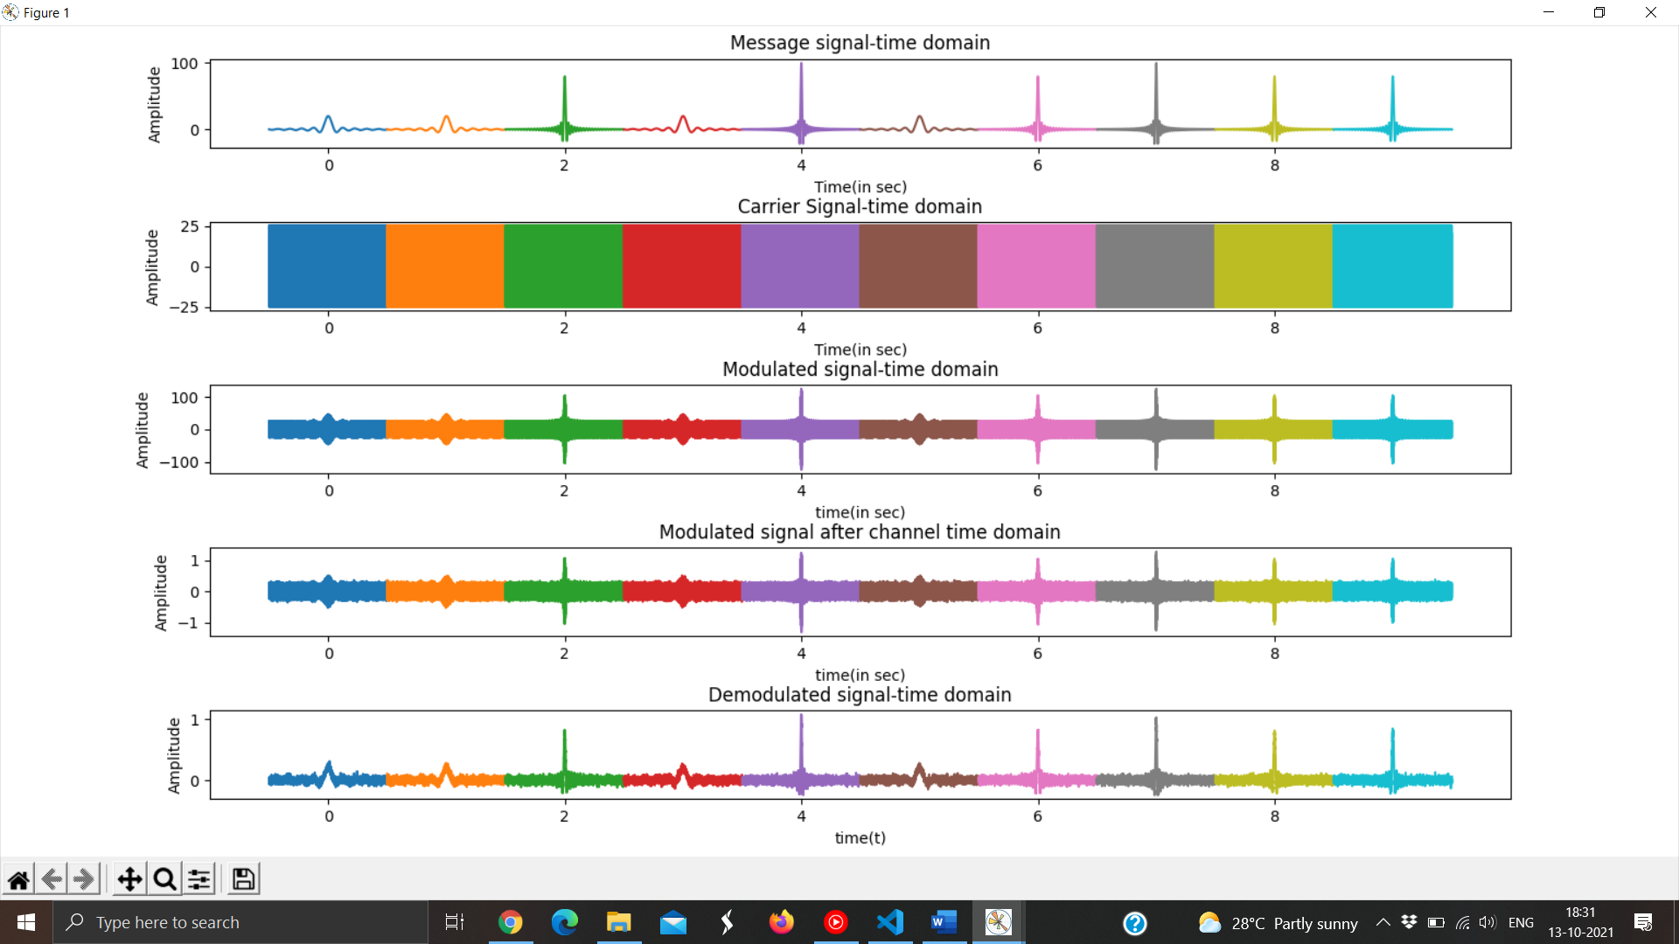

**Conclusion:** We can see that sinc pulses transmitted with carrier signal is received and demodulated at the receiver. Noise was also added to the message signal over the channel making it a little distorted. In the frequency domain we can also see that we have transmitted and received rectangular pulses (fourier transforms of sinc pulses) with noise through the channel.