UV Analysis

Carl Demolder 1/16/18

Date: 1/12/18

Time Start: 10:38 AM

Time Stop: 11:08 AM

Introduction:

This analysis was conducted to determine the difference between the UV data collected by a high-end UV dosimeter and a personal UV dosimeter placed on a flexible substrate which will be worn on the skip. Multiple graphs will be displayed showing UV Power Density vs. Time and UV Index vs. Time. These two graphs will be used to compare the performance and accuracy of our device vs the status quo (expensive, high-end UV dosimeter).

High End Dosimeter:

Hudflur #1 (Flexible Substrate UV Dosimeter)

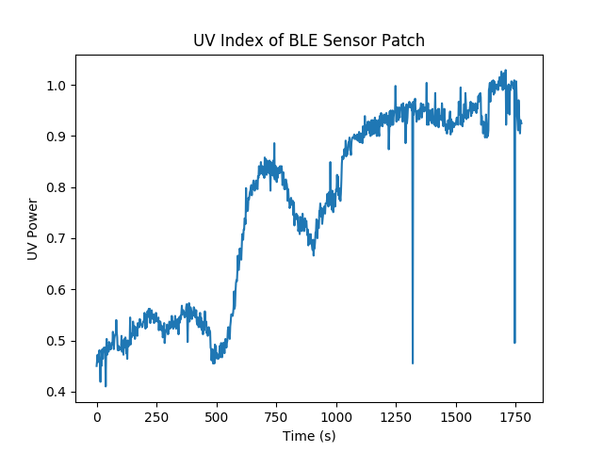

Analysis:

In order to do proper analysis, the time series for both devices should be the same. If they are the same, it will allow me to calculate R2, deviance, standard deviation, etc… We will repeat this experiment using the same time interval as well as a longer time period, than just half an hour.

Visually, we can see that the both sensors follow the same overall trend, however the flexible electronics patch is 0.5 – 1 UVI larger than the instrumental UV dosimeter.

Some problems I noticed is that the units Dr. Vanos provided me, are not correct… I could be wrong, but if I followed the data and units correctly, the UVI graph would like the following:

The UVI index is less than 0.05 continuously when it was quite sunny that day. So, I concluded that the units of the data recorded must be off. We need to clarify for future steps.

Future Step:

-Clear up Status Quo Data Measurements and Units

-Dark Noise both sensors to clear up offset. So, we need to place both sensors in black box and see the what the noise floor is on these sensors.

- Repeat experiment with the same time interval. Every 10s, every 2s… etc

-Be more careful of getting infront of sensor etc.

-Perform Statistical Analysis on the difference between both sensors…