THERAPY SESSION GUIDE

Document Overview
This document provides a structured, phase-by-phase guide for the therapy sessions built into the application. It is intended for product managers, developers, SLPs (Speech-Language Pathologists), caregivers, and any stakeholder who needs a clear understanding of how the therapy flow works inside the product.

The therapy programme is divided into twelve progressive phases:
- Phase 1 - Joint Attention Activities
- Phase 2 - Imitation Training
- Phase 3 - Oral Motor Exercises
- Phase 4 - PECS Phase 1: How to Communicate (Physical Picture Exchange)
- Phase 5 - PECS Phase 2: Distance and Persistence
- Phase 6 - PECS Phase 3: Picture Discrimination
- Phase 7 - PECS Phase 4: Sentence Structure
- Phase 8 - PECS Phase 5: Responsive Requesting (Answering Questions)
- Phase 9 - PECS Phase 6: Commenting
- Phase 10 - Turn-Taking and Social Interaction Games
- Phase 11 - Functional Communication in Daily Routines
- Phase 12 - Vocal Approximation and Sound Shaping (Emerging Speech)

Each phase contains multiple sessions. The Reinforcement Loop (RL) — the in-app guide — drives every session by prompting caregivers’ step by step, tracking performance in real time, and deciding whether the child advances, repeats, or moves to a simplified version.

Global Scoring & Progression Rules
Pass Mark | 75% across 3 consecutive sessions
Advance Condition | Child meets or exceeds pass mark across all sessions in a phase
Repeat Condition | Child does not meet pass mark — RL prompts caregiver to retake, starting from the lowest-scoring session up to the highest
Simplify Condition | Child still does not meet pass mark after retaking — RL activates the Simplified Session
Scoring Basis | % of opportunities with spontaneous gaze shift (object → person) + number of child-initiated joint attention moments
Prompt Hierarchy | Start high (gentle physical tap / hand-over-hand) → fade to verbal ('Look!') → natural waiting

Age-Bracket Transition Rule
Age groups within a phase (e.g., Ages 3–7 / 8–12 / 10–14) select which activity variant is presented — they are not a hard cutoff. A child moves to the next age-group variant only when performance shows the current framing has become too young for them, not on a birthday. No single signal can trigger this on its own, because each one can mislead in isolation: a high average score can be inflated by heavy prompting, prompt-independence is noisy session-to-session, and a low retake count only shows the pacing feels easy. A transition fires only when all three signals agree over the same evaluation window.
Evaluation Window | The child's last 3 completed sessions in the current age-group variant — matching the pass-mark window above so both progression mechanisms run on the same rhythm.
Gate 1 — Average Score | Mean score_percent across the window is ≥ 85% — a clear step above the 75% pass mark, since a bracket transition is a stronger claim than "passed the phase." Provisional threshold pending SLP sign-off.
Gate 2 — Stable Independence | The share of trials scored at the top, unprompted tier is ≥ 70% in EVERY session in the window, not on average. Requiring this in each session — rather than as a mean — is what filters out a single lucky session and confirms the independence is consistent rather than noisy. Provisional threshold pending SLP sign-off.
Gate 3 — No Retakes | Zero Repeat Condition retakes were triggered across the window. Needing a retake is direct evidence the pacing was not trivially easy, so for an upward move the honest threshold is zero.
Firing Rule | The transition fires only when Gates 1, 2, and 3 all pass on the same window. Any single gate failing holds the child at the current age-group variant.
Cooldown & Step Size | After a transition fires, re-evaluation is suppressed for the next 3 sessions so the child acclimates to the new variant before the rule can trigger again. Each firing moves the child up exactly one age-group variant — never more than one at a time.
Threshold Validation Trigger | These are launch defaults, not clinically validated numbers. Instrument every child's gate outcomes from day one: log every session where 2 of 3 gates pass but the third does not, and every session where all 3 pass. If, after the first 50 children reach a 3-session evaluation window, none of them ever clear all three gates together, the thresholds are too strict and must be revisited before formal SLP sign-off, since a rule that never fires is equivalent to having no upward transition mechanism at all.
Chronological Age Floor (Promotion Cap) | The age group assigned at onboarding (based on the child's chronological age) is the starting point for this rule, not something it changes. Each age-group variant pair (3–7 → 8–12, and 8–12 → 10–14) has its own minimum chronological age before the RL is permitted to offer it, regardless of how well Gates 1–3 are met. Performance can move a child up early within that limit, but cannot promote a child past it — this protects against a fast performer skill-wise being shifted into content built around an older child's interests before they are chronologically ready for it. If a child clears Gates 1–3 while still below the floor for the next variant, the RL holds them at the current variant and flags to the caregiver that the child is performance-ready and waiting only on the age floor. Default floor: the next variant's nominal starting age, minus 1 year — so 3–7 → 8–12 floors at age 7, and 8–12 → 10–14 floors at age 9. A 1-year window is a deliberately conservative default: it lets performance save a child at most one year of waiting, never more, which is far easier to defend to an SLP and far lower-risk than starting permissive and having to tighten it after a child is already years ahead of age-appropriate framing. This default is explicitly flagged for an SLP to widen if they judge it overly cautious for a given variant pair, rather than something to guess wider on our own.

Downward Transition Signal (Advisory Only)
This rule, as defined above, only ever moves a child up. A downward move is a heavier, more conservative decision than an upward one: it risks feeling like a demotion to a caregiver in a way promotion never does, and a score dip can mean 'this skill is genuinely hard right now' just as easily as 'this age-framing is wrong' — those need different responses, so a downward rule should not simply mirror the upward one.
- Trigger: not phase-wide, and not on the same 3-session window as the upward gates. It fires only on a persistent, activity-specific drop — score_percent on one specific activity stays clearly below the child's own established baseline for that activity across 5–6 sessions.
- Action: never moves the age-group variant automatically. It surfaces an advisory note to the caregiver — 'this activity may not be landing at the current framing; consider the previous variant for this activity only' — and the caregiver decides, exactly as with the upward transition.
- Scope: per-activity, not per-phase or global. A mismatch is more likely to be one specific reference or example not landing than the entire bracket being wrong for the child, so the signal should stay as narrow as the evidence actually supports.
Open items pending SLP input: (1) the 85% / 70% / zero-retake thresholds are launch defaults with an explicit validation trigger defined above (see Threshold Validation Trigger), not yet clinically confirmed; (2) the chronological age floor now has a concrete default (next variant's starting age minus 1 year: age 7 and age 9 respectively), flagged for an SLP to widen if judged overly conservative; (3) resolved — a downward signal exists as a narrow, advisory-only, per-activity flag (see above), deliberately not a mirror of the upward rule.

The Reinforcement Loop (RL) — How It Works
The RL is the in-app engine that orchestrates every session. It performs the following functions:
- Displays preparation checklists and Velcro card sequences before each session begins.
- Starts countdown timers (15-second intervals) once the caregiver confirms the child is engaged.
- Prompts the caregiver at each task step with a clear yes/no confirmation question.
- Records and scores each opportunity in real time.
- Displays a session summary at the end of the session.
- Offers the caregiver the option to retake the session or advance to the next one.

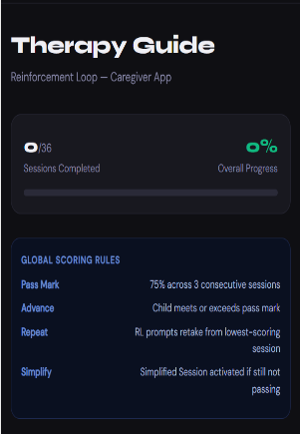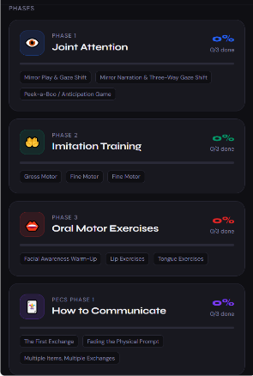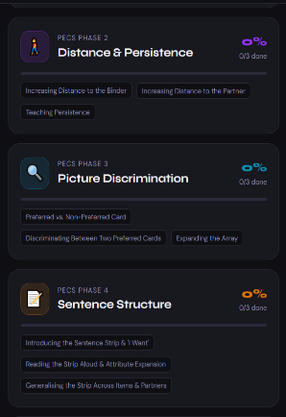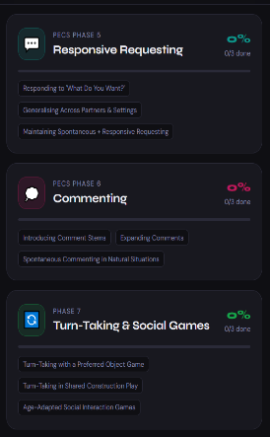
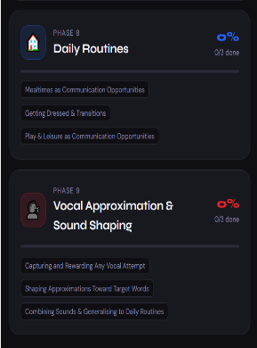
PHASE 1 — JOINT ATTENTION ACTIVITIES

Phase Overview
Joint attention is the ability to share focus on an object or event with another person. This phase trains the child to shift their gaze between a preferred object and the caregiver's face — a foundational skill for all communication and social learning.

Progress Indicators — What the Caregiver Should Look For
• Child shifts gaze between toy and caregiver's face at least 4–5 times per 10-minute play period.
• Child begins to initiate joint attention independently (shows you something or points).
• Child stays engaged in shared play for 8–10 minutes without leaving the activity.

Once these are solid (typically after 4–8 weeks depending on the child), the can programme proceeds to Phase 2: Imitation Training.

Scoring Criteria — Phase 1
Spontaneous Gaze Shift | Child looks on their own — 100% credit
Prompted Gaze Shift | Child looks only after 'Look' cue or physical tap — 50% credit; indicates prompt fading is needed
Missed Opportunity | Child stays focused on the toy — 0% credit

Session 1 — Mirror Play & Gaze Shift (10 Minutes)

Purpose
Introduce gaze shifting through imitation of the child's own play, using a mirror so the child can see both faces simultaneously.

Preparation
Prep 1 — Preferred Items | Pull out 4–6 of the child's highest-preference items (bubbles, spinning toys, favourite character figures, snacks, light-up toys, etc.).
Prep 2 — Mirror | Prepare a small, unbreakable hand mirror or a standing child-safe mirror on the floor or table. The mirror lets the child see both their own face and the caregiver at the same time.

Activity Steps
- Set the preferred items in front of the child. Sit at the child's eye level, facing them, and watch what they do.
- Imitate exactly what the child is doing — same toy, same speed, same order (e.g., if they are stacking blocks, stack the exact same way).
- Every 10–15 seconds, pause and hold the toy up near your face. Wait up to 10 seconds for the child to look at you or shift gaze between the toy and your eyes.
- When the child looks, give big, natural reinforcement: a wide smile, an excited voice ('Wow! You looked!'), then immediately continue the play.

RL Behaviour — Session 1
- After Task 1: RL asks the caregiver to confirm whether the child is playing with an item.
- On 'Yes': RL starts a 15-second countdown, then prompts the caregiver to proceed to Task 2.
- At every 15-second interval: RL asks 'Did the child look at your eyes/face?' with the three options below.
- If the child looked: RL prompts caregiver to give reward and continue play (Task 4).
- On ‘No’: RL prompts caregiver to try again, from task 2.
- After 10 minutes: RL displays 'End of Session', shows session results, and offers Retake or Advance.

RL Question Asked at Every 15-Second Interval
"Pause play. Did the child look at your eyes/face?"

• Yes, completely on their own! → Spontaneous Gaze Shift — 100% credit
• Yes, but I had to say 'Look' or tap them. → Prompted Gaze Shift — 50% credit (prompt fading needed)
• No, they stayed focused on the toy. → Missed Opportunity — 0% credit

Session 2 — Mirror Narration & Three-Way Gaze Shift (10 Minutes)

Purpose
Extend the child's gaze shift to a three-way pattern: toy → mirror → caregiver's eyes, using verbal narration to make the shared attention moment explicit.

Preparation
Prep 1 — Preferred Items | Pull out 4–6 of the child's highest-preference items.
Prep 2 — Mirror | Prepare a child-safe mirror (hand mirror or standing mirror on floor/table).

Activity Steps
- Set preferred items in front of the child. Sit at the child's eye level, facing them.
- Imitate exactly what the child is doing — same toy, same speed, same order.
- Every 15 seconds, pause, look at the mirror, and say: 'Look — our eyes are both looking at the toy!' Wait up to 10 seconds for the child to look at you or shift gaze between the toy, the mirror, and your eyes.
- When the child looks, give big, natural reinforcement ('Wow! You looked!') and immediately continue the play.

RL Behaviour — Session 2
- After Task 1: RL confirms whether the child is playing with an item.
- On 'Yes': RL starts a 15-second countdown, then prompts Task 2.
- At every 15-second interval: RL asks whether the child looked at the caregiver or shifted gaze between the toy, mirror, and caregiver's eyes.
- On ‘No’: RL prompts caregiver to try again, from task 2
- If the child looked: RL prompts caregiver to reward and continue play.
- After 10 minutes: RL displays 'End of Session', shows results, and offers Retake or Advance.

Simplified Session — Velcro Card Visual Schedule

When Activated
The Simplified Session is activated by the RL when the child has not met the 75% pass mark after retaking the relevant sessions. It uses a three-card visual sequence to reduce the child's anxiety and make the structure of joint attention predictable and game-like.

RL Display — Three Velcro Cards
Card 1 — Look | Picture of two eyes / a child looking at an adult (eye-contact icon)
Card 2 — Play | Picture of the specific toy being used (e.g., photo of bubbles or a toy car)
Card 3 — Look | Same eye-contact icon as Card 1

Activity Steps
- Point to each card and say: 'First look… then play… then look again.'
- After each step, tap on the card.
- Repeat this until the child taps a card by himself or looks at you to prompt the tapping or move to the next card.

RL Behaviour — Simplified Session
- When the caregiver taps a card, the RL moves that card to a 'Done' pocket or flips it over so the child can see their progress.
- After every 4 minutes: RL asks whether the child made eye contact or tried to tap the card.
- After 10 minutes: RL displays 'End of Session', shows results, and offers Retake or Advance
This predictability reduces anxiety and helps the child understand that joint attention is a natural part of the game, not a demand placed upon them.

Session 3 — Age-Adapted Joint Attention Games (10 Minutes)

Purpose
Build anticipation and joint attention through age-appropriate, high-motivation game formats. The RL selects or rotates the appropriate activity variant based on the child's age group.

Session 3 — Age Group 1: Ages 3–7 | Peek-a-Boo / Anticipation Game

Activity Steps
- Hide a highly preferred toy behind the caregiver's back or under a cloth.
- Say 'Where's the toy?' with exaggerated anticipation.
- Wait for the child to make eye contact before revealing it with 'There it is!' and big excitement.
- Repeat 8–12 times in a row to create a clear, predictable routine that feels like a game

RL Behaviour — Ages 3–7
- After Task 2: RL asks whether the child made eye contact.
- On 'Yes': RL prompts caregiver to reward and repeat.
- On ‘No’: RL prompts caregiver to try again, from task 2
- After 10 minutes: RL displays 'End of Session', shows results, and offers Retake or Advance.

Session 3 — Age Group 2: Ages 8–12 | Favourite Character Figure

Preparation
Prep 1 — Character Figure | Observe the child's current obsession (e.g., Spider-Man, Sonic, Pokémon, Fortnite character). Bring a small action figure or printed picture of that character.
Prep 2 — Mirror | Prepare a child-safe mirror.
Prep 3 — Positioning | Set preferred items in front of the child. Sit side-by-side (on the floor or at a table) so both are looking at the same thing.

Activity Steps
- Hold the character figure up near your face so your eyes and the figure are close together.
- Say slowly and excitedly: 'Ready… set… GO!' while pointing back and forth between the character's face and your own eyes.
- Make the character do something the child loves (e.g., Spider-Man shoots a web, Sonic runs, character does a cool dance).
- Pause and wait 5–10 seconds for the child to look at you or shift gaze between the figure and your eyes.
- The moment they look, give big, natural reinforcement: 'You looked! Spider-Man is happy you looked!' and let the character do another fun action.
- Repeat 8–12 times in a row to create a clear, predictable routine that feels like a game.

RL Behaviour — Ages 8–12 (Character Figure)
- After Task 3: RL asks whether the child looked at the caregiver or shifted gaze between the character and their eyes.
- On 'Yes': RL prompts caregiver to reward and repeat (Task 6).
- On ‘No’: RL prompts caregiver to try again, from task 1
- After 10 minutes: RL displays 'End of Session', shows results, and offers Retake or Advance.

Session 3 — Age Group 3: Ages 10–14 | Tablet Video

Preparation
Prep 1 — Video Clip | Have the child's favourite 10–15 second video clip ready (YouTube short, Minecraft gameplay, Pokémon battle, sports highlight). Mute sound if needed so the caregiver controls the audio.
Prep 2 — Mirror | Prepare a child-safe mirror.
Prep 3 — Positioning | Set preferred items in front of the child. Sit side-by-side so both can see the tablet screen easily.

Activity Steps
- Hold the tablet between you and the child so both can see the screen.
- Pause the video at an exciting moment. Say 'Ready… set… GO!' while pointing back and forth between the screen and your own eyes.
- Press “play” for 3–5 seconds of the clip. Pause again and wait for the child to look at you.
- When they make eye contact or shift gaze, immediately say 'You looked!' and play the next exciting part.
- Repeat the 'Ready… set… GO!' cue every time.

RL Behaviour — Ages 10–14 (Tablet Video)
- After Task 4: RL asks whether the child looked at the caregiver or shifted gaze between the screen and their eyes.
- On 'Yes': RL prompts caregiver to reward and repeat (Task 5).
- On ‘No’: RL prompts caregiver to try again, from task 2
- After 10 minutes: RL displays 'End of Session', shows results, and offers Retake or Advance.

Session 3 — All Ages | Song / Music Routine

Preparation
Prep 1 — Song | Have the child's favourite song ready (sing or play on a device). For younger children: 'Wheels on the Bus', 'If You're Happy and You Know It'. For older children: more complex songs or short video clips where they take turns pressing play/pause.
Prep 2 — Mirror | Prepare a child-safe mirror.
Prep 3 — Positioning | Sit side-by-side (on the floor or at a table) so both are looking at the same thing.

Activity Steps
- Sing or play each verse with big gestures.
- Pause after each verse and wait for the child to look at you before continuing.
- When they make eye contact or shift gaze, immediately say 'You looked!' and continue with the next verse.
- Repeat the 'Ready… set… GO!' cue every time.

RL Behaviour — All Ages (Song)
- After Task 3: RL asks whether the child looked at the caregiver or shifted gaze.
- On 'Yes': RL prompts caregiver to reward and repeat (Task 4).
- On ‘No’: RL prompts caregiver to try again, from task 1
- After 10 minutes: RL displays 'End of Session', shows results, and offers Retake or Advance.

Important Therapy Tips — Phase 1
• Keep sessions playful and pressure-free — never force eye contact.
• Track data consistently: % of trials with spontaneous gaze shift (target: 70%+ before advancing).
• Fade the 'Ready… set… GO!' cue over time so the child begins anticipating on their own.
• Always end with the child feeling successful and in control.

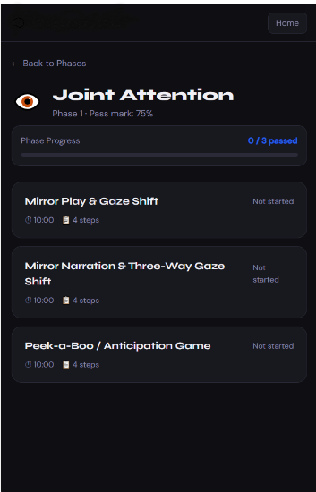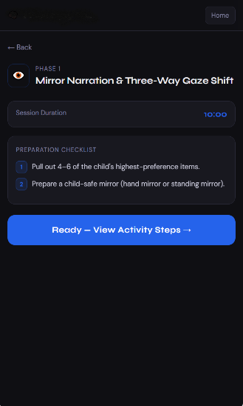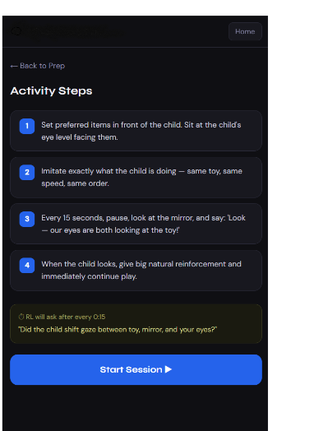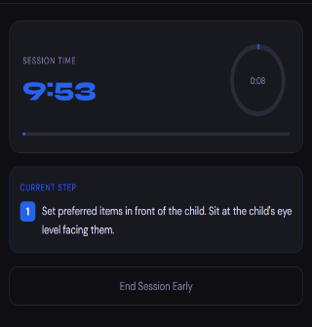
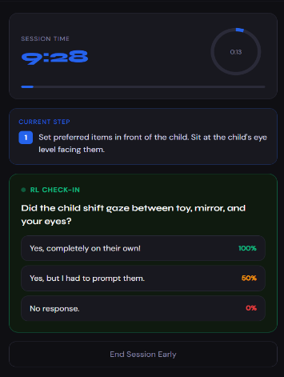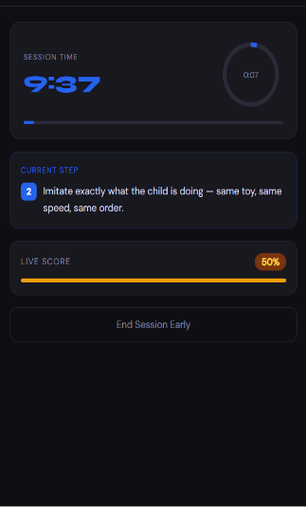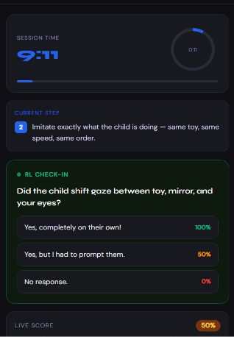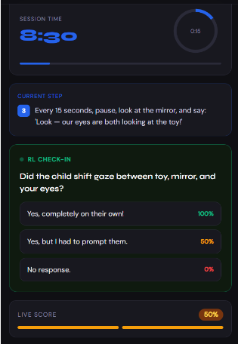

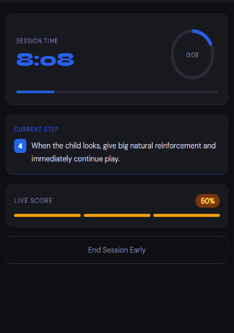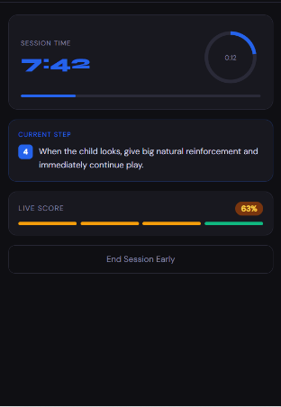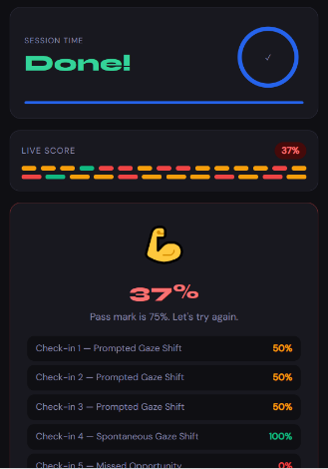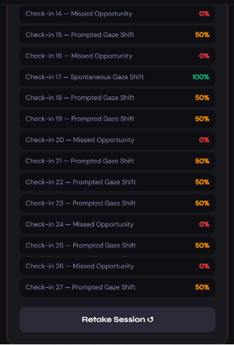
PHASE 2 — IMITATION TRAINING

Phase Overview
Imitation teaches the child how to learn from others. Copying actions and sounds builds motor planning, sustained attention, and the foundation for language acquisition. Phase 2 is divided into three skill areas:
- Gross Motor Imitation — whole-body, large movements
- Fine Motor Imitation — smaller, hand and finger movements
- Vocal Imitation — sound and speech approximations (leads into Phase 3)

Scoring Criteria — Phase 2
Spontaneous Imitation | Child copies the modelled action independently, without any physical guidance — 100% credit
Prompted Imitation | Child copies the action only after hand-over-hand guidance or a physical prompt — 25% credit; indicates prompt fading is needed
No Response | Child does not attempt to copy the action — 0% credit

Gross Motor — Session 1: Watch Me → Copy Me → Get Reward (10 Minutes)

Purpose
Establish the core imitation routine using whole-body actions and highly preferred toys as immediate reinforcement.

Preparation
Prep 1 — Preferred Items | Pull out 4–5 highly preferred items (bubbles, toy car, favourite character, snack) for use as immediate reinforcement.
Prep 2 — Mirror | Prepare a child-safe mirror (hand mirror or standing mirror on floor/table).

RL Display — Three Velcro Cards
Card 1 | Watch Me — picture of eyes / child looking at adult
Card 2 | Copy Me — picture of child mirroring an adult
Card 3 | Get Reward — reward icon

Activity Steps
- Set preferred items in front of the child. Sit at the child's eye level, facing them.
- Model big, fun whole-body actions using the child's favourite toy. Examples: clap hands, jump up and down, wave arms like a superhero.
- Say clearly: 'Watch me… ready… set… GO!' then perform the action.
- Start with a 0-second delay — caregiver and child do the action simultaneously.
- Once the child copies easily, introduce a 1–2 second pause so the child imitates after the caregiver finishes.
- Repeat the 'Ready… set… GO!' cue every time

For older children (ages 8–14): Use interest-based actions (e.g., 'Do the Spider-Man web shooter move' or 'Copy the Fortnite dance').

RL Behaviour — Gross Motor Session 1
- After Task 3: RL confirms whether the child copies the caregiver.
- On 'Yes': RL prompts the caregiver to perform the next action.
- After Task 4: RL confirms whether the child imitated.
- On 'Yes — independently': RL records Spontaneous Imitation (100% credit) and prompts the caregiver to continue with the next action.
- On 'Yes — with hand-over-hand help': RL records Prompted Imitation (partial credit) and prompts the caregiver to continue with the next action, fading the physical help next time.
- On 'No response': RL records No Response (0% credit) and prompts caregiver to try again, from task 2.

Fine Motor — Session 1: Pointing to a Preferred Toy (10 Minutes)

Preparation
Prep 1 — Items on Table | Place the child's favourite toy and another toy on the table. Have highly preferred items ready as immediate reinforcement.

Activity Steps
- Set items on the table. Sit at the child's eye level, facing them.
- Point clearly to the most preferred toy (the favourite) and say: 'Watch me…'
- When the child looks at you, say: 'Ready… set… GO!' and point again dramatically.
- Pause and wait. The goal is for the child to copy by pointing to the toy. Even reaching toward it counts.
- Once they point or reach, immediately say: 'YES! You pointed! Great job!' and hand them the favourite toy instantly. The reward must happen immediately.
- Repeat the 'Ready… set… GO!' cue every time

RL Behaviour — Fine Motor Session 1
- After Task 2: RL confirms whether the child looked at the caregiver.
- On 'Yes': RL prompts the next action.
- After Task 5: RL confirms whether the child pointed or reached.
- On 'Yes — independently': RL records Spontaneous Imitation (100% credit) and prompts caregiver to reward the child immediately.
- On 'Yes — with hand-over-hand help': RL records Prompted Imitation (partial credit) and prompts caregiver to reward the child immediately, then begin fading the physical help.
- On 'No response': RL records No Response (0% credit) and prompts caregiver to try again, from task 2.
Fine Motor — Session 2: Waving (10 Minutes)

Preparation
Prep 1 — Favourite Toy | Hold a favourite toy (or snack) behind your back to use as a surprise reward.

Activity Steps
- Hold the favourite toy behind your back.
- Wave and say 'Bye bye!' or 'Hi!' while smiling and exaggerating the movement.
- Say 'Your turn' and wait. The child is to copy the waving motion — even a small hand movement counts.
- Once they wave, immediately say 'YES! You waved! Great job!' Reveal and hand them the toy or blow bubbles.

RL Behaviour — Fine Motor Session 2
- After Task 3: RL confirms whether the child waved or made a movement.
- On 'Yes — independently': RL records Spontaneous Imitation (100% credit) and prompts caregiver to reward the child.
- On 'Yes — with hand-over-hand help': RL records Prompted Imitation (partial credit) and prompts caregiver to reward the child, then begin fading the physical help.
- On 'No response': RL records No Response (0% credit) and prompts caregiver to try again, from task 2.

Fine Motor — Session 3: Touching Nose (10 Minutes)

Preparation
Prep 1 — Preferred Items | Place highly preferred items in front of the child (bubbles, toy car, favourite character, snack) as immediate reinforcement.

Activity Steps
- Tap your nose and say: 'Watch me…'
- Say 'Touch nose!' — exaggerate it ('tap tap tap') — then wait for the child to imitate.
- Once the child touches their nose, immediately say: 'You touched your nose!' then hand them the favourite toy, a snack, or blow bubbles.

RL Behaviour — Fine Motor Session 3
- After Task 3: RL confirms whether the child touched their nose.
- On 'Yes — independently': RL records Spontaneous Imitation (100% credit) and prompts caregiver to reward the child.
- On 'Yes — with hand-over-hand help': RL records Prompted Imitation (partial credit) and prompts caregiver to reward the child, then begin fading the physical help.
- On 'No response': RL records No Response (0% credit) and prompts caregiver to try again, from task 1.

Fine Motor — Session 4: Block Stacking (10 Minutes)

Preparation
Prep 1 — Lego Blocks | Place Lego blocks (for block stacking) in front of the child.

Activity Steps
- Sit at the child's eye level, facing them.
- Stack a red block, then a blue block.
- Say 'Your turn!' and hand the child the blocks.
- When the child copies the same stacking order, give big reinforcement: wide smile, excited voice ('You did exactly what I did!'), and continue the play immediately.
- Follow up with the crash game: 'READY… SET… CRASH!' — children find this highly motivating.

RL Behaviour — Fine Motor Session 3
- After Task 3: RL confirms whether the child made an attempt (picked up a block or tried to stack).
- On 'Yes — independently': RL records Spontaneous Imitation (100% credit) and prompts caregiver to reward the child.
- On 'Yes — with hand-over-hand help': RL records Prompted Imitation (partial credit) and prompts caregiver to reward the child, then begin fading the physical help.
- On 'No response': RL records No Response (0% credit) and prompts caregiver to try again, from task 2.

Fine Motor — Session 5: Age-Adapted Imitation Games (10 Minutes)

Session 5 — Ages 8–14 | Superhero Pose & Dance Move

Activity Steps
- Sit at the child's eye level.
- Strike a superhero pose.
- Say 'Your turn!' and wait for the child to copy.
- When the child copies, give big reinforcement: 'You did exactly what I did!'
- Next, do a dance move.
- Say 'Your turn!' again and wait for the child to copy the dance move.
- When the child copies, give big reinforcement and continue the play.

RL Behaviour — Fine Motor Session 3
- After Task 3: RL confirms whether the child made an attempt.
- On 'Yes — independently': RL records Spontaneous Imitation (100% credit) and prompts caregiver to reward the child.
- On 'Yes — with hand-over-hand help': RL records Prompted Imitation (partial credit) and prompts caregiver to reward the child, then begin fading the physical help.
- On 'No response': RL records No Response (0% credit) and prompts caregiver to try again, from task 2.

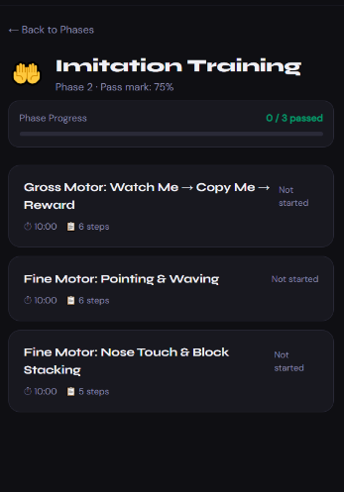`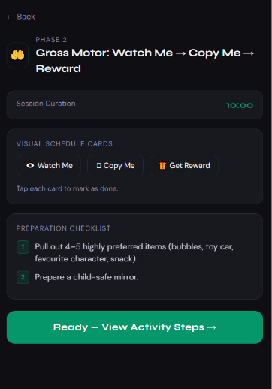 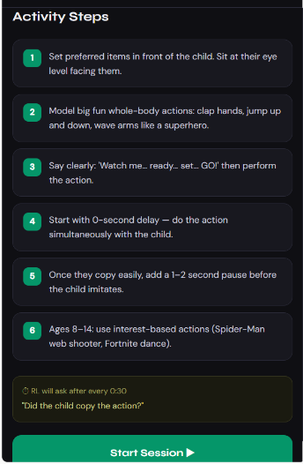

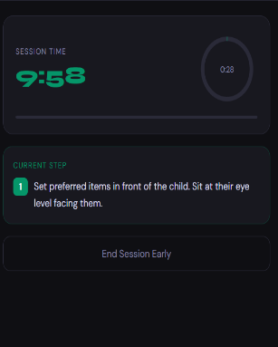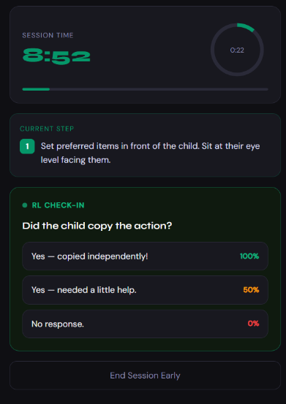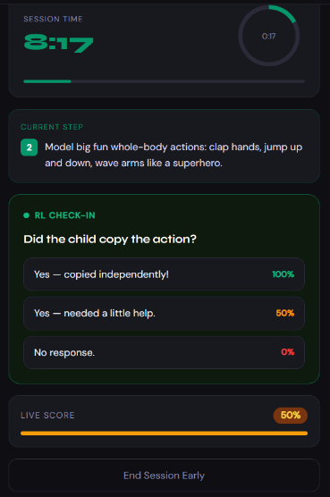

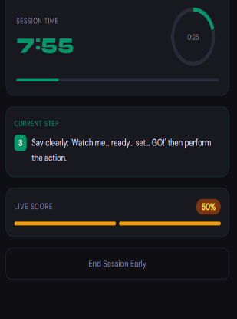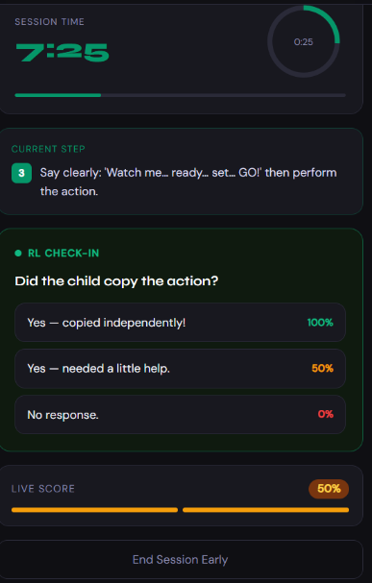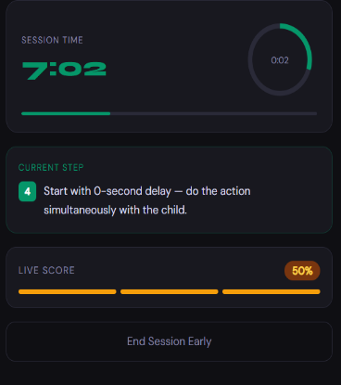
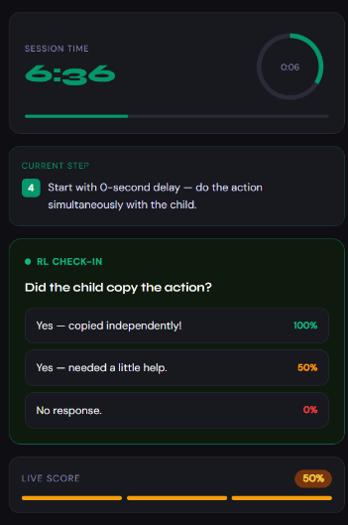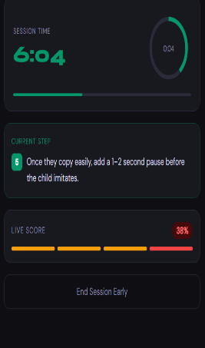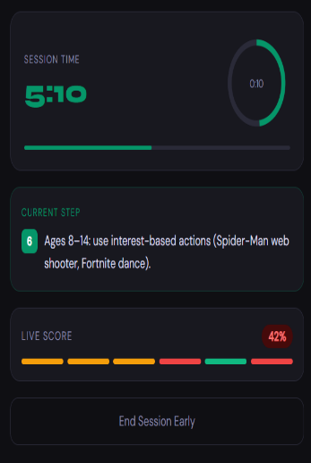

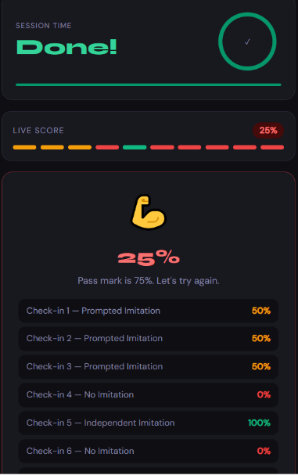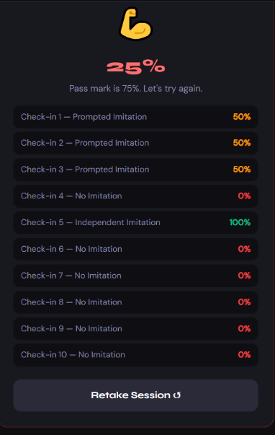
Simplified Session — Mirror-Me Single Action

When Activated
The Simplified Session is activated by the RL when the child has not met the 75% pass mark after retaking the Gross Motor or Fine Motor sessions. It reduces imitation to a single, very large action modelled with zero delay, and builds hand-over-hand guidance into every repetition from the start rather than fading it in over time.

Simplified Supports
Support 1 — Two-Card Sequence | Only 'Watch Me' and 'Copy Me' are used — the separate 'Get Reward' card is removed because the reward is now automatic and immediate every time.
Support 2 — Continuous Guidance | Hand-over-hand support is used from the very first repetition rather than being introduced only after an independent attempt does not happen.

Activity Steps
- Sit face-to-face at the child's eye level with one favourite toy in view — only one action option is offered at a time.
- Model one large, exaggerated whole-body action (e.g., clap hands overhead) while saying 'Watch me… copy me!'
- Immediately guide the child's hands through the same action using hand-over-hand support — do not wait for an independent attempt first.
- The instant the movement is completed, with or without help, celebrate warmly and give the toy or a few seconds of play right away.
- Repeat the same single action 8–10 times before introducing a second action, so the child experiences many quick, guaranteed successes.

RL Behaviour — Simplified Session
- RL displays only two cards: Watch Me / Copy Me.
- After each modelled action: RL asks whether hand-over-hand guidance was used to complete the movement.
- On any completed movement, guided or independent: RL records success and prompts the caregiver to reward immediately.
- RL does not separate independent from prompted attempts in this simplified mode — every completed repetition counts toward building the imitation habit.
- After 10 minutes: RL displays 'End of Session', shows the number of completed repetitions, and offers Retake or Advance.
Removing the waiting period between modelling and prompting lets the child experience imitation as an immediate, guaranteed success before the standard 1–2 second delay is reintroduced.

PHASE 3 — ORAL MOTOR EXERCISES

Phase Overview
Phase 3 targets awareness, coordination, and control of the lips, tongue, jaw, cheeks, and breath support — all essential for speech production and feeding. It is especially useful for children who show:
- Very limited vocal attempts
- Drooling or low oral muscle tone
- Difficulty chewing or swallowing
- Open-mouth posture or weak lip closure
- Suspected motor speech difficulties (e.g., childhood apraxia features)
- Difficulty copying mouth movements

The goal of Phase 3 is: better control → easier sound production → stronger communication attempts.

What the RL Records in Phase 3
- Which mouth movements the child can perform independently vs. with prompting
- Breath control quality
- Lip closure ability
- Tongue movement range
- Any sound attempts made during the session

Scoring Criteria — Phase 3
Spontaneous Imitation | Child imitates the mouth or tongue movement, or attempts the sound, independently and without any physical guidance — 100% credit
Prompted Imitation | Child imitates only after a physical prompt (e.g., a guided touch cue) or repeated modelling beyond the first cue — 25% credit; indicates prompt fading is needed
No Response | Child makes no attempt at the movement or sound — 0% credit

Session 1 — Facial Awareness Warm-Up (10 Minutes)

Purpose
Help the child become aware of their own face and begin noticing mouth movements — the foundation for all oral motor exercises that follow.

Preparation
Prep 1 — Preferred Items | Pull out 4–5 highly preferred items as immediate reinforcement.
Prep 2 — Mirror | Prepare a child-safe mirror. The mirror lets the child see their own mouth and the caregiver's mouth simultaneously.

RL Display — Three Velcro Cards
Card 1 | Watch Me — eye-contact icon
Card 2 | Mouth Move — mouth icon
Card 3 | Play — picture of a child playing

Activity Steps
- Set preferred items in front of the child. Sit at the child's eye level.
- Using the mirror, say: 'Look at my mouth.'
- Once the child is looking at you: smile big and say 'Look! Happy face!' Tap your cheeks and exaggerate a big smile, open mouth, and big puffed cheeks.

RL Behaviour — Session 1
- After Task 2: RL confirms whether the child looked at the caregiver.
- On 'Yes': RL prompts the caregiver to perform Task 3.
- After Task 3: RL confirms whether the child imitated the facial expression.
- On 'Yes — independently': RL records Spontaneous Imitation (100% credit) and prompts caregiver to reward the child.
- On 'Yes — with hand-over-hand help': RL records Prompted Imitation (partial credit) and prompts caregiver to reward the child, then begin fading the physical help.
- On 'No response': RL records No Response (0% credit) and prompts caregiver to try again, from task 2.

Session 2 — Lip Exercises: /m/ /p/ /b/ Sounds (45 Minutes)

Purpose
Strengthen lip closure and breath control while introducing the child to the sounds /m/, /p/, and /b/ through a playful, game-based format.

Sound Reference — What Each Sound Requires
/m/ | Lips together + voice on (humming sound)
/p/ | Lips together + air burst (no voice)
/b/ | Lips together + voice on (air burst)

Activity 1 — Bubble Blowing
- Set the preferred item (bubbles) in front of the child. Sit at the child's eye level.
- Say 'Ready… blow!' and model blowing bubbles.
- Blow a bubble while the child watches, then help the child blow a bubble.
- Set a tissue near or on your lips.
- Model 'puh!' and show the tissue moving from your lip. Child then tries.

RL Behaviour — Activity 1
- After Task 2: RL confirms whether the child looked at the caregiver.
- On 'Yes': RL prompts the caregiver to perform Task 3.
- After Task 3: RL confirms whether the child imitated.
- On 'Yes — independently': RL records Spontaneous Imitation (100% credit) and prompts caregiver to reward the child.
- On 'Yes — with hand-over-hand help': RL records Prompted Imitation (partial credit) and prompts caregiver to reward the child, then begin fading the physical help.
- On 'No response': RL records No Response (0% credit) and prompts caregiver to try again, from task 2.

Preparation for the /m/ /p/ /b/ Game
Mirror | Prepare a child-safe mirror — lets the child see their tongue and mouth movements alongside the caregiver's.
Video Clips | Record short 5-second clips on your phone so the child can hear themselves. Caregiver records first, then records the child — play both back-to-back so the child can compare and self-correct.
Mystery Box | Have a mystery box containing a snack and a bubble wand inside.

Activity 2 — /m/ /p/ /b/ Game
Stage 1 — In-App Display: The app shows a visual representation of how to pronounce each sound.

- Model in the mirror: 'Watch my tongue… now watch yours.' Fade cues gradually so the child begins catching their own errors.
- Start with /m/. With a big facial expression, model 'Mmmm… More' while holding a snack for the child.
- Pause and wait for the child to imitate (even a small 'hmmm' counts).
- Once the child imitates, give a tiny bite immediately.
- Next, /p/. Reach into the mystery box and pull out the bubble wand with excitement. Say 'Pppp… Pop' while popping a bubble.
- Pause and wait for the child to attempt (even a small 'p' counts). On success: blow more bubbles.
- Finally, /b/. Point at the bubble and say 'Bbbb… Bubble' while blowing. Pause and wait. On success: blow more bubbles.

RL Behaviour — Activity 2
- The RL displays a ‘start’ and ‘stop’ button, once the caregiver clicks on the ‘start’ button the RL starts the timer and Activity 2 begins.
- The caregiver clicks on the ‘stop’ button to notify the RL that the first round of Activity 2 has been completed.
- RL confirms whether the child imitated after task 2, task 5 and task 7.
- On 'Yes — independently': RL records Spontaneous Imitation (100% credit) and prompts caregiver to reward the child.
- On 'Yes — with hand-over-hand help': RL records Prompted Imitation (partial credit) and prompts caregiver to reward the child, then begin fading the physical help.
- On 'No response': RL records No Response (0% credit) and prompts caregiver to try again, from task 1.
After 10 minutes: RL displays 'End of Session', shows results, and offers Retake or Advance.

Stage 2 — In-App Game: A bubble appears on screen. When the child says 'More, Pop, Bubble' clearly, the bubble pops. If unclear, the bubble moves but does not pop. This is Knowledge of Results feedback — one of the most powerful tools in speech motor learning.

Session 2 — Timetable
0–15 min | Warm-up with mirror and modelling (Activity 1)
15–25 min | Record 4–5 short video clips, watch together, celebrate the good ones
25–35 min | Modelling practice (Activity 2)
35–45 min | Bubble Pop game (many trials + mirror) (Stage 2)

RL Behaviour — Session 2
- After 45 minutes: RL displays 'End of Session', shows results, and offers Retake or Advance.

Session 3 — Tongue Exercises: /t/ /d/ /l/ /n/ Sounds (45 Minutes)

Purpose
Build tongue tip placement and coordination while introducing the sounds /t/, /d/, /l/, and /n/ through structured play with edible rewards and interactive games.

Sound Reference — What Each Sound Requires
/t/ | Tongue tip up (touches behind the top teeth) + air burst (no voice)
/d/ | Tongue tip up (touches behind the top teeth) + air burst (voice on)
/l/ | Tongue tip up + voice on (air flow)
/n/ | Tongue tip up + voice on + air through the nose

Preparation
Prep 1 — Edible Rewards | Set safe edible reward items in front of the child: lollipop, yogurt on a spoon, small amount of chocolate spread.
Prep 2 — Mirror | Prepare a child-safe mirror.
Prep 3 — Preferred Items | Have highly preferred items (bubbles, toy car, favourite character, snack) ready as additional reinforcement.

RL Display — Three Velcro Cards
Card 1 | Watch Me — eye-contact icon
Card 2 | Tongue Move — tongue icon
Card 3 | Play — picture of a child playing

Activity 1 — Tongue Placement Warm-Up
- Model first: take the edible reward, hold it up near the left side of your face. Exaggerate moving your tongue to the left to lick it. Make it obvious and playful.
- Place the edible reward near the left side of the child's face. Say 'Your turn' or 'Lick here' and point. Wait. Even a small tongue movement toward the left counts — not perfect licking, just movement in the correct direction is a success.
- Repeat the same steps for the right side, then upward, then downward.
Important: Do not push the lollipop inside the child's mouth — only near the lips. The goal is intentional tongue movement, not passive licking.

RL Behaviour — Activity 1
- The RL displays a ‘start’ and ‘stop’ button, once the caregiver clicks on the ‘start’ button the RL starts the timer and Activity 1 begins.
- The caregiver clicks on the ‘stop’ button to notify the RL that the first round of Activity 1 has been completed.
- RL confirms whether the child imitated after task 2.
- On 'Yes — independently': RL records Spontaneous Imitation (100% credit) and prompts caregiver to reward the child.
- On 'Yes — with hand-over-hand help': RL records Prompted Imitation (partial credit) and prompts caregiver to reward the child, then begin fading the physical help.
- On 'No response': RL records No Response (0% credit) and prompts caregiver to try again, from task 1.
After 10 minutes: RL displays 'End of Session', shows results, and offers Retake or Advance.

Activity 2 — /t/ /d/ /l/ /n/ Game
Stage 1 — In-App Display: The app shows a visual representation of how to pronounce each sound.

- Model in the mirror: 'Watch my tongue… now watch yours.' Fade cues gradually.
- Start with /t/. Model 'Tttt… Tap' with big facial expression. Use finger tapping on the table while holding a snack for the child.
- Pause and wait for the child to imitate (even a small 'Tap' counts). On success: give a tiny bite immediately.
- Next, /d/. Pull out a toy drum or drum on the table. Hit it dramatically: 'Dddd… Drum'.
- Pause and wait. On success: more drumming.
- Next, /l/. Point at a light and say 'Llll… Light' while looking up at a bulb or using a flashlight.
- Pause and wait. On success: give a reward.
- Finally, /n/. Point to your nose or a toy and say 'Nnn… Nose'.
- Pause and wait. On success: encourage the child to touch their own nose and give a reward.

RL Behaviour — Activity 2
- The RL displays a ‘start’ and ‘stop’ button, once the caregiver clicks on the ‘start’ button the RL starts the timer and Activity 2 begins.
- The caregiver clicks on the ‘stop’ button to notify the RL that the first round of Activity 2 has been completed.
- RL confirms whether the child imitated after task 2, task 4, task 6 and task 8.
- On 'Yes — independently': RL records Spontaneous Imitation (100% credit) and prompts caregiver to reward the child.
- On 'Yes — with hand-over-hand help': RL records Prompted Imitation (partial credit) and prompts caregiver to reward the child, then begin fading the physical help.
- On 'No response': RL records No Response (0% credit) and prompts caregiver to try again, from task 1.
After 10 minutes: RL displays 'End of Session', shows results, and offers Retake or Advance.

Stage 2 — In-App Game: A finger and a nose appear on screen. When the child says 'Tap, Drum, Light, Nose' clearly, the finger taps the nose. Immediate, tangible feedback = higher motivation.

Session 4 — Tongue Exercises: /t/ /d/ /l/ /n/ Sounds (45 Minutes)

Purpose
Build tongue tip placement and coordination while introducing the sounds /t/, /d/, /l/, and /n/ through structured play with edible rewards and interactive games.

Sound Reference — What Each Sound Requires
/t/ | Tongue tip up (touches behind the top teeth) + air burst (no voice)
/d/ | Tongue tip up (touches behind the top teeth) + air burst (voice on)
/l/ | Tongue tip up + voice on (air flow)
/n/ | Tongue tip up + voice on + air through the nose

Preparation
Prep 1 — Edible Rewards | Set safe edible reward items in front of the child: lollipop, yogurt on a spoon, small amount of chocolate spread.
Prep 2 — Mirror | Prepare a child-safe mirror.
Prep 3 — Preferred Items | Have highly preferred items (bubbles, toy car, favourite character, snack) ready as additional reinforcement.

RL Display — Three Velcro Cards
Card 1 | Watch Me — eye-contact icon
Card 2 | Tongue Move — tongue icon
Card 3 | Play — picture of a child playing

Activity 1 — Tongue Placement Warm-Up
- Model first: take the edible reward, hold it up near the left side of your face. Exaggerate moving your tongue to the left to lick it. Make it obvious and playful.
- Place the edible reward near the left side of the child's face. Say 'Your turn' or 'Lick here' and point. Wait. Even a small tongue movement toward the left counts — not perfect licking, just movement in the correct direction is a success.
- Repeat the same steps for the right side, then upward, then downward.
Important: Do not push the lollipop inside the child's mouth — only near the lips. The goal is intentional tongue movement, not passive licking.

RL Behaviour — Activity 1
- The RL displays a ‘start’ and ‘stop’ button, once the caregiver clicks on the ‘start’ button the RL starts the timer and Activity 1 begins.
- The caregiver clicks on the ‘stop’ button to notify the RL that the first round of Activity 1 has been completed.
- RL confirms whether the child imitated after task 2.
- On 'Yes — independently': RL records Spontaneous Imitation (100% credit) and prompts caregiver to reward the child.
- On 'Yes — with hand-over-hand help': RL records Prompted Imitation (partial credit) and prompts caregiver to reward the child, then begin fading the physical help.
- On 'No response': RL records No Response (0% credit) and prompts caregiver to try again, from task 1.
After 10 minutes: RL displays 'End of Session', shows results, and offers Retake or Advance.

Activity 2 — /t/ /d/ /l/ /n/ Game
Stage 1 — In-App Display: The app shows a visual representation of how to pronounce each sound.

- Model in the mirror: 'Watch my tongue… now watch yours.' Fade cues gradually.
- Start with /t/. Model 'Tttt… Tap' with big facial expression. Use finger tapping on the table while holding a snack for the child.
- Pause and wait for the child to imitate (even a small 'Tap' counts). On success: give a tiny bite immediately.
- Next, /d/. Pull out a toy drum or drum on the table. Hit it dramatically: 'Dddd… Drum'.
- Pause and wait. On success: more drumming.
- Next, /l/. Point at a light and say 'Llll… Light' while looking up at a bulb or using a flashlight.
- Pause and wait. On success: give a reward.
- Finally, /n/. Point to your nose or a toy and say 'Nnn… Nose'.
- Pause and wait. On success: encourage the child to touch their own nose and give a reward.

RL Behaviour — Activity 2
- The RL displays a ‘start’ and ‘stop’ button, once the caregiver clicks on the ‘start’ button the RL starts the timer and Activity 2 begins.
- The caregiver clicks on the ‘stop’ button to notify the RL that the first round of Activity 2 has been completed.
- RL confirms whether the child imitated after task 2, task 4, task 6 and task 8.
- On 'Yes — independently': RL records Spontaneous Imitation (100% credit) and prompts caregiver to reward the child.
- On 'Yes — with hand-over-hand help': RL records Prompted Imitation (partial credit) and prompts caregiver to reward the child, then begin fading the physical help.
- On 'No response': RL records No Response (0% credit) and prompts caregiver to try again, from task 1.
After 10 minutes: RL displays 'End of Session', shows results, and offers Retake or Advance.

Stage 2 — In-App Game: A finger and a nose appear on screen. When the child says 'Tap, Drum, Light, Nose' clearly, the finger taps the nose. Immediate, tangible feedback = higher motivation.

Session 3 — Timetable
0–15 min | Warm-up with mirror and modelling (Activity 1)
15–25 min | Record 4–5 short video clips, watch together, celebrate the good ones
25–35 min | Modelling practice (Activity 2)
35–45 min | Nose Tap game (many trials + mirror) (Stage 2)

RL Behaviour — Session 3
- After 45 minutes: RL displays 'End of Session', shows results, and offers Retake or Advance.

Age Adaptation — Older Children (Ages 8–14) in Phase 3
• Instead of a toy drum: use desk tapping with a rhythm.
• Instead of a ceiling bulb: use the phone flashlight.
• Instead of the cartoon nose game: use a mirror challenge.
Same sounds. Better presentation. Respect matters.

Simplified Session — One Sound, One Sense

When Activated
The Simplified Session is activated by the RL when the child has not met the pass mark after retaking the lip or tongue sound sessions. It narrows practice to a single sound target for the whole session and adds a direct touch cue, so the child is not asked to process a mirror, a sequence of sounds, and a new motor pattern all at once.

Simplified Supports
Support 1 — Single Sound Target | Only one sound is practised for the whole session instead of moving through the full /m/ /p/ /b/ or /t/ /d/ /l/ /n/ sequence.
Support 2 — Touch Cue | The snack or wand touches the child's lips directly to draw attention to the mouth, and the mirror is optional rather than required.

Activity Steps
- Choose only one sound to target for the whole session (e.g., /m/ using the bubble-blowing or humming game).
- Sit close, at the child's eye level. Use the mirror only if the child finds it helpful — otherwise, focus on the caregiver's face alone.
- Bring the snack or bubble wand right up near your own mouth and make the single sound slowly and clearly three times in a row: 'Mmm… Mmm… Mmm.'
- Touch the child's lips gently with the snack or wand to draw attention to the mouth area, then wait up to 10 seconds.
- Reward any mouth movement at all — a lip purse, a puff of air, an open mouth, or an actual sound — with the snack, bubble, or big praise immediately.
- Repeat the same single sound 10–12 times in the session rather than introducing new sounds.

RL Behaviour — Simplified Session
- RL displays a single sound target selected before the session begins.
- After each trial: RL asks whether the child made any mouth movement toward the sound.
- On 'Yes — any movement or sound': RL records success and prompts immediate reward.
- On 'No': RL prompts the caregiver to touch the child's lips with the item again and retry, without introducing a new sound.
- After 10 minutes: RL displays 'End of Session', shows total mouth-movement attempts, and offers Retake or Advance.
Staying on a single sound and pairing it with touch and taste lowers the processing demand, helping children who find the standard mirror-and-sound-sequence format overwhelming build oral awareness one small step at a time.

PECS PHASE 1 — HOW TO COMMUNICATE (PHYSICAL PICTURE EXCHANGE)

Phase Overview
PECS (Picture Exchange Communication System) Phase 1 teaches the child the fundamental act of communication: that giving a picture to another person results in getting what they want. Before a child can use language functionally, they must first understand that communication is an exchange — a deliberate action that produces a response from another person.

This phase does not require the child to speak. It does not require eye contact. It does not require pointing. The only goal is that the child picks up a picture card of a desired item and physically places it into the caregiver's hand in order to receive that item.

Everything in PECS Phase 1 is built around that single, powerful act.

What the Caregiver Should Look For — Progress Indicators
• Child spontaneously picks up the picture card without being prompted to do so.
• Child moves toward the caregiver to hand over the card — even across a short distance.
• Child makes the exchange consistently across at least 3 different preferred items.
• Child attempts the exchange with more than one communication partner (caregiver, another adult, sibling).

Once these are solid across sessions, the programme proceeds to PECS Phase 2: Distance and Persistence.

Scoring Criteria — PECS Phase 1
Spontaneous Exchange | Child picks up the card and hands it over without any physical or verbal prompt — 100% credit
Gestural Prompt | Child hands over the card only after a pointing gesture toward the card — 50% credit; fade the gesture
Physical Prompt | Child hands over the card only after hand-over-hand guidance — 25% credit; begin fading physical support
No Response | Child does not initiate or attempt the exchange — 0% credit

Session 1 — The First Exchange: Single Picture, High Motivation (10 Minutes)

Purpose
Teach the child that handing a picture card to the caregiver immediately produces the item shown on the card. This is the child's first experience of intentional, functional communication through PECS.

Roles
Caregiver A (Communication Partner) | Sits facing the child. Holds the desired item visibly. Receives the picture card and immediately gives the item.
Caregiver B (Physical Prompter) | Sits slightly behind or beside the child. Provides hand-over-hand physical guidance — never verbal — to help the child pick up the card and hand it over. Fades physical support as quickly as possible.

Preparation
Prep 1 — Preferred Items | Identify 3–5 of the child's highest-preference items (snacks, toys, bubbles, sensory items). These must be items the child genuinely wants right now — not just sometimes.
Prep 2 — Picture Card | Prepare one clear picture card of the most preferred item. The card should show a real photo or simple illustration of the item. Laminate if possible. Start with just one card — do not place multiple cards in front of the child in this session.
Prep 3 — PECS Binder | Have a small PECS communication binder or board ready. The picture card will be placed on the binder within reach of the child before the session begins.

Activity Steps
- Caregiver A sits facing the child at eye level and holds the preferred item visibly — in view but not yet within the child's reach.
- Caregiver B positions behind the child, ready to prompt physically without speaking.
- Caregiver A says nothing — no verbal prompt. Simply hold the item in view and wait.
- Caregiver B uses hand-over-hand guidance to help the child pick up the picture card from the binder and physically place it into Caregiver A's open, waiting hand.
- The instant the card touches Caregiver A's hand: Caregiver A says excitedly '[Item name]! You want [item]!' and immediately gives the child the item. No delay. No waiting. The reward is instant.
- Allow the child to enjoy the item for 20–30 seconds, then gently take it back and reset the card on the binder. Repeat.
- Run 8–12 trials per session. Begin fading the physical prompt from the very first session — reduce hand-over-hand to wrist guidance, then elbow tap, then no touch.

RL Behaviour — Session 1
- Before the session: RL prompts the caregiver to confirm both roles (Communication Partner and Physical Prompter) are in position and the picture card is on the binder.
- RL displays a 'Start' button. Once tapped, the RL begins the session timer (10 minutes).
- At every 60-second interval: RL asks 'Did the child pick up and hand over the picture card?'
- On 'Yes — on their own': RL records Spontaneous Exchange (100% credit) and prompts the caregiver to reward immediately.
- On 'Yes — with physical help': RL records Prompted Exchange (partial credit) and reminds the caregiver to begin fading the physical prompt.
- On 'No': RL reminds the caregiver to use hand-over-hand guidance and try again.
- After 10 minutes: RL displays 'End of Session', shows results, and offers Retake or Advance.

Session 2 — Fading the Physical Prompt (10 Minutes)

Purpose
Systematically reduce the physical guidance from Session 1 so that the child initiates the picture exchange independently, without hand-over-hand support from Caregiver B.

Preparation
Prep 1 — Preferred Items | Use the same 3–5 high-preference items from Session 1. Rotate items across trials to maintain motivation.
Prep 2 — Picture Cards | Use the same single picture card as Session 1. The card remains on the PECS binder within the child's reach.

Prompt Fading Hierarchy — Follow This Order
Level 1 — Full Hand-Over-Hand | Guide child's hand from card to Caregiver A's hand. (Use only if child does not initiate at all.)
Level 2 — Wrist Tap | Tap the child's wrist lightly to prompt the reach. Do not guide the full movement.
Level 3 — Elbow Tap | Tap the child's elbow only. Child reaches and hands card independently.
Level 4 — Shoulder Tap | Touch child's shoulder only — a minimal cue that fades quickly.
Level 5 — No Prompt | Child initiates the exchange entirely independently. This is the target.

Activity Steps
- Begin each trial at the lowest prompt level the child needs — never start at a higher level of support than necessary.
- Caregiver A holds the item in view and waits. Caregiver B uses the minimum prompt required.
- When the child hands over the card: Caregiver A immediately says '[Item]! You want [item]!' and gives the item.
- After each successful trial, attempt the next trial with one prompt level less than the previous.
- If the child fails with less prompting, return one level and stabilise before fading again.
- Target: by the end of Session 2, the child should be completing exchanges at Level 3 (elbow tap) or better.

RL Behaviour — Session 2
- RL displays prompt level selector at the start of each trial: Full / Wrist / Elbow / Shoulder / None.
- Caregiver selects the prompt level used after each trial.
- RL tracks prompt levels across all trials and displays a fading progress summary at the end of the session.
- On 'No response': RL instructs caregiver to return to the previous prompt level.
- After 10 minutes: RL displays 'End of Session', shows prompt-fading progress, and offers Retake or Advance.

Session 3 — Multiple Items, Multiple Exchanges (10 Minutes)

Purpose
Generalise the exchange skill across multiple different preferred items, confirming that the child understands the communication concept — not just that handing a specific card produces a specific item in a rote way.

Preparation
Prep 1 — Multiple Picture Cards | Prepare 3–5 picture cards, each showing a different preferred item. Place them one at a time on the binder — do not present all cards simultaneously in this session.
Prep 2 — Preferred Items | Have all corresponding items ready and visible to the child.
Prep 3 — PECS Binder | Ensure the binder is within easy reach of the child throughout the session.

Activity Steps
- Place one picture card on the binder. Hold the corresponding item in view.
- Wait. Use the minimum prompt level the child required at the end of Session 2.
- When the child exchanges the card: immediately say '[Item]! You want [item]!' and give the item.
- After the child enjoys the item briefly, swap the card on the binder for a different item's picture card. Hold the new item in view.
- Repeat across all 3–5 items, rotating through them across the session's trials.
- Begin introducing a second communication partner partway through the session — a different adult or an older sibling — so the child practises exchanging with someone other than the primary caregiver.

RL Behaviour — Session 3
- RL prompts the caregiver to log which item's card was used for each trial.
- At every 60-second interval: RL asks 'Did the child exchange the card for the correct item?'
- On 'Yes': RL records success and prompts the caregiver to swap the card for the next item.
- On 'No': RL prompts the caregiver to use minimum required prompt and try the same item again before rotating.
- After 10 minutes: RL displays 'End of Session', shows per-item success rates, and offers Retake or Advance.

Simplified Session — Errorless Hand-to-Hand Exchange

When Activated
The Simplified Session is activated by the RL when the child has not met the pass mark after retaking Sessions 1 and 2. It uses continuous, un-faded hand-over-hand support and keeps the picture card and Caregiver A's hand within easy reach throughout, so every trial ends in a successful exchange while the basic pattern becomes familiar.

Simplified Supports
Support 1 — Continuous Physical Support | Caregiver B's hand stays near the child's hand throughout every trial rather than being offered only when the child does not initiate.
Support 2 — Single Item, Fixed Distance | Only one preferred item and one picture card are used, positioned within easy reach for the whole session.

Activity Steps
- Caregiver A sits directly facing the child, close enough that the picture card, the item, and Caregiver A's open hand are all within easy reach without any searching.
- Caregiver B sits beside the child with a hand resting gently near the child's hand the entire time — support is present continuously, not just when needed.
- Caregiver A holds the preferred item in view and says nothing.
- Caregiver B guides the child's hand to the card right away and all the way into Caregiver A's open palm — there is no waiting period before guidance begins.
- The moment the card touches Caregiver A's hand, celebrate warmly and give the item at once.
- Use only one item and run 6–8 trials in a row so the sequence becomes fully predictable before any fading begins.

RL Behaviour — Simplified Session
- RL displays a single 'Guided Exchange' counter instead of the Spontaneous / Gestural / Physical breakdown used in the standard session.
- After each trial: RL asks whether the full hand-over-hand exchange was completed.
- On 'Yes': RL records a completed exchange and prompts the caregiver to reward immediately.
- On 'No': RL reminds the caregiver that support should be continuous, not occasional, in this simplified mode, and prompts a retry.
- After 10 minutes: RL displays 'End of Session', shows the number of completed guided exchanges, and offers Retake or Advance.
Removing the expectation of independent initiation lets the child experience the full communication-consequence sequence, uninterrupted, until the pattern itself becomes familiar and rewarding.

Important Therapy Tips — PECS Phase 1
• Never ask 'What do you want?' or name the item before the child exchanges — this teaches waiting for a verbal cue, not initiating.
• Caregiver B must NEVER speak during prompting. Physical guidance only.
• The reward must be instant — any delay breaks the communication-consequence link.
• Use only items the child genuinely wants right now. Motivation drives initiation.
• Do not correct the child if they grab the item instead of the card — simply block access to the item gently and redirect to the card.
• Sessions can be run multiple times per day. The more exchanges, the faster the skill develops.

PECS PHASE 2 — DISTANCE AND PERSISTENCE

Phase Overview
PECS Phase 2 teaches the child that communication works across distances and requires persistence. In Phase 1, the child learned to hand a picture card to a partner sitting close by. Phase 2 extends that skill in two key directions: the child must now travel to reach the communication partner, and the child must tolerate a brief, intentional delay before receiving their item. These additions mirror real-world communication — a person who wants something must seek out a listener and wait for a response.
Phase 2 also consolidates use of the communication book: a portable PECS binder the child retrieves their picture cards from independently. This shifts ownership of the communication system from the caregiver to the child.

What the Caregiver Should Look For — Progress Indicators
• Child independently travels 1–2 metres to reach the communication partner and hand over the card.
• Child retrieves the picture card from the communication book without prompting.
• Child persists in the exchange attempt — does not give up if the partner does not respond immediately.
• Child tolerates a 3–5 second response delay before receiving the item.
• Child generalises the exchange to at least two different communication partners.
Once these are solid across sessions, the programme proceeds to PECS Phase 3: Picture Discrimination.

Scoring Criteria — PECS Phase 2
Spontaneous Exchange | Child independently travels to the partner, retrieves the card, and hands it over without any prompt — 100% credit
Gestural Prompt | Child initiates only after a pointing gesture toward the card or the partner — 50% credit; fade the gesture
Physical Prompt | Child requires hand-over-hand guidance to retrieve or hand over the card — 25% credit; continue fading
No Response | Child does not initiate the exchange attempt — 0% credit

Session 1 — Increasing Distance: Child Travels to the Partner (10 Minutes)

Purpose
Build the child’s understanding that communication requires moving toward a listener. The child must now stand up and walk to reach Caregiver A in order to complete the exchange — the first step in making PECS a truly functional, portable communication system.

Preparation
Prep 1 — Preferred Items | Use the same 3–5 high-preference items from PECS Phase 1. The child must still strongly desire these items for motivation to carry the exchange across a distance.
Prep 2 — Communication Book | The child’s PECS binder should now be portable. The picture card for the target item should be attached to the front page with Velcro and placed within arm’s reach of the child.
Prep 3 — Distance Setup | Caregiver A starts seated approximately 1 metre from the child. Caregiver B (physical prompter) remains near the child to prompt card retrieval if needed.

Activity Steps
- Caregiver A moves approximately 1 metre away and sits with the preferred item visible but out of the child’s reach.
- Caregiver B uses minimum prompting to help the child pick up the picture card from the communication book.
- Caregiver B physically prompts the child (at the lowest level needed) to walk toward Caregiver A with the card.
- Caregiver A holds out an open hand and waits. When the child places the card in Caregiver A’s hand: immediately say ‘[Item]! You want [item]!’ and give the item with no delay.
- Allow the child to enjoy the item for 20–30 seconds, then reset. Gradually increase the walking distance across trials — from 1 metre to 1.5 metres to 2 metres.
- Run 8–12 trials per session. Track how much physical prompting Caregiver B needed for each trial.

RL Behaviour — Session 1
- Before session: RL prompts the caregiver to confirm both roles are in position and the starting distance is logged.
- RL displays a ‘Start’ button. Once tapped, the 10-minute session timer begins.
- At every 60-second interval: RL asks ‘Did the child travel to the partner and hand over the card?’
- On ‘Yes — independently’: RL records Spontaneous Exchange (100% credit) and prompts the caregiver to increase the distance for the next trial.
- On ‘Yes — with prompt’: RL records Prompted Exchange (partial credit) and reminds the caregiver to use one prompt level less on the next trial.
- On ‘No’: RL reminds the caregiver to use hand-over-hand guidance and retry at the same distance.
- After 10 minutes: RL displays ‘End of Session’, shows distance-by-distance success data, and offers Retake or Advance.

Session 2 — Partner Distance: Caregiver Moves Further Away (10 Minutes)

Purpose
Extend the communication distance further by having Caregiver A move to different positions in the room — including turning away briefly — so the child learns to seek out a listener who is not already watching and waiting.

Preparation
Prep 1 — Preferred Items | Continue with the same high-preference items. Rotate items across trials to sustain motivation.
Prep 2 — Communication Book | Communication book remains within the child’s reach at their starting position.
Prep 3 — Partner Positions | Caregiver A begins at 2 metres. Across trials, Caregiver A moves to different spots in the room — behind the child, to the side, near a doorway — and briefly turns away to simulate a naturally inattentive listener.

Activity Steps
- Caregiver A moves to a new position in the room (2–3 metres away) and turns slightly away, not actively attending to the child.
- Caregiver B uses minimum prompting to help the child pick up the correct picture card.
- Caregiver B prompts the child (at the lowest level needed) to walk toward Caregiver A and physically tap Caregiver A’s arm or hand to get attention before handing the card.
- The moment Caregiver A feels the tap: turn toward the child, receive the card, and immediately say ‘[Item]! You want [item]!’ and give the item.
- Reset and repeat. Vary Caregiver A’s position each trial so the child learns to find a listener — not just walk to one fixed spot.
- Run 8–12 trials. Track whether the child independently tapped to get the partner’s attention or required prompting.

RL Behaviour — Session 2
- RL logs Caregiver A’s position at the start of each trial (e.g., behind child, side of room, near door).
- At every 60-second interval: RL asks ‘Did the child seek out the partner and initiate the exchange?’
- On ‘Yes — tapped independently’: RL records 100% credit and prompts the caregiver to vary the next position.
- On ‘Yes — needed attention prompt’: RL records partial credit and notes that attention-getting needs more practice.
- On ‘No’: RL prompts the caregiver to reduce distance and retry.
- After 10 minutes: RL displays ‘End of Session’, shows success by partner position, and offers Retake or Advance.

Session 3 — Persistence and Delayed Reinforcement (10 Minutes)

Purpose
Teach the child that communication does not always produce an instant result — and that repeating the exchange attempt is the correct response to a delayed or missed reply. This mirrors real-world communication where a listener may be busy, slow to respond, or momentarily unavailable.

Delay Hierarchy — Introduce in Order
Level 1 — 1-second delay | Caregiver A pauses 1 second before accepting the card and giving the item.
Level 2 — 3-second delay | Caregiver A pauses 3 seconds. Child must hold the card out and wait.
Level 3 — 5-second delay | Caregiver A pauses 5 seconds. If the child withdraws, Caregiver B prompts persistence.
Level 4 — Repeated attempt | Caregiver A ‘doesn’t notice’. Child must approach again and re-present the card. This is the persistence target.

Activity Steps
- Caregiver A sits at 2–3 metres distance. The child retrieves the picture card and approaches.
- When the child presents the card, Caregiver A delays the response by the number of seconds at the current delay level.
- If the child holds out the card and waits through the delay: immediately give the item with enthusiastic praise.
- If the child withdraws the card before the delay is up: Caregiver B gently prompts the child to re-extend the card and hold it out again.
- At Level 4 (persistence): Caregiver A pretends not to notice. Caregiver B prompts the child to tap Caregiver A’s hand again to re-initiate. When Caregiver A responds, give the item with big reinforcement.
- Run 8–12 trials. Track the maximum delay level the child tolerated independently.

RL Behaviour — Session 3
- RL displays the current delay level at the start of each trial.
- At every 60-second interval: RL asks ‘Did the child hold out the card through the delay and complete the exchange?’
- On ‘Yes’: RL records success and prompts the caregiver to increase the delay level on the next trial.
- On ‘No — child withdrew’: RL records partial credit and instructs the caregiver to hold the current delay level before progressing.
- On ‘No — no approach’: RL prompts the caregiver to reduce distance and use minimum prompting.
- After 10 minutes: RL displays ‘End of Session’, shows delay-level progress across trials, and offers Retake or Advance.

Simplified Session — Arm's-Length Exchange, No Delay

When Activated
The Simplified Session is activated by the RL when the child has not met the pass mark after retaking Sessions 1–3. It returns to an arm's-length exchange with an instant reward, then reintroduces distance and delay one at a time rather than together, so the child is never asked to manage two new demands at once.

Simplified Supports
Support 1 — No Combined Demands | Distance and delay are never increased in the same trial — only one variable changes at a time.
Support 2 — Arm's-Length Starting Point | Sessions restart at arm's length with zero delay before either variable is reintroduced.

Activity Steps
- Caregiver A sits at arm's length from the child — no walking is required.
- Caregiver B stays close enough to guide the child's hand if needed.
- Caregiver A holds the item in view and extends an open hand right away.
- The moment the child hands over the card, give the item immediately — with no delay of any length.
- Once the child completes 8 successful arm's-length exchanges in a row, increase the distance by a small step (half a metre) for the next trial only.
- Only after distance is comfortable at 1–1.5 metres should any delay be reintroduced, starting at 1 second.

RL Behaviour — Simplified Session
- RL displays the current distance in use and updates it only after 8 consecutive successful exchanges.
- After each trial: RL asks whether the exchange was completed at the current distance.
- On 'Yes': RL records success and holds the distance steady for the next trial.
- On 'No': RL prompts the caregiver to reduce distance to the last successful level and retry.
- After 10 minutes: RL displays 'End of Session', shows the highest distance reached, and offers Retake or Advance.
Separating the two demands of distance and delay, rather than combining them as in the standard sessions, lets the child build confidence with one new challenge at a time.

Important Therapy Tips — PECS Phase 2
• Never call the child over to the partner — the child must initiate the travel independently.
• Caregiver B should fade physical prompting as quickly as possible. The goal is an independent communicator.
• If the child gives up before completing the exchange, Caregiver B uses the minimum prompt to restart — not Caregiver A.
• Vary the preferred items across trials. Consistent motivation drives persistent communication.
• Ensure at least two different adults serve as Caregiver A across sessions so the child generalises to multiple partners.
• The communication book should always be in the same accessible location so the child knows exactly where to retrieve their cards.

PECS PHASE 3 — PICTURE DISCRIMINATION

Phase Overview
PECS Phase 3 introduces choice and intentional selection. Until now, the child has exchanged a single picture card for a single item. Phase 3 teaches the child to discriminate between two or more picture cards — selecting the specific card that matches the item they actually want, rather than handing over any available card. This is an evidence-based step in PECS implementation that confirms the exchange is genuinely communicative and not a rote motor habit.

Picture discrimination is the cognitive and communicative bridge between physical exchange and meaningful language. A child who can consistently select the correct card from an array of five is demonstrating intentional, choice-based communication — the same underlying skill that drives all language.

Progress Indicators — What the Caregiver Should Look For
• Child selects the correct picture card from a 2-card array consistently (80%+ of trials across 3 sessions).
• Child selects the correct card from a 3–5 card array.
• Child self-corrects when given the wrong item — returns it and exchanges the correct card.
• Child discriminates between two preferred item cards (not just preferred vs. non-preferred).
• Card position rotation does not affect accuracy — confirming true discrimination rather than position learning.

Once consistent, the programme proceeds to PECS Phase 4: Sentence Structure.

Scoring Criteria — PECS Phase 3
Correct Discrimination | Child selects the card matching the item they want from the array — 100% credit
Error + Self-Correction | Child selects wrong card, receives wrong item, returns it, then exchanges the correct card — 75% credit; positive sign of emerging discrimination
Error — No Self-Correction | Child accepts the wrong item without correcting — 0% credit; run the 4-step error correction procedure
Position-Based Selection | Child always selects the card in the same position regardless of which card is there — 0% credit; increase rotation frequency

Session 1 — Discriminating Between a Preferred and a Non-Preferred Card (10 Minutes)

Purpose
Teach the child to select one specific picture card from an array of two — the target preferred item card and a distractor card representing a non-preferred or unrelated item — confirming that the exchange is intentional and not random.

Preparation
Prep 1 — Two-Card Array | Place two picture cards on the PECS binder: the target card (highly preferred item) and a distractor card (non-preferred item or unrelated object the child has no interest in). Laminate both cards if possible.
Prep 2 — Both Items Present | Have both the preferred and non-preferred item available. When the child exchanges the distractor card, give the non-preferred item — this is the error consequence, not a punishment. The natural consequence of exchanging the wrong card teaches discrimination.
Prep 3 — Card Rotation | After every 2 trials, swap the left and right positions of both cards. Record position changes so you can identify position-based vs. true discrimination patterns.

Activity Steps
- Caregiver A holds both items in view. The binder displays both picture cards — target and distractor.
- Child approaches the binder and selects a card. Do not react before the card is handed over.
- Caregiver A immediately gives the item that matches the card exchanged — whether correct or not. No correction, no hesitation. Give the natural consequence.
- If the child selected the correct card: big celebration — 'YES! [Item]! You chose [item]!' and give the preferred item immediately.
- If the child selected the distractor card: give the non-preferred item neutrally and silently. Wait 3–5 seconds. If the child rejects it or looks dissatisfied, allow them to return to the binder and exchange the correct card. This is the natural error correction.
- Rotate card positions (left/right swap) after every 2 trials throughout the session.
- Run 10–12 trials per session.

Four-Step Error Correction Procedure
Use this procedure if the child accepts the wrong item without attempting to self-correct:
Step 1 — Model | Point to the correct card on the binder and say the item name once — do not physically prompt yet.
Step 2 — Prompt | If no response within 5 seconds, use a light physical prompt to guide the child's hand to the correct card.
Step 3 — Switch | Run one easy, distraction-free trial the child will succeed at (e.g., single card exchange) to close on success.
Step 4 — Retry | Return to the two-card array and repeat the discrimination trial.

RL Behaviour — Session 1
- After each exchange: RL asks 'Which card did the child select?' — Correct Card / Distractor Card.
- On 'Correct Card': RL records 100% credit and prompts the caregiver to rotate card positions for the next trial.
- On 'Distractor Card': RL asks 'Did the child self-correct after receiving the wrong item?' — Yes / No.
- On 'Yes — self-corrected': RL records Error + Self-Correction (partial credit).
- On 'No — no self-correction': RL prompts caregiver to run the 4-step error correction procedure.
- After 10 minutes: RL displays 'End of Session', shows discrimination accuracy and position rotation log, and offers Retake or Advance.

Session 2 — Discriminating Between Two Preferred Items (10 Minutes)

Purpose
Increase the difficulty of discrimination by presenting two cards that both represent items the child wants — requiring a genuine choice between two preferred things rather than simply avoiding a non-preferred item. This is a more clinically demanding step that confirms the child is reading the picture cards meaningfully.

Preparation
Prep 1 — Two Preferred Cards | Place two picture cards on the binder: both represent preferred items. Select one that the child wants more right now based on current observation (the target) and one that is also preferred but slightly less so in this moment (the foil).
Prep 2 — Both Items Present | Have both preferred items visible and available. Give whichever item the card represents without hesitation.
Prep 3 — Rotation | Rotate card positions every 2 trials. Vary which item is presented more prominently to ensure the child is reading the card rather than selecting by saliency of the item.

Activity Steps
- Caregiver A holds both preferred items in view. Child approaches the binder and selects a card.
- Caregiver A gives the item matching the card exchanged immediately and without comment.
- If the child accepts the item happily: correct and intentional choice — celebrate with enthusiasm.
- If the child rejects the item and appears to want the other one: do not swap items. Allow the child to return to the binder and exchange the other card. This teaches self-correction and persistent, accurate communication.
- If the child consistently selects by position (always left or always right regardless of which card is there): increase rotation frequency to every trial and check whether card images are visually distinct enough.
- Run 10–12 trials. Vary which item is more available or prominently held across trials to ensure the child is truly discriminating based on the card image.

RL Behaviour — Session 2
- After each exchange: RL asks 'Did the child accept the item they received — Yes / No?'
- On 'Yes — accepted': RL records Correct Discrimination and prompts caregiver to rotate card positions.
- On 'No — self-corrected and exchanged the other card': RL records Error + Self-Correction (partial credit — positive indicator).
- On 'No — did not correct': RL prompts caregiver to run the 4-step error correction procedure.
- After 10 minutes: RL displays 'End of Session', shows discrimination accuracy and self-correction rate, and offers Retake or Advance.

Session 3 — Expanding the Array to 3–5 Cards (10 Minutes)

Purpose
Progressively expand the picture array from 2 to 3, then 4, then 5 cards within the session — building the child's discrimination capacity toward a functional, multi-symbol communication board. This is the standard PECS progression for Phase 3 and prepares the child directly for Phase 4 sentence structure.

Preparation
Prep 1 — Expanded Array | Start with 3 picture cards on the binder. Add a 4th card if accuracy reaches 80%+ after 4 consecutive correct trials. Add a 5th card if accuracy holds at 80%+ after 4 more consecutive correct trials.
Prep 2 — Card Variety | Include a mix of preferred and mildly preferred items. Ensure all corresponding items are available and ready.
Prep 3 — Clear Organisation | Arrange cards clearly on the binder with consistent spacing — not overlapping. The child must be able to scan the array comfortably without cards obstructing each other.
Prep 4 — Rotation | Rotate all card positions after every 3 trials to prevent position-based selection habits.

Activity Steps
- Start the session with 3 cards on the binder. Child selects a card and exchanges it for the matching item.
- Celebrate correct selections. Run the 4-step error correction procedure for any error with no self-correction.
- After 4 consecutive correct trials at 3 cards: add the 4th card to the binder and continue.
- After 4 consecutive correct trials at 4 cards: add the 5th card to the binder and continue.
- If accuracy drops below 80% after adding a new card: remove the most recently added card and stabilise at the smaller array for 4 successful trials before attempting the expansion again.
- Rotate all card positions after every 3 trials throughout the session.

RL Behaviour — Session 3
- RL displays an array size tracker: 3 Cards / 4 Cards / 5 Cards. Caregiver updates the tracker when a new card is added.
- RL auto-prompts: 'Accuracy is at 80%+ across 4 consecutive trials — add the next card now.' or 'Accuracy has dropped — remove the last card and stabilise before expanding again.'
- After each exchange: RL records Correct Discrimination / Error + Self-Correction / Error — No Self-Correction.
- After 10 minutes: RL displays 'End of Session', shows accuracy by array size and rotation log, and offers Retake or Advance.

Simplified Session — Errorless Two-Card Choice

When Activated
The Simplified Session is activated by the RL when the child has not met the pass mark after retaking Sessions 1–3. It uses two highly distinct cards and gently guides the child's hand toward the correct card before an error can happen, rather than allowing the natural-consequence error used in the standard session.

Simplified Supports
Support 1 — Highly Distinct Cards | The two cards look as different as possible from each other, rather than two similarly preferred items.
Support 2 — Errorless Guidance | The caregiver gently guides the child's hand toward the correct card before a wrong selection happens, rather than correcting it afterward.

Activity Steps
- Choose two cards that look as different as possible from each other — for example, a photo of a favourite food next to a plain shape card the child has never wanted.
- Place both cards on the binder with the item in view.
- As the child's hand moves toward a card, gently guide it toward the correct card if it drifts toward the other one — the goal is to prevent the error rather than correct it afterward.
- The instant the correct card is exchanged, celebrate warmly and give the item right away.
- Run 8–10 trials with this same highly distinct pair before introducing a closer, more similar pair of cards.
- Rotate the left/right position of the two cards every trial from the start, so position never becomes a habit.

RL Behaviour — Simplified Session
- RL displays only two outcomes: Correct Card / Guided to Correct Card — there is no 'distractor accepted' option in this simplified mode, since errors are prevented rather than corrected.
- After each trial: RL asks whether the child needed guidance to reach the correct card.
- RL records both outcomes as successful exchanges and tracks the guided-to-independent ratio separately for the caregiver's reference.
- After 10 minutes: RL displays 'End of Session', shows the guided-to-independent trend, and offers Retake or Advance.
Errorless teaching keeps every trial rewarding while the child builds the underlying visual discrimination skill. Once accuracy is consistently independent with this highly distinct pair, the standard two-card session with a natural-consequence distractor can be reintroduced.

Important Therapy Tips — PECS Phase 3
• Never express disappointment when the child selects incorrectly — give the item neutrally. The natural consequence of receiving the wrong item is the teaching moment.
• The 4-step error correction must be calm, fast, and consistent — same steps, every time, every trial.
• Position rotation is non-negotiable. Without rotating card positions, you may be teaching left/right habits rather than discrimination.
• If a child is stuck at 2-card discrimination, check whether the card images are visually distinct enough. Similar-looking or low-quality images create unnecessary perceptual difficulty.
• Generalise across different communication partners throughout this phase — the child should discriminate accurately with any adult, not only the primary caregiver.
• Generalise to different environments partway through Session 3 — move to a different room or surface to check that discrimination is not context-dependent.

PECS PHASE 4 — SENTENCE STRUCTURE

Phase Overview
PECS Phase 4 introduces multi-symbol communication — the beginning of sentence construction. The child learns to build a simple sentence strip by first placing an 'I want' symbol card on the strip, then adding the picture card of the desired item, and then handing the entire sentence strip to the communication partner.

This phase marks the transition from single-symbol requesting to structured, expandable language. The sentence strip gives the child their first experience of syntax — that communication can be built from components arranged in a meaningful order. This is one of the most clinically significant milestones in the PECS programme.

Progress Indicators — What the Caregiver Should Look For
• Child independently places the 'I want' card on the sentence strip before selecting the item card.
• Child hands the complete sentence strip — not just the item card alone — to the communication partner.
• Child builds the sentence strip correctly across 3+ different item requests.
• Caregiver reading the strip aloud triggers any vocalisation from the child (even a vowel sound — document it).
• Child begins adding an attribute card (e.g., colour, size) to the sentence strip when prompted.

Once consistent, the programme proceeds to PECS Phase 5: Responsive Requesting.

Scoring Criteria — PECS Phase 4
Full Sentence Exchange | Child places 'I want' + item card on strip and hands complete strip to partner independently — 100% credit
Partial Sentence Exchange | Child hands only the item card or omits 'I want' — 75% credit; model the full strip and retry
Prompted Sentence Building | Child requires a physical prompt to place cards on the strip in correct order — 25% credit; fade promptly
Reversion to Single Card | Child reverts to handing over a single card only — 0% credit; block the exchange and redirect to the strip

Session 1 — Introducing the Sentence Strip and 'I Want' (10 Minutes)

Purpose
Introduce the physical sentence strip and the 'I want' symbol card. Teach the child to place the 'I want' card in the first slot on the strip, then add the item card, then hand the complete strip to the communication partner. This is introduced using the same high-preference items and low-prompt approach established across Phases 1–3.

Preparation
Prep 1 — Sentence Strip | Prepare a velcro sentence strip — a long card with two velcro slots side by side. Pre-attach the 'I want' symbol card to the first slot. Leave the second slot open for the item card.
Prep 2 — Item Cards | Begin with 2–3 of the child's highest-preference item cards placed on the binder alongside the sentence strip.
Prep 3 — Preferred Items | Have all corresponding items available and visible to Caregiver A.
Prep 4 — Model First | Before the first trial, model the full sequence yourself so the child sees the complete action before being prompted to attempt it.

Activity Steps
- Model the sentence strip sequence for the child first: pick up the 'I want' card, place it on the strip, pick up the item card, place it next to 'I want' on the strip, then hand the entire strip to Caregiver A. Say 'I want [item]!' as you hand it over. Make it obvious, slow, and exciting.
- Reset the strip and prompt the child to do the same. Use hand-over-hand guidance if needed — guiding them to place 'I want' first, then the item card, then hand the strip to Caregiver A.
- Caregiver A reads the strip aloud slowly, pointing to each symbol: 'I… want… [item]!' then gives the item immediately.
- After each exchange: remove the item card from the strip and reset it on the binder. Leave the 'I want' card pre-attached to the strip so the child only needs to add the item card each trial.
- Fade physical prompts across trials: full hand-over-hand → wrist guidance → pointing to the strip → no prompt.
- Run 8–10 trials. Use only 1–2 item cards in this first session to keep the child's focus on learning the strip structure rather than discriminating between cards.

RL Behaviour — Session 1
- Before the session: RL displays a visual diagram of the sentence strip (I want + [item card]) for the caregiver's reference.
- After each trial: RL asks 'Did the child build the sentence strip correctly — I want + item card?'
- On 'Yes — independently': RL records Full Sentence Exchange (100% credit) and prompts caregiver to celebrate and reset.
- On 'Yes — with prompt': RL records Prompted Sentence Building (partial credit) and reminds caregiver to reduce the prompt level on the next trial.
- On 'No — handed only the item card': RL prompts caregiver to block the exchange, model the full strip again, and retry.
- After 10 minutes: RL displays 'End of Session', shows sentence-building accuracy by trial, and offers Retake or Advance.

Session 2 — Reading the Strip Aloud and Expanding with Attributes (10 Minutes)

Purpose
Reinforce the sentence strip skill by having the caregiver read it aloud at every exchange — modelling the full spoken sentence paired with the symbol sequence. For children who are ready, introduce a simple attribute card (colour, size, or texture) to begin expanding the sentence. This is consistent with the PECS Phase 4 expansion described in the Frost and Bondy clinical protocol.

Preparation
Prep 1 — Sentence Strip | Same strip as Session 1 with both slots active: 'I want' + item card.
Prep 2 — Attribute Cards | Prepare 2–3 simple attribute cards (e.g., 'big', 'red', 'crunchy', 'cold') for children who are ready to extend. Place these on the binder as an optional extension — do not introduce them unless the base sentence is fully stable.
Prep 3 — Preferred Items | Have 3–5 preferred items available. Increase variety from Session 1.

Activity Steps
- Child builds the sentence strip (I want + item card) and hands it to Caregiver A.
- Caregiver A reads the strip aloud every single time — slowly and clearly — pointing to each symbol as they read: 'I… want… [item]!' then gives the item immediately.
- Never skip reading the strip aloud. This is how the child begins to associate the written symbol sequence with the spoken sentence — a critical bridge toward emerging speech.
- For children who are ready: after 4–5 successful base sentence trials, prompt the child to add an attribute card before the item card on the strip (e.g., 'I want big bubbles'). Model the expanded strip first. Use hand-over-hand if needed. Read the expanded strip aloud: 'I… want… big… bubbles!'
- Do not require speech from the child at this stage — the strip is the communication. If the child vocalises any sounds while handing over the strip, celebrate immediately with extra enthusiasm and document the sound produced.
- Run 10–12 trials. Expand to 3–5 different item cards across the session.

RL Behaviour — Session 2
- After each trial: RL asks 'Did the child hand over a complete sentence strip — I want + item card?'
- RL also asks: 'Did the child attempt any vocalisation while exchanging? — Yes / No.' Records as a vocal attempt for cross-phase tracking.
- On 'Yes — expanded sentence with attribute card': RL records a +10 point bonus (capped at 100) and logs the attribute used.
- After 10 minutes: RL displays 'End of Session', shows sentence accuracy and any vocal attempts logged, and offers Retake or Advance.

Session 3 — Generalising the Sentence Strip Across Items and Partners (10 Minutes)

Purpose
Ensure the sentence strip becomes the child's default mode of requesting across a variety of items and with more than one communication partner. By the end of this session, the sentence strip should be used consistently — any reversion to single-card exchange should be blocked and redirected.

Preparation
Prep 1 — Expanded Binder | Place 4–6 item cards on the binder alongside the sentence strip.
Prep 2 — Second Partner | Introduce a second communication partner (a different adult, therapist, or older sibling) partway through the session.
Prep 3 — Natural Setting Option | If possible, run part of this session in a natural setting (kitchen, living room) rather than at a therapy table to begin real-world generalisation.

Activity Steps
- Child selects from the expanded binder (4–6 cards), builds the sentence strip (I want + item card), and hands the complete strip to whichever communication partner is currently available.
- Both partners take turns receiving exchanges across the session — the child must approach whichever partner is nearest.
- If the child attempts a single-card exchange (reverts): calmly block the exchange with a flat hand, point to the sentence strip without speaking, and wait. Do not provide a verbal prompt. Wait up to 10 seconds before using a minimum gestural prompt toward the strip.
- Continue for 12–15 trials, cycling through different items and different partners.
- For any vocalisation that occurs with the strip exchange: celebrate loudly and record the sound, the item, and the context. These vocalisations are early speech attempts.

RL Behaviour — Session 3
- RL tracks which communication partner received each exchange — displays a partner distribution summary at the end of the session.
- After each trial: RL asks 'Did the child use the sentence strip or revert to single card?'
- On 'Reverted to single card': RL prompts caregiver to block and redirect to the strip.
- RL asks at the end: 'Did the child use the sentence strip with the second communication partner?'
- After 10 minutes: RL displays 'End of Session', shows sentence strip usage rate, partner distribution, and vocal attempt log, and offers Retake or Advance.

Simplified Session — One Card to Add

When Activated
The Simplified Session is activated by the RL when the child has not met the pass mark after retaking Sessions 1–3. It keeps the 'I want' card permanently attached to the sentence strip so the only motor step required of the child is placing a single item card, removing the multi-step sequencing demand of the standard session.

Simplified Supports
Support 1 — Pre-Attached 'I Want' | The 'I want' card stays permanently on the strip so the child only has one new step to learn: adding the item card.
Support 2 — Single Item Card | Only one item card is available at a time to remove the discrimination demand while the sequencing skill is built.

Activity Steps
- Keep the 'I want' card permanently attached to the sentence strip for the whole session — the child never needs to pick it up or place it.
- Show the child only one item card at a time next to the strip.
- Model placing the single item card onto the open slot, then handing the whole strip over: 'I want [item]!'
- Guide the child's hand to place just the item card, using hand-over-hand support if needed, then guide the strip into Caregiver A's hand.
- Read the strip aloud immediately and give the item without any delay.
- Repeat with the same one item card for 8–10 trials before introducing a second item card.

RL Behaviour — Simplified Session
- RL displays a single check for each trial: 'Did the child place the item card and hand over the strip?'
- On 'Yes — with guidance' or 'Yes — independently': both are recorded as a completed simplified exchange.
- After 10 minutes: RL displays 'End of Session', shows total completed exchanges, and offers Retake or Advance.
By removing the 'I want' placement step entirely, this simplified session isolates the one new skill — adding the item card — so the child is not asked to learn sequencing and card discrimination at the same time.

Important Therapy Tips — PECS Phase 4
• Never skip the 'I want' card — even when it feels repetitive. The structure of the sentence strip is the skill being taught.
• Read the strip aloud every single time. This consistent pairing of symbol → spoken word is what builds the bridge toward speech.
• If a child begins to say 'I want' or just the item name while handing the strip over: respond with maximum reinforcement. Even an approximation ('I wa…' or just the vowel) is a milestone.
• Attribute expansion (big, red, cold, crunchy) is optional in Phase 4 and should only be introduced when the base sentence is fully stable across 3 sessions.
• The sentence strip must be physically accessible at all times. It should live at the child's preferred request location — not stored on a shelf.

PECS PHASE 5 — RESPONSIVE REQUESTING (ANSWERING QUESTIONS)

Phase Overview
PECS Phase 5 introduces responsive communication — answering a direct question. The child learns to respond to the spoken question 'What do you want?' by building and exchanging a sentence strip. All exchanges in Phases 1–4 were child-initiated. Phase 5 teaches the child that communication is also a responsive act: someone asks, and you communicate back.

This phase is the bridge between requesting and conversation. The child learns to link a spoken question to a specific communicative response — a skill that underpins all future receptive and expressive language use. Importantly, spontaneous requesting must be maintained alongside responsive requesting throughout this phase.

Progress Indicators — What the Caregiver Should Look For
• Child responds to 'What do you want?' by building and handing over a sentence strip within 5 seconds — without additional prompting.
• Child does not become confused or inactive when the question is asked.
• Child continues to initiate spontaneous exchanges independently (from Phases 1–4) alongside responding to questions.
• Child generalises the response to different communication partners asking the question.
• Child begins to vocalise any sounds during the response — document every attempt.

Once consistent, the programme proceeds to PECS Phase 6: Commenting.

Scoring Criteria — PECS Phase 5
Spontaneous Response (0–5 sec) | Child builds and exchanges sentence strip within 5 seconds of hearing 'What do you want?' — 100% credit
Delayed Response (6–15 sec) | Child responds correctly but takes 6–15 seconds — 75% credit; work on reducing response latency
Prompted Response | Child needs a gesture toward the binder before responding — 25% credit; fade the gesture across trials
No Response (>15 sec) | Child does not respond within 15 seconds — 0% credit; use error correction and retry

Session 1 — Responding to 'What Do You Want?' (10 Minutes)

Purpose
Teach the child to consistently build and exchange a sentence strip in direct response to the spoken question 'What do you want?' — without any additional gestural, verbal, or physical prompting beyond the question itself.

Preparation
Prep 1 — Binder and Strip | PECS binder with 3–5 item cards and the sentence strip with 'I want' pre-attached — within the child's reach.
Prep 2 — Preferred Items | Have all corresponding items ready and visible with Caregiver A.
Prep 3 — Question Delivery | The question 'What do you want?' is delivered clearly once — no gesture toward the binder, no pointing at items, no further verbal prompts. The spoken question alone is the cue. This is the standard Phase 5 implementation per the PECS protocol.
Prep 4 — Response Window | Allow a 5-second response window after the question. If the child does not initiate within 5 seconds, use the minimum prompt — a single gesture toward the binder — and record as Prompted Response.

Activity Steps
- Caregiver A holds a preferred item in view. Before the child can spontaneously initiate an exchange, ask clearly: 'What do you want?'
- Wait. Do not gesture toward the binder, point at items, or repeat the question. Hold the 5-second response window.
- If the child builds the sentence strip and exchanges it: celebrate — read the strip aloud: 'I want [item]! Here you go!' and give the item immediately.
- If the child does not respond within 5 seconds: Caregiver B uses a single gesture toward the binder (no speech). Record as Prompted Response.
- Alternate trials between question-prompted exchanges and spontaneous exchanges (no question asked — child must initiate independently). Do not let Phase 5 replace spontaneous requesting — both must be active.
- Run 10–12 trials with at least 5 question-prompted trials per session.

RL Behaviour — Session 1
- RL displays a 5-second countdown timer when the caregiver taps 'Question Asked'.
- After the timer: RL asks 'Did the child respond within 5 seconds — Yes or No?'
- On 'Yes': RL asks 'Was the response spontaneous or prompted?' and records accordingly.
- On 'No': RL prompts caregiver to use minimum gesture prompt and retry. Records as 0% credit.
- RL tracks spontaneous exchanges vs. question-prompted exchanges separately across the session.
- After 10 minutes: RL displays 'End of Session', shows response accuracy, latency distribution, and spontaneous vs. prompted exchange ratio, and offers Retake or Advance.

Session 2 — Generalising the Response Across Partners and Settings (10 Minutes)

Purpose
Ensure the child can respond to 'What do you want?' from different communication partners, in different physical settings, and across a wider variety of items — confirming that the responsive requesting skill is genuinely generalised and not limited to one person or environment.

Preparation
Prep 1 — Two Partners | Include at least two different adults who will take turns asking 'What do you want?' across the session.
Prep 2 — Setting Variation | If possible, conduct part of the session in a different room or at a different table from Session 1.
Prep 3 — Expanded Array | Use 5–6 item cards on the binder to increase demand and prevent rote selection.

Activity Steps
- Partner 1 asks 'What do you want?' and waits for the sentence strip exchange. Runs 3–4 trials.
- After 3–4 trials, Partner 2 takes over and asks the same question — same delivery, same response window.
- Vary the items offered across trials to ensure the child is responding to genuine current want rather than habit.
- Continue to include spontaneous trials (no question asked) to maintain independent requesting throughout.
- For the final 2–3 trials: move to a different setting (different room or different seating arrangement) and run both a question-prompted trial and a spontaneous trial.
- Target by end of session: child responds correctly to both partners within 5 seconds across 80%+ of trials.

RL Behaviour — Session 2
- RL tracks which partner asked the question for each trial and logs separately.
- RL tracks setting (Setting 1 / Setting 2) for each trial.
- After each prompted trial: RL asks 'Did the child respond within 5 seconds?'
- After 10 minutes: RL displays 'End of Session', shows response accuracy by partner and setting, spontaneous exchange rate, and offers Retake or Advance.

Session 3 — Maintaining Spontaneous Requesting Alongside Responsive Requesting (10 Minutes)

Purpose
Confirm that the child maintains spontaneous communication initiation (without being asked) while also responding reliably to direct questions. Both are essential communication skills. Responsive requesting must never replace spontaneous requesting — if spontaneous initiation drops, the balance of trials must be adjusted.

Activity Steps
- Run mixed trials throughout the session: some where no question is asked (child must initiate spontaneously) and some where 'What do you want?' is asked first.
- Do not ask the question every time — allow the child to initiate unprompted for the majority of trials, then introduce the question selectively.
- If the child stops initiating spontaneously and begins waiting for the question before communicating: immediately shift the trial balance — run 3–4 spontaneous trials in a row without any question-prompted trials until independent initiation re-emerges.
- Celebrate both types of communication with equal enthusiasm. Both are valid and clinically important.
- By the end of this session: spontaneous exchanges should account for at least 50% of the child's total communication attempts.

RL Behaviour — Session 3
- RL tracks and displays two live counters simultaneously: Spontaneous Exchanges and Question-Prompted Exchanges.
- RL flags automatically if spontaneous exchange rate drops below 40% of total trials: 'Spontaneous requesting rate is low — shift to spontaneous trials now.'
- After 10 minutes: RL displays 'End of Session', shows both counters and percentage split, and offers Retake or Advance.

Simplified Session — Question Paired with an Immediate Gesture

When Activated
The Simplified Session is activated by the RL when the child does not respond within the standard response window after retaking Sessions 1 and 2. It pairs the spoken question with a gesture toward the binder every time, rather than holding a silent waiting window, so the child is never left without support while learning to respond.

Simplified Supports
Support 1 — Paired Gesture | The spoken question and a gesture toward the binder are given together every time, rather than the standard silent waiting window.
Support 2 — Reduced Array | Only 2–3 item cards are shown, reducing the visual search the child must complete before responding.

Activity Steps
- Hold the preferred item in view and ask 'What do you want?' — and, at the very same moment, gesture toward the binder.
- Do not hold the 5-second silent waiting window used in the standard session — the gesture is given alongside the question every time.
- When the child builds and exchanges the strip: celebrate warmly, read the strip aloud, and give the item at once.
- Use only 2–3 item cards on the binder during this simplified session to reduce the visual search demand.
- Run 8–10 question-and-gesture trials in a row with the same caregiver and setting before varying anything else.

RL Behaviour — Simplified Session
- RL displays 'Question + Gesture Given' as the single trial type in this mode.
- After each trial: RL asks whether the child completed the exchange after the paired question and gesture.
- On 'Yes': RL records success.
- On 'No': RL prompts the caregiver to guide the exchange fully and try the next trial.
- After 10 minutes: RL displays 'End of Session', shows the completion rate, and offers Retake or Advance.
Once the child reliably responds to the question-plus-gesture pairing, the gesture can be faded on its own, one small step at a time, before returning to the standard silent response window.

Important Therapy Tips — PECS Phase 5
• 'What do you want?' must be delivered without gesture, without pointing, and without repeating. The spoken question alone is the cue. Adding gestures teaches the child to wait for visual support rather than processing the spoken word.
• Never allow responsive requesting to replace spontaneous requesting. A child who only communicates when asked is not yet a functional communicator.
• If the child becomes dependent on the question as a prompt, reduce question-prompted trials significantly and increase spontaneous trial opportunities.
• Celebrate any vocalisation that co-occurs with a strip exchange — even a single vowel sound paired with the exchange is the beginning of speech. Document it, date it, and report it to the SLP.
• Generalise the question across all daily routines: breakfast, playtime, getting dressed, bath time. 'What do you want?' should appear naturally in daily conversation — not only in structured sessions.

PECS PHASE 6 — COMMENTING

Phase Overview
PECS Phase 6 is the most advanced phase of the PECS programme. It teaches the child that communication is not only about requesting things — it is also about sharing observations, reactions, and thoughts with another person simply because they want to share them. This is the skill of commenting: 'I see…', 'I hear…', 'I feel…', 'It is…'

Commenting is what transforms functional requesting into true social communication. When a child can point to a dog and communicate 'I see a dog' without wanting the dog — simply to share that moment — they have crossed from transactional communication into social language. Phase 6 lays the essential foundation for conversation, joint attention, and social relationships.

Progress Indicators — What the Caregiver Should Look For
• Child builds and exchanges a comment sentence strip ('I see…', 'I hear…') in response to interesting events or objects.
• Child uses commenting spontaneously — without being asked — in at least 2 different natural situations per session.
• Child uses different commenting stems (I see / I hear / I feel / It is) appropriately across different contexts.
• Child selects the correct commenting stem (not 'I want') when responding to a novel event.
• Child begins to vocalise any part of the comment while handing the strip — even an approximation is significant.

Phase 6 is the final PECS phase. After completion, the programme proceeds to Turn-Taking and Social Interaction Games.

Scoring Criteria — PECS Phase 6
Spontaneous Comment | Child builds and exchanges a comment strip without being asked — 100% credit
Responsive Comment | Child builds comment strip when asked 'What do you see/hear/feel?' — 50% credit; work toward spontaneous commenting
Request Instead of Comment | Child builds an 'I want' strip for a commenting opportunity — 0% credit; model the correct stem and retry without consequence
Correct Stem Selection | Child selects the contextually correct commenting stem (e.g., 'I hear' for a sound) — +10 point bonus, capped at 100 (-10 if incorrect, floored at 50); indicates genuine semantic understanding

Session 1 — Introducing Comment Stems: 'I See' and 'I Hear' (10 Minutes)

Purpose
Introduce the child to the concept of commenting by teaching two new sentence strip starters — 'I see' and 'I hear' — and making a clear, explicit distinction between these commenting stems and the 'I want' requesting stem from Phase 4. This distinction between requesting and commenting is the core clinical goal of Phase 6.

Preparation
Prep 1 — Comment Strips | Prepare two new sentence strips: one with 'I see' in the first slot, one with 'I hear' in the first slot. Place both alongside the 'I want' strip on the binder so all three strips are visible.
Prep 2 — Commenting Triggers | Select 3–4 interesting objects or events that the child notices or reacts to but does not necessarily want: a spinning top, a musical toy, a blinking light, a funny sound, a pet walking past.
Prep 3 — Commenting Picture Cards | Prepare picture cards of the interesting objects to attach to the comment sentence strip alongside the commenting stem.

Activity Steps
- Present an interesting object or event (e.g., spin a top in front of the child). Say nothing. Wait for any reaction.
- Model the comment: pick up the 'I see' strip, attach the picture card of the top, and hand the complete strip to Caregiver A. Say 'I see a spinning top!' with genuine excitement.
- Reset and prompt the child to do the same — using hand-over-hand if needed.
- Caregiver A receives the comment strip and responds with a natural social response — not with a tangible item: 'Yes! A spinning top! Wow — look at it go!'
- Critical clinical distinction: commenting is NOT rewarded with the item. The reward is entirely social — enthusiasm, shared excitement, facial expression, and joint attention. This teaches the child the difference between requesting and commenting. Mixing tangible rewards into commenting trials undermines Phase 6.
- Repeat with 'I hear' using a sound-based trigger (e.g., a drum, a song, a doorbell). Run 6–8 trials per commenting stem.
- If the child reaches for the object or builds an 'I want' strip: acknowledge the request, honour it briefly, then redirect — 'Yes, and look — I see it spinning!' — and model the 'I see' strip.

RL Behaviour — Session 1
- RL displays two options at the start of each trial: 'I see' or 'I hear' — caregiver selects which stem is being practised.
- After each trial: RL asks 'Did the child build and exchange a comment strip?'
- On 'Yes — spontaneous': RL records Spontaneous Comment (100% credit).
- On 'Yes — responsive': RL records Responsive Comment and logs whether 'I see' or 'I hear' was used.
- On 'No — used I want strip': RL prompts caregiver to model the correct stem and retry without consequence.
- After 10 minutes: RL displays 'End of Session', shows comment vs. request ratio and stem distribution, and offers Retake or Advance.

Session 2 — Expanding Comments: 'I Feel' and 'It Is' (10 Minutes)

Purpose
Introduce two additional clinically important commenting stems — 'I feel' and 'It is' — expanding the child's commenting vocabulary to include internal emotional states and descriptive observation. These stems begin to build the child's awareness of their own inner experience as a communicable concept.

Preparation
Prep 1 — Additional Strips | Add 'I feel' and 'It is' sentence strips to the binder. All four strips are now visible: I want / I see / I hear / I feel / It is.
Prep 2 — Emotion Cards | Prepare simple emotion picture cards: happy, surprised, scared, excited, tired. Use clear, unambiguous illustrations or real photographs.
Prep 3 — Descriptive Cards | Prepare simple descriptive picture cards: big, hot, cold, loud, quiet, soft. Use these with the 'It is' strip.
Prep 4 — Trigger Situations | Plan 4–5 situations that will trigger a clear feeling or sensory reaction: a cold ice cube (It is cold), a favourite song starting (I feel happy), a loud noise (I hear a bang / It is loud), a big toy (It is big).

Activity Steps
- Present a planned situation that triggers a clear emotional or sensory reaction (e.g., hand the child a cold ice cube — 'It is cold').
- Model the comment using the appropriate strip: pick up 'It is', attach the 'cold' descriptor card, hand the strip to Caregiver A. Say 'It is cold!' with a genuine facial reaction.
- Prompt the child to build the same comment. Use hand-over-hand if needed.
- Social reward only: Caregiver A responds with genuine shared emotion — 'It IS cold! Brr!' No tangible item.
- Repeat with 'I feel' using an emotion trigger (favourite song starts → 'I feel happy'). Model and prompt.
- Mix all four commenting stems across the session so the child practises selecting the contextually correct strip based on the situation rather than habit.
- Run 8–10 trials mixing all four stems. Celebrate any spontaneous commenting — regardless of which stem is used — with maximum social reinforcement.

RL Behaviour — Session 2
- RL displays four stem options: 'I see' / 'I hear' / 'I feel' / 'It is' — caregiver selects which stem is being targeted each trial.
- After each trial: RL asks 'Did the child select the correct comment strip for the situation — Yes / No?'
- On 'Yes — correct stem': RL records Correct Stem Selection (+10 point bonus, capped at 100).
- RL tracks stem-specific accuracy and displays a per-stem breakdown at session end.
- After 10 minutes: RL displays 'End of Session', shows per-stem accuracy and spontaneous vs. prompted comment ratio, and offers Retake or Advance.

Session 3 — Spontaneous Commenting in Natural Situations (10 Minutes)

Purpose
Generalise commenting to natural, everyday situations — moving it entirely out of structured trials and into real interactions where the child comments on events, objects, and feelings spontaneously as they arise. The target for this session is at least 3 spontaneous comments without prompting.

Preparation
Prep 1 — Natural Environment | Conduct this session in a natural setting: living room, garden, kitchen, or playground — wherever the child's daily life happens.
Prep 2 — Portable Binder | Ensure the PECS binder is portable and accessible throughout the environment. If the child cannot reach the binder, commenting cannot happen.
Prep 3 — Planned Triggers | Pre-plan 4–5 events likely to trigger comments: a pet walking in, a funny video clip, a cold or warm item, a loud sudden sound, a big or surprising object appearing in the environment.
Prep 4 — No Structured Prompts | Do not set up trials in this session. Allow the session to flow as naturally as possible and react to whatever the child notices rather than directing their attention.

Activity Steps
- Allow the session to flow naturally in the chosen environment. Introduce one planned trigger at a time and wait for the child to comment spontaneously.
- If the child does not comment within 10 seconds of a trigger: ask 'What do you see/hear/feel?' — a single spoken question only, no gesture.
- When the child comments (spontaneously or responsively): respond with genuine social reinforcement — 'Yes! It IS loud! Wow!' — matching the child's emotional register. No tangible reward.
- Mix in spontaneous requesting opportunities so the child continues to use all PECS skills together in the same natural setting.
- Document every commenting attempt: spontaneous or prompted, which stem was used, what triggered it, and any vocalisation that occurred.
- Target: at least 3 spontaneous comments (without being asked) per 10-minute session by the end of Phase 6.

RL Behaviour — Session 3
- RL tracks spontaneous comments and prompted comments in two separate counters — both visible to the caregiver throughout the session.
- RL displays a live spontaneous comment counter with target: 'Spontaneous Comments: [X] / Target: 3'.
- RL flags if no spontaneous comment has occurred within the first 4 minutes and prompts caregiver to introduce a new trigger.
- After 10 minutes: RL displays 'End of Session', shows spontaneous comment count, stem distribution, and any vocal attempts logged, and offers Retake or Advance.

Simplified Session — One Comment Stem, Big Reactions

When Activated
The Simplified Session is activated by the RL when the standard two-stem or four-stem commenting sessions are too much for the child to sustain. It narrows practice to the single 'I see' stem with one highly obvious, motivating trigger, modelled with maximum caregiver enthusiasm and immediate hand-over-hand guidance.

Simplified Supports
Support 1 — One Stem Only | Only the 'I see' strip is used for the whole session; 'I hear', 'I feel', and 'It is' are set aside until this stem is stable.
Support 2 — One Big Trigger | A single, highly obvious and motivating trigger is repeated throughout instead of varying triggers and stems.

Activity Steps
- Use only the 'I see' strip for the whole session — set the other stems aside for now.
- Choose one big, obvious, highly motivating trigger the child already loves noticing (e.g., blowing bubbles across the room, a favourite wind-up toy).
- Trigger the event and immediately model the comment yourself with big excitement: 'I see bubbles!' while attaching the picture card to the strip.
- Guide the child's hand through the same sequence right away — do not wait for a spontaneous attempt in this simplified mode.
- Respond to the strip with maximum social enthusiasm only — no tangible item, matching the standard Phase 6 rule.
- Repeat the same single trigger 8–10 times so the 'I see' pattern becomes familiar before introducing a second trigger or stem.

RL Behaviour — Simplified Session
- RL tracks a single counter: 'I See' Comments Completed.
- After each trial: RL asks whether the child completed the comment strip exchange, guided or independent.
- After 10 minutes: RL displays 'End of Session', shows the completed-comment count, and offers Retake or Advance.
Narrowing to one stem and one trigger keeps the social, non-tangible reward pattern of commenting clear and consistent while the child builds the foundation skill, before the full range of stems is reintroduced.

Important Therapy Tips — PECS Phase 6
• Never reward a comment with a tangible item. Social praise — enthusiasm, shared attention, mirroring the child's emotion — is the only appropriate reinforcer for commenting. Mixing tangible rewards into commenting trials teaches the child that commenting is just another form of requesting.
• Accept any comment that is genuine — even if the stem selected is slightly wrong. The intent to share an observation matters more than perfect form at this stage.
• If the child is vocalising any sounds alongside their comment strip exchanges, shape and celebrate those vocalisations immediately. Phase 6 is often when spontaneous speech first emerges in children who have been non-verbal.
• Document every vocalisation: the date, the sound produced, the item or event that triggered it, and whether it was spontaneous. This data is essential for the SLP's ongoing speech plan.
• Continue all PECS phases simultaneously in daily routines — requesting, responding, and commenting are now all active communication skills that should appear throughout the child's day.

TURN-TAKING AND SOCIAL INTERACTION GAMES

Phase Overview
Turn-taking is the fundamental rhythm of all human communication. Every conversation, every shared activity, and every cooperative social exchange is built on the ability to take a turn, wait, observe the other person's turn, and then take a turn again. Children who struggle with turn-taking find social participation, peer interaction, and conversational back-and-forth significantly harder — regardless of how strong their vocabulary or communication system is.

This phase teaches the child the structure and reward of social reciprocity through play-based, high-motivation activities. It is grounded in the reciprocal imitation training and floor-time approaches used by SLPs, including Greenspan DIR/Floortime principles and ABA-based turn-taking protocols. The sessions use preferred games and objects to make waiting feel worthwhile rather than aversive.

Progress Indicators — What the Caregiver Should Look For
• Child waits for their turn without leaving the activity, grabbing the toy, or becoming dysregulated.
• Child signals when it is the other person's turn — gives an object, points, says or signs 'your turn', or gestures.
• Child sustains a back-and-forth interaction for at least 5 consecutive turns without prompting.
• Child begins to anticipate their turn — shows excitement or readiness just before it is their turn.
• Child generalises turn-taking to a second person or a small group of 3.

Once solid, the programme proceeds to Functional Communication in Daily Routines.

Scoring Criteria — Turn-Taking Sessions
Independent Turn-Taking | Child takes their turn and waits for the partner's turn without any prompting — 100% credit
Prompted Wait | Child takes their turn but requires a verbal cue ('My turn') or physical prompt to wait — 75% credit; fade the prompt
Turn Theft | Child takes multiple consecutive turns without yielding — 0% credit; use visual turn card and physical block
Session Abandonment | Child leaves the activity entirely — 0% credit; return to a preferred game and rebuild engagement before retrying

Session 1 — Introducing Turn-Taking with a Preferred Object Game (10 Minutes)

Purpose
Introduce the concept of structured turn-taking using a simple, high-motivation object-based game. The activity must be enjoyable enough that waiting for a turn feels worthwhile to the child. This session uses a visual turn card — a clinically standard support tool — to make the abstract concept of 'waiting' concrete and predictable.

Preparation
Prep 1 — Visual Turn Card | Prepare a visual turn card: a card with a picture of a hand or arrow, labelled 'MY TURN' on one side and 'YOUR TURN' on the other. Flip the card visibly and slowly at each turn change throughout the session.
Prep 2 — Preferred Game | Select a simple, highly motivating object-based game: rolling a ball back and forth, taking turns pressing a button on a light-up toy, taking turns blowing bubbles, or taking turns with a cause-and-effect toy. The child must love the activity.
Prep 3 — Clear Play Space | Set up a clearly defined play space so it is visually obvious whose side the object is on during each turn.
Prep 4 — Waiting Support | For children who struggle to wait physically: have a 'waiting object' — a small fidget toy the child can hold in their hands during the partner's turn to help manage the physical sensation of waiting.

Activity Steps
- Sit facing the child. Place the turn card showing 'MY TURN' toward the caregiver. Say 'My turn!' clearly.
- Caregiver takes a turn (e.g., rolls the ball to the child) and then flips the card to 'YOUR TURN', says 'Your turn!' clearly, and waits.
- Wait up to 10 seconds for the child to take their turn. Do not rush or prompt immediately — hold the waiting space.
- When the child takes their turn: celebrate — 'Great turn! My turn now!' — flip the card back and take another turn. Keep the energy high throughout.
- If the child does not take their turn within 10 seconds: use a minimum physical prompt (e.g., gently tap the ball toward the child's hands) to complete the turn, then celebrate immediately.
- If the child takes multiple turns without yielding: calmly block the action with a flat hand, flip the card to 'MY TURN', take the toy briefly and complete the caregiver's turn, then return it.
- Target: 10 complete back-and-forth turns per session (5 for each person). Increase to 15 turns in later trials within the same session as the child's turn-waiting improves.

RL Behaviour — Session 1
- RL displays a turn counter: Caregiver Turn / Child Turn — caregiver taps the screen after each turn is completed.
- RL asks every 2 turns: 'Did the child wait for their turn without prompting?'
- On 'Yes — independently': RL records Independent Turn-Taking (100% credit).
- On 'No — needed a prompt': RL records Prompted Wait (partial credit) and reminds caregiver to fade the prompt.
- On 'No — took multiple turns': RL reminds caregiver to use the turn card as a visual block and retry.
- After 10 minutes: RL displays 'End of Session', shows turn count and independent wait rate, and offers Retake or Advance.

Session 2 — Turn-Taking in Shared Construction Play (10 Minutes)

Purpose
Extend turn-taking into a shared construction activity where both partners contribute to building something together. Shared construction requires more sustained waiting, greater investment in the shared outcome, and the beginning of collaborative goal-directed play — a key milestone in social development that SLPs target through structured play therapy.

Preparation
Prep 1 — Construction Materials | Use Lego bricks, stacking cups, magnetic tiles, or interlocking puzzle pieces — materials where each person contributes one piece per turn toward a shared, visible structure.
Prep 2 — Shared Goal Preview | Show the child what you will build together before starting: a tower, a house, a train track, a bridge. A clear shared goal increases motivation to sustain the activity and wait for turns.
Prep 3 — Visual Turn Card | Keep the turn card from Session 1 in use. Flip it visibly at every turn change.
Prep 4 — Piece Control | Keep all remaining building pieces beside the caregiver rather than in front of the child. The caregiver distributes one piece per turn — this naturally structures the turn-taking without requiring the child to resist grabbing.

Activity Steps
- Show the child the construction goal together: 'We're building a tall tower — let's do it together!'
- Caregiver places the first piece, says 'My turn!', flips the turn card to 'YOUR TURN', and hands the child one piece: 'Your turn!'
- Child places their piece. Caregiver responds with shared excitement: 'Look at our tower! My turn!' and flips the card back.
- Continue alternating, one piece per turn. Caregiver controls piece distribution to prevent grabbing.
- If the child grabs multiple pieces: calmly retrieve the extra pieces, show the turn card ('My turn!'), place one more piece, then hand the child a single piece for their turn.
- When the structure is finished together: celebrate the shared achievement with maximum enthusiasm — 'WE built it! TOGETHER! Look what WE made!' This shared success feeling is the social reward that motivates future turn-taking.

RL Behaviour — Session 2
- RL displays a piece-placement tracker — caregiver taps after each piece is placed to log the turn.
- RL asks every 3 turns: 'Is the child waiting for their turn without grabbing pieces?'
- RL asks at the end: 'Did the child and caregiver complete the structure together?'
- After 10 minutes: RL displays 'End of Session', shows turn count, wait rate, and structure completion status, and offers Retake or Advance.

Session 3 — Age-Adapted Social Interaction Games (10 Minutes)

Purpose
Extend turn-taking into age-appropriate social games — increasing the complexity and duration of the back-and-forth exchange and, where appropriate, introducing a third player for small-group turn-taking. The RL selects or rotates activities based on the child's age group.

Session 3 — Ages 3–7 | Simple Rule-Based Games

Clinically Recommended Activities
- Simple board games: Snakes and Ladders, Lotto/Bingo, simple Matching or Memory card games. Each player completes one action per turn (roll the dice, flip a card, place a token).
- Balloon keep-up: take turns tapping the balloon to keep it in the air. Each tap is one turn. Highly motivating and naturally enforces brief, rhythmic waiting.
- Musical instruments: take turns playing one beat each on a drum or xylophone. Use the turn card between each hit.

Activity Steps — Ages 3–7
- Use the turn card consistently throughout. Show the card at every turn change — 'MY TURN' then 'YOUR TURN'.
- Keep the game short: 5–8 minutes maximum. End before the child becomes dysregulated.
- Celebrate every turn — the child's AND the caregiver's — making the entire game feel fun and shared throughout.
- For the final 2 minutes: introduce a third player (sibling or another adult) and practise three-way turn-taking with the same activity. Point clearly to each player when it is their turn.

Session 3 — Ages 8–14 | Interest-Based Games and Digital Turn-Taking

Clinically Recommended Activities
- Card games matched to interest: Uno, Top Trumps with favourite characters, quiz cards about preferred topics (sport, gaming, animals). Each player takes one action per turn.
- Collaborative digital games: Minecraft co-op mode, turn-based strategy games, or any game with a built-in turn structure — where waiting for a partner's turn is part of the game mechanics rather than an external demand.
- Real conversation turn-taking: topic-based Q&A — one person asks a question, the other answers, then swaps. Use a physical object (talking stick, favourite toy) to mark who is speaking. This builds conversational reciprocity directly.

Activity Steps — Ages 8–14
- Introduce 'your turn' / 'my turn' language naturally within the game context — not as a therapy prompt but as normal game vocabulary.
- Introduce a third player (sibling or another adult) for group turn-taking once two-person turns are stable across the session.
- For digital games: use the game's own turn structure rather than the external turn card — the goal at this age is internalised turn-taking without visual supports.
- Fade the visual turn card across the session for older children — move from card → verbal only → natural game turn → independent awareness.

RL Behaviour — Session 3 (All Ages)
- RL tracks number of turns completed and whether each wait was independent or prompted.
- RL asks at the end: 'Did the child sustain the game for the full session without abandoning it?'
- RL asks: 'Was a third player introduced successfully?'
- After 10 minutes: RL displays 'End of Session', shows turn count, wait rate, and session completion rate, and offers Retake or Advance.

Simplified Session — Two-Turn Micro Rounds

When Activated
The Simplified Session is activated by the RL when the child cannot sustain the standard 5-turn target after retaking Sessions 1 and 2. It shrinks each round to just two turns — one caregiver turn, one child turn — using a highly preferred toy and a waiting object the child holds during the caregiver's turn.

Simplified Supports
Support 1 — Two-Turn Rounds | Each round is shortened to one caregiver turn and one child turn, instead of the standard 5-turn target.
Support 2 — Waiting Object | The child holds a small fidget or squeeze toy during the caregiver's turn to make the brief wait easier to tolerate.

Activity Steps
- Choose the single most highly motivating toy available — the shorter wait must still feel worth it.
- Give the child a small waiting object (a soft fidget toy or squeeze ball) to hold during the caregiver's turn.
- Show the turn card ('MY TURN'), take one quick turn (a few seconds only), then flip to 'YOUR TURN' immediately.
- Celebrate the child's turn the moment it happens, then reset for another two-turn round right away.
- Run 8–10 short two-turn rounds rather than one longer back-and-forth sequence.
- Gradually extend to three-turn rounds only once two-turn rounds are consistently successful without prompting.

RL Behaviour — Simplified Session
- RL displays a round counter instead of a total turn counter.
- After each round: RL asks whether the child waited through the caregiver's turn and took their own turn.
- On 'Yes': RL records a completed round and prompts the caregiver to celebrate and reset.
- On 'No': RL prompts the caregiver to shorten the caregiver's turn further and retry.
- After 10 minutes: RL displays 'End of Session', shows completed rounds, and offers Retake or Advance.
Shortening both the wait and the round length keeps turn-taking rewarding and manageable, building the waiting skill in small, successful steps before the standard 5-turn session is reintroduced.

Important Therapy Tips — Turn-Taking and Social Interaction
• The visual turn card is non-negotiable in Sessions 1 and 2. It makes the abstract concept of 'waiting' visible and predictable — which reduces frustration and regulatory difficulty significantly.
• Keep the game short and the activity highly preferred. A bored or under-motivated child does not practise waiting — they leave. Match activity difficulty and length to the child's current tolerance.
• Celebrate both turns equally and with equal energy — the caregiver's AND the child's. A caregiver who is visibly delighted by their own turn models genuine enjoyment of shared play.
• Never turn turn-taking into a power struggle. If the child refuses to yield, end the game calmly without comment and try again later with a different activity. Forced compliance does not teach genuine turn-taking.
• Fade the turn card gradually across sessions — the long-term goal is for the child to take turns in natural social contexts without any visual support. Fade card → verbal cue → natural awareness.

FUNCTIONAL COMMUNICATION IN DAILY ROUTINES

Phase Overview
All of the communication skills developed across the PECS phases and the turn-taking sessions must now be embedded into the child's everyday life. Functional Communication in Daily Routines takes structured therapy skills and systematically moves them into the natural contexts where the child actually lives: mealtimes, getting dressed, bath time, bedtime, playtime, and transitions between activities.

This phase is not about teaching new skills — it is about making existing skills automatic, generalised, and meaningfully useful in real life. Research consistently shows that communication skills learned only in structured therapy settings rarely transfer spontaneously to daily routines without deliberate, planned practice in natural contexts. This phase ensures that transfer happens. It is grounded in the Milieu Teaching approach and Natural Environment Training (NET) protocols used by SLPs.

Progress Indicators — What the Caregiver Should Look For
• Child uses PECS, gestures, vocalisations, or AAC spontaneously during at least 3 different daily routines.
• Child communicates needs, wants, or comments during routines without being prompted to do so.
• Child uses communication to manage transitions — signals when they want an activity to end or to change.
• Child generalises communication across all family members and regular caregivers — not only the primary caregiver.
• Frequency of communication attempts increases noticeably across daily routines over 2–3 weeks.

Once solid, the programme proceeds to Vocal Approximation and Sound Shaping.

Scoring Criteria — Daily Routines Sessions
Spontaneous Functional Communication | Child uses any communication tool (PECS, gesture, vocalisation, AAC) during the routine without being prompted — 100% credit
Prompted Communication | Child communicates only after a verbal or gestural prompt from the caregiver — 50% credit; fade the prompt
No Communication Attempt | Child does not communicate during the routine despite an obvious opportunity — 0% credit; engineer a more salient communication trigger
Distress Without Communication | Child becomes dysregulated but does not attempt to communicate — 0% credit; provide errorless communication support immediately

Session 1 — Mealtimes as Communication Opportunities (15 Minutes)

Purpose
Transform mealtimes — one of the most frequent, predictable, and motivating daily routines — into rich communication opportunities. The child practises requesting food, commenting on food, signalling for more, and indicating when they are finished. Mealtimes are the highest-frequency natural communication context for most children and are prioritised first in this phase.

Preparation
Prep 1 — Communication Tool at Table | The child's PECS binder, AAC device, or communication support must be physically present at the table for every mealtime. This is non-negotiable. If the tool is not present, communication cannot happen.
Prep 2 — Small Portion Strategy | Serve food in very small portions — a few pieces at a time. Each small portion creates a natural communication opportunity. The child must communicate to receive the next portion. This is the Milieu Teaching technique of 'piece by piece' presented during mealtimes.
Prep 3 — Key Mealtime Cards | Ensure the binder or communication system includes: 'more', 'finished' / 'all done', picture cards for preferred foods, and an 'I don't want' or 'no' option.
Prep 4 — Consistent Response Rule | Every family member at the table must follow the same rule: do not give more food until the child communicates — by any method. Inconsistency across adults is the single most common barrier to mealtime communication generalisation.

Activity Steps
- Place a small portion of the child's preferred food on their plate. Wait. Do not offer more until the child communicates by any means.
- If the child reaches for more food without communicating: gently block the reach with a flat hand, point to the communication tool, and wait 5 seconds. No speech — pointing only.
- When the child communicates using any method (PECS card, gesture, vocalisation, gaze, sign): immediately give more food and respond verbally: 'More! Great asking!' This is the Mand-Model technique embedded in a natural routine.
- When the child appears finished: prompt them to communicate 'finished' before leaving the table rather than simply walking away. If they leave without communicating: calmly bring them back, help them locate the 'finished' card, and model its use before releasing them.
- Throughout the meal: comment on the food yourself — 'Mmm, it is warm!' / 'I see chicken!' — modelling commenting during natural routines as established in PECS Phase 6.
- Apply this exact approach at every mealtime, every day. Daily consistency has a greater effect on generalisation than any single structured session.

RL Behaviour — Session 1
- RL displays a mealtime communication log: caregiver records each communication attempt — Type (PECS / gesture / vocalisation / AAC / none) and Content (more / finished / specific food / comment).
- RL calculates spontaneous communication rate at the end of the session.
- RL asks at the end: 'Did the child communicate to signal finished before leaving the table — Yes / No?'
- After 15 minutes: RL displays 'End of Session', shows communication log summary with spontaneous rate, and offers Retake or Advance.

Session 2 — Getting Dressed and Transitions as Communication Routines (15 Minutes)

Purpose
Use the daily routines of getting dressed and transitioning between activities as structured communication opportunities — particularly for practising protest communication ('no', 'stop', 'I don't want'), requesting help, and understanding visual schedules. These are the routines where communication breakdowns most commonly lead to distress and behavioural dysregulation in children with communication difficulties.

Preparation
Prep 1 — Visual Schedule | Prepare a simple picture-based visual schedule of the morning routine: Wake Up → Toilet → Wash Hands → Get Dressed → Breakfast. Display it at the child's eye level where they can see it throughout the routine.
Prep 2 — First-Then Board | Prepare a First-Then visual board (e.g., 'First get dressed — Then tablet'). This is a widely used SLP and behaviour support tool that makes the demand-reward sequence explicit and predictable, reducing transition resistance.
Prep 3 — Key Cards | Ensure the communication system includes: 'help', 'stop' / 'no', 'wait', 'finished', and 'I don't want'. These cards allow the child to communicate protest and need rather than expressing them through behaviour.

Activity Steps
- Point to the visual schedule at the start of the routine together: 'First we get dressed — look — then breakfast.' Touch each picture as you name it.
- During dressing, pause deliberately at a step that requires help (e.g., a tricky button, a zip, putting shoes on the correct feet) and wait for the child to request help using the 'help' card or any other communication tool.
- If the child shows signs of distress during a transition: acknowledge the feeling verbally — 'I know you don't want to stop' — and then immediately prompt the 'stop' or 'no' card as an appropriate way to communicate the protest. Responding to the communication (even if it is a protest) before redirecting teaches the child that communication works.
- When the child uses any communication during the routine: respond immediately and warmly — validate the communication before redirecting: 'You said stop — I hear you. Two more minutes, then we go.' This response sequence is standard Functional Communication Training (FCT) — the evidence base for replacing challenging behaviour with communication.
- After completing the routine: show the child the visual schedule and check off the completed steps together. This closing ritual reinforces routine comprehension and provides a sense of completion.

RL Behaviour — Session 2
- RL displays a routine step tracker: caregiver logs each step of the routine and whether the child communicated at that step (Yes — spontaneous / Yes — prompted / No).
- RL tracks separately: help requests, protest communications, transition communications, and 'finished' signals.
- After 15 minutes: RL displays 'End of Session', shows communication frequency per routine step and category breakdown, and offers Retake or Advance.

Session 3 — Play and Leisure as Communication Opportunities (15 Minutes)

Purpose
Embed communication into free play and leisure time — the settings where children are most relaxed, most intrinsically motivated, and most likely to produce spontaneous communication. This session uses the Sabotage technique — a clinically established Milieu Teaching strategy — to create natural, non-intrusive communication opportunities within preferred play without imposing structured demands.

Preparation
Prep 1 — Child-Led Activity | Allow the child to choose their preferred play activity at the start of the session. Child-led choice maximises motivation and reduces resistance.
Prep 2 — Communication Tool | Keep the binder or communication device accessible but not directly in the play space — the child should retrieve it when they need to communicate, as they would in a natural setting.
Prep 3 — Sabotage Opportunities | Plan 3–4 communication opportunities using the Sabotage technique: hide a toy piece, lock a container that requires help to open, run out of a preferred material (last bubble), or turn off a toy unexpectedly. Each creates a genuine need to communicate.
Prep 4 — Time Delay | For each sabotage: introduce a Time Delay of 5–10 seconds before offering any support. Time Delay is a core Milieu Teaching strategy that creates a window for spontaneous communication before prompting occurs.

Activity Steps
- Allow the child to play freely for the first 3–4 minutes. Join in naturally — follow the child's lead using the parallel play imitation from Phase 1 of this programme.
- Introduce the first sabotage without announcement: remove a favourite toy piece and set it just out of reach. Wait 5–10 seconds (Time Delay). Do not prompt.
- When the child communicates (any method): respond immediately — 'You want the piece! Here it is!' — and return it. The communication worked. This is the essential teaching moment.
- If the child does not communicate within 10 seconds: provide a Mand-Model prompt — gesture toward the communication tool and say 'Tell me' — then wait another 5 seconds before providing the piece anyway.
- Introduce the second and third sabotages across the session, spacing them approximately 3 minutes apart so the play feels natural between communication opportunities.
- Comment on the play yourself throughout the session — 'I see you building!' / 'It is so tall!' — modelling spontaneous commenting during leisure as established in PECS Phase 6.
- End the session on the child's terms — allow them to signal 'finished' rather than ending it from the adult's side. This reinforces the child's communicative control over their environment.

RL Behaviour — Session 3
- RL tracks spontaneous communication attempts separately from sabotage-triggered communication attempts.
- RL records the type of communication used for each attempt: PECS / gesture / vocalisation / AAC / gaze.
- RL asks after each sabotage: 'Did the child communicate within the 10-second Time Delay window — Yes / No?'
- After 15 minutes: RL displays 'End of Session', shows spontaneous vs. triggered communication ratio, communication method distribution, and offers Retake or Advance.

Simplified Session — One Routine, One Card

When Activated
The Simplified Session is activated by the RL when the standard multi-routine sessions are too much to track or generalise at once. It narrows practice to a single daily routine — mealtime is recommended first, as it is the most frequent — and a single communication card, modelled constantly by the caregiver throughout.

Simplified Supports
Support 1 — Single Routine | Only mealtime is targeted in this simplified session; dressing, transitions, and play routines are set aside for now.
Support 2 — Single Card | Only the 'more' card is used, modelled by the caregiver every single time, rather than the full set of mealtime cards.

Activity Steps
- Choose only mealtime for this simplified session — set aside dressing, transitions, and play routines for now.
- Keep only the 'more' card visible and accessible at the table, rather than the full set of mealtime cards.
- Serve a small portion of a favourite food. As soon as it is gone, hold up the 'more' card yourself and say 'More!' before guiding the child's hand to it.
- The moment the child touches or exchanges the card, with or without guidance, give more food immediately and warmly.
- Repeat this same single-card routine at every meal for several days before introducing the 'finished' card or a second routine.

RL Behaviour — Simplified Session
- RL tracks a single counter: 'More' Card Uses (guided or independent).
- After each use: RL asks whether the child touched or exchanged the card.
- After 15 minutes: RL displays 'End of Session', shows total card uses, and offers Retake or Advance.
Focusing on one routine and one card at a time makes the communication expectation completely predictable, which helps children who become overwhelmed when several different routines and cards are introduced together.

Important Therapy Tips — Functional Communication in Daily Routines
• Communication tools must be accessible at all times in every room the child uses — not stored on a shelf or in a bag. If the tool is not present, communication cannot happen.
• Every family member and regular caregiver must respond to communication attempts consistently and immediately. Inconsistency across adults — even one family member who does not use the same approach — significantly slows generalisation.
• Respond to every communication attempt, however small. A reach, a sound, a look toward the tool — all are communication. Respond to them as if they are the clearest message in the world. This is what teaches the child that communication works.
• The Sabotage technique is powerful but must be used lightly and resolved quickly. The goal is communication, not prolonged frustration. Always resolve the sabotage within 15 seconds of the communication attempt.
• Document daily: which routines the child communicated in, what method they used, and whether it was spontaneous or prompted. Small daily data points collected over 2–3 weeks reveal the real generalisation trajectory — and give the SLP the information they need to guide the next steps.

VOCAL APPROXIMATION AND SOUND SHAPING (EMERGING SPEECH)

Phase Overview
Vocal Approximation and Sound Shaping is the final phase of this programme. It is designed for children who are beginning to produce vocal sounds — even inconsistently — and focuses on systematically shaping those sounds into functional, recognisable speech approximations. This phase bridges the gap between oral motor control (Phase 3), symbol-based communication (PECS Phases 1–6), and true spoken language.

This phase is grounded in the principles of Motor Learning Theory for speech — specifically the work of Maassen, van der Merwe, and the Dynamic Systems approach to childhood apraxia intervention — as well as the Nuffield Dyspraxia Programme (NDP3), the Rapid Syllable Transition Treatment (ReST), and the PROMPT technique. It does not require perfect pronunciation. It requires vocal movement — any sound approximation, any consistent pairing of a sound with meaning, any volitional use of the voice.

Progress Indicators — What the Caregiver Should Look For
• Child consistently produces a vowel or consonant sound when shown a high-preference item — even if it does not resemble the target word yet.
• Child produces the same approximate sound for the same item across multiple sessions (consistent mapping — a key indicator of intentional vocalisation).
• Child's approximations become meaningfully closer to the target word over successive sessions.
• Child initiates vocal attempts spontaneously in at least one daily routine — without being prompted.
• Child combines two sounds or approximations (e.g., 'mo ba' for 'more bubble') — the first sign of multi-syllabic speech.

This is the final phase of the programme. Continued growth beyond this phase is supported by an SLP with a personalised, child-specific speech therapy plan.

Scoring Criteria — Vocal Approximation Sessions
Spontaneous Vocal Attempt | Child produces any sound when shown the item without any modelling or prompting — 100% credit
Imitated Vocal Attempt | Child produces a sound after the caregiver models it — 25% credit; shape and celebrate every attempt
Closer Approximation | Child's sound exceeds their rolling 5-attempt baseline step for that word — +10 point bonus, capped at 100; this is the core goal of shaping
No Vocal Attempt | Child does not produce any sound despite a 10-second wait and a model — 0% credit; return to oral motor warm-up from Phase 3

Session 1 — Capturing and Rewarding Any Vocal Attempt (15 Minutes)

Purpose
Create optimal conditions for the child to produce any vocalisation — then immediately capture and reinforce that vocalisation to increase its frequency and reliability. The first goal is simply more vocal output, from any source, for any reason. This is the foundation of all speech shaping work and is consistent with the Mand Training approach used in ABA-based speech development, where the first step is simply getting the voice 'switched on' in a functional context.

Preparation
Prep 1 — Preferred Items | Have 4–5 of the child's highest-preference items ready. These items will be the vocal targets — the child's desire for the item is what motivates the attempt.
Prep 2 — Mirror | Prepare a child-safe mirror. Both the caregiver and the child watch their own mouths in the mirror during modelling — this is Visual-Articulatory Feedback, a core technique in motor speech therapy.
Prep 3 — Recording Device | Have a phone or tablet ready to record 5-second clips of the child vocalising. Immediate playback — hearing their own voice — is a powerful form of auditory self-feedback used in motor learning therapy.
Prep 4 — Quiet Environment | Reduce background noise. A quieter environment significantly increases the child's awareness of their own voice output and makes it easier to detect and reward quiet or brief vocalisations.

Activity Steps
- Hold up a preferred item and wait — no model, no prompt, no spoken word. Look at the child with an expectant, excited expression. Hold the 10-second waiting space.
- If the child produces any sound — any vowel, any consonant, any vocalisation at all — immediately give the item with maximum reinforcement: 'YES! I heard you! Here it is!' The voice got the result. That is the lesson.
- If the child produces no sound after 10 seconds: model the first sound of the item's name slowly and clearly (e.g., 'buh…' for bubble, 'mmmm' for more) and wait another 5 seconds. If the child just opens their mouth or approximates a lip movement: reward it. Mouth movement is the beginning of speech.
- Record any vocalisation that occurs. Play it back to the child immediately: 'Listen — that's YOUR voice!' Point to the child and then to the speaker. Make it exciting. Auditory self-monitoring begins here.
- Run 10–12 trials across 3–4 different preferred items. Document every sound produced: which sound, which item, spontaneous or imitated.

RL Behaviour — Session 1
- RL displays item selector: caregiver taps the target item before each trial.
- RL starts a 10-second countdown timer when the caregiver taps 'Waiting'.
- After each trial: RL asks 'Did the child produce any vocal sound — Yes or No?'
- On 'Yes — spontaneous': RL records Spontaneous Vocal Attempt (100% credit) and prompts caregiver to log the sound produced (free text or phoneme selector).
- On 'Yes — imitated': RL records Imitated Vocal Attempt (partial credit) and prompts caregiver to log the sound.
- On 'No': RL prompts caregiver to model the first sound and retry with the same item.
- After 15 minutes: RL displays 'End of Session', shows vocal attempt rate by item and sound log, and offers Retake or Advance.

Session 2 — Shaping Approximations Toward Target Words (15 Minutes)

Purpose
Take the vocalisations captured in Session 1 and begin systematically shaping them toward the actual target words — using differential reinforcement to reward sounds that are progressively closer to the correct pronunciation. This is the Shaping procedure drawn directly from Applied Behaviour Analysis and is also consistent with the principles of integral stimulation used in motor speech therapy: the child watches, listens, then attempts, with reinforcement calibrated to the quality of the attempt.

The Shaping Principle
Shaping means rewarding successive approximations — sounds that are progressively closer to the target. Reward the best attempt in each trial, not only perfect productions. Do not wait for perfect pronunciation before reinforcing. Progress measured in steps, not words.

Shaping Sequence — Example for the Word 'More'
Step 1 — Any vocalisation | Child produces any sound. Reward immediately — this is the baseline.
Step 2 — Vowel sound | Child produces 'ah' or 'oh'. Reward with extra enthusiasm — voice and vowel shape are present.
Step 3 — Nasal approximation | Child produces 'mmm' or 'moh'. Celebrate loudly — bilabial closure + voice is a major motor milestone.
Step 4 — Close approximation | Child produces 'mo' or 'mor'. Maximum reinforcement — this is the functional target.
Step 5 — Target word | Child produces 'more'. Full reinforcement every single time this occurs.

Preparation
Prep 1 — Sound Review | Review the sounds recorded in Session 1. Identify which shaping step the child is currently at for each target item. Write this down before the session begins.
Prep 2 — Mirror | Use the mirror during all modelling — the child watches your mouth shape as you model the sound, then watches their own mouth as they attempt it. This is integral stimulation: watch me → listen → now you.
Prep 3 — Recording Device | Record the child's best attempts from each trial for playback. Play the best attempt from the previous session first so the child hears their own progress.

Activity Steps
- Review the Session 1 sound log. For each target item, identify the child's current shaping step.
- Hold up the preferred item. Model the target word slowly and clearly in the mirror: 'Watch my mouth… [word].' Point to your mouth, then to the child's mouth in the mirror. Wait.
- If the child produces their current-level sound (same step as last session): give the item but no extra celebration. They have maintained the skill.
- If the child produces a sound that is one step closer to the target word: give the item AND extra reinforcement — louder praise, more of the item, longer access, record the moment. This differential reinforcement is what drives the shaping.
- If the child produces a sound that is further from the target or no sound: give the item after a maximum of 3 models, without withdrawing reinforcement for the attempt. Never punish a regression — simply model and try again.
- Run 8–10 trials per target word. Focus on 2 target words per session maximum — depth of practice per word matters more than breadth.
- End the session by playing back the child's best vocalisation from the session: 'Listen to your voice — you did it!'

RL Behaviour — Session 2
- RL displays a shaping step tracker for each target word: Step 1 / 2 / 3 / 4 / 5 — caregiver selects the step achieved after each trial.
- RL auto-records: 'Child moved from Step 2 to Step 3 for [item] — Closer Approximation logged. Bonus credit.'
- RL tracks the shaping step reached per target word across all trials and displays a shaping curve at session end.
- After 15 minutes: RL displays 'End of Session', shows shaping step per target word and step progression curve, and offers Retake or Advance.

Session 3 — Combining Sounds and Generalising to Daily Routines (15 Minutes)

Purpose
Build on shaped approximations by encouraging the child to combine two sounds or approximations — the first step toward multi-word communication — and by embedding vocalisation practice into natural daily routines so that vocal attempts begin to occur spontaneously in everyday life rather than only in structured sessions.

Preparation
Prep 1 — Target Combinations | Select 2 approximations the child has successfully produced in Session 2 and pair them into a natural two-word combination: 'mo' + 'ba' → 'more bubble', 'ah' + 'go' → 'all gone', 'da' + 'di' → 'daddy'. Use combinations that are motivating and functional.
Prep 2 — Daily Routine Target | Identify one daily routine (mealtime, bath time, playtime, getting dressed) where the target sounds can be practised naturally. Prepare the environment so at least 3 vocalisation opportunities will arise.
Prep 3 — Mirror and Recording | Keep the mirror and recording device available throughout both parts of the session.

Activity Steps — Combining Sounds (First 8 Minutes)
- Hold up two preferred items together simultaneously (e.g., a snack and a bubble wand). Model the combined approximation with exaggerated excitement: 'mo ba!' or 'more bubble!' — say it slowly, watch it in the mirror, then repeat.
- Wait for the child to produce any combination attempt — even two separate sounds with a gap between them counts: 'mo' (pause) 'ba'. Two sounds in sequence, even slowly, is a two-word combination.
- When the child produces a two-sound combination: maximum reinforcement — both items immediately, loudest celebration, record the moment. This is a clinical milestone.
- If the child produces only one of the two sounds: give one of the two items and model the full combination again. Accept and celebrate the single sound while modelling the target.
- Run 6–8 combination trials using 2–3 different target pairs across the first 8 minutes of the session.

Activity Steps — Generalising to a Daily Routine (Final 7 Minutes)
- Move to the identified daily routine environment. Allow the routine to proceed naturally.
- At each planned vocalisation opportunity: pause and apply a 5-second Time Delay before offering assistance — creating a space for the child to vocalise spontaneously.
- When the child vocalises during the routine: respond immediately to the communication content ('You said more — here you go!') AND celebrate the vocalisation separately ('I heard your voice — great talking!').
- If the child does not vocalise within 5 seconds: provide a single model of the target approximation, wait 3 more seconds, then assist. Never withhold the item for long — the routine itself must feel normal and manageable.
- Document each vocalisation during the routine: the sound produced, the context, the item or event, and whether it was spontaneous or prompted. This is the data the SLP needs.

RL Behaviour — Session 3
- RL displays two separate trackers: Combination Trials (first 8 minutes) and Routine Vocalisations (final 7 minutes).
- For combination trials: RL asks after each trial 'Did the child produce two sounds in sequence — Yes or No?' Records step achieved.
- For routine section: RL asks at 3 logged events 'Did the child vocalise within the 5-second Time Delay — Yes or No?' Records spontaneous vs. prompted.
- After 15 minutes: RL displays 'End of Session', shows combination success rate, routine vocalisation count, and offers Retake or Advance.

Simplified Session — Any-Sound Capture

When Activated
The Simplified Session is activated by the RL when the standard shaping sessions move too fast for the child to keep producing sounds. It removes the demand for closer approximations entirely and rewards any mouth movement or sound, using one repeated item to build a reliable habit of vocalising.

Simplified Supports
Support 1 — Any Attempt Counts | Any sound, breath, or mouth movement is rewarded — there is no expectation of a closer approximation in this simplified mode.
Support 2 — One Repeated Item | The same single preferred item is used across all trials so the child experiences many quick, guaranteed successes.

Activity Steps
- Choose the single item the child wants most right now.
- Hold the item up and wait with an excited, expectant face — no spoken model yet.
- Reward any attempt at all: a sound, an open mouth, a lip movement, a breath — anything counts as success in this simplified mode.
- Give the item immediately and celebrate warmly, even for the smallest attempt.
- If nothing happens after 10 seconds, model a single exaggerated mouth movement (a full sound is not required) and wait 5 more seconds before rewarding any response.
- Repeat with the same single item for 10–12 trials so the child experiences many quick, guaranteed successes.

RL Behaviour — Simplified Session
- RL tracks a single counter: Any Vocal or Mouth-Movement Attempt.
- After each trial: RL asks whether the child made any attempt at all, however small.
- On 'Yes': RL records success and prompts immediate reward.
- On 'No': RL prompts the caregiver to model a mouth movement and retry.
- After 15 minutes: RL displays 'End of Session', shows the total attempt count, and offers Retake or Advance.
This simplified session removes any expectation of accuracy, so the child's voice becomes associated purely with success — a stable foundation the standard shaping steps can then build on.

Important Therapy Tips — Vocal Approximation and Sound Shaping
• Celebrate every single vocal attempt — no matter how small, how brief, or how far from the target. The voice is fragile at this stage. Over-correction or visible disappointment at an approximation causes children to stop vocalising altogether.
• Never correct an approximation by emphasising the error: 'No — say MORE, not mo.' Instead, model the target word naturally with warmth: 'More! Yes — more bubbles!' and move on. This is the standard Recasting technique used in speech-language therapy.
• Shaping takes weeks per sound for most children. Do not rush the shaping steps. A stable Step 3 approximation that the child produces consistently is more valuable clinically than a brief, inconsistent Step 5 production.
• If the child produces good approximations in structured sessions but not in daily life: the everyday environment currently has too high a demand or too low a reward rate. Reduce expectations at home and create more low-pressure, high-motivation vocalisation opportunities using the daily routines from the previous phase.
• Every approximation produced should be documented with the date, the context, the form of the sound, and whether it was spontaneous. This record is the child's speech development history and is essential for the SLP record.

APPENDIX — SCORING REFERENCE (ALL PHASES)

This appendix defines how score_percent is calculated across every phase of the curriculum. It replaces the undefined 'Partial credit' language used throughout the phase-by-phase Scoring Criteria tables with specific numbers, so that every phase's data is calculated the same way and can be compared consistently in a child's phase_history.
Pass mark note: only Phase 1's overview table states an explicit pass mark (75% across 3 consecutive sessions). No other phase states its own number, even though every phase references 'the pass mark' as its Advance / Repeat / Simplify trigger. Confirmed: 75% across 3 consecutive sessions is the pass mark in every phase of the curriculum, not just Phase 1 — this is the number the Age-Bracket Transition Rule's Gate 1 (85%) is defined as 'a step above.'

1. Base Scale — Level of Support Required
Used by 8 phases: Phase 1 (Joint Attention), Phase 2 (Imitation Training), Phase 3 (Oral Motor Exercises), PECS Phase 1, PECS Phase 2, PECS Phase 4, PECS Phase 6, Functional Communication in Daily Routines, and Vocal Approximation and Sound Shaping. This scale measures one thing only: how much support the child needed to complete the target response. It does not measure accuracy or closeness of the response — see the bonus mechanisms in Section 3 for that.
100% | Independent | Spontaneous response with no prompt of any kind.
75% | Verbal Prompt | A spoken instruction or verbal cue is given, with no gesture or physical touch.
50% | Gestural/Visual Prompt | A pointing gesture or visual cue is given, directing the child toward the target.
25% | Physical Prompt | Hand-over-hand or other physical guidance is required to complete the response.
0% | No Response | The child makes no attempt at the target response.

Ordering rationale: gestural/visual prompts are treated as a higher level of support than verbal prompts because, in paediatric speech-sound and motor-skill therapy, visual and gestural cues are typically introduced earlier — while the child still needs to see the support — and verbal cues are faded in later, once the child needs only a spoken reminder rather than a demonstration. This scale does not apply to PECS Phase 3, PECS Phase 5, or Turn-Taking, which each measure a different underlying skill (see Section 2).

2. Exception Scales
Three phases do not score level of support, because the skill being measured in those phases is not 'how much help did the child need.' Each uses its own scale below, but still outputs a 0-100% score_percent so it remains comparable to every other phase in phase_history.

2a. PECS Phase 3 — Discrimination & Self-Correction
Measures accuracy of card selection and the child's ability to catch their own errors, not prompt level.
100% | Correct Discrimination | Correct card selected on the first attempt.
75% | Self-Corrected Error | Child initially reaches for the wrong card but corrects before completing the exchange, without caregiver intervention.
25% | Caregiver-Corrected Error | Child selects the wrong card and requires the 4-step error correction procedure to complete the exchange.
0% | Position-Based Selection | Selection is driven by position or habit rather than picture identity.

2b. PECS Phase 5 — Response Latency
Measures response speed as well as prompt level, since a slow-but-independent response is a different signal from a prompted one.
100% | Spontaneous Response (0-5s) | Correct, unprompted response within 5 seconds.
75% | Delayed Response (6-15s) | Correct, unprompted response, but slower than 5 seconds.
25% | Prompted Response | A prompt was required, regardless of how quickly the child then responded.
0% | No Response (>15s) | No response within the 15-second window.

2c. Turn-Taking — Behavioural Compliance
Measures whether the child waited and took their turn appropriately, not level of support. Turn Theft and Session Abandonment both compute as 0% for score_percent, but are logged as separate categories in session data so caregivers can distinguish grabbing from disengagement, even though both zero the score.
100% | Independent Turn-Taking | Child waits and takes their turn without any prompting.
75% | Prompted Wait | Child waits appropriately only after a caregiver prompt or reminder.
0% | Turn Theft | Child takes an item or turn without waiting.
0% | Session Abandonment | Child disengages from the activity entirely.

3. Bonus Mechanisms
Three phases layer an additional, additive bonus on top of the base or exception score above. Bonuses only apply to trials that already scored above 0% — a trial with no genuine attempt cannot earn bonus credit for accuracy, since there is nothing to be accurate about.

3a. PECS Phase 6 — Correct Stem Selection
Applies only during multi-stem sessions (2 or more stems in play). Correct stem selection: +10 points, capped at 100. Incorrect stem selection: -10 points, floored at 50 (the Prompted-tier equivalent) so that a spontaneous exchange with the wrong stem can never score lower than a prompted exchange with the correct stem — initiating the exchange is always worth more than labelling it correctly.

3b. Phase 12 — Closer Approximation
Applies only to Imitated Vocal Attempt (base score 25%) trials. +10 points when the attempt exceeds the child's rolling baseline — the most frequent step reached across their last 5 attempts at that sound or word, not simply their previous attempt — so a single lucky trial cannot trigger the bonus on its own. Spontaneous trials are already capped at 100% and do not display the bonus numerically, though it is still logged in the Approximation Trend metric.

3c. PECS Phase 4 — Attribute Expansion
Applies only to Full Sentence Exchange (base score 100%) or Partial Sentence Exchange trials. +10 points, capped at 100, when the child spontaneously adds a correct attribute card (e.g., 'I want big cookie' instead of 'I want cookie'). There is no penalty tier for this bonus: not yet using an attribute card is not an error, since attribute use is an elective refinement rather than a required discrimination task.

