Business Case: SmartMed Health Digital Patient Appointment & Feedback System

# 1. Executive Summary

SmartMed Health is a rapidly growing private hospital chain. Manual appointment booking has led to inefficiencies and poor patient experience. This business case proposes a Digital Patient Appointment & Feedback System to automate bookings and feedback collection. Expected benefits include improved efficiency, patient satisfaction, and informed decision-making.

# 2. Problem Statement

- Long queues and wait times  
- Inefficient manual processes  
- Revenue loss due to no-shows  
- Lack of structured patient feedback  
- Low patient satisfaction

# 3. Current State Analysis

- Manual logbook used for bookings  
- No centralized scheduling  
- No automated reminders  
- Verbal feedback collection  
- Lack of integration with EMR

# 4. Future State Vision

- Web/mobile self-service system  
- Automatic reminders  
- Structured digital feedback  
- Dashboards for utilization & satisfaction  
- EMR integration

# 5. Options Considered

|  |  |  |  |
| --- | --- | --- | --- |
| Option | Description | Pros | Cons |
| Do Nothing | Continue manual process | No cost | Persisting inefficiencies |
| Build Custom | In-house development | Tailored solution | High cost, time |
| Buy Software | Purchase off-the-shelf | Proven, quick setup | License cost, limited fit |
| Hybrid | Buy & Customize | Balance of speed & fit | Medium cost |

# 6. Expected Benefits

- Improved patient experience  
- Increased staff efficiency  
- Revenue from reduced no-shows  
- Data-driven decisions  
- Competitive edge

# 7. Risks and Mitigation

|  |  |  |
| --- | --- | --- |
| Risk | Impact | Mitigation |
| Low adoption | High | User education, UI testing |
| Staff resistance | Medium | Training, inclusion |
| Integration issues | Medium | Early feasibility study |
| Data privacy | High | Strong security, compliance |
| Vendor issues | Medium | SLA and due diligence |

# 8. Estimated Costs

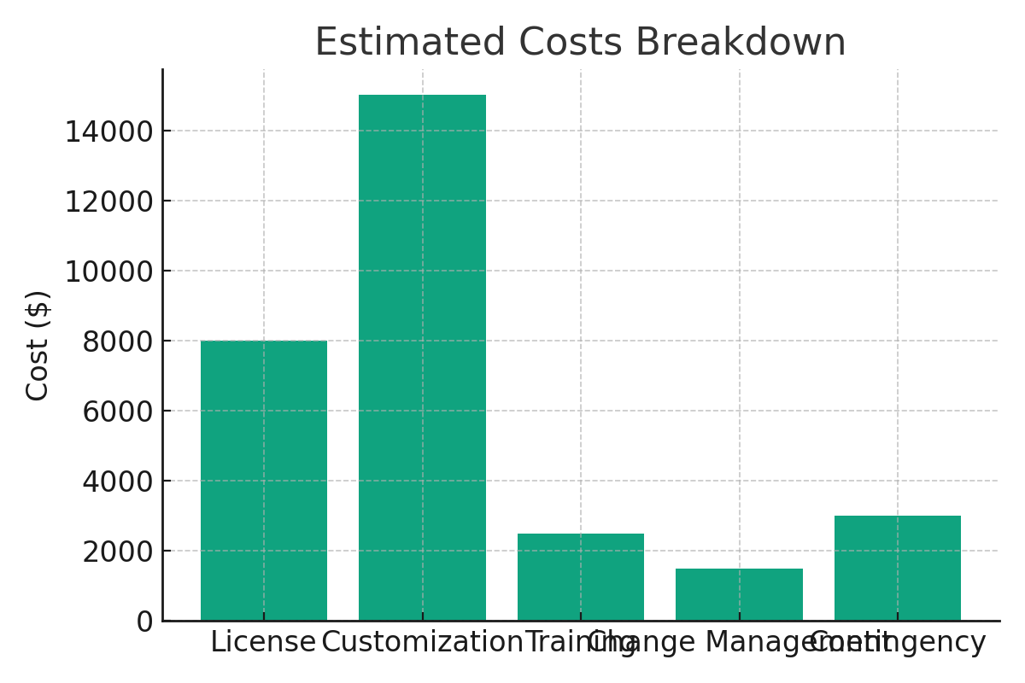

Total Estimated Cost: $30,000

# 9. Financial Analysis

- Annual Savings: $12,000  
- Additional Revenue: $18,000/year  
- Payback Period: < 2 years  
- ROI (3-year): ~120%

# 10. Implementation Timeline

|  |  |
| --- | --- |
| Phase | Duration |
| Requirements & Planning | 2 weeks |
| Vendor Selection | 2 weeks |
| Customization & Integration | 4 weeks |
| Testing & Training | 2 weeks |
| Rollout | 2 weeks |

# 11. Recommendation

Proceed with the Hybrid (Buy and Customize) approach to ensure fast deployment and alignment with hospital processes. A Business Analyst will oversee implementation, manage vendors, ensure stakeholder engagement, and monitor benefit realization.