3CONSULTING LIMITED

# DATA PROTECTION AUDIT REPORT

June, 2025

# EXECUTIVE SUMMARY

**3CONSULTING LIMITED**, a licensed Data Protection Compliance Organization (DPCO), offers a comprehensive array of services encompassing various privacy disciplines. These include compliance assessments, training, program design, policy development, auditing, consulting, and other services aimed at ensuring adherence to the Nigeria Data Protection Act (NDPA) and any relevant foreign data protection laws or regulations applicable in Nigeria, as stipulated under Article 33 of the NDPA.

This audit aimed to verify the adequacy of 3CONSULTING LIMITED 's technical and organizational measures in guaranteeing compliance with the Nigeria Data Protection Act (NDPA). Additionally, it aimed to evaluate the 3CONSULTING LIMITED monitoring mechanisms for assessing the efficacy of compliance with established policies and procedures.

## AUDIT SCOPE

|  |  |
| --- | --- |
| **SCOPE** | **DESCRIPTION** |
| Governance & Accountability | The extent to which information governance accountability, policies and procedures, performance measurement controls, and reporting mechanisms to monitor data protection compliance to NDPA is in place and in operation throughout the organization |
| Awareness & Training | The provision and monitoring of staff data protection, records management and information security training, including awareness of data protection regulation requirements relating to their roles and responsibilities. |
| Data Processing and Sharing | The design and operation of controls to ensure processing and sharing of personal data complies with the principles of NDPA. |
| Administration | Managing/handling all aspects of data protection procedures, and practices digitally. |
| Capturing | The process of collecting and acquiring data in a secure and compliant manner digitally. This involves capturing data from various sources, such as internal systems, external databases, or third-party vendors, while adhering to established data protection policies and procedures. |
| Actions On Security | Measures to safeguard data from unauthorized access, breaches, and misuse. This includes establishing access controls, authentication mechanisms, and authorization processes to ensure only authorized personnel can access and modify data. |

# AUDIT SUMMARY

|  |  |  |
| --- | --- | --- |
| **Audit Scope Area** | **Assurance Rating** | **Overall Opinion** |
| Governance & Accountability | Limited | The organization has limited assurance in governance & accountability, requiring significant improvements to ensure compliance. |
| Awareness & Training | Limited | The organization has limited assurance in awareness & training, requiring significant improvements to ensure compliance. |
| Data Processing and Sharing | Limited | The organization has limited assurance in data processing and sharing, requiring significant improvements to ensure compliance. |
| Administration | Limited | The organization has limited assurance in administration, requiring significant improvements to ensure compliance. |
| Capturing | Limited | The organization has limited assurance in capturing, requiring significant improvements to ensure compliance. |
| Actions On Security | Limited | The organization has limited assurance in actions on security, requiring significant improvements to ensure compliance. |

# CHARTS & GRAPHS

The pie charts below show the summary of the percentage breakdown of the assurance rating given for each audit scope.

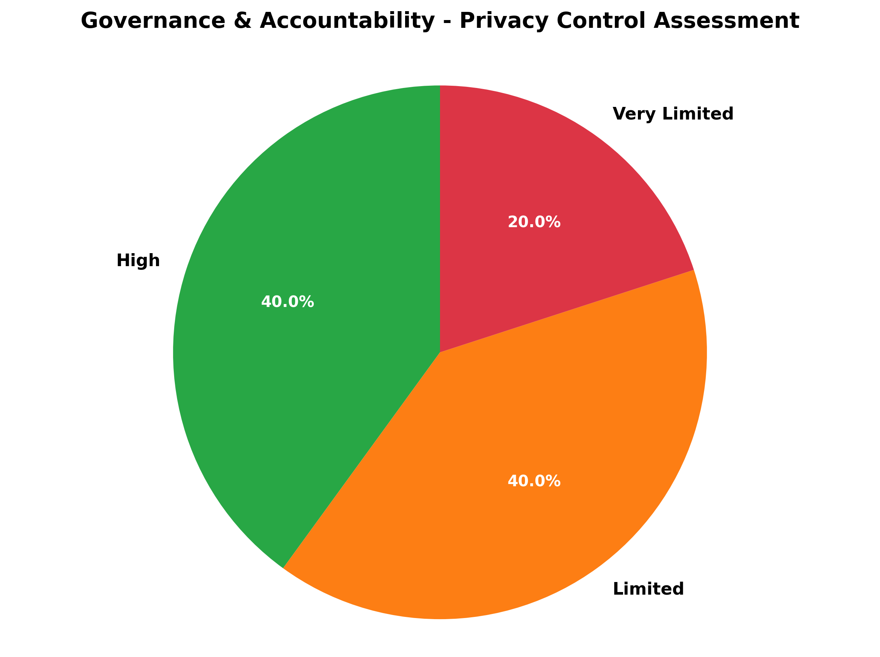

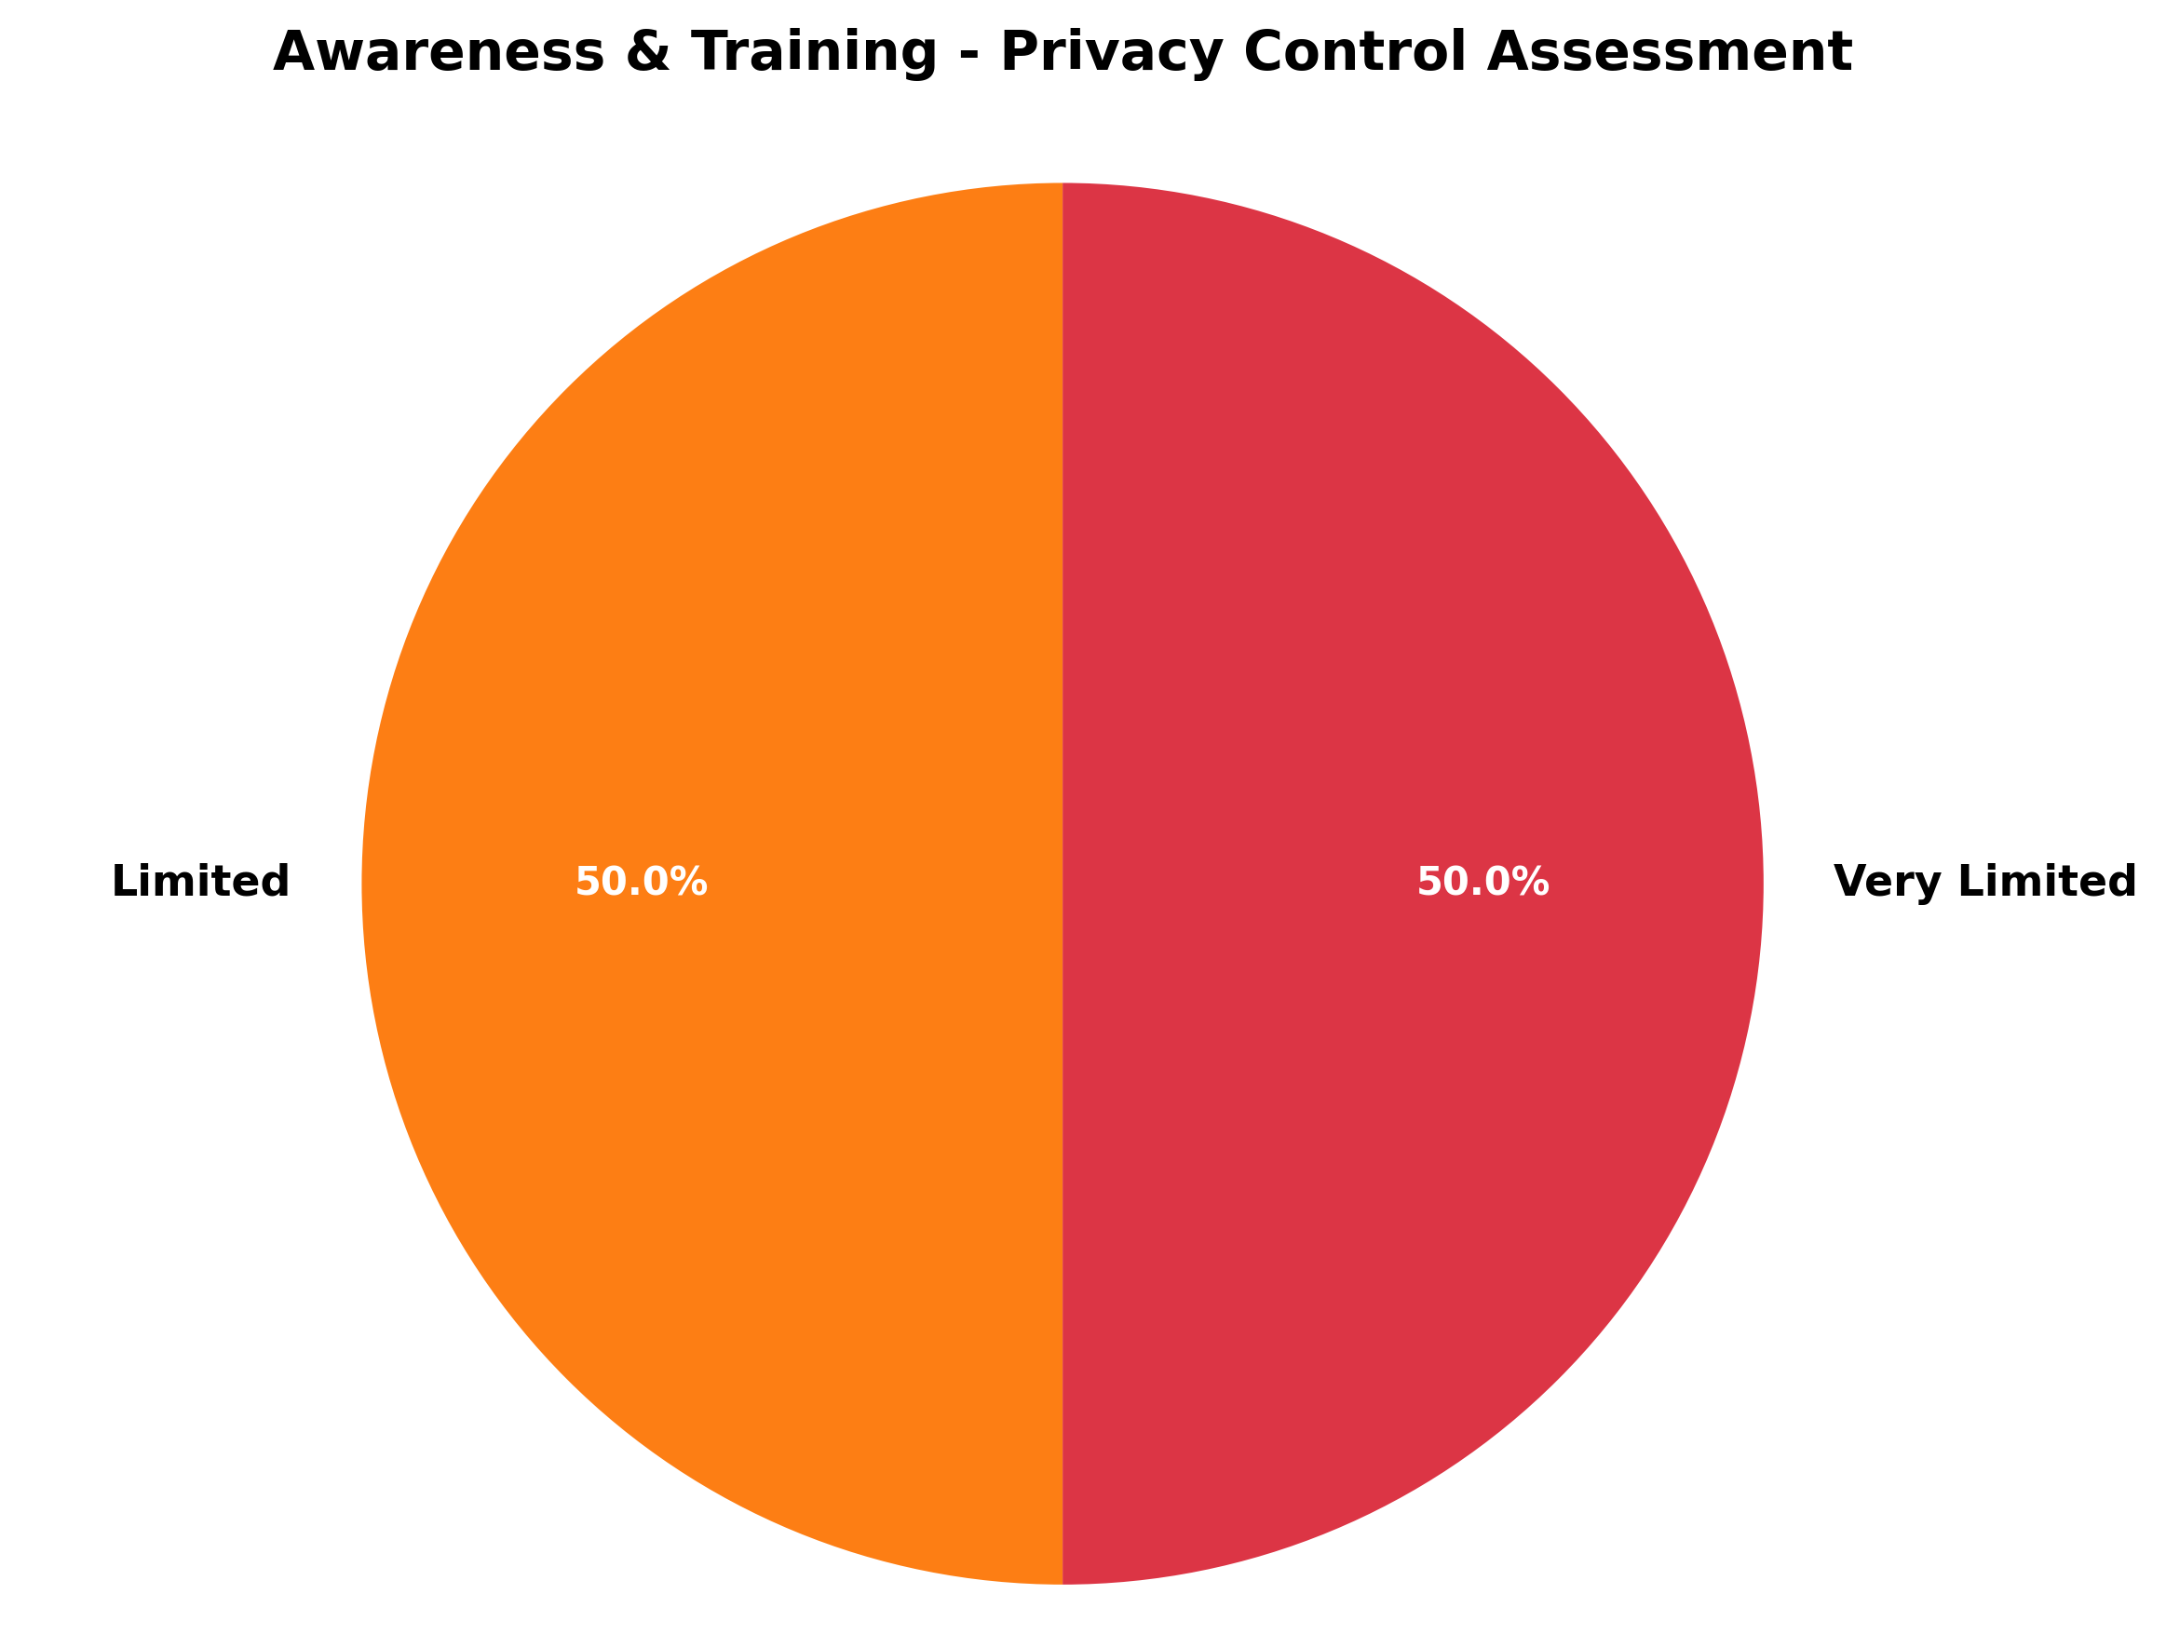

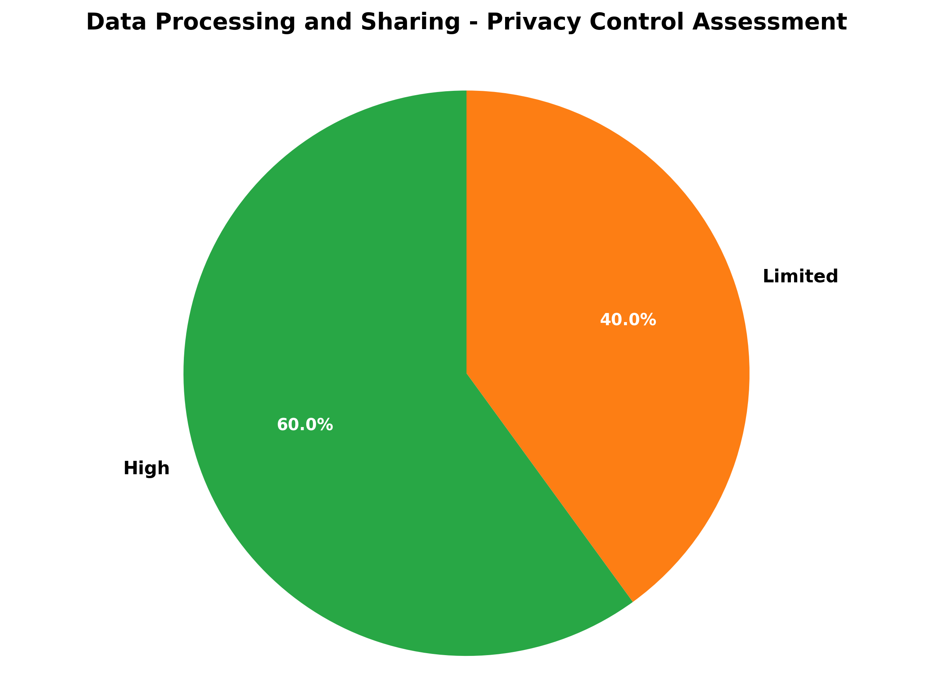

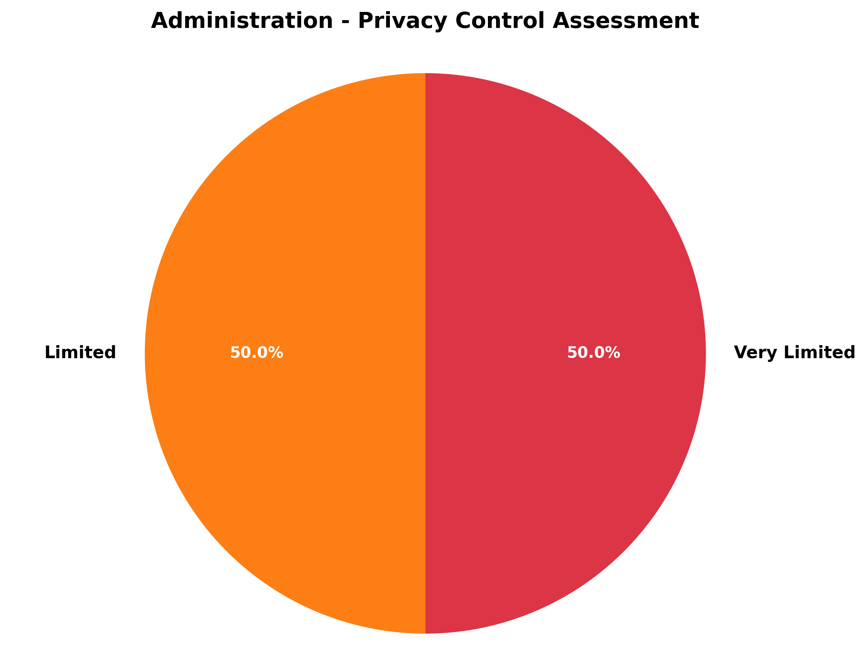

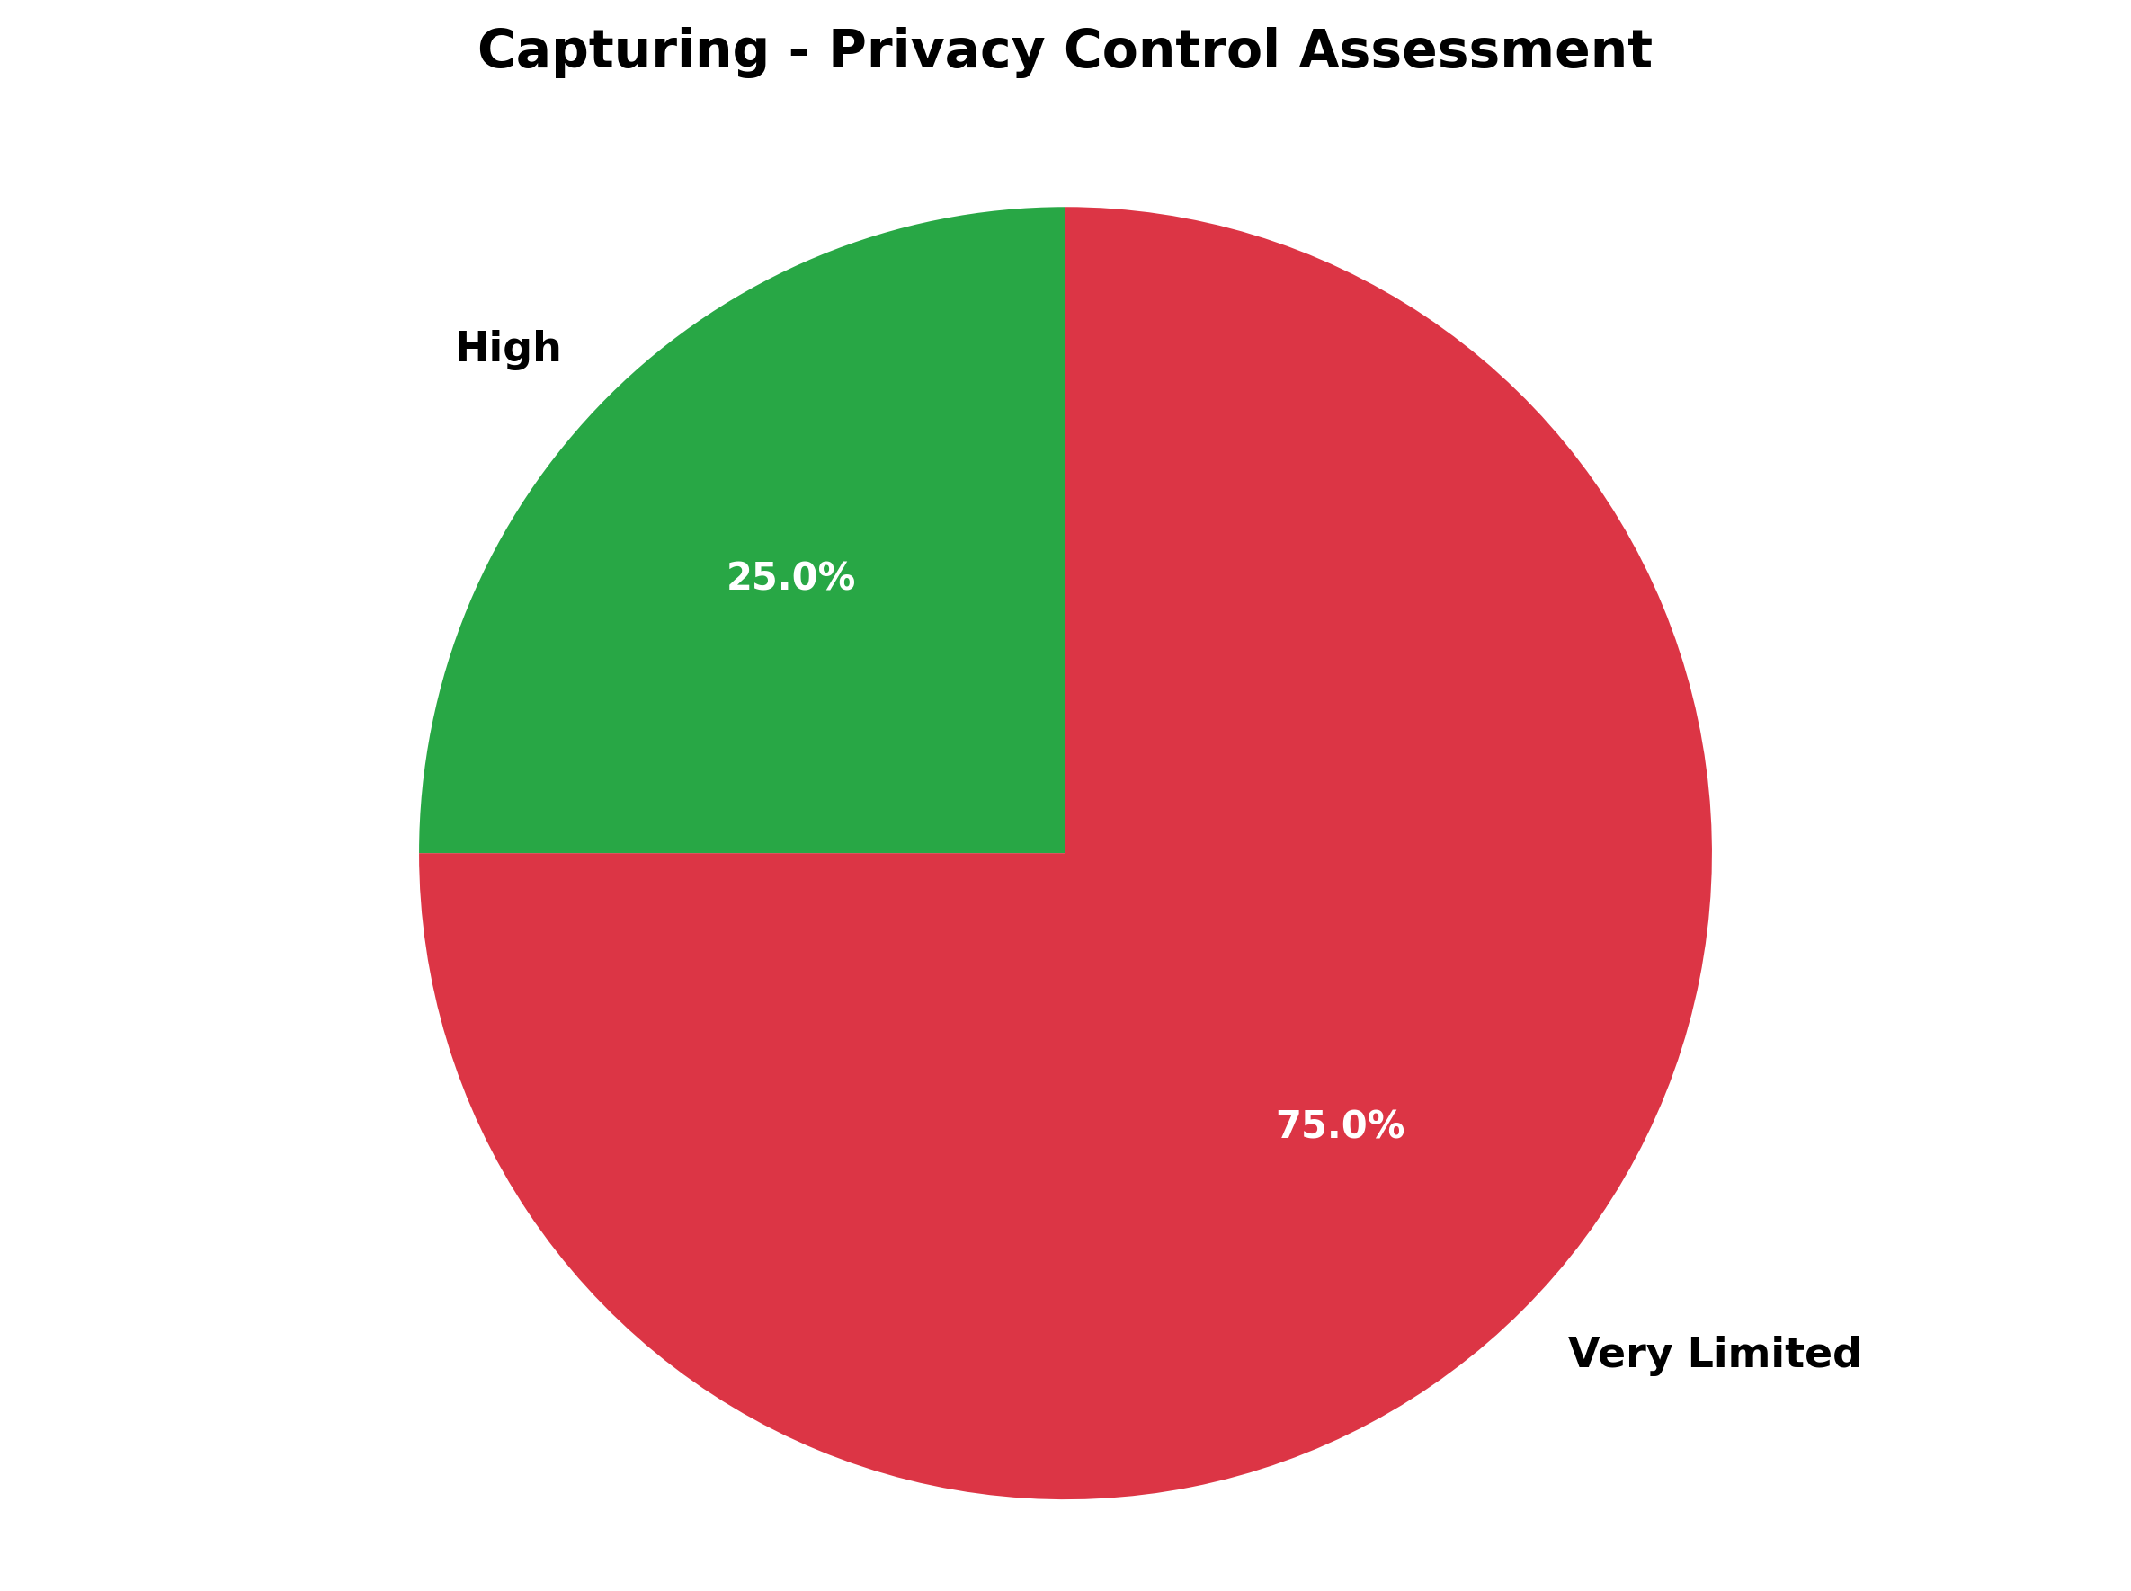

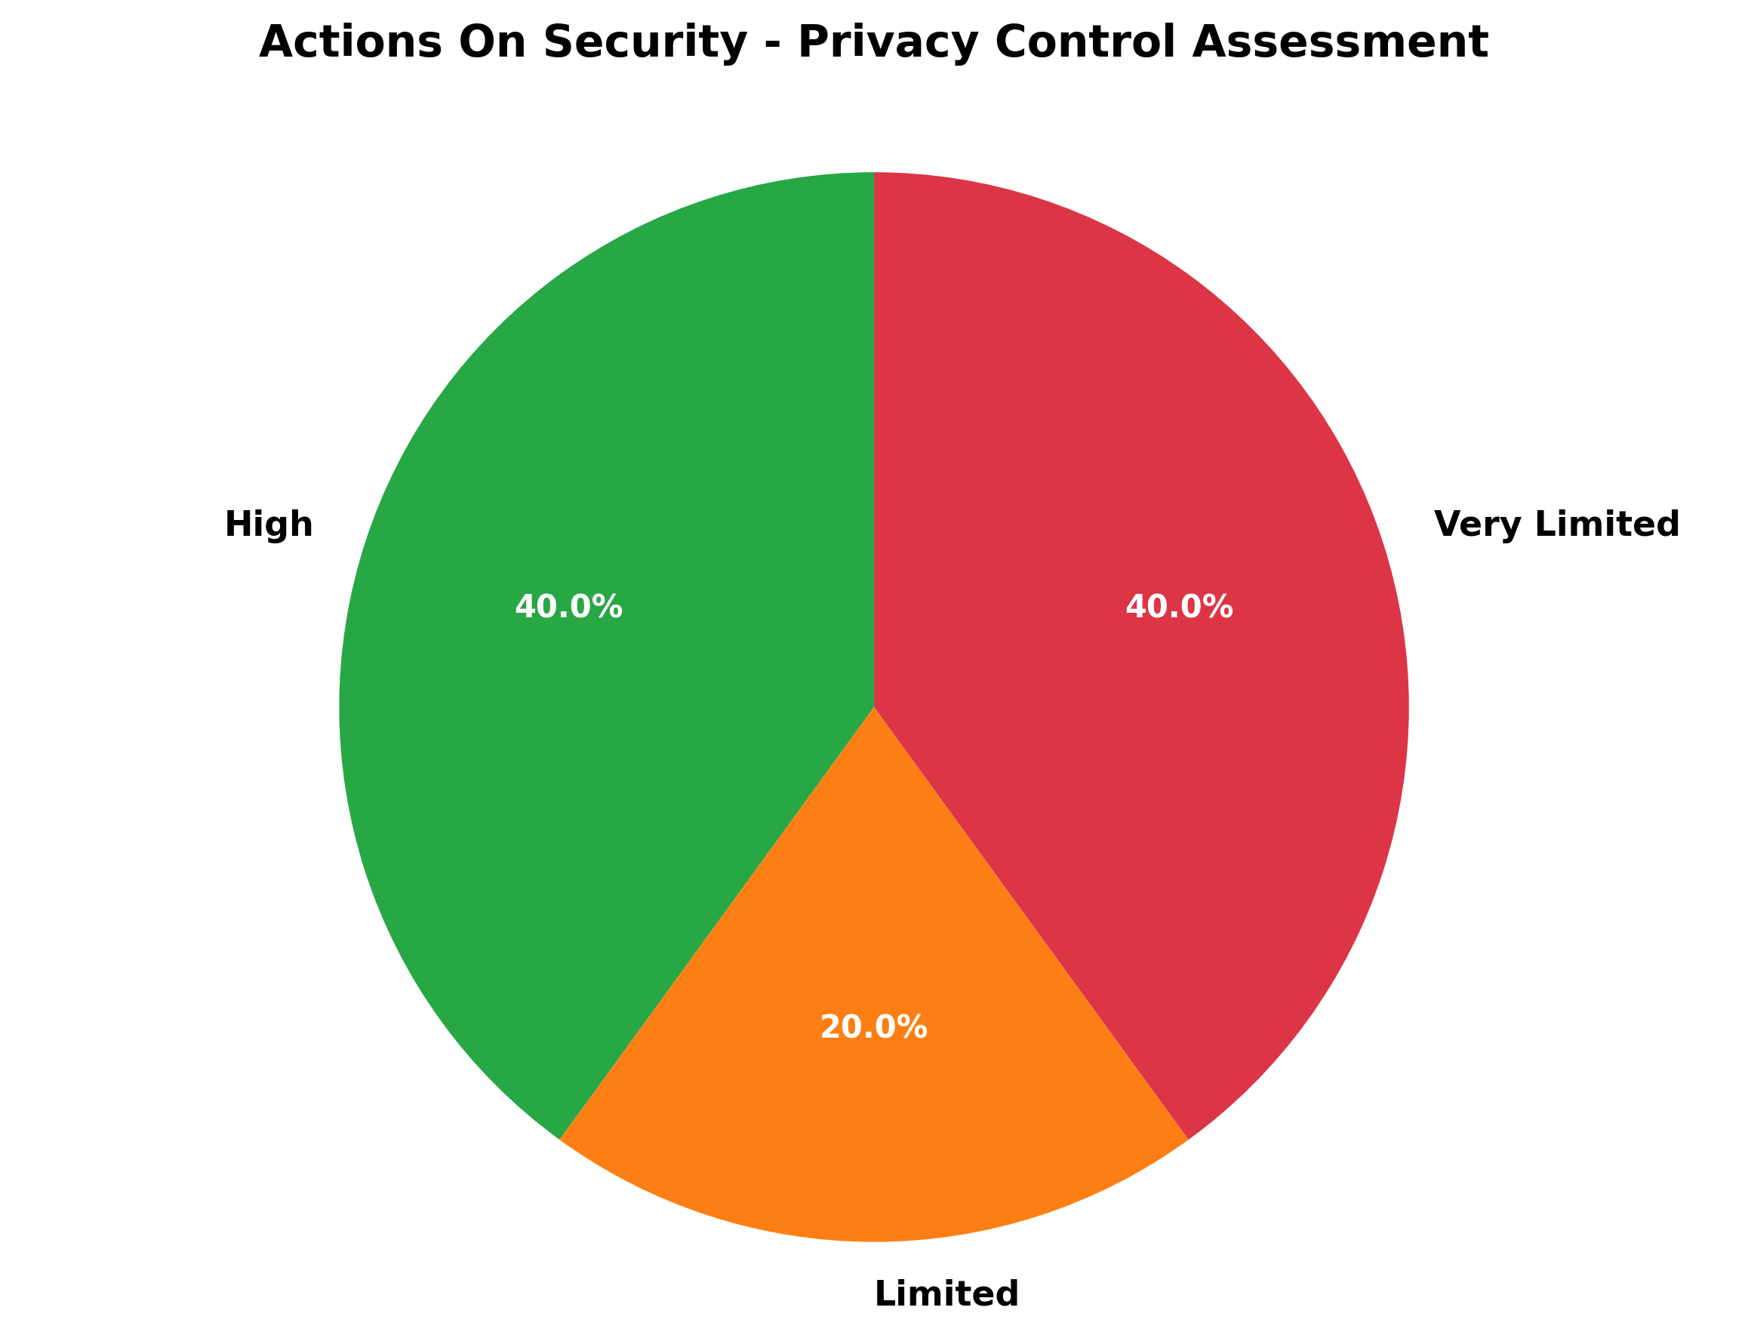

# ORGANIZATION DETAILS

|  |  |
| --- | --- |
| **ORGANIZATION** | 3CONSULTING LIMITED |
| **EMAIL** | oabinusawa@3consult-ng.com |
| **AUDIT DATE** | June 11, 2025 |
| **AUDIT REF** | NDPA-3CO-202506 |

## AREAS FOR IMPROVEMENT

Based on the audit findings, the following areas have been identified for improvement:

**1.** Strengthen governance framework and accountability measures

**2.** Enhance staff training and awareness programs

**3.** Improve data processing and sharing controls

**4.** Enhance administrative procedures and documentation

**5.** Improve data collection and capturing processes

**6.** Strengthen information security measures

## DISCLAIMER

This audit report is based on the information provided during the assessment period. 3Consulting Limited makes no representations or warranties regarding the completeness or accuracy of the information provided. This report is intended for the exclusive use of **3consulting limited**  and should not be distributed to third parties without prior written consent from 3Consulting Limited.