**User Research and Results**

Thomas Kwok

998041177

thomas.kwok@mail.utoronto.ca

**Executive Summary**

In the document are findings of an interview and questionnaire with three participants. Participant 1 is a business professional working in Florens Containers Company, with the work entailing business trips in countries of operation such as Pakistan, Saudi Arabia and India. Participant 2 is a fourth-year university student, a backpacker and loves visiting developing countries in South East Asia. The interview and questionnaire questions aimed at eliciting response concerning the aids participants use in case of a language barrier, means of coping with the barriers in case the aid or Wi-Fi are not available, including the problem encountered using the aids. Results revealed similarities and differences between the participants. The first participant, who is a bilingual Pakistan, relies on his business aid and Wi-Fi in interacting with customers. Considering Wi-Fi is not available most of the time and limitations of Google Translate, he uses body language for communication. Participant 3 is trilingual and uses his staff mate and translation application such as SpeakText for communication in local cities of China and in sight-seeing. Unavailability of Wi-Fi at times coupled with limited language similarity and demand for language pair are major challenges. The participant overcomes these through pictures for communication. Participant 3 who is a bilingual Chinese experiences language barriers in his travels and relies on online translation to overcome the barrier with limitations such as poor working apps. The participants have common attributes in terms of communication barriers. They highlighted the need for offline portable translation apps, visual representation and a combination of grammatical and statistical based apps. The interview and questionnaire results indicate the need for collaboration among business professionals, travelers, app developers, local shops, device manufacturers, local hotels and language educators in overcoming language barriers.

Questionnaire: Participant 1, 2 and 3

Interview: Participant 1 and 2

**Methodology**

**Characteristics of participants:**

Participant 1 is a business professional, an employee of Florens Containers, a logistic and shipping company which focuses on the supply of dry and refrigerated containers on long-term leases for Middle East and Asian-based accounts. It has business operations in China, Japan, South Korea, Hong Kong, Pakistan, India and Saudi Arabia. He always make business trips between Pakistan, India and Saudi Arabia.

Participant 2 is a seasonal economics professor at University of Toronto. He regularly attends the China Economics Annual Conference, which promotes academic researches, communication and cooperation between schools of economics in Chinese universities and economics institutions abroad, such as U of T. It is held by different Chinese universities across China annually, ranging from modern cities, such as Beijing and Shanghai, to less developed cities, such as Chongqing and Changchun.

Participant 3 is a fourth year Western University student. He is a backpacker and loves visiting developing countries in South-East Asia, such as Thailand, Malaysia, Indonesia and Vietnam.

**High level description of questions asked:**

Questions are designed to elicit participant’s responses regarding what aids they use when they encounter a language barrier, how they cope with the barrier when aid or Wi-Fi are not available, and the main problem they find using the aids.

**Results**

Participant 1 is 25 years old and he is a bilingual Pakistani. His mother tongue is Urdu and fluent in English. However, he frequently experiences a language barrier when he interacts with his customers in India and Saudi Arabia, while his local business partner is not available for translation. Since there are some similarities between the language of Urdu and Hindi, so he could occasionally be able to guess the meaning of words. Otherwise, he heavily relies on his smartphone’s online access to Google Translate if Wi-Fi is available. But roughly 50% of the time, Wi-Fi is not accessible for him, therefore, he would try to use body language in order to overcome his language barrier. It usually takes him a week to pick up a new language, and learns phrases in general greetings. He often brings his laptop and smartphone when he travels. Business conferences and client meetings are the two activities which require a great deal of communication. He finds electronic aid works pretty mediocre and he personally believes that the main problem with Goggle Translate is that it only works with small sentences, and fails to translate ones with some structure.

Participant 2 is 48 years old and he is a trilingual Persian. His mother tongue is Persian, and fluent in both English and German. On one hand, he generally does not experience a language barrier when he travels to modern cities in China, such as Beijing, Nanjing, Guangzhou and Shanghai since the residents are relatively capable of speaking English. On the other hand, he sometimes experience a language barrier when he is in less developed Chinese cities, such as Chongqing, Kunming and Changchun. He usually go sightseeing and shopping after work without the companion of a native university staff. He would use online translation application such as SpeakText from his smartphone if Wi-Fi is accessible. Unfortunately, he would even draw pictures and use body language when Wi-Fi is not available. It usually takes him few days to pick up a new language, and learn phrases in general greetings and famous Chinese dishes. He often carries his laptop, smartphone and iPad when he travels. Academic talks and meetings with researchers on campus require a great deal of communication, however, the medium of communication is in English, while sightseeing and shopping require less but he still need to rely on online translation application. He finds electronic aids work poorly. He believes that the quality of machine translation in general, largely depend on: 1. the similarity of languages, for example, German and English are closer related than Mandarin and English. German and English belong to the Indo-European family whereas Mandarin belongs to the Altaic family. German has many rules that neither English nor Mandarin have, including genders, object article conjugations, differentiation in complement triggers, such as ‘that’. Because of these features, it is difficult for translation applications to integrate all these rules with the Statistical Machine Translation method. 2. The demand for a language pair, and therefore resources invested to this date. For example, Persian to English has less demand than Mandarin to English.

Participant 3 is 22 years old and he is a bilingual Chinese. His mother tongue is Cantonese and fluent in English. He experiences a language barrier from time to time. He only carries his smartphone when he travels and relies on online translation application from his smartphone to overcome language barrier. He finds electronic aids work poorly. He personally believes that the primary issue with today’s translation application is the inadequacy of the recorded corpus of language that is used for reference. The corpus is limited to past forms of the language and mostly to the narrow scope of formal, written discourse.

**Attributes in common:**

The three participants are capable of speaking two or more languages fluently. They interact with people who speak a different language besides English weekly on average. All three of the participants would carry at least a smartphone when they travel. They think that a physical translator (e.g. dictionary or a tour guide) would strongly help but is often not available and electronic aids would somewhat help. They all agree that electronic aids, such as online translation applications have its own limitations, meanwhile, half of the time Wi-Fi is not accessible for them on average. And finally they all believe that picture dictionary through voice recognition or keyword search would be a great solution to the problem with today’s online translation application.

**User need list:**

1. Offline portable translation device
2. Visual representation of words feature
3. Combination of statistical and grammatical rule-based approaches

**Stakeholders Description:**

1. Business professionals
2. Travelers
3. Mobile phone manufactures
4. App Developers
5. Local hotels
6. Local shops
7. Language educators

**User Need:**

**Language Translation**

Sub task:

Repeat the process

Task:

Draw pictures

Task:

Use body language

Sub Task:

Native companion translates to the local

Sub Scenario 1:

Native companion is available

Scenario 2:

Not accessible to Wi-Fi

Sub Sub Task:

Type in the words and show the result to the local

Sub Task:

Select the right language pair

Task:

Use any online translation application from your smartphone

Scenario 1:

Accessible to Wi-Fi

Sub Scenario 2:

Native companion is not available

Goal:

The local is able to understand what you are saying

Task:

Explain to your native companion what you want to say

Sub Sub Scenario:

Local does not understand

**Scenario**

James is a lone backpacker who often travels to the developing countries in South-East Asia. One day, he shopped around in one of the less developed cities of Thailand, Pattaya, where Wi-Fi is limited, and he came across a small jacket boutique. He wondered what materials are the jackets made of, so he decided to ask the shop keeper. However, she does not speak English. After a few attempts of using body languages and drawing pictures, yet the shop keeper still could not understand what James meant.

**Persona**

**Primary**

Peter is 35 years old bilingual Canadian and works as a sales with a vacuum cleaner company based in Toronto. This firm has business operations in developing countries in South America, such as Brazil, Argentina and Chile, and Peter always make business trips to these countries.

Peter often experiences a language barrier when he interacts with his customers while his local business partner is not available for translation. He finds himself using the online language translation application on his iPhone all the time. However, Wi-Fi can only be accessible 50% of the time when he is abroad. Peter wonders if he would be able to cope with the language barrier by drawing pictures and using body languages.

**Additional**

1. Backpacker James
2. Professor Kim
3. Journalist Jane
4. Tourist Tom

**Appendix**

**Sample raw data**

Participant 1

**Questionnaires**

Top of Form

**What is your occupation?**

* +   White collar
  +   Student
  +   Professor

**Age**

* +   0 - 10
  +   11 - 20
  +   21 - 30
  +   31 - 40
  +   41 - 50
  +   51 - 60
  +   61 - 70

**Gender**

* +   Male
  +   Female

**What is your first language?**

Urdu

**Did you experience a language barrier while traveling abroad?**

* +   Yes
  +   No

**While traveling abroad what/who do you rely on to get pass the language barrier?**

Google Translate

**Do you experience a language barrier while interacting with others in your current location?**

* +   Yes
  +   No

**How often do you interact people who speak a different language besides English?**

|  |  |  |  |  |  |  |
| --- | --- | --- | --- | --- | --- | --- |
|  | 1 | 2 | 3 | 4 | 5 |  |
| not at all |  |  |  |  |  | daily |

**How difficult was it to get the idea across**

|  |  |  |  |  |  |  |
| --- | --- | --- | --- | --- | --- | --- |
|  | 1 | 2 | 3 | 4 | 5 |  |
| very easy |  |  |  |  |  | very hard |

**Did you use any aids to help with the language barrier**

* +   yes
  +   no

**Name at most 3 aids used**

1. Get help from native business partner
2. Google Translate

**How helpful were aid #1**

|  |  |  |  |  |  |  |
| --- | --- | --- | --- | --- | --- | --- |
|  | 1 | 2 | 3 | 4 | 5 |  |
| very helpful |  |  |  |  |  | not helpful at all |

**How helpful were aid #2**

|  |  |  |  |  |  |  |
| --- | --- | --- | --- | --- | --- | --- |
|  | 1 | 2 | 3 | 4 | 5 |  |
| very helpful |  |  |  |  |  | not helpful at all |

**How helpful were aid #3**

|  |  |  |  |  |  |  |
| --- | --- | --- | --- | --- | --- | --- |
|  | 1 | 2 | 3 | 4 | 5 |  |
| very helpful |  |  |  |  |  | not helpful at all |

**Do you think a physical translator would help?**

i.e. dictionary

|  |  |  |  |  |  |  |
| --- | --- | --- | --- | --- | --- | --- |
|  | 1 | 2 | 3 | 4 | 5 |  |
| Strongly disagree |  |  |  |  |  | Strongly agree |

**Do you think an electronic translator would help?**

i.e. smartphone

|  |  |  |  |  |  |  |
| --- | --- | --- | --- | --- | --- | --- |
|  | 1 | 2 | 3 | 4 | 5 |  |
| Strongly disagree |  |  |  |  |  | Strongly Agree |

**Do you own a smartphone?**

* +   yes
  +   no

**How often do you use it?**

|  |  |  |  |  |  |  |
| --- | --- | --- | --- | --- | --- | --- |
|  | 1 | 2 | 3 | 4 | 5 |  |
| rarely |  |  |  |  |  | all the time |

**While traveling abroad, do you carry your smartphone?**

* +   yes
  +   no

**Which smartphone app do you think will help the most with language barrier?**

* +   Instant translation through voice recognition, acts like a real time subtitle
  +   Picture dictionary through voice recognition or keyword search
  +   Voice recognition and instant playback the translated language

**Do you feel uncomfortable when the person you are talking to suddenly starts talking to their phone?**

|  |  |  |  |  |  |  |
| --- | --- | --- | --- | --- | --- | --- |
|  | 1 | 2 | 3 | 4 | 5 |  |
| Strongly disagree |  |  |  |  |  | Strongly agree |

Bottom of Form

**Interview**

How many developing counties have you traveled in the past year?

3

How many languages do you speak?

2

How many languages do you speak as a first language, and what are they?

1, Urdu

How fast do you pick up a foreign language?

Roughly a week.

What types of phrase do you learn?

General greetings, such as hello, how are you doing and bye.  
Do you usually bring electronic devices when you travel?  
Yes  
if so please list out the top 3 electronic devices you frequently bring.

1. Laptop
2. iPhone

What are your general traveling experiences? Good or Bad? Please elaborate.

My general travel experience to India is good. India was loud and crowded and there were days when walking down the street amazed me, and days when it overwhelmed me. Sometimes the auto rickshaw drivers weaved in and out of traffic so recklessly that I gasped audibly. I witnessed beautiful, sacred moments: a family setting a boat made of banana leaves and filled with flowers adrift on the Ganges River. And I witnessed beautiful, profane moments: a monk walking down the street with his dog.

What activities do you do when you are traveling, which require a great deal of communication?   
Business conferences and client meetings

Does language barrier play a part in your experience?  
Yes  
if so did you use any electronic aid? What are they?  
Yes, my iPhone   
How helpful were the electronic aids? What would you suggest for improvement?   
They work pretty mediocre and the main problem with Goggle Translate is that it only works with small sentences, and fails to translate ones with some structure. A combination of statistical and grammatical rule-based approaches should be implemented in the future.  
Do you find yourself using the internet a lot while you're traveling?

Yes, a lot of time

If you had good experiences without internet, what helped to overcome the obstacles?

Body languages  
How accessible was internet for the best and worst experiences?  
Roughly 50% of the time  
If I introduced a new product that deals with language barrier would you try it out?

I would love to try it

**Consent forms**

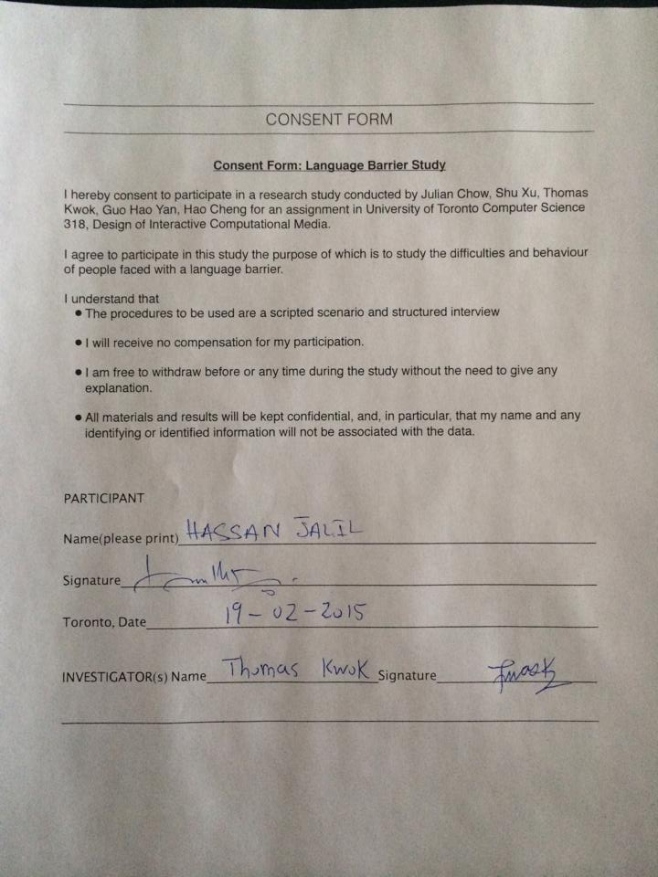

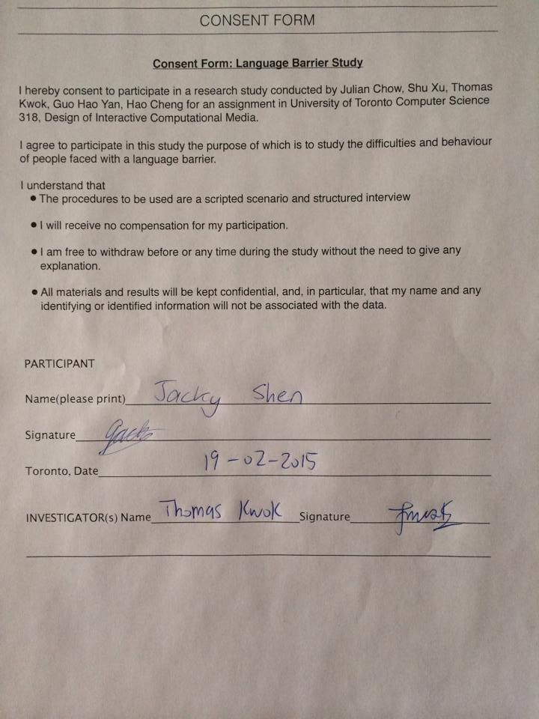

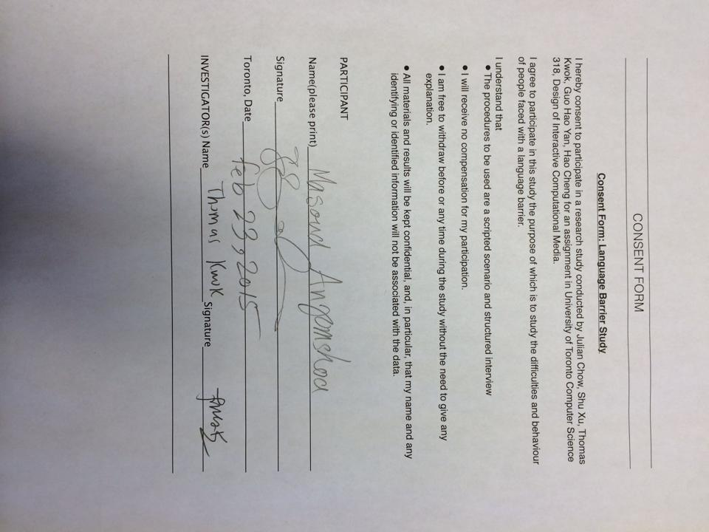

Top of Form