**CONNECTION TIME DISTRIBUTION**

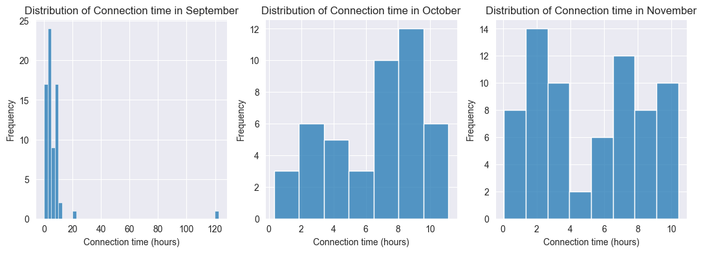

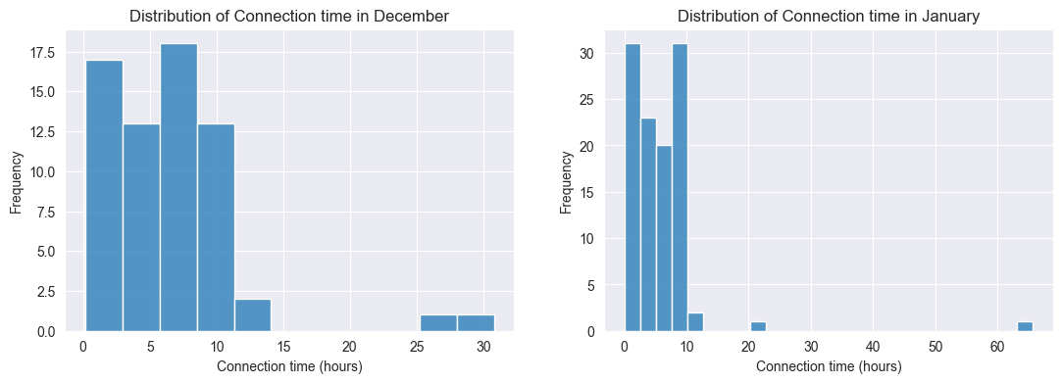

The connection time is skewed to the right in September, December and January. These are due to high connection times, which occur very less frequently, compared to other connection times in the respective months. To avoid generalizing wrongly due to these outlier connection times, the median is used to calculate the connection time, instead of mean, for the days of the week in each month. This is because the mean is more affected by these outliers.

**TOTAL CONNECTION TIME (MONTHLY)**

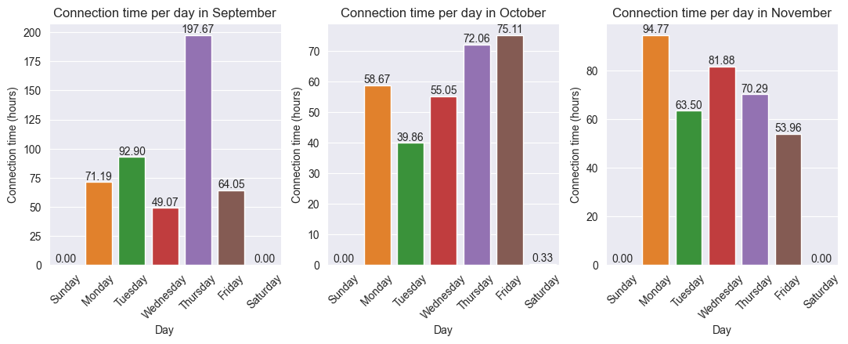

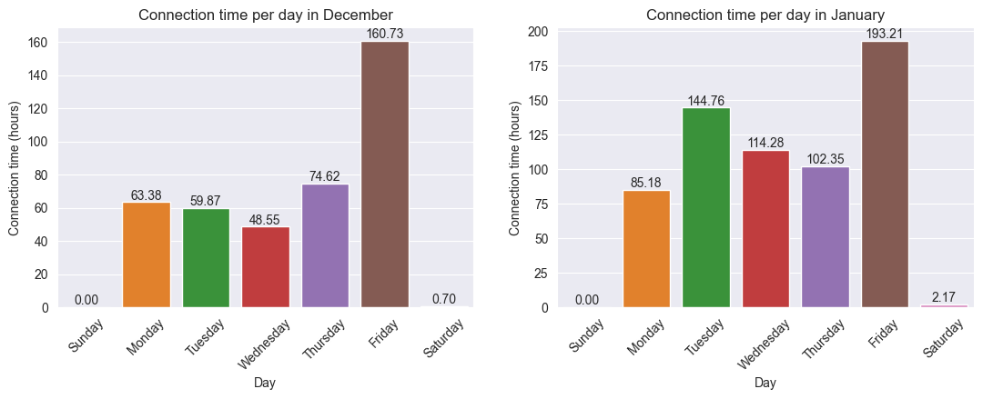

**MEDIAN CONNECTION TIME (HOURS) FOR EACH DAY IN EACH MONTH**

|  |  |  |  |  |  |  |  |
| --- | --- | --- | --- | --- | --- | --- | --- |
|  | Sunday | Monday | Tuesday | Wednesday | Thursday | Friday | Saturday |
| September | - | 7.64 | 5.72 | 3.11 | 8.07 | 3.57 | - |
| October | - | 7.39 | 4.48 | 8.80 | 7.60 | 7.88 | 0.33 |
| November | - | 6.60 | 3.74 | 6.71 | 6.06 | 3.56 | - |
| December | - | 3.18 | 7.06 | 3.08 | 9.34 | 6.34 | 0.70 |
| January | - | 4.70 | 7.45 | 5.13 | 5.14 | 3.98 | 2.17 |

No employee connected their EV on Sunday. Some connected on Saturday in November, December and January.

**DISTRIBUTION OF CHARGE TIME**

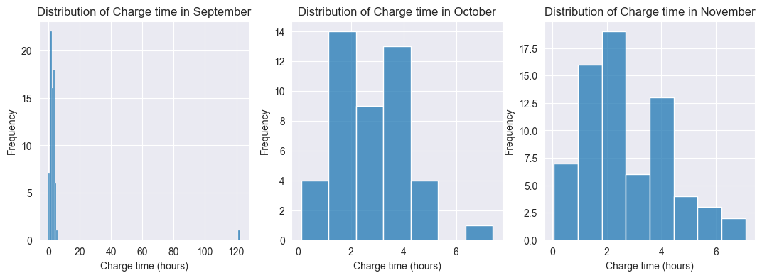

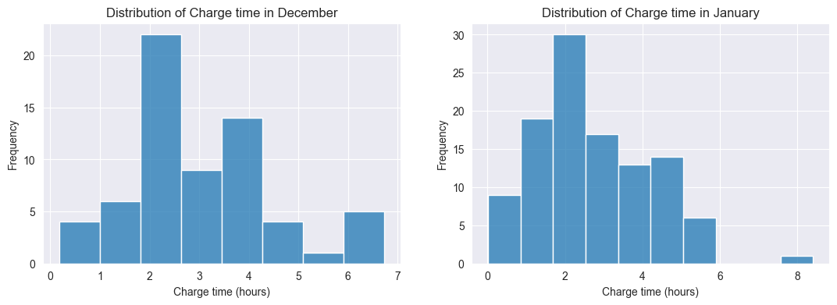

Most of the charge time in September had a duration less than 8 hours. There is an outlier with a charge time of over 120 hours. The rest of the months had a charge time duration less than 8 hours, with majority of the duration falling between 1 and 5 hours.

**CONSUMPTION DISTRIBUTION**

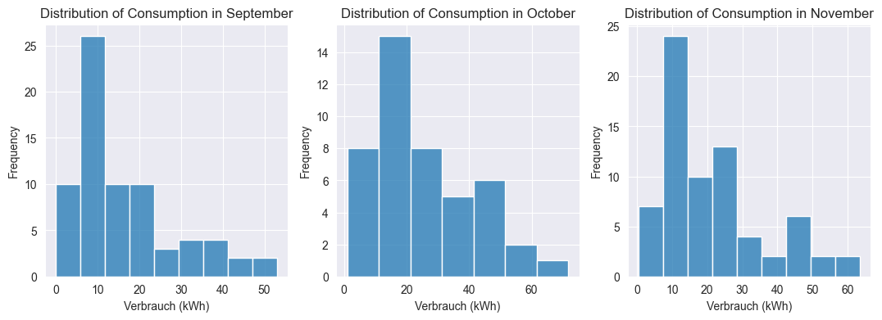

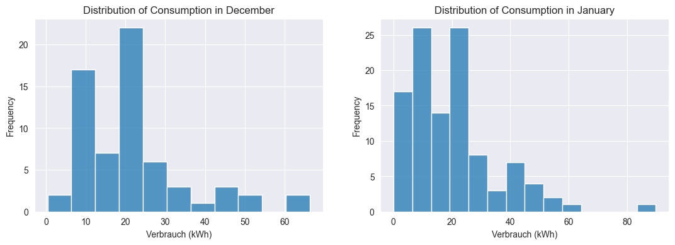

Energy consumption was mostly between 5 and 40 kWh. Consumption was as high as 80 kWh for a charge session in January, with the rest of the months having less than 65 kWh. The energy consumption for all the months seems to be right skewed, which means the mean is consumption is likely to be influenced by outlier consumption (like the 80 kWh) for each month.

**TOTAL CONSUMPTION (MONTHLY)**

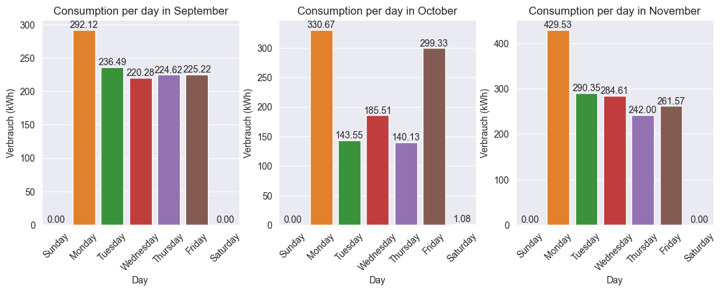

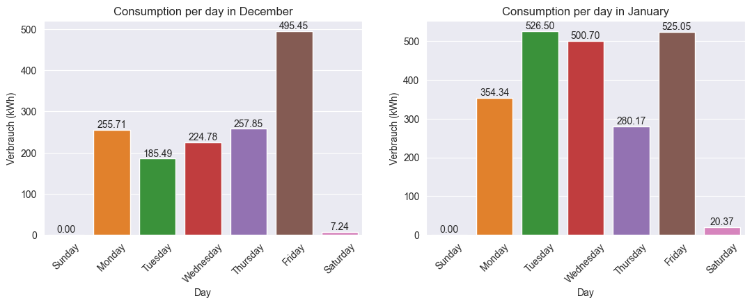

**MEDIAN ENERGY CONSUMPTION (kWh) FOR EACH DAY**

|  |  |  |  |  |  |  |  |
| --- | --- | --- | --- | --- | --- | --- | --- |
|  | Sunday | Monday | Tuesday | Wednesday | Thursday | Friday | Saturday |
| September | - | 22.411 | 11.308 | 11.280 | 11.961 | 11.208 | - |
| October | - | 40.826 | 18.115 | 22.263 | 12.360 | 30.254 | 1.077 |
| November | - | 23.1115 | 15.640 | 14.791 | 14.1330 | 17.2455 | - |
| December | - | 21.285 | 21.011 | 16.229 | 22.917 | 21.327 | 7.239 |
| January | - | 17.6045 | 21.5595 | 21.9175 | 10.8830 | 15.6500 | 20.3670 |

**HOGGING TIME DISTRIBUTION**

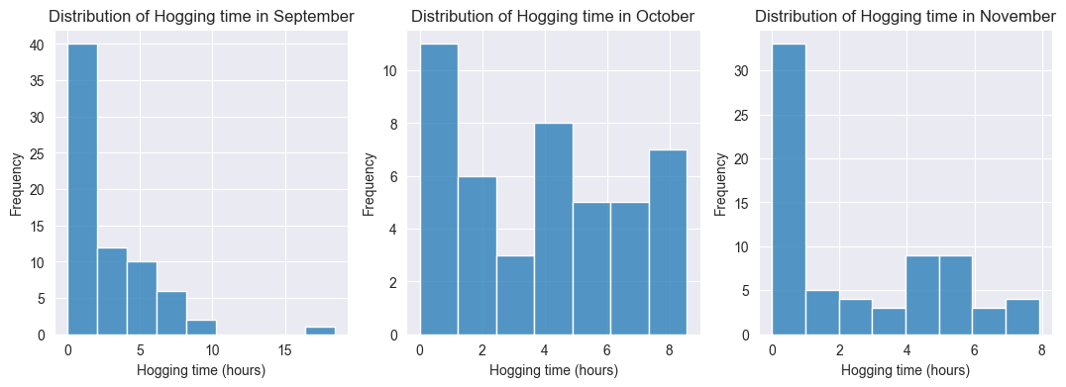

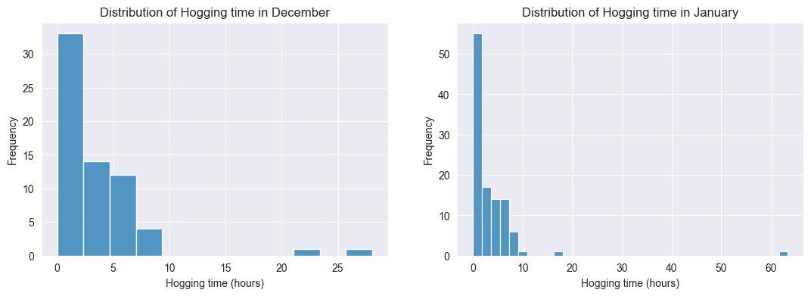

Hogging time in October seems balanced between 0 and 9 hours. In September, only 1% of the hogging time was above 15 hours. 47% of the hogging time in November was less than 1 hour. December and January had longer hogging time with 2 charge sessions above 20 hours (December) and 1 charge session above 60 hours (January).

**AVERAGE CONNECTION AND CHARGE TIME (MONTHLY)**

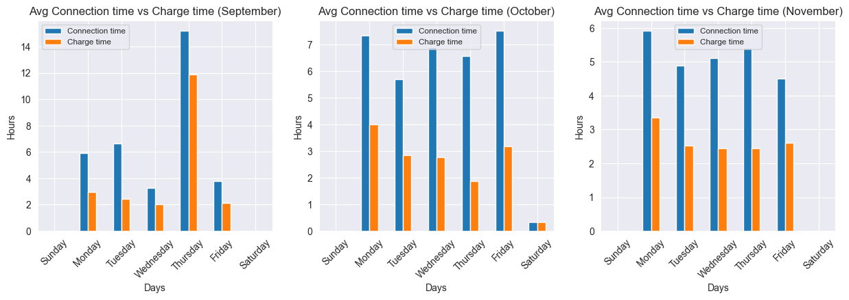

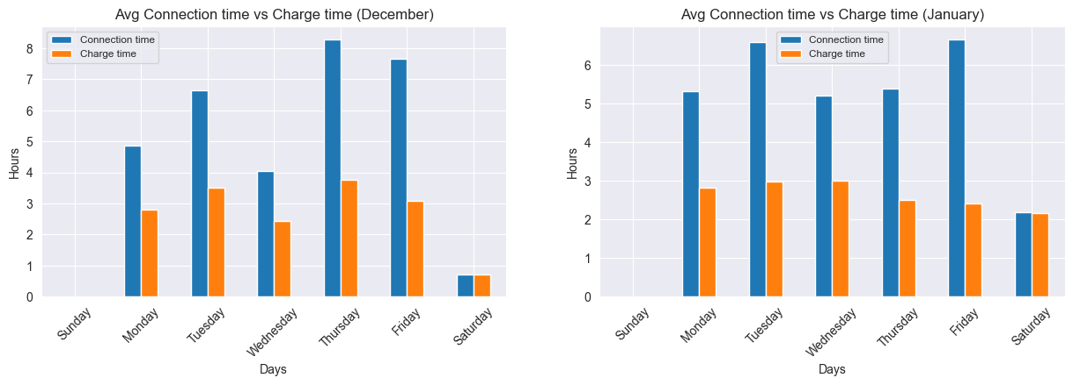

**MEAN CONNECTION AND CHARGE TIME PER MONTH**

|  |  |  |
| --- | --- | --- |
|  | Average connection time | Average charge time |
| September | 6.69 | 4.08 |
| October | 6.69 | 2.82 |
| November | 5.21 | 2.69 |
| December | 6.27 | 3.02 |
| January | 5.89 | 2.71 |

**NUMBER OF CHARGE SESSIONS (DAILY)**

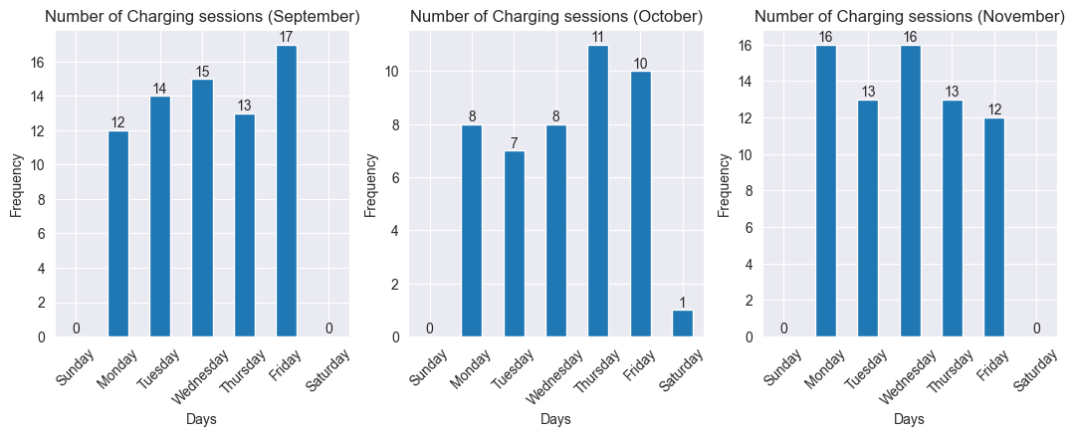

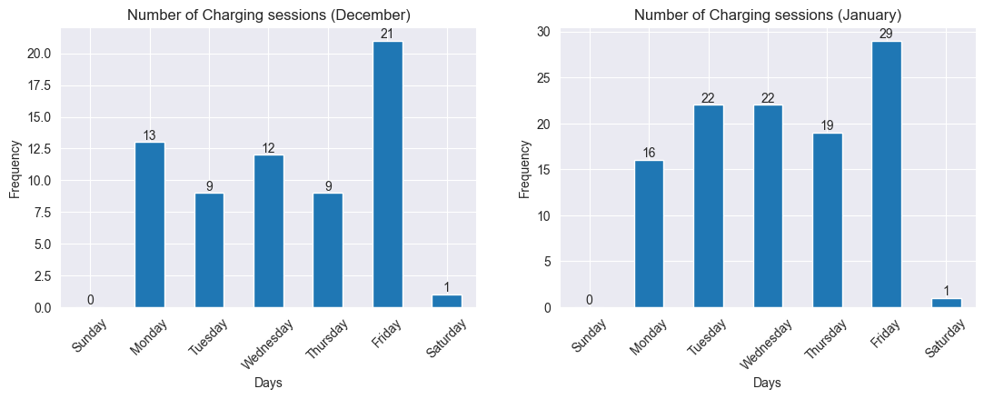

Most employees charged during the weekdays. There were 3 charge sessions overall that occurred during the weekend (3 Saturday and none on Sunday).

**NUMBER OF CHARGE SESSIONS BY PLUG-IN AND UNPLUGGED TIMES**

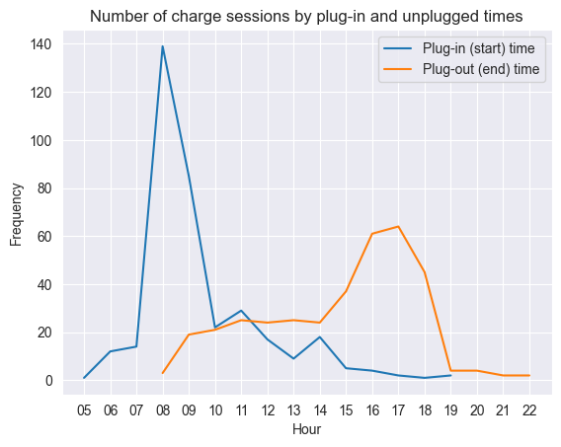

**CONNECTION TIME OF EACH EMPLOYEE**

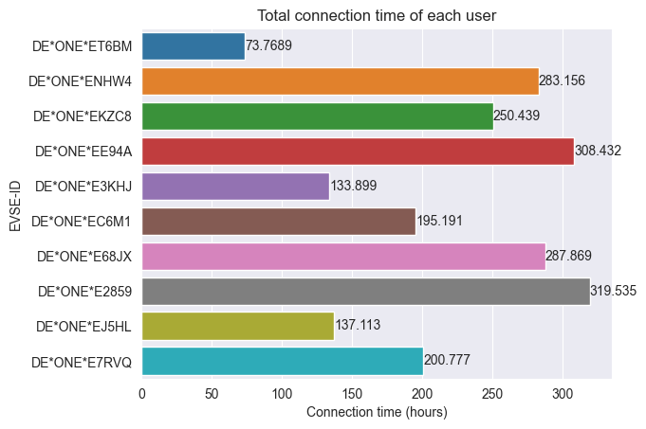

**CHARGE TIME OF EACH EMPLOYEE**

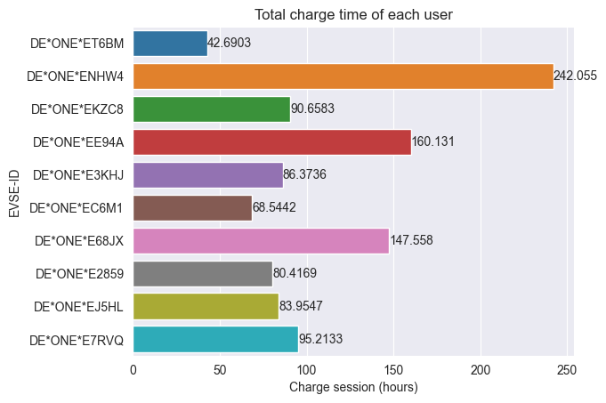

**HOGGING TIME OF EACH EMPLOYEE**

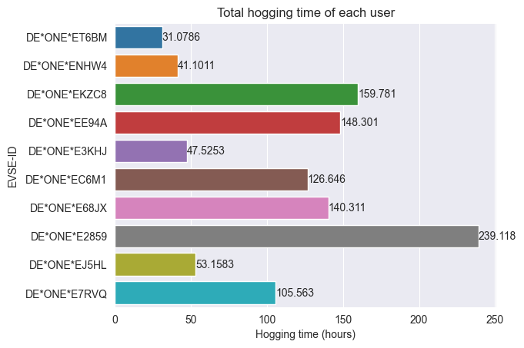

**CHARGE UTILIZATION**

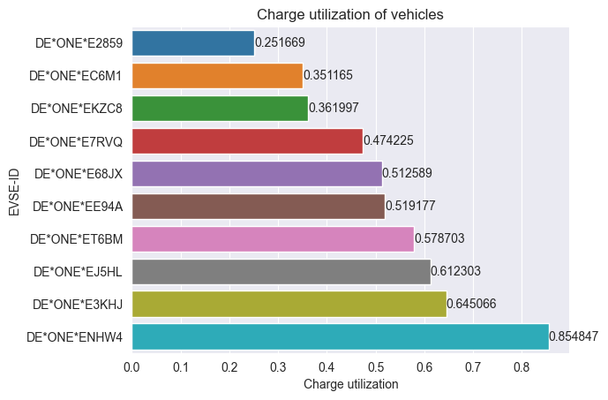

**CONSUMPTION PER MONTH**

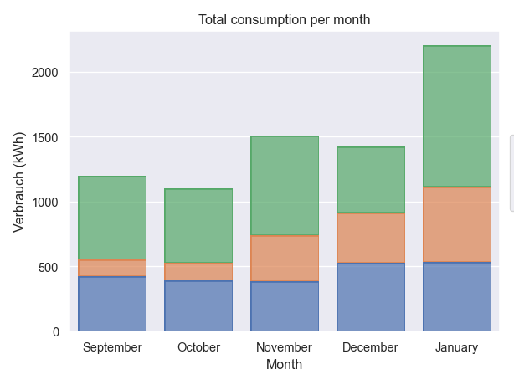

**CONSUMPTION PER CHARGE STATION**

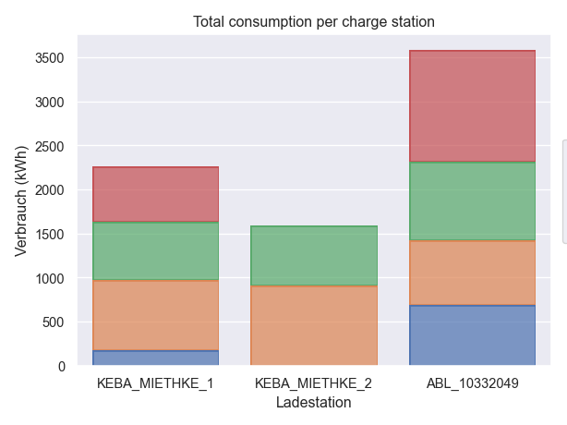

**CONNECTION TIME PER CHARGE STATION**

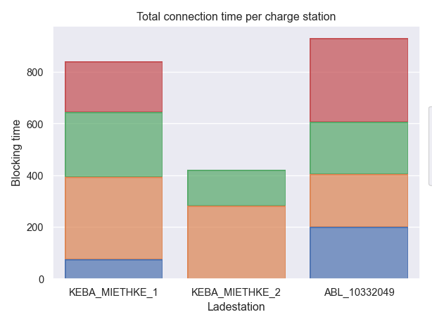

**CHARGE TIME PER CHARGE STATION**

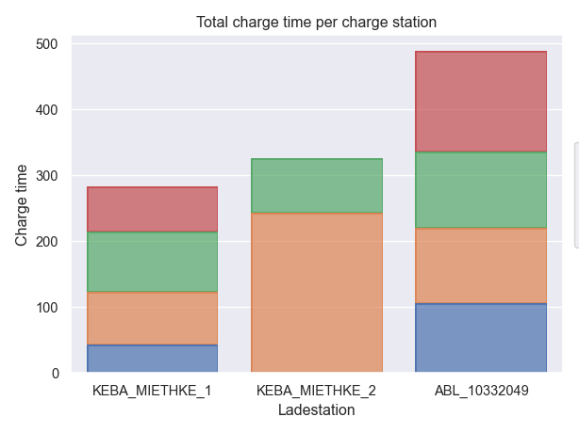

**CAPACITY UTILIZATION**

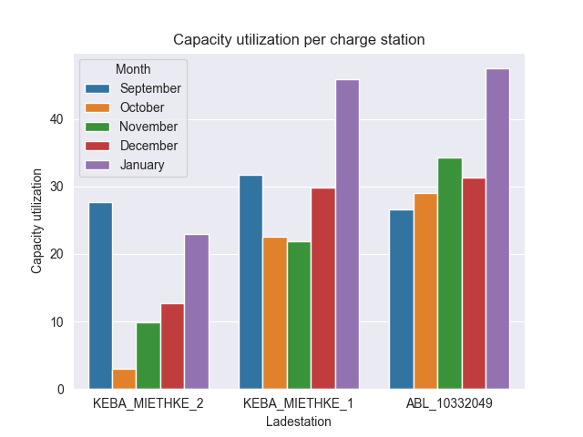

**NIGHTTIME USERS**

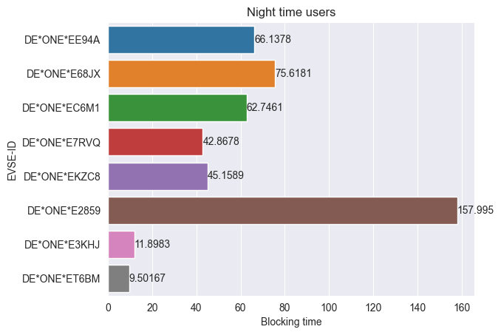

**DAYTIME AND NIGHTIME CONSUMPTION**

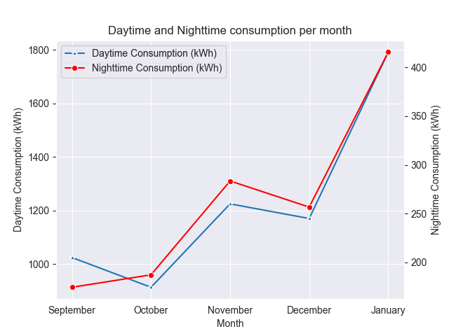

**CONSUMPTION PER SESSION PER MONTH**

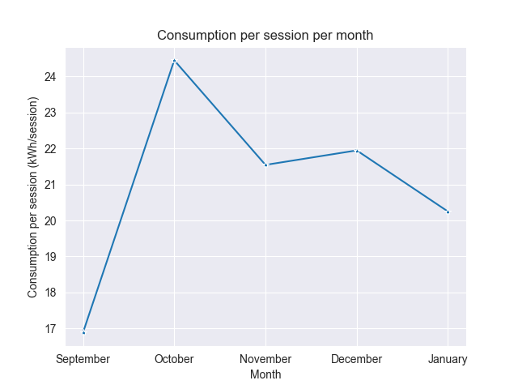

**CHARGE SESSIONS PER MONTH**

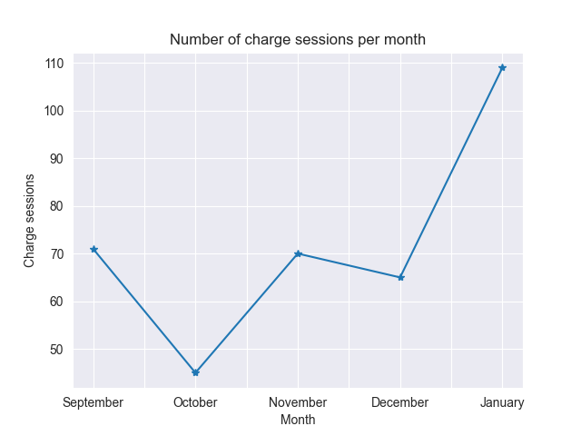

**CHARGE SESSIONS PER CHARGE STATION**

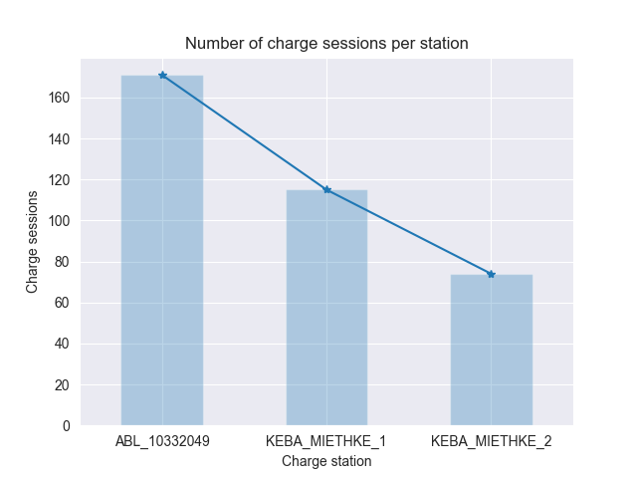

USERS

**DISTRIBUTION OF CONNECTION TIME**

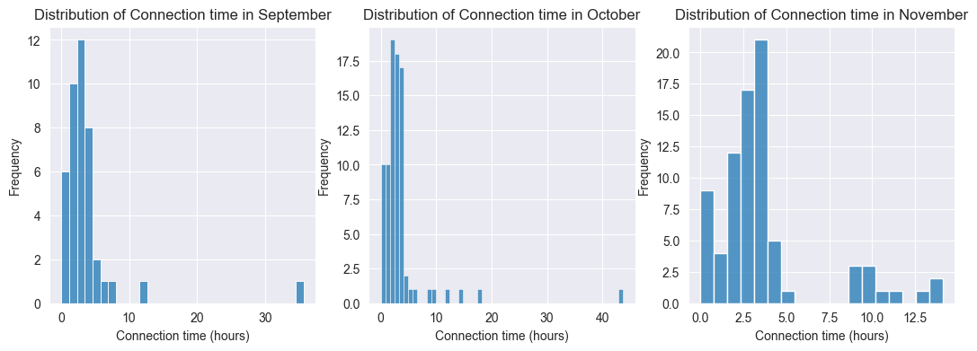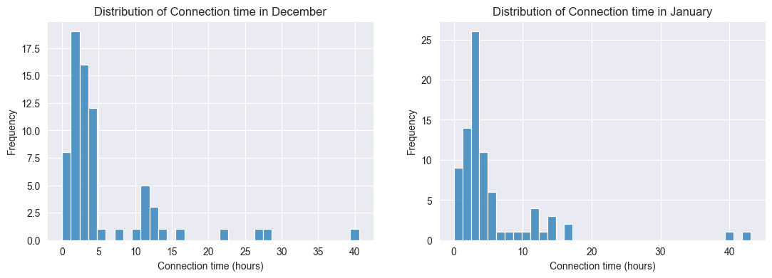

**CONNECTION TIME (MONTHLY)**

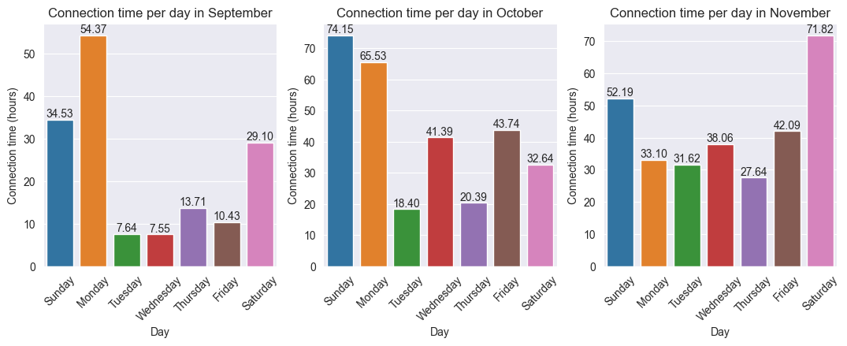

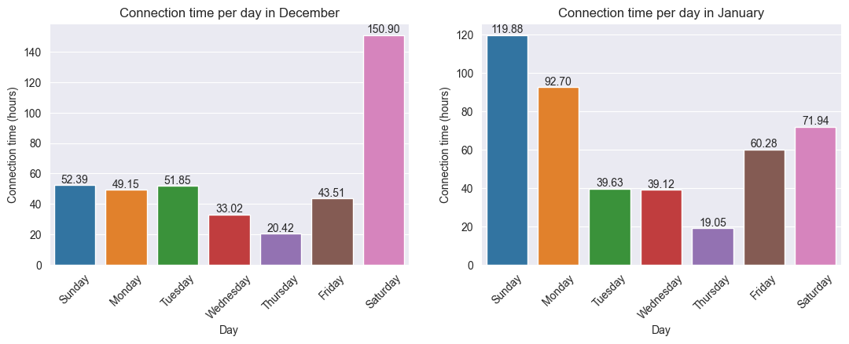

**DISTRIBUTION OF CHARGE TIME**

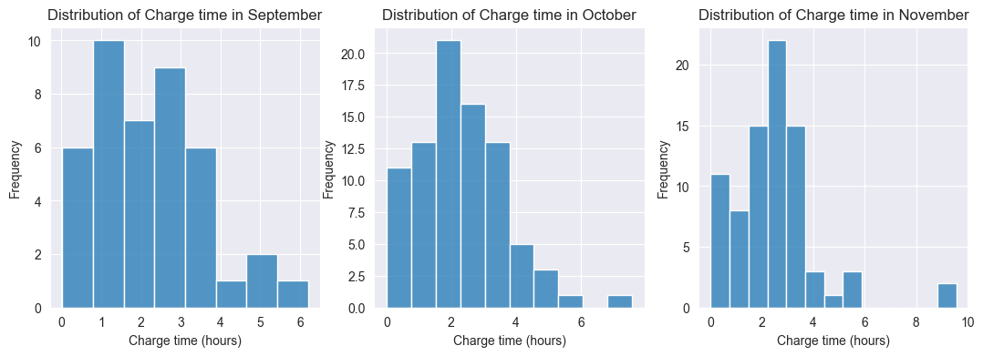

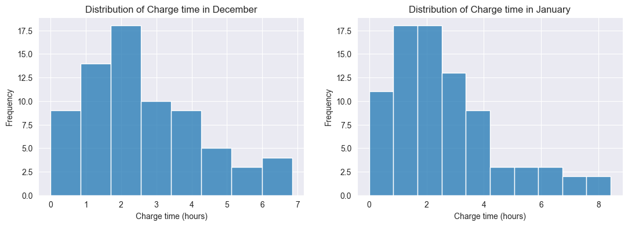

**DISTRIBUTION OF CONSUMPTION**

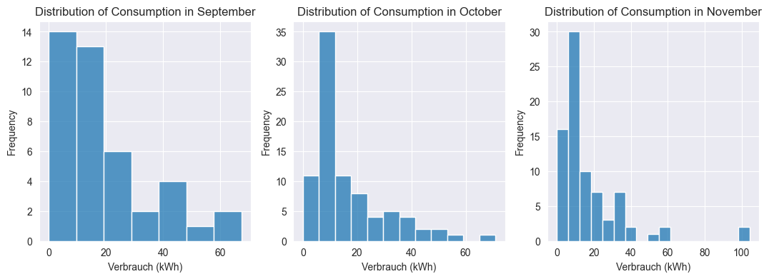

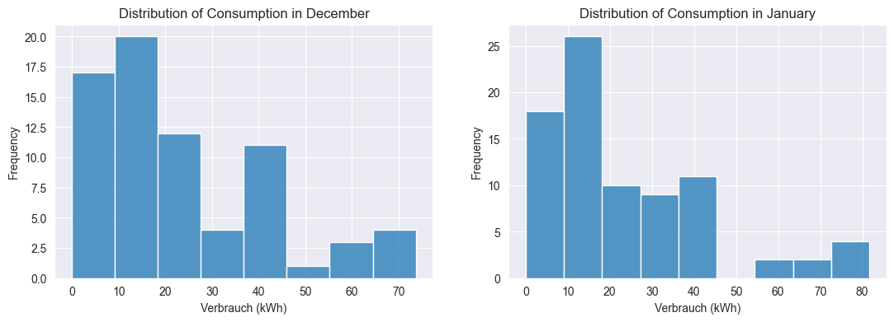

**CONSUMPTION (MONTHLY)**

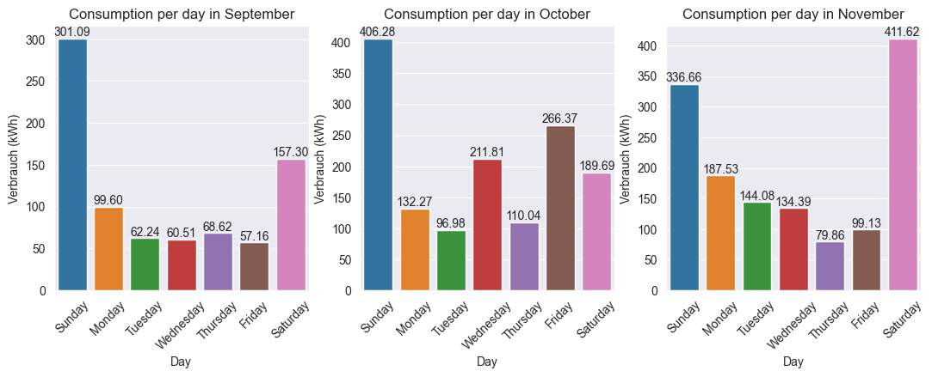

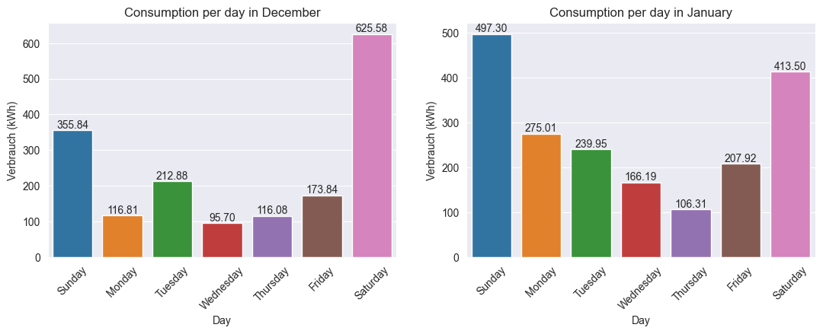

**DISTRIBUTION OF HOGGING TIME**

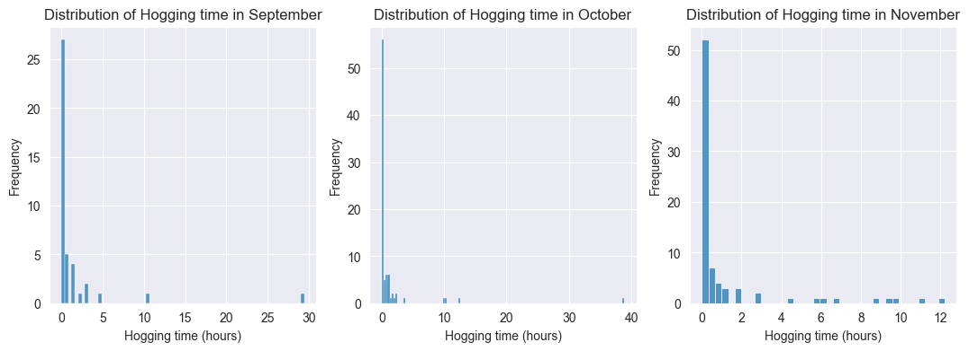

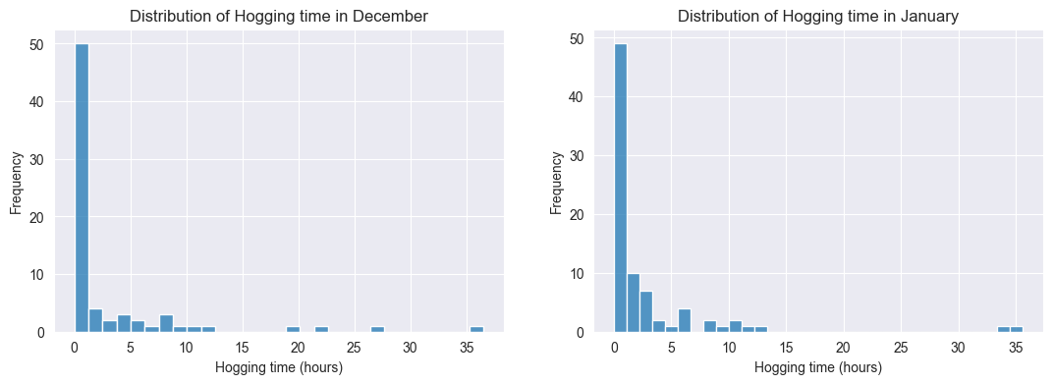

**AVERAGE CONNECTION AND BLOCKING TIMES (MONTHLY)**

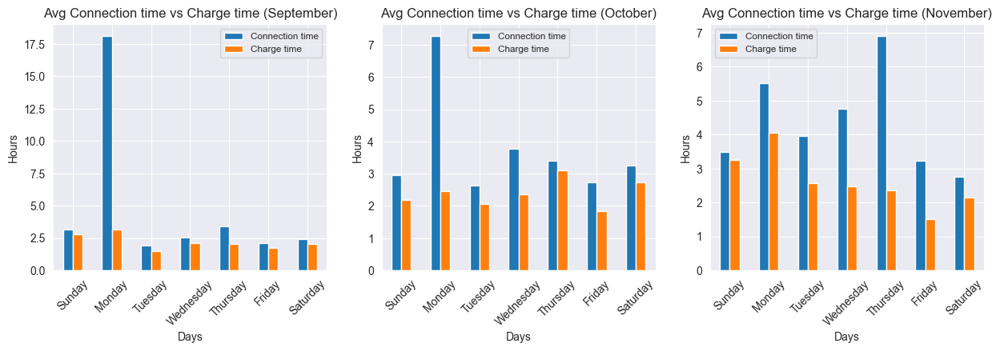

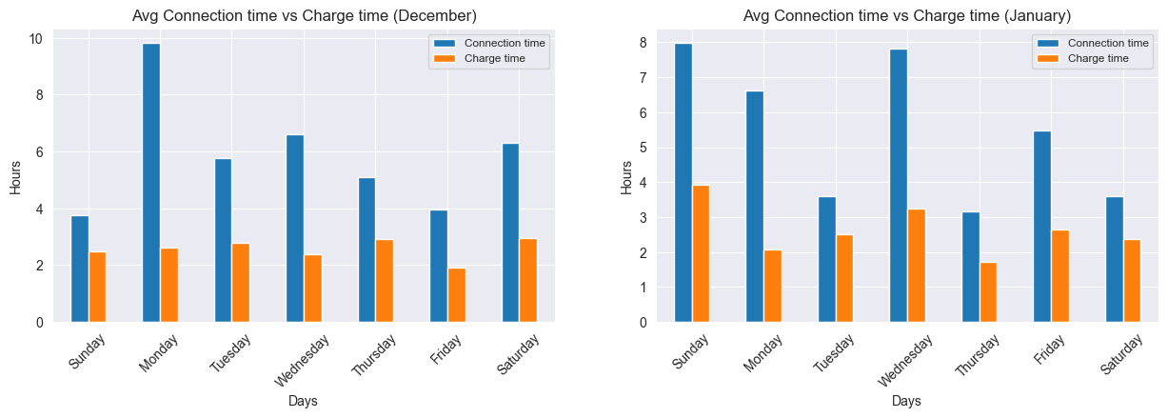

**NUMBER OF CHARGE SESSIONS**

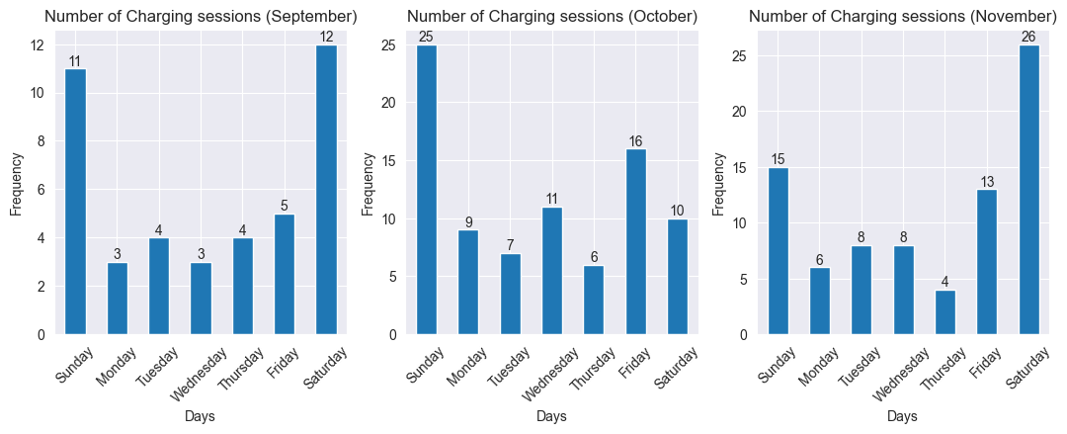

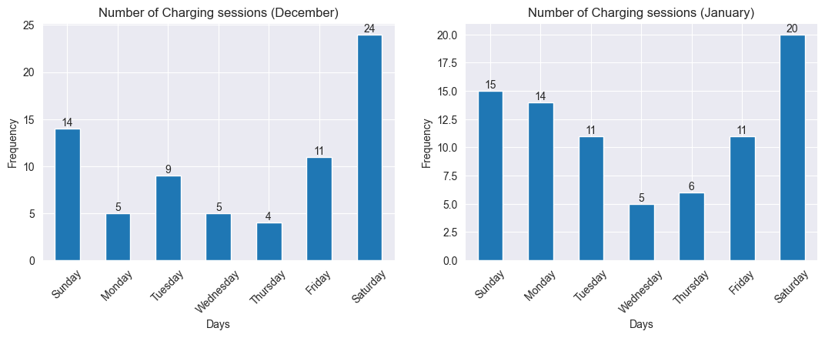

**PLUG-IN AND PLUG-OUT FREQUENCY**

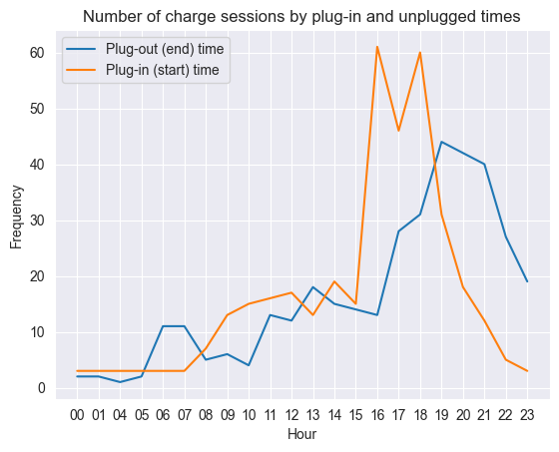

**CONNECTION TIME**

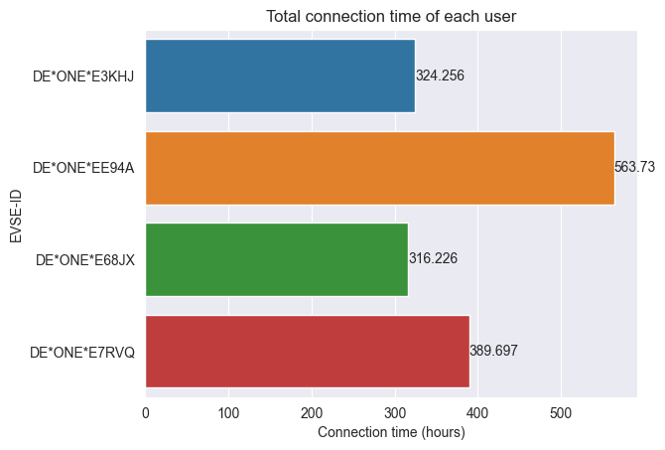

**CHARGE TIME**

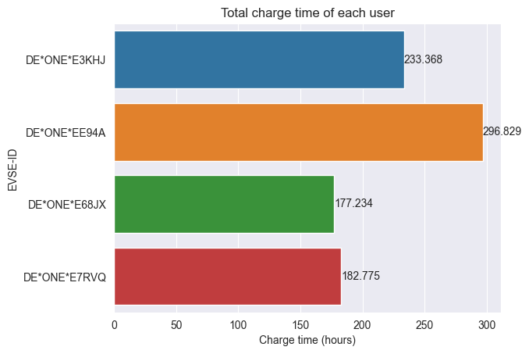

**HOGGING TIME**

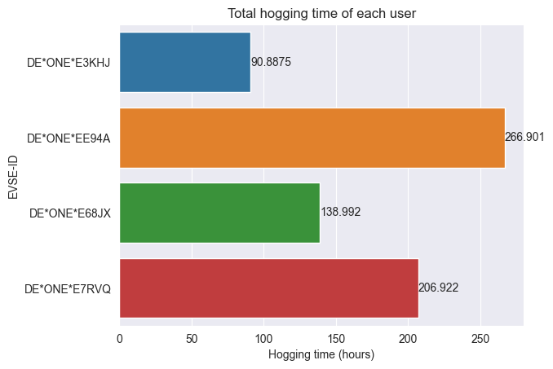

**CHARGE UTILIZATION**

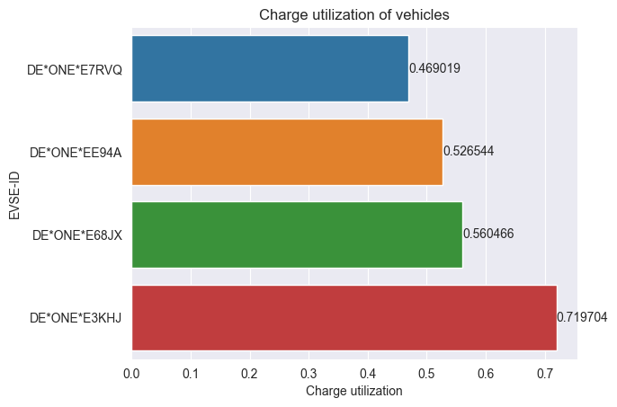

**CONSUMPTION PER MONTH**

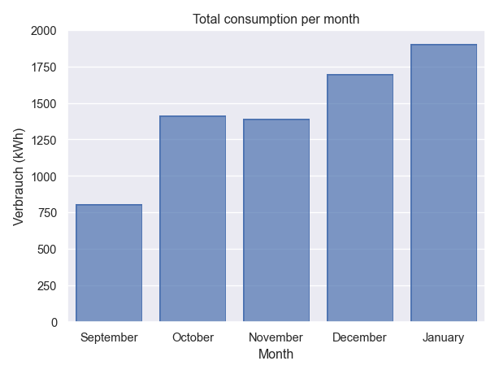

**CONSUMPTION PER CHARGE POINT**

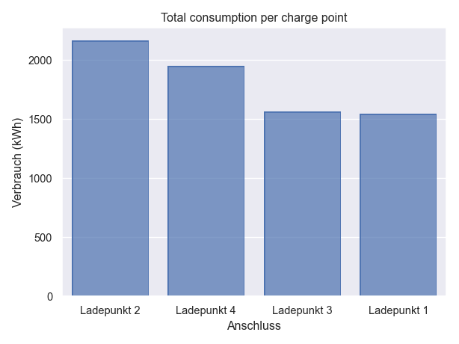

**CONNECTION TIME PER CHARGE POINT**

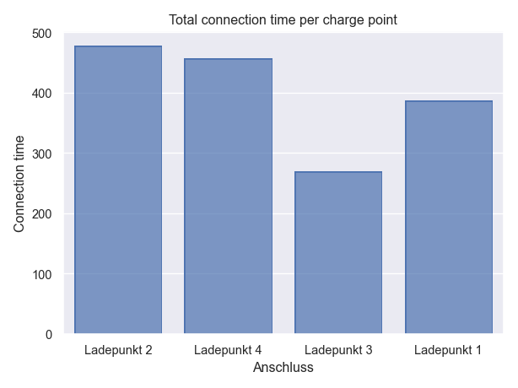

**CHARGE TIME PER CHARGE POINT**

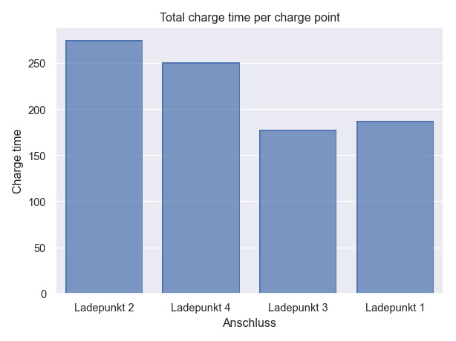

**CAPACITY UTILIZATION**

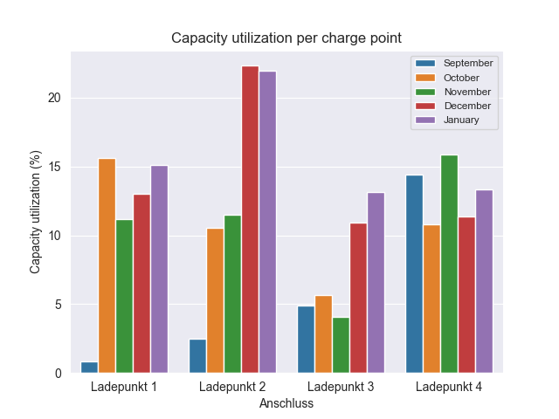

**NIGHTTIME USERS**

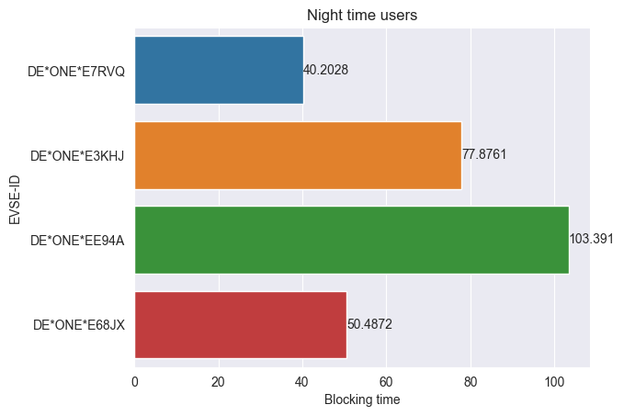

**DAYTIME AND NIGHTTIME CONSUMPTION**

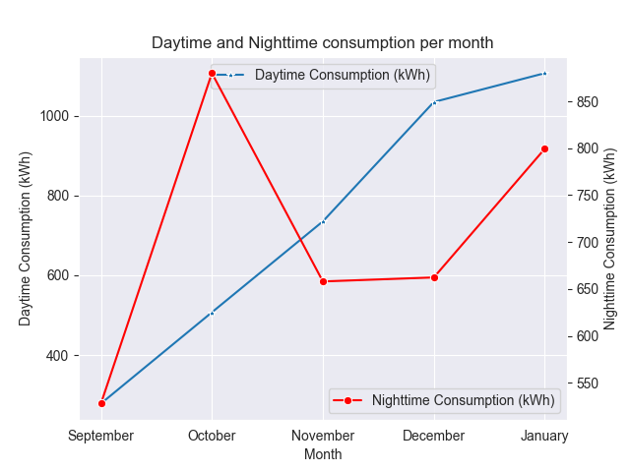

**CONSUMPTION PER SESSION PER MONTH**

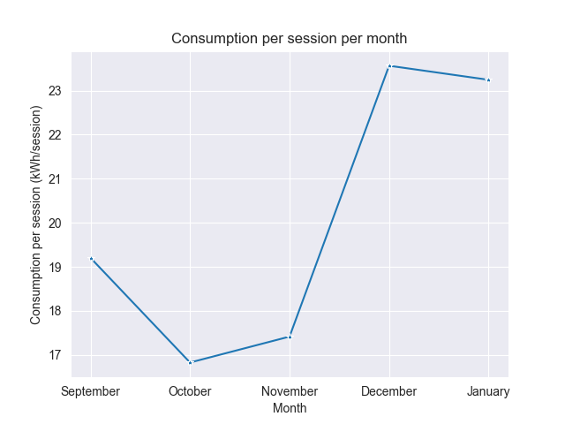

**CHARGE SESSIONS PER MONTH**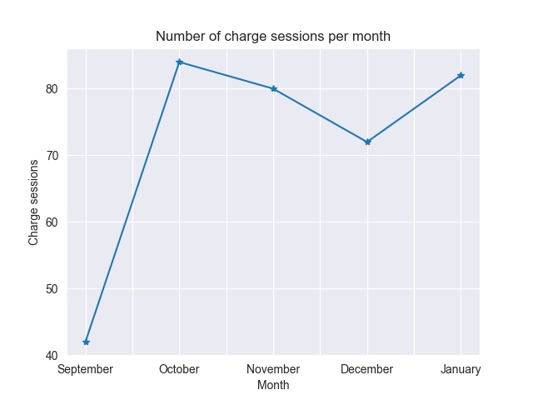

**CHARGE SESSIONS PER CHARGE POINT**

