Group 1 Capstone Project
FormFlow — Dockerized 3-Tier App with Full CI/CD
Full Project Documentation — Phase 0 through Phase 16
We are Group 1 on the Cloud & DevOps Bootcamp, and this document explains exactly how we built, deployed, and operated our capstone project — a small SaaS application we containerized with Docker, provisioned to Azure using Terraform, and connected to an automated deployment pipeline. We wrote this so that anyone reading it — including someone with no cloud or DevOps background — can understand not just what we built, but why we made each decision along the way.
Every phase below is explained in plain language first, followed by what we actually did, and a screenshot proving it. Where we don't yet have a screenshot for a phase, we've marked it clearly so we know exactly what's still outstanding.

Phase 0 — GitHub Repository
A GitHub repository is simply an online folder that keeps every version of our project's code and tracks every change anyone on the team makes to it. Before writing a single line of code, we created our repository first, because everything else in this project — our app, our Docker files, our pipeline — needed a shared home that the whole team and, later, our automated deployment tool, could reach.
What we did:
- Created a new GitHub repository for the project, giving the team a single shared source of truth.
- Set the default branch to main — this is the branch our deployment pipeline watches and deploys from.
- Gave every group member access so we could all push code and open pull requests.
[SCREENSHOT NEEDED: GitHub repository homepage showing the repo name, description, and initial commit]

Phase 1 — .gitignore + README.md
A .gitignore file tells Git which files to never track or upload — things like local secrets, dependency folders, and temporary build files. A README.md file is the first thing anyone sees when they open our repository; it explains what the project is and how to run it.
What we did:
- .gitignore — we excluded node_modules/ (installed dependencies, which are large and can be reinstalled from package.json), .env (our real secrets, which must never be committed), and build/log output folders.
- README.md — we documented the project name, the tech stack, how to run it locally with Docker Compose, and how deployment works.
[SCREENSHOT NEEDED: Repository file list showing .gitignore and README.md, and the rendered README on GitHub]

Phase 2 — Build Application
Before any Docker or cloud work, we needed a real, working application. We built an expense-management SaaS application (in our system it's referred to as the Expense Claim API on the backend, and the product-facing name shown on the login screen is ClaimFlow) that lets a user sign in and submit, review, and track expense claims.
Our tech stack:
- Frontend — Next.js (React), which we chose because it has a straightforward production build process (npm run build) and serves well from a small Node container.
- Backend — Node.js with Express, using Prisma as our ORM (Object-Relational Mapper) to talk to the database. Prisma generates type-safe database queries and manages schema changes for us through migrations.
- Database — PostgreSQL, chosen because our data (users, roles, expense records) is naturally relational — records need to reference other records (e.g. an expense claim belongs to a user) — which is exactly what a relational database is built for.
Our database's User table includes columns for id, name, email, password, role, createdAt, updatedAt, and isActive — this last column becomes important later in our incident report.
[SCREENSHOT NEEDED: Local application homepage/dashboard and a short note on core features]

Phase 3 — Dockerize Frontend + Backend
A Dockerfile is a plain text recipe that tells Docker exactly how to package our application — what base operating system to start from, what dependencies to install, and what command to run when the container starts. We created one Dockerfile inside the frontend/ directory and a separate one inside backend/, since each tier has different dependencies and a different startup command.
Both Dockerfiles use a multi-stage build — meaning the Dockerfile has more than one FROM instruction, one stage that installs everything needed to build the app, and a second, smaller stage that only keeps the finished build output. This keeps our final images small, since none of the build-only tools end up in the image we actually deploy.
- Frontend Dockerfile: based on node:20-alpine, installs dependencies, runs npm run build to produce a standalone Next.js build, then copies only the compiled output into the final image.
- Backend Dockerfile: based on node:20-alpine, installs dependencies, copies our Prisma schema, runs npx prisma generate (creates the database client code) and npm run build:all, then copies the compiled dist/ folder, the Prisma migration files, and the generated Prisma client into the production image.
Below is our actual build output for both images, run through Docker Compose:
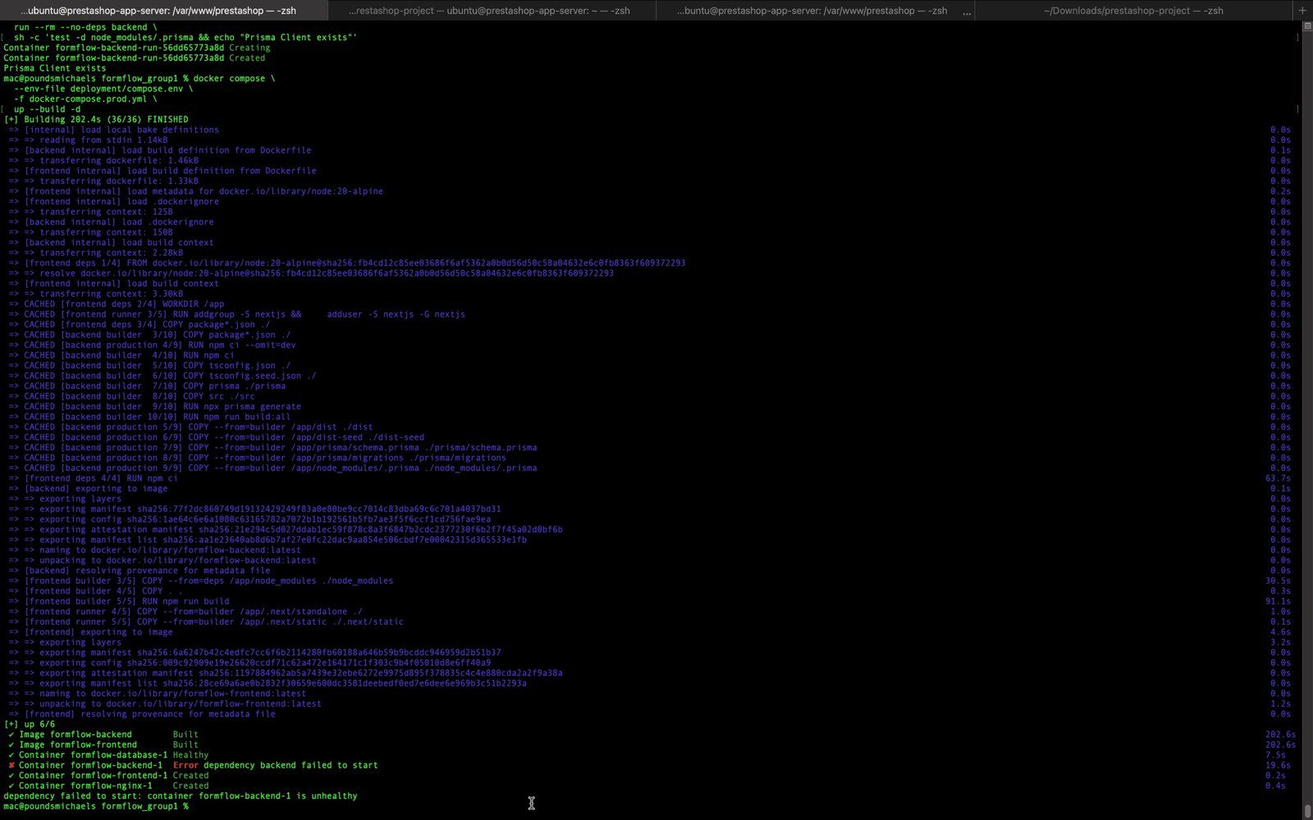
Docker building both the frontend (Next.js multi-stage) and backend (Prisma multi-stage) images from their own Dockerfiles.

Phase 4 — Docker Compose
docker-compose.yml (in our case, docker-compose.prod.yml for production) lets us define every container our app needs — frontend, backend, database, and an nginx reverse proxy — in one file, and start them all together with a single command instead of running four separate docker run commands by hand.
Inside our compose file, each service defines: which folder to build the image from, which ports to expose, which environment variables to inject (pulled from a .env file, never hardcoded), a healthcheck (a small command Docker runs periodically to confirm the service is actually working, not just started), and depends_on with condition: service_healthy, so a service only starts once the one it depends on is confirmed healthy — not just running.
After fixing an early issue with our healthchecks (documented in our incident report), here is our stack coming up cleanly, with every container passing its healthcheck and both endpoints responding successfully:
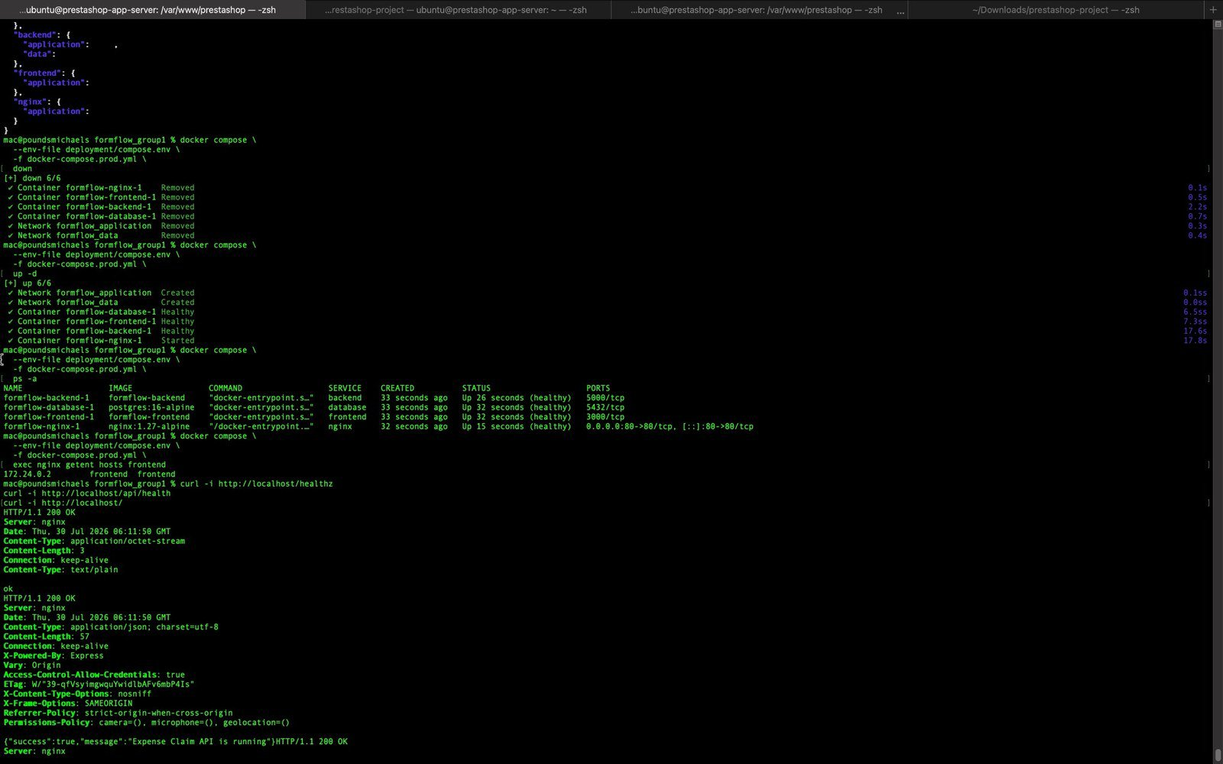
docker compose up -d bringing up all four services as Healthy, followed by successful curl health checks against nginx and the backend API.

Phase 5 — Containerize and Push to Docker Hub (Initial Image)
Docker Hub is where we store our finished, packaged application images online — the same way GitHub stores our source code online. Before pushing anything, we first confirmed our containers actually worked by running them on our own laptops.
What we did:
- Built both images locally with docker compose build.
- Started the full stack locally with docker compose up -d.
- Opened the app in a browser on localhost to confirm the frontend, backend, and database were all talking to each other correctly.
- Logged in to Docker Hub with docker login, tagged our images, and pushed the first version.
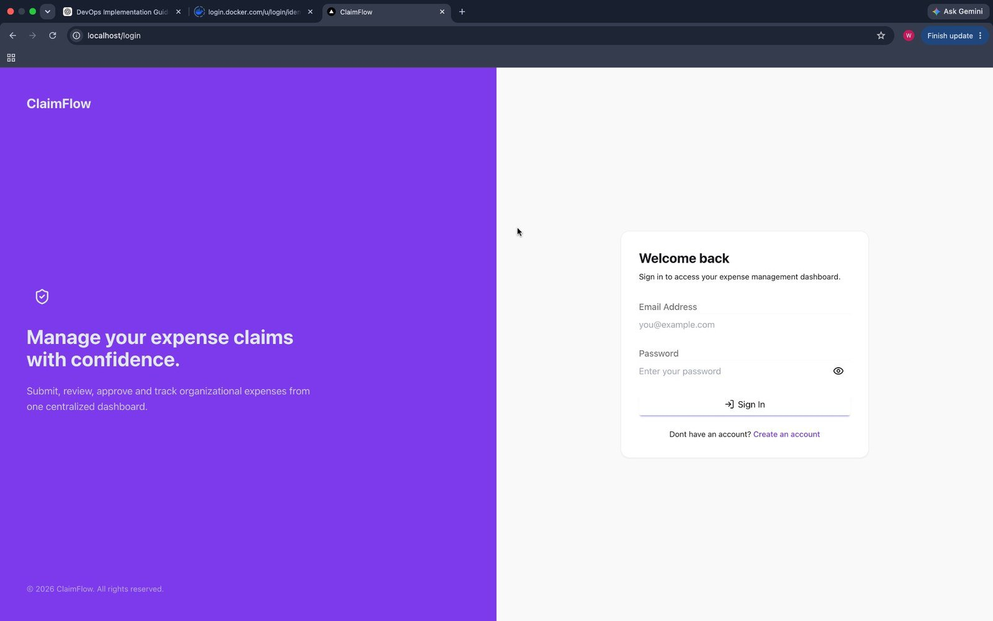
Our application's login screen, loading successfully from localhost — confirming the local container was actually working, not just running.
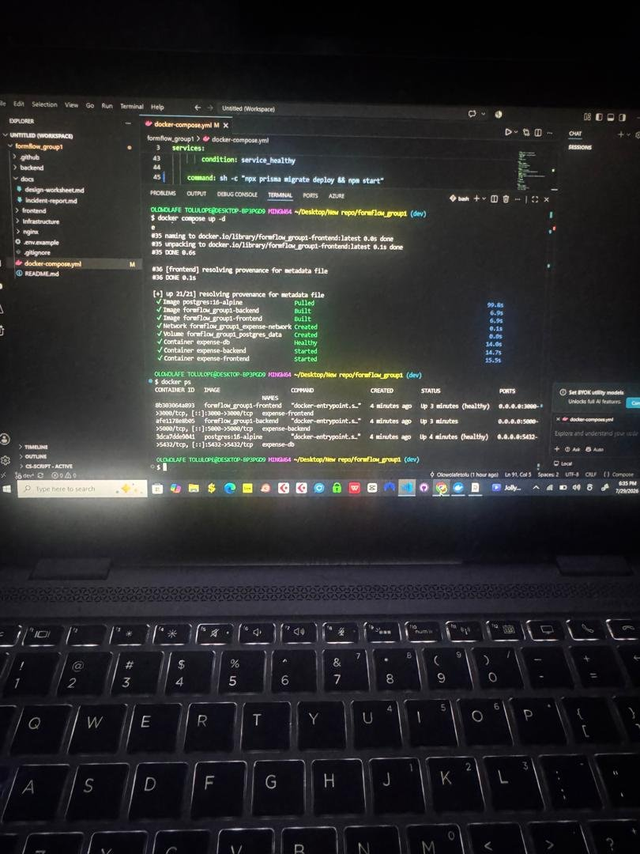
docker ps confirming all four containers (frontend, backend, database, nginx) up and reporting healthy on our own machine before anything touched Docker Hub or Azure.

Phase 6 — Terraform Infrastructure
Terraform is a tool that lets us describe our cloud infrastructure — the resource group, network, and virtual machine we need — as code, in a file called main.tf, instead of clicking through the Azure Portal by hand. This means our infrastructure can be recreated exactly, by anyone on the team, just by running the same file.
Before running Terraform, we logged in to our Azure account from the command line (az login) so Terraform had permission to create resources on our behalf. Our main.tf defines: a resource group, a virtual network with an address space of 10.10.0.0/16, a subnet, a network security group (a firewall controlling what traffic is allowed in and out), a network interface, and the Linux virtual machine itself.
Below is Terraform showing us exactly what it's about to create, before we approved it — this preview step (terraform plan, shown as part of terraform apply) is what lets us catch mistakes before anything is actually built:
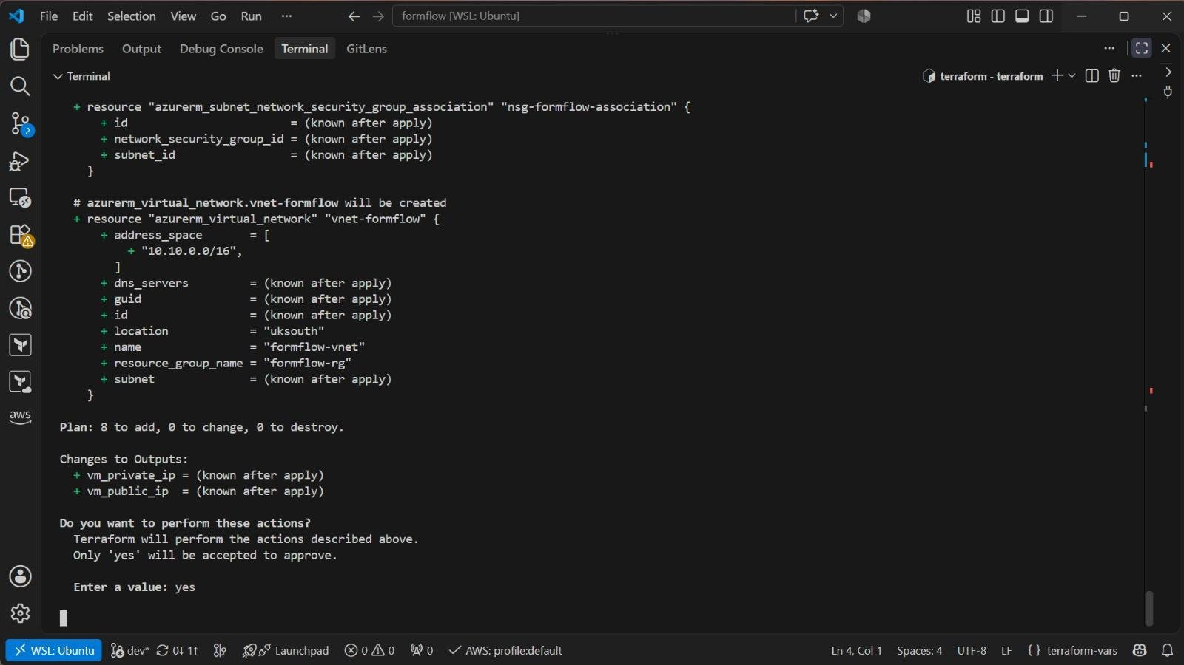
Terraform's plan output listing every resource it will create — virtual network, subnet, NSG association — waiting for our explicit 'yes' confirmation before touching Azure.

Phase 7 — Azure VM Provisioned
Once we approved the plan, Terraform created every resource in order and confirmed each one as it finished. The final output includes our new VM's private IP address (used for traffic inside the Azure network) and its public IP address (used for us to reach it, and eventually for the internet to reach our deployed app).
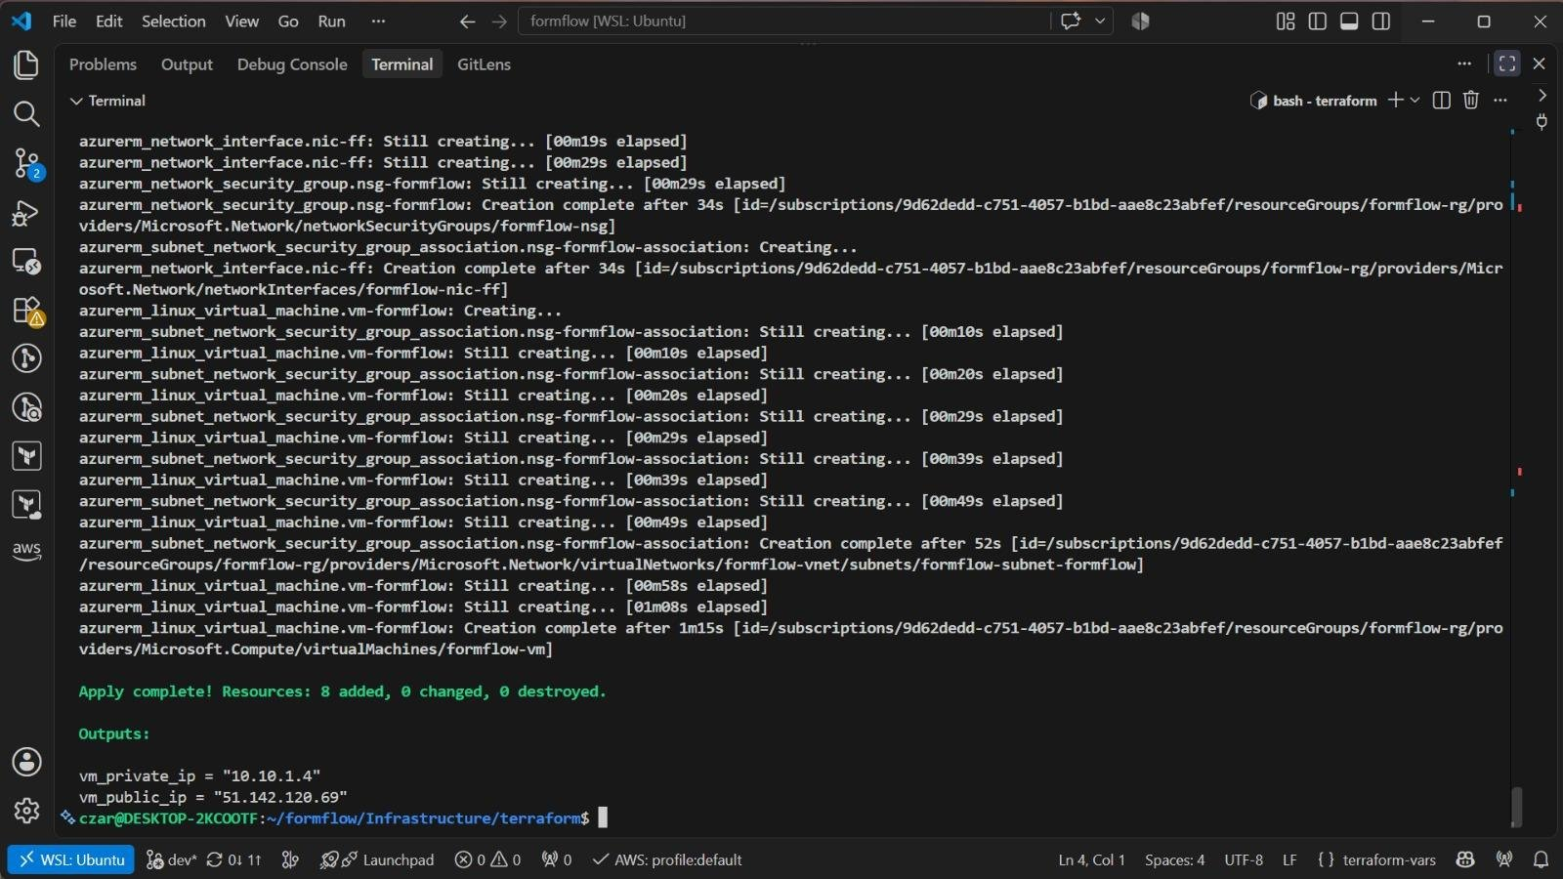
Terraform's apply completing — 'Apply complete! Resources: 8 added, 0 changed, 0 destroyed' — with our new VM's private and public IP addresses printed as outputs.

Phase 8 — VM Configured with Docker
A freshly created Azure VM is just a blank Linux computer — it doesn't have Docker installed by default. To run our containers on it, we had to connect to it remotely and install Docker ourselves.
What we did:
- Connected to the VM with ssh azureuser@<vm-public-ip>, using the SSH key pair generated when the VM was created.
- Updated the VM's package list and installed docker.io and the Docker Compose plugin.
- Added our user to the docker group so we didn't need to type sudo before every Docker command.
[SCREENSHOT NEEDED: Terminal showing SSH connection to the VM, followed by 'docker --version' and 'docker compose version' confirming both are installed]

Phase 9 — Manual Deployment
Before we automated anything, we deployed the application to the VM by hand once — this let us confirm the whole chain (VM → Docker → our images from Docker Hub → a running app) actually worked, before trusting a pipeline to do it automatically.
What we did:
- Cloned our repository onto the VM.
- Created a .env file directly on the VM containing our real environment variables — this file is never committed to GitHub.
- Ran docker compose pull to fetch our images from Docker Hub, followed by docker compose up -d.
- Confirmed every container was healthy with docker ps, and made our helper scripts (check-version.sh and rollback.sh, explained in Phase 12 and Phase 14) executable with chmod +x.
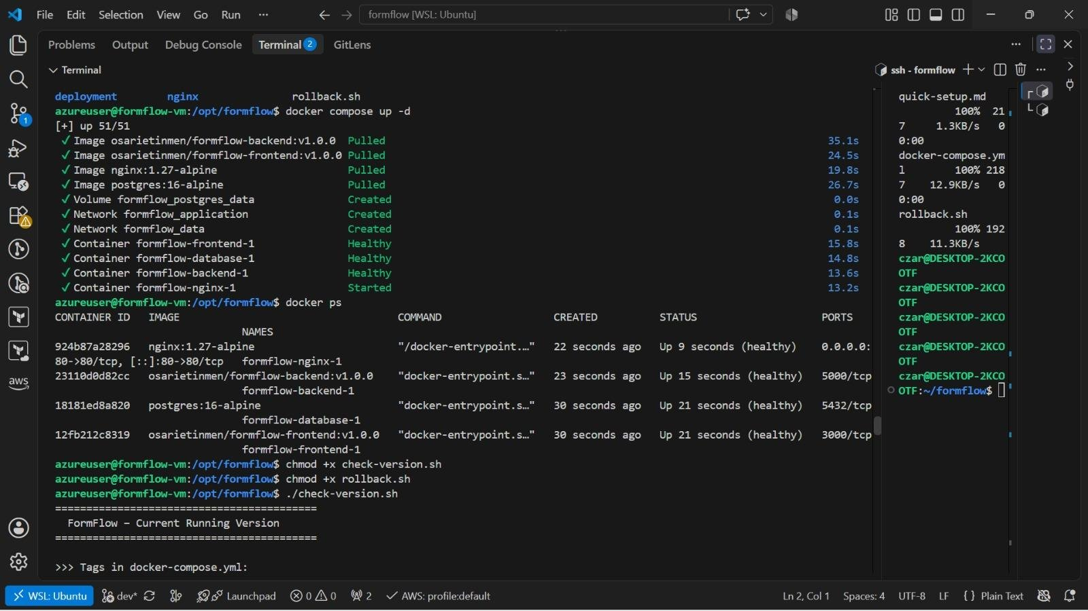
Deploying on the VM itself: pulling our tagged images from Docker Hub, all four containers reporting Healthy, and confirming with docker ps and docker compose logs.

Phase 10 — GitHub Secrets
GitHub Secrets are encrypted values stored inside our repository's settings, which our automated pipeline can use without ever exposing the real value in our code or in any log. This is how our pipeline logs in to Docker Hub and connects to our VM without us ever typing a password into a file that gets committed.
The secrets we configured (names only — the values themselves are never visible, even to us, once saved):
- DOCKERHUB_USER and DOCKERHUB_TOKEN — used to log in to Docker Hub and push images.
- VM_HOST — the VM's public IP address, so the pipeline knows where to deploy.
- VM_USER — the SSH username on the VM.
- VM_SSH_KEY — the private SSH key used to connect to the VM without a password prompt.
[SCREENSHOT NEEDED: GitHub repo Settings → Secrets and variables → Actions, showing the secret names configured (values hidden by GitHub)]

Phase 11 — GitHub Actions CI/CD
GitHub Actions is our automation pipeline — a set of instructions, written in a file at .github/workflows/devops.yml, that runs automatically every time we push code to the main branch. It builds our images, tags them, pushes them to Docker Hub, and deploys them to our VM, without anyone needing to run any of Phase 9's manual steps again.
Our tagging style: we tag every image with a version number, for example formflow-frontend:2.0.1 and formflow-backend:2.0.1, rather than using the default latest tag. We chose this because latest is just a label that keeps getting overwritten — it tells nobody which exact version is actually running. A version number lets anyone on the team look at the tag and know precisely what's live, and lets us roll back to an exact previous version instead of guessing.
Our pipeline, in order: checks out our code, logs in to Docker Hub using our stored secrets, builds and tags both images, pushes them to Docker Hub, then connects to our VM over SSH and runs docker compose pull followed by docker compose up -d to bring the new version live.
[SCREENSHOT NEEDED: GitHub Actions tab showing devops.yml, with each step of a completed run expanded]

Phase 12 — Versioned Deployment
Once our pipeline exists, every push to main automatically produces a new, uniquely tagged version and deploys it — we never have to guess what's currently live. We also wrote a small helper script, check-version.sh, that reads the tags in our compose file and checks the live containers, so anyone on the team can instantly answer 'what version is running right now' — the exact requirement in our client brief.
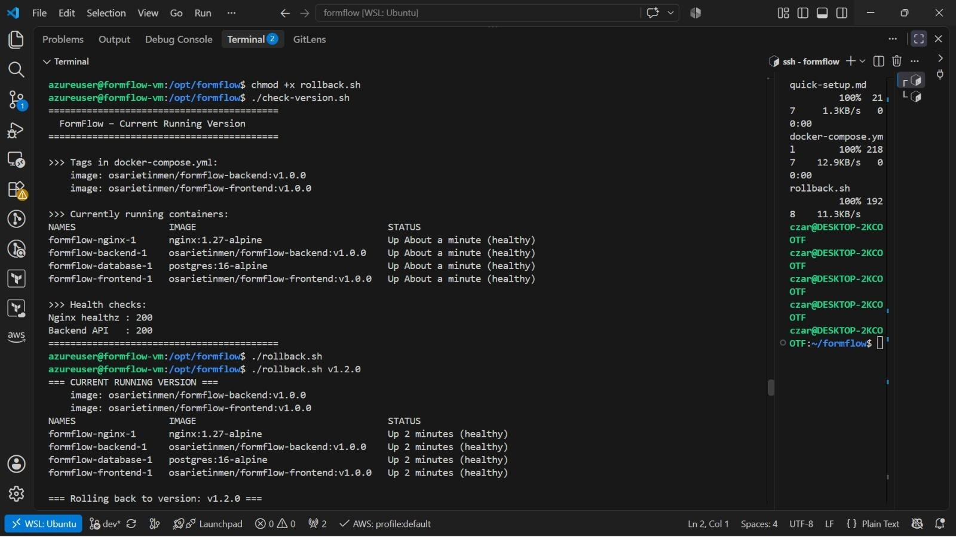
Our check-version.sh script confirming the exact image tags (v1.0.0) currently deployed, alongside live health checks returning HTTP 200 for both nginx and the backend.

Phase 13 — Automated Deployment Test
This is the stage where every member of the group pushes a small change and confirms the full pipeline runs end to end on their own change — proving the automation works for the whole team, not just whoever set it up.
[SCREENSHOT NEEDED: GitHub Actions run triggered by a teammate's push, plus the resulting version confirmed live on the VM]

Phase 14 — Rollback Test
A rollback is returning to the last known-good version after a bad deployment. We tested this for real: we deployed version v1.2.0, which broke, and then used our rollback.sh script to attempt to return to the previous working version, v1.0.0.
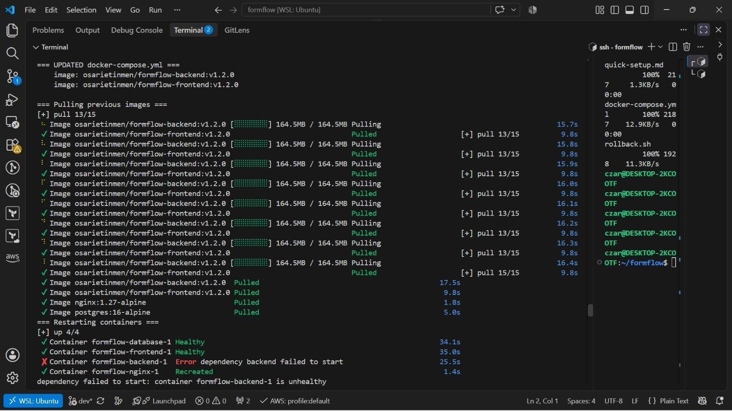
Pulling and deploying v1.2.0 — the backend container fails its dependency check and never becomes healthy: 'Error dependency backend failed to start'.
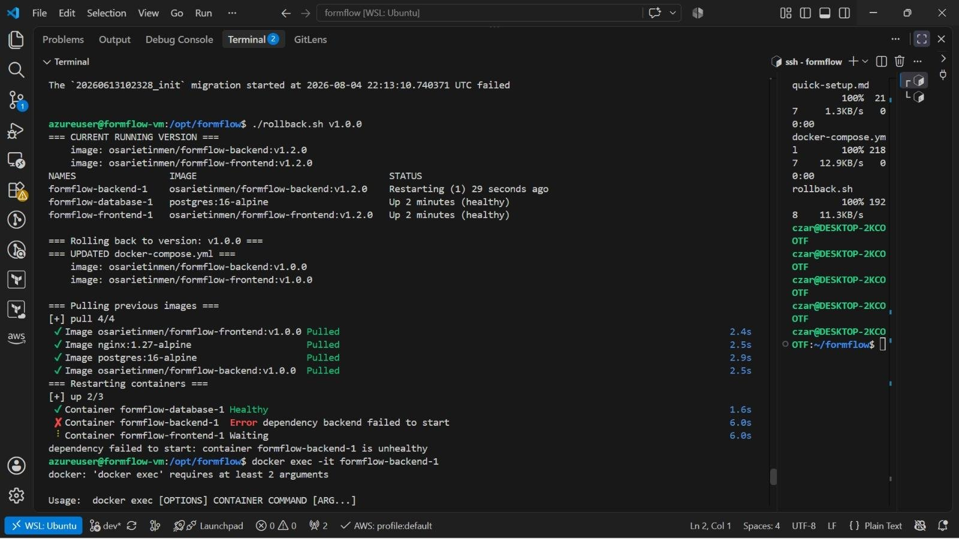
Running rollback.sh v1.0.0 to return to the previous version — the backend container still failed to start cleanly, which told us the problem wasn't only about which image tag was running (this became the subject of our incident report).

Phase 15 — Incident Report
This is a real incident we hit during our rollback test, documented exactly as it happened.

Symptom
After deploying version v1.2.0, the formflow-backend-1 container entered a restart loop and never reached a healthy state. Because our other services depend on the backend being healthy before they start, the frontend and nginx containers were blocked from starting too — 'dependency failed to start: container formflow-backend-1 is unhealthy'. Running rollback.sh to return to v1.0.0 did not immediately fix it.

Investigation trail
- Checked docker ps — confirmed the backend container was stuck in a Restarting state rather than simply stopped.
- Checked the container logs with docker compose logs backend and found a failed database migration: 'The 20260613102328_init migration started ... failed'.
- Queried the database directly with psql to list the actual columns in the User table, and compared them against our Prisma schema.
- Ran npx prisma migrate status inside the backend container, which reported migrations our database hadn't applied yet.
- Found the exact error: a PrismaClientKnownRequestError, code P2022, stating 'The column isActive does not exist in the current database' — thrown while our seed script tried to run prisma.user.upsert().
- Separately, we also found containers failing their Docker healthcheck with 'exec failed: unable to start container process: exec: "curl": executable file not found in $PATH' — because our healthchecks called curl, which isn't installed in the lightweight node:20-alpine base image.
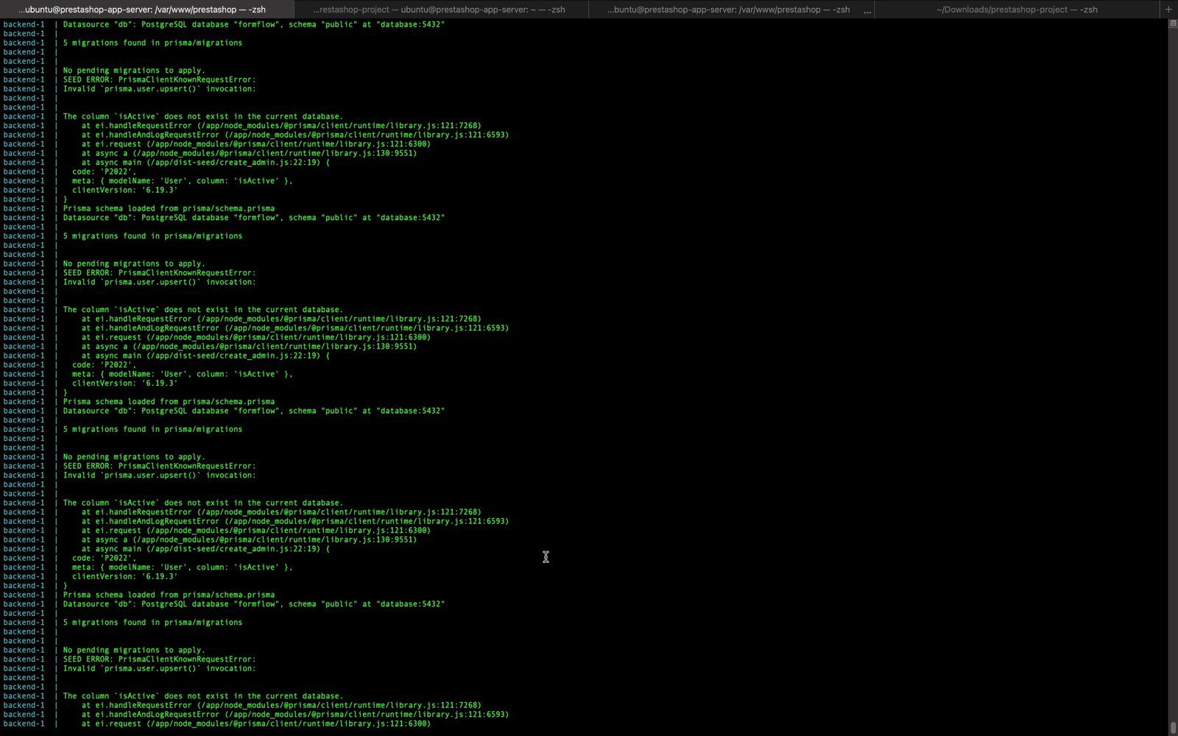
The exact Prisma error we found in the logs: code P2022 — the isActive column referenced by our seed script did not exist in the live database.

Root cause
Two separate issues combined to cause this incident. First, a Prisma migration that added an isActive column to our User table had been written and committed to our repo, but had not actually been applied to the production database before the application tried to use that column — a schema drift between our code and our real database. Second, our Docker healthchecks were written using curl, a tool that isn't included in the node:20-alpine base image we chose for its small size, so Docker was reporting containers as unhealthy purely because of a missing tool, not because the app itself was broken.

Fix
We ran the pending migration directly against the database with Prisma's migrate deploy command, which added the missing isActive column. We then re-ran our seed script, which completed successfully this time. Separately, we rewrote our healthchecks to use Node's built-in fetch function instead of curl (for example: node -e "fetch('http://127.0.0.1:5000/api/health')..."), since Node is already present in every one of our containers and needs no extra package installed.
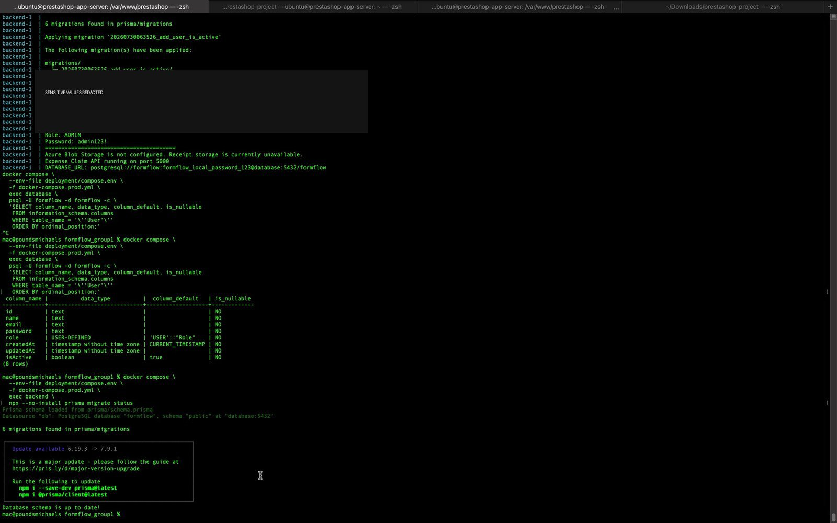
After applying the missing migration: the seed script completes successfully, and our backend health endpoint confirms the database schema is now up to date.
After both fixes, every container reported Healthy, and both http://.../api/health and our nginx health endpoint returned HTTP 200 with a successful JSON response.

Design reflection
Our Phase 0 tagging strategy did exactly what it was meant to do — it let us identify precisely which version was live at every point in this incident, and it gave us a specific, known-good tag (v1.0.0) to roll back to. But this incident also showed us a gap in our design: rolling back the application's image tag alone does not roll back the database schema. If a new version's migration has already partially run, or if a migration was simply never applied, going back to an older image doesn't undo that on its own. If we were to improve this design, we'd add a migration status check as an explicit step in our rollback script, so it can warn us — or refuse to proceed — if the database schema doesn't match what the target image version expects, rather than letting us discover it through a failed container.

Phase 16 — Final Documentation
This document is our final documentation. To summarize: we built a Next.js and Node.js/Express expense-management application backed by PostgreSQL, containerized each tier with Docker using multi-stage builds, ran them together with Docker Compose behind an nginx reverse proxy, provisioned our Azure infrastructure with Terraform, deployed manually first to prove the process worked, then automated the entire build-tag-push-deploy sequence with GitHub Actions using a versioned tagging strategy instead of latest. We tested a real rollback, hit a genuine incident involving a database migration and a Docker healthcheck bug, diagnosed both from first principles, and fixed them.
What we learned: a working deployment and a designed deployment are not the same thing. Our incident showed us that version tagging solves 'what's running' but not 'is the database in the state this version expects' — a distinction we only fully understood by actually breaking something.

Repository structure
Folder / File | Contents
.github/workflows/ | devops.yml — our GitHub Actions CI/CD pipeline
backend/ | Backend Dockerfile, Express + Prisma source, migrations
frontend/ | Frontend Dockerfile, Next.js source
nginx/ | Reverse proxy configuration
Infrastructure/ | Terraform main.tf and related files
docs/ | design-worksheet.md, incident-report.md, and this documentation
docker-compose.yml / docker-compose.prod.yml | Defines and links all four services
.env.example | Template listing required environment variables (no real values)
.gitignore | Excludes node_modules/, .env, and build artifacts from Git
README.md | Project overview and setup instructions
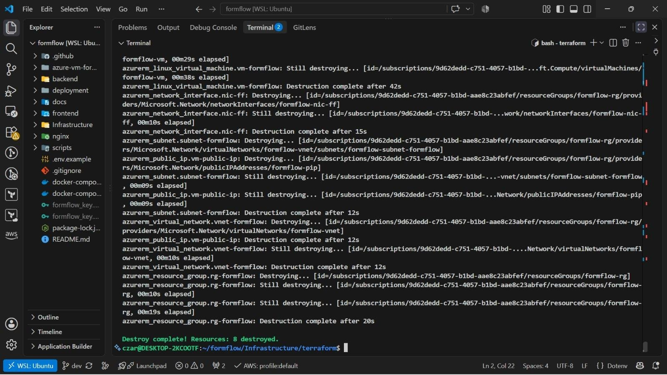
Tearing down our Azure infrastructure with terraform destroy once testing was complete, confirming every resource we created was also fully removed.

