Self-Supervised Learning (SSL) for Crop Diseases Classification using Sentinel-2 Data

Rabina Twayana
Université Bretagne Sud
Vannes, France
twayana.e2406754@etud.univ-ubs.fr
Ethel Awuor Ogallo
Université Bretagne Sud
Vannes, France
ogallo.e2406751@etud.univ-ubs.fr
Omowonuola Molayosi Akintola
Université Bretagne Sud
Vannes, France
akintola.e2406755@etud.univ-ubs.fr

Abstract—Accurate crop disease classification is crucial for precision agriculture, yet acquiring labeled satellite imagery remains expensive and time-consuming. This study investigates self-supervised learning (SSL) approaches to address the challenge of limited labelled data in remote sensing. We evaluate the MoCo v2 contrastive learning framework with a ResNet50 encoder and its associated projection head to perform contrastive pretraining on unlabeled data. The encoder was pretrained twice: first on a subset of 32,567 patches of the unlabeled data, and again on the entire unlabeled dataset consisting of 166,775 patches. Following pretraining, the projection head was replaced with a linear classifier for supervised downstream classification. Using 900 labeled crop disease images from the ICPR 2026 competition, we trained and evaluated classification performance across four disease categories (Aphid, Blast, RPH, and Rust). Our results demonstrate that SSL pretraining on the subset yielded a macro F1-score of 68.7% outperforming both the full dataset pretraining (64.9% Macro F1-score) and the ResNet50 ImageNet baseline (58.7% Macro F1-score). These findings indicate that task-specific SSL pretraining might be critical for optimal performance in label-scarce scenarios.
We hypothesize that the performance gap may stem from the fact that, as MoCo v2 lacks temporal capability, each timestamp in the full dataset was treated as an independent sample. This introduced greater spectral and phenological variability during pretraining, potentially pushing the model toward overly general representations less suited for the task.

Keywords— SSL, ResNet, MoCo, Classification, Crop Disease

Introduction
Recent advances in deep learning approaches, particularly deep neural networks (DNNs), have demonstrated remarkable success in the interpretation of Earth Observation imagery [1]. Despite these achievements, a fundamental limitation of DNN-based applications is that they require large amounts of annotated training data [1], [2]. Although the increasing availability of Earth observation data allows access to vast amounts of information, generating a good-quality labelled dataset from these complex remotely sensed images poses significant challenges [2].
Manual annotation is labor-intensive, time-consuming, and expensive procedure, which remains difficult to obtain at scale [3]. For dynamic domains such as agriculture, the challenge is more prominent when the focus is on crop disease classification and monitoring. The symptoms of crop disease can differ significantly across crop types, geographic regions, and seasons, making consistent annotation extremely difficult [3]. Additionally, plant disease is highly time-sensitive; labels generated at one instance may lose validity after a certain time due to changes in phenological stage, environmental, and weather conditions [3], [4]. As a result, producing reliable, up-to-date labelled datasets for agricultural disease detection and classification demands continuous expert involvement and substantial resources, which significantly constrain the scalability of supervised learning approaches [4]. This is where employing a self-supervised learning (SSL) approach becomes valuable to learn meaningful representations from large, unlabeled Sentinel satellite datasets before fine-tuning on a limited set of labelled samples [5].
The primary goal of this study is to improve the accuracy and efficiency of crop disease classification in a label-scare scenario. To address the critical challenge of limited labelled data in agricultural remote sensing, Self-supervised learning is leveraged to learn robust and meaningful feature representations from large volumes of unlabelled Sentinel satellite imagery. These representations are then subsequently fine-tuned on a small set of labelled samples. Additionally, this study explores the use of pretrained geospatial foundation models, leveraging their learned representations from large-scale satellite imagery and finetuning them directly on a small set of labelled samples. As a result, this study aims to contribute to significant advancements in precision farming and sustainable agricultural practices, ultimately supporting global food security.
The paper is organized as follows: Section 2 describes the datasets and methods adopted, Section 3 presents our experiments, Section 4 presents our results and analysis, and Section 5 summarizes our conclusions.

Methodology
This study implements Momentum Contrast (MoCo), a self-supervised contrastive learning framework to improve crop disease classification performance:

DATASET AND PRE-PROCESSING
This study utilizes the datasets provided by the ICPR 2026 Beyond Visible Spectrum: AI for Agriculture competition, which includes data for two main tasks: self-supervised representation learning and supervised crop disease classification [6].

Pre-Processing for Contrastive Learning Methods (MoCo): The self-supervised learning (SSL) dataset was approximately 125 GB in compressed tar.gz format, and about 130 GB when uncompressed. It consists of a total of 32567 instances. It consists of unlabelled Sentinel-2 (S2A) time-series imagery organized by geographical location and acquisition timestamp, with each scene stored as individual TIFF files corresponding to the 12 spectral bands available for Sentinel 2 multispectral imagery. For each image per timestamp, the spectral bands were stacked to form a multispectral tensor. To ensure compatibility with pretrained architectures that expect 13 channels, we generated a dummy band B10, which was missing in the imagery, resulting in a 13-band input tensor. The images were resampled to a fixed spatial dimension of 224*224 and clamp pixel values between 0 and 10000.
The supervised dataset consists of labelled crop disease images organized in a folder‑based class structure, where each folder corresponds to a specific disease category. Similar to the SSL data, we stack all the spectral bands for each sample to form a multispectral tensor, and a synthetic B10 band was also generated as an all‑zero channel to obtain a consistent 13‑channel input representation with all images resampled and resized to 224*224 to ensure a similar spatial resolution across all bands and clamp pixel values between 0 and 10000. The dataset showed a high-class imbalance and was therefore split into a train and a validation subset, using an 80/20 stratified split to preserve overall class distribution, while the evaluation unlabelled dataset provided by the competition was set aside as the test set. To mitigate the class imbalance in the training subset, we computed class frequencies and derived inverse-frequency weighting factors that were used to implement a weighted random sampling strategy that is used during mini-batch creation. This strategy reduces bias towards majority classes, ensuring the model sees the minority classes more during training.
Finally, the inputs for both SSL pretraining and supervised classification are multispectral tensors resized to the model‑specific input shape of 13 × 224 × 224 to match the expected dimensions of the model architectures.

SELF-SUPERVISED LEARNING
For self-supervised pretraining, we adopt the MoCo v2 framework to learn generalizable representations from large unlabeled Sentinel imagery. It is a momentum-based contrastive learning approach where the task is to maximize agreement between augmented views of the same image (positive pairs) while contrasting them across many stored negative pairs. Our choice to use MoCo is driven mainly by the computational resources’ constraint. Compared to other self-supervised frameworks such as SimCLR , MoCo requires far smaller batch sizes during pretraining [7], [8]. We adopt MoCo v2 instead of MoCo v1 due to its improved feature representation quality as it incorporates stronger data augmentations and a two-layer MLP projection head instead of a linear projection, which leads to more robust and transferable embeddings [7].
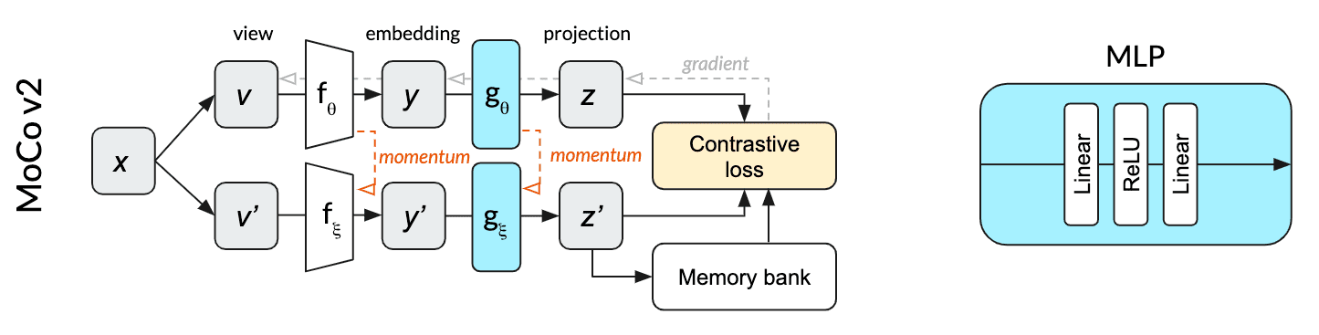
Fig 1. MoCo V2 Framework [9]
Figure 1 represents the MoCo v2 self-supervised contrastive learning framework. It consists of a feature encoder, a projection head (MLP), and a momentum encoder that maintains a queue of feature embeddings to stabilize contrastive training. MoCo splits the single network into an online network (top path) parameterized by θ and a momentum network (bottom path) parameterized by ξ. The online network is updated by stochastic gradient descent (backpropagation), while the momentum network is updated based on an exponential moving average of the online network weights. The momentum network allows MoCo to efficiently use a memory bank that stores many past projections as negative examples for contrastive loss. This memory bank provides a large set of negative samples without requiring huge batches [9]. During pretraining, the model learns to map different augmentations of the same image close together in the embedding space while pushing apart the embeddings of other images.

DOWNSTREAM TASK
For the MoCo Framework, the downstream classifier uses the pretrained MoCo ResNet50 encoder as a feature extractor. The projection head of the contrastive pretraining is removed, and a linear classification layer replaces it to map the 2048-dimensional feature embeddings to the target classes. The backbone is frozen for training the linear classification layer.

LOSS FUNCTION AND METRICS
The self- supervised learning uses a contrastive loss function called InfoNCE [10], which is such that it brings representations of positive (similar) sample pairs closer while pushing representations of negative (dissimilar) samples apart.
$$L_{q,k+,k-} =-log \frac{\exp\left(q·k^{+}/τ\right)}{\exp\left(q·k^{+}/τ\right)+\sum_{k^{-}}{\exp\left(q·k^{-}/τ\right)}}$$
where q is a query representation, k⁺ is a representation of
The positive key sample, and {k⁻} are representations of the negative key samples. τ is a temperature hyper-parameter.
Because of the imbalanced nature of the dataset for the downstream task, we utilize the focal loss [11] which is defined as:
$$FL\left(p_{t}\right)=-{\left(1-p_{t}\right)}^{γ}\log\left(p_{t}\right)$$
where p_{t} is the predicted probability for the true class, α_{t} is the weighting factor, and γ>0 is the tunable focusing parameter.
We assess the performance of the model with the Macro F1-score, which is the mean of all the per-class F1 scores, the harmonic mean of precision and recall per class. This score treats all classes equally, regardless of their weight.

Experimental Setup

Self-Supervised Pretraining
We performed MoCo pretraining on two sets of data using ResNet50 backbone adapted to 13 Sentinel2 bands (224*224 patches) using strong spatial and radiometric augmentations to generate two views per image. The encoder is initialized from MoCo pretrained Sentinel2 weights (ResNet50_Weights.SENTINEL2_ALL_MOCO) and optimized with Adam. Both the ResNet50 backbone (23.54M params) and MoCo projection head (26.22M params) are fully trainable during pretraining, totaling 47.76M trainable parameters out of 99.52M overall. ResNet50 backbone momentum (23.54M params) and projection head momentum (26.22M params) remain frozen. Table 1 summarizes the model parameters and pre-training setup. Data augmentation was applied following standard contrastive learning principles that include random resized cropping, horizontal and vertical flips, Gaussian blur, and brightness adjustments, which helps the model to learn invariant representations under different conditions.

Subset of data: A subset of data was created by selecting 1 middle timestamp from each instance, which results in 32,567 patches. The configuration uses a learning rate of 0.0002, momentum of 0.9, batch size of 128, a memory bank of 4096 negatives, and a maximum of 50 epochs with a batch size of 128.

Full dataset: The complete dataset comprises 32,567 instances, which results in 166,775 patches. All other hyperparameters were kept identical to the subset configuration, except for an increased memory_bank_size of 16384, 100 maximum epochs, batch size of 128, a learning rate of 0.0002, and momentum of 0.9.
Exp Id | Dataset | Epoch | Batch Size | Memory Bank  Size | #Parameter(M)
 |  |  |  |  | Total | Trainable
1 | Subset | 50 | 128 | 4096 | 99.5 | 47.8
2 | Full | 50 | 128 | 16384 | 99.5 | 47.8
- Pretraining Configurations

Downstreaming Task
As a baseline, we utilized a ResNet50 backbone initialized with Sentinel-2 MoCo pretrained weights. The training was conducted using a batch size of 16, AdamW optimizer, weight decay of 10⁻⁵, and a learning rate of 10⁻³ over 100 maximum epochs. Due to class imbalance, we use focal loss and early stopping with patience of 30 epochs based on the macro F1-score on the validation set. Building on the baseline, we conducted several experiments and optimized the model hyperparameters using Optuna with a shared space for all the experiments. We defined the objective function with the batch sizes {8,16,24}, learning rate logarithmically of range 10⁻⁵ to 10⁻², weight decay logarithmically of range 10⁻⁶ to 10⁻³, focal gamma of range {1.0-4.0}, and label smoothing {0.0-0.2}. The final hyperparameter configuration chosen was experiment-based. Experiment 1 involved a backbone initialized with SSL-pretrained weights obtained from training on a subset of the unlabeled data, and further tests included adding some augmentation to the labelled to reduce overfitting observed. Experiment 2 involved using a backbone initialized with SSL-pretrained weights trained on the full unlabeled dataset.
The experiments were conducted within the Pytorch framework. The SSL MoCo pretraining was conducted using a high-end laptop with an Intel Core i9-14900HX (24 cores/32 threads), NVIDIA RTX 4090 Laptop GPU, 16 GB GPU Memory, and 64 GB RAM was used for the full dataset. The downstream task based on the MoCo encoder was trained on the Kaggle GPU environment using the dual NVIDIA Tesla T4 GPUs.

Results and Discussions

Pre-Training
Table II presents the pre-training performance of two experimental configurations, reporting the number of epochs, total training time, final training loss, and standard deviation.
Experiment 1 (using a subset of data) achieved the lowest training loss (3.2313). The loss standard deviation (0.0159) is slightly higher than the other experiments, indicating marginally greater fluctuation during training. However, the lower loss suggests that this configuration converged faster and more effectively within fewer computational resources.
Experiment 2 (using the full dataset) was trained for 50 epochs. Despite training on the full dataset, experiment 2 resulted in a higher training loss of 3.4031. The loss standard deviation is lower than that of experiment 1, as shown in figure 2, which indicates slightly more stable training. However, despite the pretraining on the full dataset, the loss still did not surpass the performance of Experiment 1.
- Pre-training Performance
Exp Id | Epoch | Training Time | Train Loss | Train Std
1 | 50 | 1 hr 19 min | 2.2729 | 0.0164
2 | 50 | 6 hr 38 min | 3.4031 | 0.0162

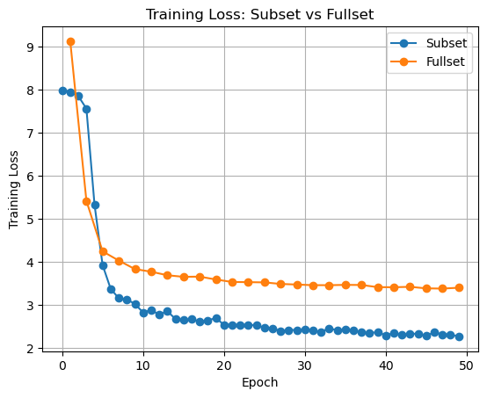Figure 2. SSL training loss curves comparison between the training on subset of the unlabeled data and the full dataset.

DownstreamingTask
Table III presents the performance metric of the experiments done for the downstream crop disease classification task. The baseline model achieved a Macro F1-score of 58.7%, which provided a reference for assessing the benefit of self-supervised learning pretraining.
- Performance metrics for each experiment
Exp id | Weights | Val Macro F1-score (%) | Evaluation Score (%)
Baseline | ResNet50 S2 weights | 58.7 | 81.25
1 | SSL pretrained subset | 68.7 | 87.5
2 | SSL pretrained full | 64.9 | 81.5

Experiment 1 uses the SSL-pretrained weights from a subset of the unlabeled dataset which shows an improvement on the Macro F1-score to 68.7%, showing that domain-specific pretraining enhances feature extraction for crop disease classification. This improvement suggests that SSL enabled the model to learn meaningful representations related to crop disease patterns. However, this experiment also showed signs of overfitting as seen in figure 3, likely due to the relatively small size of the labeled dataset used during fine-tuning.
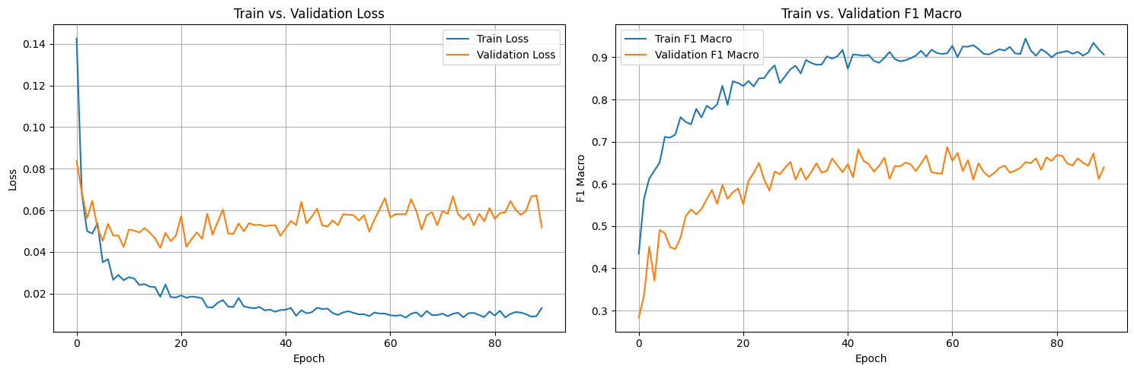Fig 3. Loss and F1 score curves for both training and validation sets using the SSL weights pretrained on a subset of the data (Exp id 1)
To address the overfitting, we applied data augmentation during downstream training, resulting in a slight decrease in the Macro F1-score but with improved generalization overall. This is because data augmentation introduces variability in the training samples, allowing the model to learn more invariant features, improving model stability and reducing overfitting.
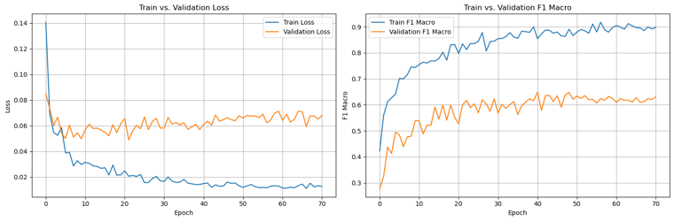
Experiment 2 uses the SSL-pretrained weights provided from the full unlabelled dataset. This resulted in an unexpected performance drop, with the Macro F1-score decreasing to 64.9% with increased overfitting during fine-tuning as seen in figure 4.
Fig 4. Loss and F1 score curves for both training and validation sets using the SSL weights pretrained on the full data (Exp id 2)
The decrease in performance likely occurred because our SSL weights trained on the full dataset did not account for the temporal nature of the unlabelled data, while the labeled dataset was not temporal, causing the model to not generalize well.

Conclusion
This study investigated the effectiveness of deep learning approaches for crop disease classification using the Sentinel-2 dataset: MoCo, a self-supervised contrastive learning approach. Our study shows that SSL pre-training using a small subset helps to enhance the model performance. However, unexpected behaviour was observed in the downstream task when using the SSL-pretrained weights trained on the full dataset, leading to reduced performance. This outcome was likely due to our model not considering the temporal aspect of the data during SSL pretraining, treating each image as independent.
Overall, the findings suggest that pre-training strategies, dataset volume, and augmentation techniques play critical roles in determining model performance. Further experiments and investigation are required to understand why the SSL pre-training using the entire dataset did not perform as expected.

Data and Code Availability
The full dataset used for SSL is accessed and available at "Beyond Visible Spectrum: AI for Agriculture 2026" Kaggle competition [Link]. The subset of the full dataset for SSL is uploaded in Kaggle datasets [Link]. The source code for model training and evaluation is available at GitHub [Link].

References
[1] S. Lahrichi, Z. Sheng, S. Xia, K. Bradbury, and J. Malof, “Is Self-Supervised Pre-training on Satellite Imagery Better than ImageNet? A Systematic Study with Sentinel-2,” Feb. 15, 2025, arXiv: arXiv:2502.10669. doi: 10.48550/arXiv.2502.10669.
[2] Y. Wang, C. M. Albrecht, N. A. A. Braham, L. Mou, and X. X. Zhu, “Self-supervised Learning in Remote Sensing: A Review,” Sep. 02, 2022, arXiv: arXiv:2206.13188. doi: 10.48550/arXiv.2206.13188.
[3] M. Shafay et al., “Recent advances in plant disease detection: challenges and opportunities,” Plant Methods, vol. 21, p. 140, Oct. 2025, doi: 10.1186/s13007-025-01450-0.
[4] J. Dong et al., “Data-centric annotation analysis for plant disease detection: Strategy, consistency, and performance,” Front. Plant Sci., vol. 13, Dec. 2022, doi: 10.3389/fpls.2022.1037655.
[5] Y. Xu, Y. Ma, and Z. Zhang, “Self-supervised pre-training for large-scale crop mapping using Sentinel-2 time series,” ISPRS Journal of Photogrammetry and Remote Sensing, vol. 207, pp. 312–325, Jan. 2024, doi: 10.1016/j.isprsjprs.2023.12.005.
[6] “AgVision – ICPR 2026 Competition on “Beyond Visible Spectrum: AI for Agriculture.” Accessed: Feb. 16, 2026. [Online]. Available: https://han-research.gitlab.io/Agvision/
[7] X. Chen, H. Fan, R. Girshick, and K. He, “Improved Baselines with Momentum Contrastive Learning,” Mar. 09, 2020, arXiv: arXiv:2003.04297. doi: 10.48550/arXiv.2003.04297.
[8] T. Chen, S. Kornblith, M. Norouzi, and G. Hinton, “A Simple Framework for Contrastive Learning of Visual Representations,” Jul. 01, 2020, arXiv: arXiv:2002.05709. doi: 10.48550/arXiv.2002.05709.
[9] “Understanding self-supervised and contrastive learning with ‘Bootstrap Your Own Latent’ (BYOL) - imbue.” Accessed: Feb. 16, 2026. [Online]. Available: https://imbue.com/research/2020-08-24-understanding-self-supervised-contrastive-learning/
[10] K. He, H. Fan, Y. Wu, S. Xie, and R. Girshick, “Momentum Contrast for Unsupervised Visual Representation Learning,” Mar. 23, 2020, arXiv: arXiv:1911.05722. doi: 10.48550/arXiv.1911.05722.
[11] T.-Y. Lin, P. Goyal, R. Girshick, K. He, and P. Dollár, “Focal Loss for Dense Object Detection,” Feb. 07, 2018, arXiv: arXiv:1708.02002. doi: 10.48550/arXiv.1708.02002.

