**Name:- Om Ramakant Parvate Div:-"B" Roll.no 168 Batch:-B6**

**Practical no 1:- Web 2 Perform Arithmatic Opration**

<!DOCTYPE html>

<html lang="en">

<head>

    <title>Document</title>

</head>

<body>

    <script>

        let num1=30;

        let num2=10;

        let addition = num1 + num2;

        console.log("Addition:" + addition);

        let subtraction = num1 - num2;

        console.log("subtraction:" + subtraction);

        let multiplication = num1 * num2;

        console.log("multiplication:" + multiplication);

        let division = num1 / num2;

        console.log(" division:" + division);

    </script>

</body>

</html>

**Output:-**

Addition:40

subtraction:20

multiplication:300

division:3

Name:- Om Ramakant Parvate Div:-"B" Roll.no 168 Batch:-B6

Practical no 2:- Control Structure : Implement a JavaScript program using if-else statement and loops

<!DOCTYPE html>

 <html>

 <head>

    <title>Control structures in javaScript</title>

 </head>

 <body>

    <script>

        let number=10;

        if (number > 0)

    {

        console.log(number + "is positive number.");

    }

    else if (number > 0)

    {

        console.log(number + "is nagaitive number.");

    }

    else

    {

        console.log("The number is zero.");

    }

    console.log("\nNumber from 1 to 5:");

    for(let i = 1; i<= 10; i++)

    {

        console.log(i);

    }

    console.log("\nNumber from 1 to 10 using while loop:");

    let i =1;

    while(i<=10)

    {

        console.log(i);

        i++;

    }

    </script>

 </body>

 </html**>**

Name:- Om Ramakant Parvate Div:-"B" Roll.no 168 Batch:-B6

Practical no 3:- Function

<!DOCTYPE html>

<html>

<head>

<title>Javascripts function</title>

</head>

<body>

<script>

function addNumber(a,b) {

return a+b;

}

function calculateArea (radius) {

return Math.PI*radius*radius;

}

function greetuser(name) {

console.log("Hello," + name + "!");

}

function introduce(name = "Guest")

{

console.log("welcome,"+ name + "!");

}

function isEven(number)

{

if (number % 2 === 0){

console.log(number + " is an even number.");

} else {

console.log(number + " is an odd number.");

}

}

let sum = addNumber(50,50);

console.log("sum of 50 & 50: + sum");

let area = calculateArea (6);

console.log("Area of the circles:"+area.toFixed(2));

greetuser("pawan");

greetuser("pooja");

introduce("pawan")

introduce("pooja")

isEven(12);

isEven(7);

</script>

</body>

</html>

Name: Parab Ravindra Swami Roll no.: 194 Div: B

Class: FYBCA Sem-2 Practical no. -4

<!DOCTYPE html>

<html lang="en">

<head>

<meta charset="UTF-8">

<meta name="viewport" content="width=device-width, initial-scale=1.0">

<title>Event Handling Example</title>

<style>

body{

font-family: Arial, Helvetica, sans-serif;

padding: 20px;

}

.button-container{

margin-top: 20px;

}

#message{

margin-top: 20px;

font-size: 1.5rem;

font-weight: bold;

}

.highlight{

background-color: yellow;

}

</style>

</head>

<body>

<h1>JavaScript Event Handling</h1>

<button id="clickButton">Click ME!</button>

<button id="changeTextButton">Change Text</button>

<p id="message">This is the original text.</p> <!-- Fixed space issue here -->

<button id="highlightTextButton">Highlight Text</button>

<script>

document.getElementById("clickButton").addEventListener("click", function() {

alert("Button clicked!");

});

document.getElementById("changeTextButton").addEventListener("click", function() {

document.getElementById("message").innerHTML = "You have changed the text!";

});

document.getElementById("changeTextButton").addEventListener("mouseover", function() {

document.getElementById("changeTextButton").style.backgroundColor = "lightblue";

});

document.getElementById("changeTextButton").addEventListener("mouseout", function() {

document.getElementById("changeTextButton").style.backgroundColor = "yellow";

});

document.getElementById("highlightTextButton").addEventListener("click", function() {

const messageElement = document.getElementById("message");

messageElement.classList.toggle("highlight");

});

</script>

</body>

</html>

Name:- Om Ramakant Parvate Roll.no:- 168 Class:- FY.BCA Batch:- B6

Practical:- 5 Installation of Node . Js.

Step 1 : Download Node .js

Go to the official Node .js website :http://nodejs.org

Choose the LTS(Long-Term Support) version for better stability (recommended) or the latest version for new features.

Download the installer based on your operating system:

Windows: .msi file

Mac: .pkg file

Linux: Use package managers like apt or yum

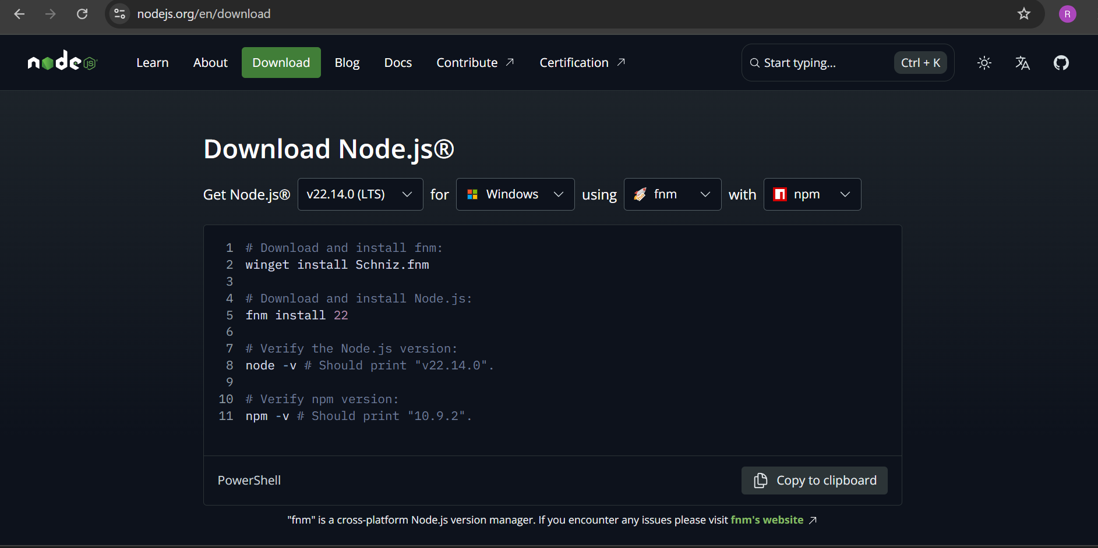

Step 2 :Install Node.js

For Windows & macOs Run the downloaded installer. Follows the installation wizard:

Accept the license agreement. Choose the installation directory (default is fine). Ensure that the option “Add to PATH” is checked. Click Install and wait for the process to complete . For Linux (Debian / Ubuntu) Open the terminal and run:

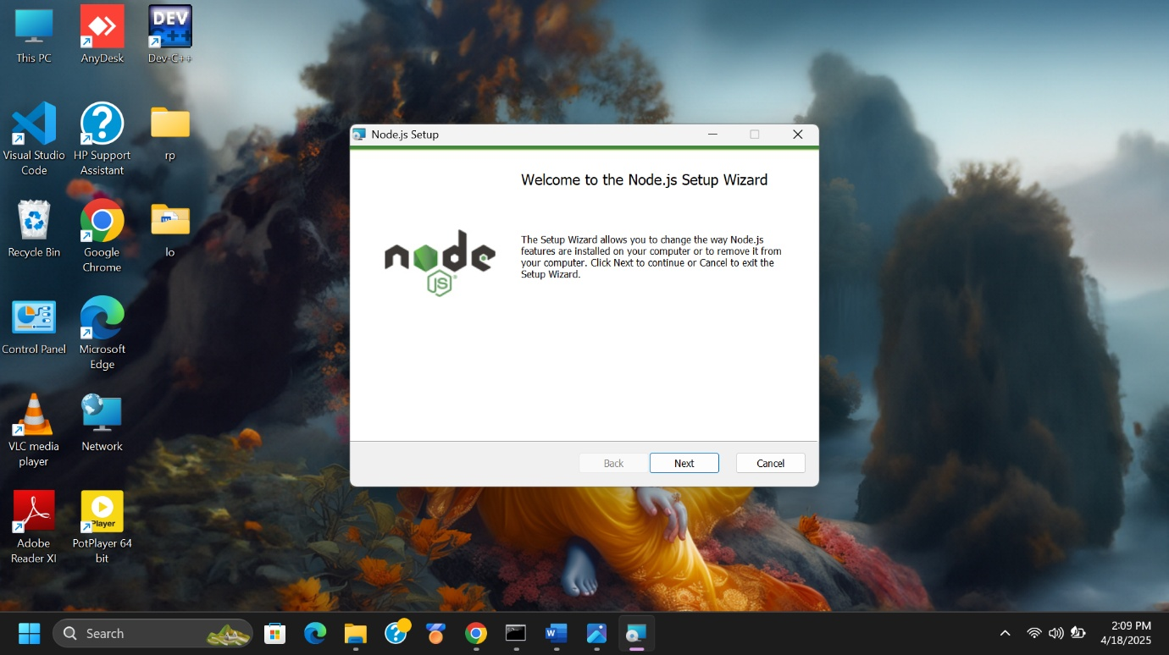

Step 3: Verify Node .js

Open Node .js’s Command Prompt (NOT SYSTEM’S CMD) & type following code to get response for the system.

node -v (to check node.js version) = v22.14.0

npm -v (to check node.js package manager version) =10.9.2

npm init -y (to create a package .jason file for node.js)

{

"name": "mylapkart",

"version": "1.0.0",

"main": "index.js",

"scripts": {

"test": "echo \"Error: no test specified\" && exit 1"

},

"keywords": [],

"author": "",

"license": "ISC",

"dependencies": {

"express": "^5.1.0"

},

"devDependencies": {},

"description": ""

}

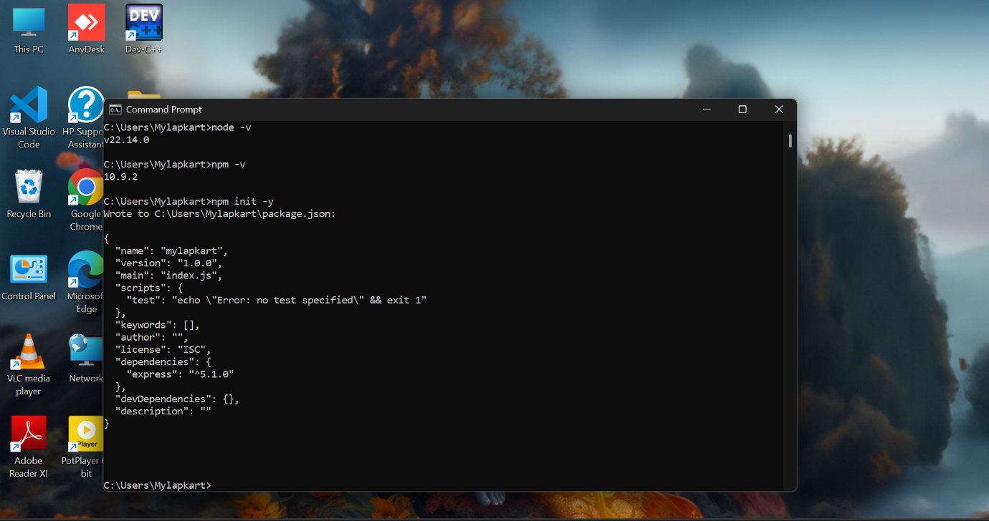

**Name :- Om Ramakant Parvate Roll.no :-168 Class :-FY.BCA Batch :-B6**

**Practical :-6 Create a node .js server in java-script.**

**Step to create a server in node js:**

* mkdir server1-Make a directory (Folder).
* Cd server 1- Current directory.
* npm init -y – Dependancies for node.js

Script file:-

const http = require('http');

const port = 3000;

const host = '127.0.0.1';

const server = http.createServer((req,res)=>{

    res.statusCode = 200;

    res.setHeader('Content-Type','text/plain');

    res.end('welcome to IMR!');

});

server.listen(port,host,() => {

    console.log(`Server is running at http://${host}:${port}/`);

});

**Output:-**

**Open link in browser for response-**

Name:- Om Ramakant Parvate Roll.no:- 168 Class:- FY.BCA Batch:-B6

Practical_No: 7

Create a REST API with Node.js

• Develop a basic REST API using Node.js that performs CR (Create, Read) operations on a simple data set

const express = require('express');

const app = express();

const port = 3000;

app.use(express.json());

let users = [

{ id: 1, name: 'Tony', age: 30 },

{ id: 2, name: 'Mike', age: 25 }

];

app.post('/users', (req, res) => {

const { name, age } = req.body;

const newUser = { id: users.length + 1, name, age };

users.push(newUser);

res.status(201).json(newUser);

});

app.get('/users', (req, res) => {

res.status(200).json(users);

});

app.get('/users/:id', (req, res) => {

const userId = parseInt(req.params.id, 10);

const user = users.find(u => u.id === userId);

if (user) {

res.status(200).json(user);

} else {

res.status(404).json({ message: 'User not found' });

}

});

app.listen(port, () => {

console.log(`Server is running on http://localhost:${port}`);

});

Output:-

1. Run Command on Terminal: node rest1.js

2. Copy link and Paste on THUNDER-CLIENT to get POST & GET Responses

**Name:- Om Ramakant Parvate Roll.no:- 168 Class:- FY.BCA Batch:-B6**

**Practical_No: 8 Create a REST API with Node.js • Develop a basic REST API using Node.js that performs UD ( Update, Delete) operations on a simple data set.**

**Step 1. Type this command on Terminal :-**

1. **mkdir node-rest-api**
2. **cd node-rest-api**
3. **npm init -y**

**Step 2. Install Express:-**

1. **npm install express**

**Step 3: Create app.js File:- (CODE)**

**const express = require('express');**

**const app = express();**

**const port = 3000;**

**// Middleware**

**app.use(express.json());**

**// In-memory data**

**let users = [**

**{ id: 1, name: 'John Doe', age: 30 },**

**{ id: 2, name: 'Jane Doe', age: 25 },**

**{ id: 3, name: 'Jim Brown', age: 35 },**

**];**

**// GET - Fetch all users**

**app.get('/users', (req, res) => {**

**res.status(200).json(users);**

**});**

**// PUT - Update user by ID**

**app.put('/users/:id', (req, res) => {**

**const userId = parseInt(req.params.id);**

**const updatedData = req.body;**

**let user = users.find(u => u.id === userId);**

**if (!user) return res.status(404).send({ error: 'User not found' });**

**user.name = updatedData.name || user.name;**

**user.age = updatedData.age || user.age;**

**res.status(200).json(user);**

**});**

**// DELETE - Delete user by ID**

**app.delete('/users/:id', (req, res) => {**

**const userId = parseInt(req.params.id);**

**const userIndex = users.findIndex(u => u.id === userId);**

**if (userIndex === -1) return res.status(404).send({ error: 'User not found' });**

**const deletedUser = users.splice(userIndex, 1);**

**res.status(200).json({ message: 'User deleted successfully', deletedUser });**

**});**

**// Start Server**

**app.listen(port, () => {**

**console.log(`Server running on http://localhost:${port}`);**

**});**

**Step 4: Run the Server:-**

1. **node app.js**

**Output:- Get:-** [**http://localhost:3000/users**](http://localhost:3000/users)

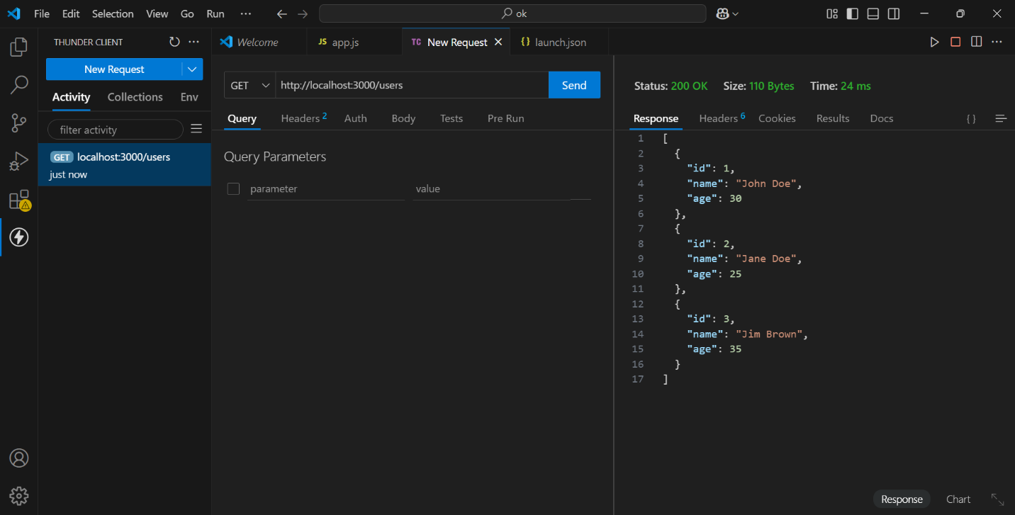

**PUT:-** [**http://localhost:3000/users/1**](http://localhost:3000/users/1)

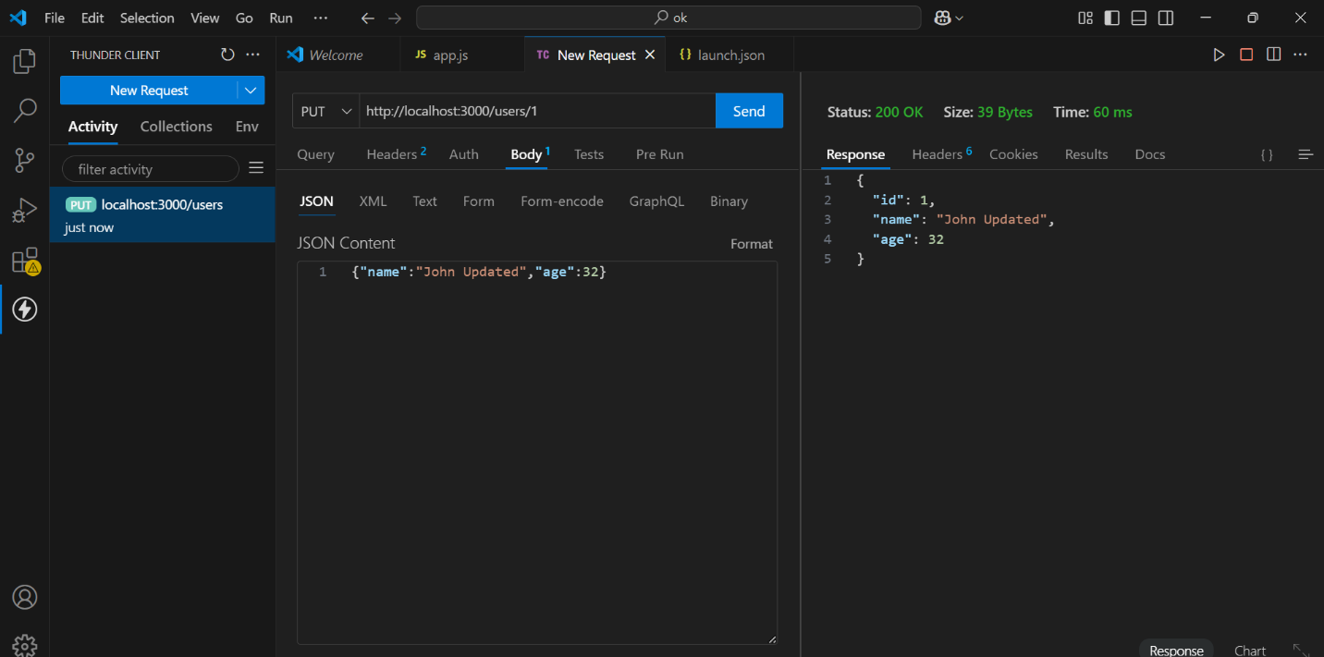

DELEIT:- [**http://localhost:3000/users/2**](http://localhost:3000/users/2)

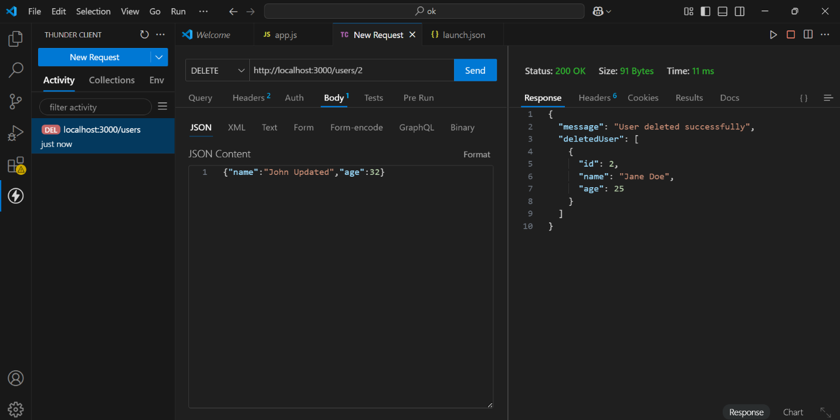

Name:- Om Ramakant Parvate Roll.no:- 168 Class:-FY.BCA Batch:-B6

Practical_No: 9 :-Perform a practical on bootstrap setup.

<!DOCTYPE html>

<html lang="en">

<head>

    <meta charset="UTF-8">

    <meta name="viewport" content="width=device-width, initial-scale=1.0">

    <title>Bootstrap Example</title>

    <!-- Bootstrap CSS via CDN -->

    <link href="https://cdn.jsdelivr.net/npm/bootstrap@5.3.0-alpha1/dist/css/bootstrap.min.css" rel="stylesheet">

</head>

<body>

    <!-- Example Container with Bootstrap Classes -->

    <div class="container">

        <h1 class="text-center my-4">Welcome to my Bootstrap page</h1>

        <div class="row">

            <div class="col-md-4">

                <div class="card">

                    <img src="op.jpg" class="card-img-top" alt="...">

                    <div class="card-body">

                        <h5 class="card-title">Runing Horse</h5>

                        <p class="card-text">symbolize dynamic energy, progress, and positive life force, often associated with success, wealth, and speed.</p>

                    </div>

                </div>

            </div>

            <div class="col-md-4">

                <div class="card">

                    <img src="charlie.jpg" class="card-img-top" alt="...">

                    <div class="card-body">

                        <h5 class="card-title">Charlie chaplin</h5>

                        <p class="card-text">people must rise up against dictators and unite in peace.</p>

                    </div>

                </div>

            </div>

            <div class="col-md-4">

                <div class="card">

                    <img src="images.jpg" class="card-img-top" alt="...">

                    <div class="card-body">

                        <h5 class="card-title">Elon Musk</h5>

                        <p class="card-text">“When something is important enough, you do it even if the odds are not in your favour.”</p>

                    </div>

                </div>

            </div>

        </div>

        <!-- Bootstrap Button -->

        <button class="btn btn-primary mt-4">Click Me!</button>

    </div>

    <!-- Bootstrap JS and Popper.js via CDN -->

    <script src="https://cdn.jsdelivr.net/npm/@popperjs/core@2.11.6/dist/umd/popper.min.js"></script>

    <script src="https://cdn.jsdelivr.net/npm/bootstrap@5.3.0-alpha1/dist/js/bootstrap.min.js">

</script>

</body>

</html>

Name:- Om Ramakant Parvate Roll.no:-168 Class:- FY.BCA Batch:-B6

Practical_No: 10 Bootstrap Grid Layout: Create a responsive web page layout using Bootstrap’s grid system.

<!DOCTYPE html>

<html lang="en">

<head>

    <meta charset="UTF-8">

    <meta name="viewport" content="width=device-width, initial-scale=1.0">

    <title>Responsive Web Page Layout</title>

    <!-- Bootstrap CSS via CDN -->

    <link href="https://cdn.jsdelivr.net/npm/bootstrap@5.3.0-alpha1/dist/css/bootstrap.min.css" rel="stylesheet">

</head>

<body>

    <!-- Header Section -->

    <header class="bg-primary text-white text-center py-4">

        <h1>India's History</h1>

    </header>

    <!-- Main Content Section -->

    <div class="container my-4">

        <div class="row">

            <!-- Sidebar (on larger screens, occupies 3 columns) -->

            <aside class="col-lg-3 col-md-4 col-sm-12">

                <div class="card">

                    <div class="card-body">

                        <h5 class="card-title">History</h5>

                        <p>India's history, spanning millennia, encompasses the rise and fall of empires, periods of intense cultural and intellectual flourishing, and the eventual integration of diverse cultures and influences. From ancient civilizations like the Indus Valley to the Mughal and British empires, India's history is marked by significant changes and enduring legacies</p>

                    </div>

                </div>

            </aside>

            <!-- Main Content (on larger screens, occupies 9 columns) -->

            <main class="col-lg-9 col-md-8 col-sm-12">

                <div class="card">

                    <div class="card-body">

                        <h5 class="card-title">Key Themes and Legacies</h5>

                        <p>Diverse Cultural Influences:

influences from neighboring cultures, including Greek, Persian, and European. .</p>

                        <p>Impact on Global History:

                            India has played a significant role in shaping global history, particularly in its intellectual, artistic, and scientific contributions. .</p>

                    </div>

                </div>

            </main>

        </div>

    </div>

    <!-- Footer Section -->

    <footer class="bg-dark text-white text-center py-3">

        <p>&copy; 2025 My Website | All Rights Reserved</p>

    </footer>

    <!-- Bootstrap JS and Popper.js via CDN -->

    <script src="https://cdn.jsdelivr.net/npm/@popperjs/core@2.11.6/dist/umd/popper.min.js"></script>

    <script src="https://cdn.jsdelivr.net/npm/bootstrap@5.3.0-alpha1/dist/js/bootstrap.min.js"></script>

</body>

</html>

Output:-

Name:- Om Ramakant Parvate Roll.no:-168 Class:- FY.BCA Batch:- B6

Practical_No: 11

Bootstrap Components: Implement a navigation bar and modal using Bootstrap components.

<!DOCTYPE html>

<html lang="en">

<head>

    <meta charset="UTF-8">

    <meta name="viewport" content="width=device-width, initial-scale=1.0">

    <title>Navigation Bar and Modal</title>

    <!-- Bootstrap CSS via CDN -->

    <link href="https://cdn.jsdelivr.net/npm/bootstrap@5.3.0-alpha1/dist/css/bootstrap.min.css" rel="stylesheet">

</head>

<body>

    <!-- Navigation Bar -->

    <nav class="navbar navbar-expand-lg navbar-dark bg-dark">

        <div class="container-fluid">

            <a class="navbar-brand" href="#">Amazon.in</a>

            <button class="navbar-toggler" type="button" data-bs-toggle="collapse" data-bs-target="#navbarNav" aria-controls="navbarNav" aria-expanded="false" aria-label="Toggle navigation">

                <span class="navbar-toggler-icon"></span>

            </button>

            <div class="collapse navbar-collapse" id="navbarNav">726

                <ul class="navbar-nav ms-auto">

                    <li class="nav-item">

                        <a class="nav-link active" aria-current="page" href="#">Home</a>

                    </li>

                    <li class="nav-item">

                        <a class="nav-link" href="#">Customer Service</a>

                    </li>

                    <li class="nav-item">

                        <a class="nav-link" href="#">Today's Deals</a>

                    </li>

                    <li class="nav-item">

                        <a class="nav-link" href="#">Contact</a>

                    </li>

                </ul>

            </div>

        </div>

    </nav>

    <!-- Main Content Section -->

    <div class="container my-5">

        <h2>Welcome to Amazon</h2>

        <p>Great deals on Amazon — Prime Members can enjoy unlimited Free Shipping, early access to Lightning Deals and more.</p>

        <!-- Button to trigger modal -->

        <button type="button" class="btn btn-primary" data-bs-toggle="modal" data-bs-target="#exampleModal">

            Open Modal

        </button>

    </div>

    <!-- Modal -->

    <div class="modal fade" id="exampleModal" tabindex="-1" aria-labelledby="exampleModalLabel" aria-hidden="true">

        <div class="modal-dialog">

            <div class="modal-content">

                <div class="modal-header">

                    <h5 class="modal-title" id="exampleModalLabel">Shopping</h5>

                    <button type="button" class="btn-close" data-bs-dismiss="modal" aria-label="Close"></button>

                </div>

                <div class="modal-body">

                    <p>Amazon Shopping offers app-only benefits to help make shopping on Amazon faster and easier than shopping on your desktop. Never miss a delivery. Get real-time ...</p>

                </div>

                <div class="modal-footer">

                    <button type="button" class="btn btn-secondary" data-bs-dismiss="modal">Close</button>

                    <button type="button" class="btn btn-primary">Save changes</button>

                </div>

            </div>

        </div>

    </div>

    <!-- Bootstrap JS and Popper.js via CDN -->

    <script src="https://cdn.jsdelivr.net/npm/@popperjs/core@2.11.6/dist/umd/popper.min.js"></script>

    <script src="https://cdn.jsdelivr.net/npm/bootstrap@5.3.0-alpha1/dist/js/bootstrap.min.js"></script>

</body>

</html>