
LOG BOOK FOR
“Rice Leaf Disease Detection Using
Deep Learning”

By
- Mohammad Yamaan Mohammad Saleem Ansari(231106021)
- Om Prashant Deshmukh(231106039)
- Niraj Manoj Mahajan(231106027)
- Tejas Narendra Borse(231106060)

Under the Guidance of Prof. S.K.Bhandare

Department of Computer Science & Engineering (Data Science)
The Shirpur Education Society’s

R. C. Patel Institute of Technology, Shirpur - 425405.

[2025-26]

Introduction
Date: 20/08/2025 to 25/08/2025

Problem Statement:

Rice crops are highly susceptible to leaf diseases that significantly reduce yield and quality. Traditional disease detection methods rely on manual inspection, which is time-consuming, inaccurate, and not easily accessible to farmers. Therefore, there is a need for an automated and accurate system that can detect and classify rice leaf diseases from images using deep learning techniques to enable early diagnosis and effective crop management.

Objectives:

 | Objective | Success Metric
1 | Automate Rice Leaf Disease Detection | Correctly classify rice leaf images into healthy and diseased categories with high accuracy (>90%).
2 | Improve Early Disease Diagnosis | Enable detection of diseases at an early stage using image-based analysis.
3 | Enhance Model Accuracy Using Deep Learning | Achieve improved performance compared to traditional manual or rule-based methods.

Application Scope:
  - The system can be used by farmers to identify rice leaf diseases at an early stage using images captured through mobile phones or digital cameras.
  - It assists agricultural experts and researchers in analyzing and monitoring rice crop health efficiently.
  - The application can be deployed as a web-based or mobile-based tool for real-
time disease detection and decision support.

Remark :

Literature Survey
Dates: 17/09/2025 to 25/09/2025

Background:
Traditionally, rice leaf disease identification is performed through manual inspection by farmers or agricultural experts. This approach is time-consuming, subjective, and often inaccurate due to limited expertise and lack of timely access to specialists, especially in rural areas. With the advancement of digital imaging and artificial intelligence, deep learning techniques—particularly Convolutional Neural Networks (CNNs)—have shown great potential in automating plant disease detection using leaf images.

Existing Systems:

- Rice leaf diseases are detected mainly through manual visual inspection by farmers or agricultural experts.

- Disease identification depends on experience and expert knowledge, making it subjective.

- Early-stage diseases are often misidentified due to similar visual symptoms.

- Access to experts is limited in rural areas, causing delayed diagnosis.

- Existing digital systems using basic image processing provide limited accuracy and scalability.

Key Research Findings:

- Deep learning models, especially Convolutional Neural Networks (CNNs), are highly effective for plant leaf disease detection using image data.
- Transfer learning models (such as EfficientNet, MobileNet, and ResNet) provide higher accuracy with less training time compared to traditional CNNs.
- Image preprocessing and data augmentation significantly improve model generalization and reduce overfitting.

Remark :

Methodology
Dates: 26/09/2025 to 05/10/2025

Hardware and Software Requirements:

Development Environment: Google Colab

Deep Learning Framework: TensorFlow and Keras.

Libraries: NumPy, Pandas, OpenCV, Matplotlib, Scikit-learn.

Frontend Framework: Streamlit (for web application).

Deployment Platform: Hugging Face Spaces / Streamlit Cloud.

Programming Language: Python

System Design(block diagram):

Uploaded Image

↓

Image Preprocessing

↓

EfficientNet Feature Extraction

↓

Feature Scaling

↓

SVM Classification

↓

Top-K Disease Prediction

Dataset Specifications:

Dataset: Rice Leaf Disease Dataset (Kaggle)

Type: Image dataset

Total Images: ~3,800

Classes: 6 (Bacterial Leaf Blight, Brown Spot, Healthy, Leaf Blast, Leaf Scald, Sheath

Blight)

Preprocessing: Resizing (224×224), normalization, data augmentation.

Data Split: 80% training, 20% validation.

Usage: Training and evaluation of rice leaf disease classification model.

Remark :

Implementation Details
Dates: 07/10/2025 to 20/10/2025
Module 1: Data Collection
- Rice leaf images are collected from a publicly available Kaggle dataset.
- Dataset includes healthy and multiple diseased rice leaf classes.
Module 2: Data Preprocessing
- Images are resized to 224 × 224 pixels.
- Pixel values are normalized between 0 and 1.
- Data augmentation techniques such as rotation, zooming, and flipping are applied.
Module 3: Feature Extraction
- A CNN / Transfer Learning model is used to extract important visual features from images.
- Pretrained weights help improve accuracy and reduce training time.
Module 4: Model Training
- The model is trained using an 80:20 train-validation split.
- Early stopping and learning rate reduction callbacks are applied to optimize training.
Module 5: Model Evaluation
- Model performance is evaluated using accuracy, precision, recall, F1-score, and confusion matrix.
- Validation results are analyzed to ensure generalization.
Module 6: Model Saving
- The trained model is saved in .h5 format for reuse and deployment.

Results
Dates: 22/10/2025 to 16/11/2025
- Dataset Used (Include Citation):
Rice Leaf Disease Dataset collected from Kaggle, consisting of labeled images of healthy and diseased rice leaves.
Source: Kaggle – Rice Disease Dataset by Anshul M.
(https://www.kaggle.com/datasets/anshulm257/rice-disease-dataset/data)
- Performance Metrics:
The model performance is evaluated using accuracy, precision, recall, F1-score, and confusion matrix to measure classification effectiveness across multiple disease classes.
- Report Writing (Sem-VI):
Project documentation including problem statement, methodology, system design, dataset specification, implementation details, and preliminary results has been completed as part of Semester VI.
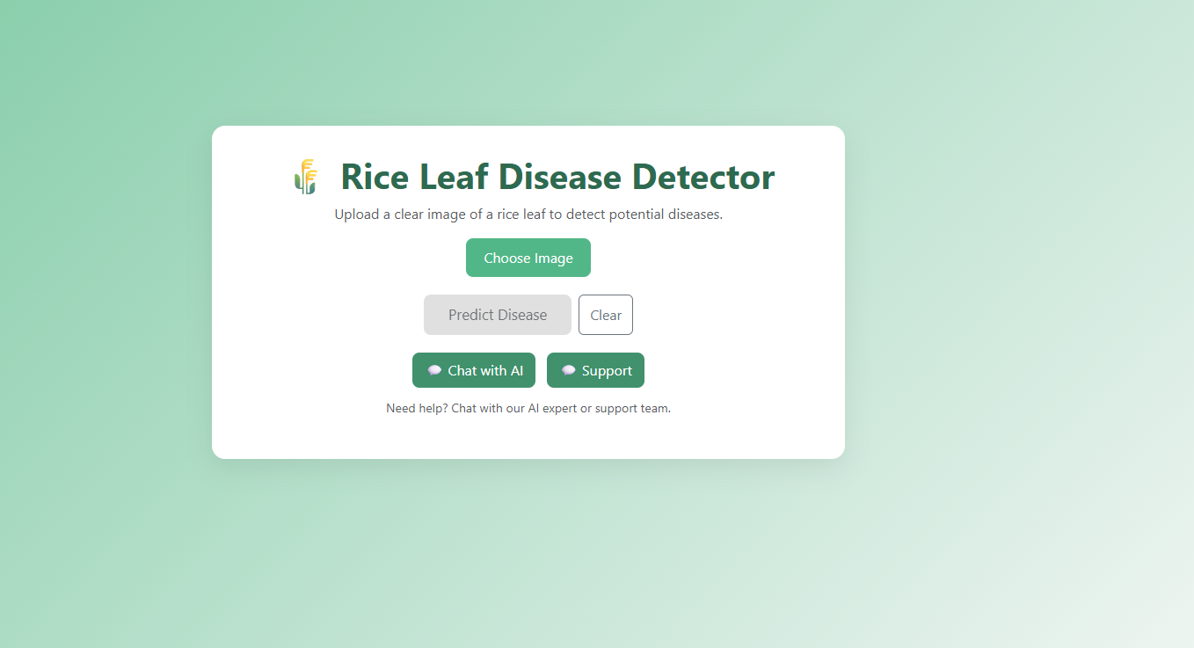

6. Conclusion & Future Work:

The Rice Leaf Disease Detection system successfully demonstrates the application of deep learning techniques for automated identification and classification of rice leaf diseases. By using image preprocessing and a CNN-based model, the system achieves high accuracy and reliable performance across multiple disease classes. The developed web-based application enables real-time disease detection, reducing dependency on manual inspection and expert intervention. This approach supports early diagnosis, minimizes crop loss, and contributes to efficient and sustainable agricultural practice.

- Extend the system to detect additional rice diseases and other crop types.
- Integrate disease severity analysis to classify infection stages.
- Implement explainable AI techniques such as Grad-CAM for better model interpretability.
- Optimize the model for mobile deployment to improve accessibility for farmers.
- Integrate IoT sensors and environmental data for predictive disease analysis.

7.References:

Anshul M., Rice Disease Dataset, Kaggle.
https://www.kaggle.com/datasets/anshulm257/rice-disease-dataset

Mohanty, S. P., Hughes, D. P., & Salathé, M., “Using Deep Learning for Image-Based Plant Disease Detection,” Frontiers in Plant Science, 2016.

TensorFlow Documentation, https://www.tensorflow.org

Streamlit Documentation, https://docs.streamlit.io

GitHub Repository Structure
Copy

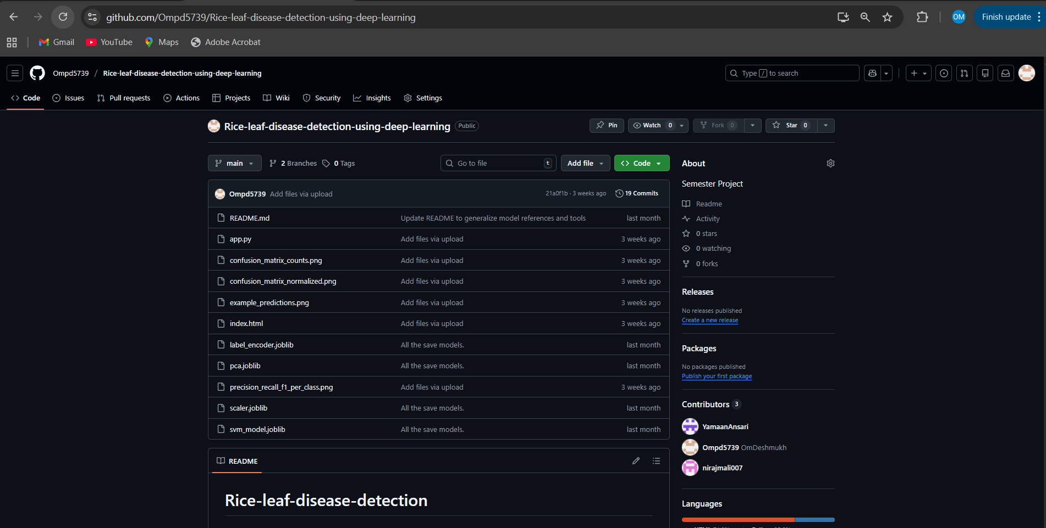

Repository Link:
https://github.com/Ompd5739/Rice-leaf-disease-detection-using-deep-learning

