**Lab#1(a) Creating a registration Page with HTML 5 Validation**

|  |  |  |
| --- | --- | --- |
| **TAGS USED** | **ATTRIBUTES USED** | **DESCRIPTION** |
| <HTML> | -- | HTML root element |
| <HEAD> | -- | Container for metadata |
| <TITLE> | -- | Title of the page |
| <BODY> | -- | Body of the page |
| <br> | -- | Line break |
| <form> | -- | Form container |
| <h2> | -- | Heading for form title |
| <label> | for | Label for form fields |
| <input> | type, id, name, required, minlength, maxlength, value | Input fields |

**Final Outcome:**

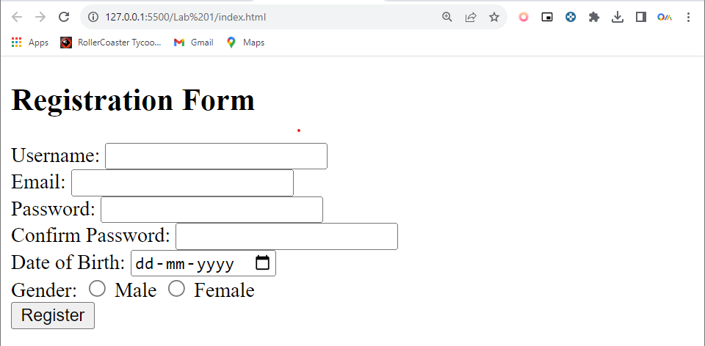

(Basic HTML, Hyperlink and Commenting code)[Font Cambria size 12]

**Code Snippet:**

<html>

<head>

<meta charset="UTF-8">

<meta name="viewport" content="width=device-width, initial-scale=1.0">

<title>Registration Page</title>

<link rel="stylesheet" href="style.css">

</head>

<body>

<h2>Registration Form</h2>

<form action="#" method="post">

<label for="username">Username:</label>

<input type="text" id="username" name="username" required minlength="4" maxlength="20">

<br>

<label for="email">Email:</label>

<input type="email" id="email" name="email" required>

<br>

<label for="password">Password:</label>

<input type="password" id="password" name="password" required minlength="6">

<br>

<label for="confirm_password">Confirm Password:</label>

<input type="password" id="confirm_password" name="confirm_password" required minlength="6">

<br>

<label for="dob">Date of Birth:</label>

<input type="date" id="dob" name="dob" required>

<br>

<label>Gender:</label>

<div class="gender-container">

<label for="male">Male</label>

<input type="radio" id="male" name="gender" value="male" required>

<label for="female">Female</label>

<input type="radio" id="female" name="gender" value="female" required>

</div>

<br>

<input type="submit" value="Register">

</form>

</body></html>

**Lab#1(b) Adding a external stylesheet to make registration form look elegant**

|  |  |  |
| --- | --- | --- |
| **TAGS USED** | **ATTRIBUTES USED** | **DESCRIPTION** |
| <HTML> | -- | HTML root element |
| <HEAD> | -- | Container for metadata |
| <TITLE> | -- | Title of the page |
| <BODY> | -- | Body of the page |
| <br> | -- | Line break |
| <link> | rel, href | Form container |
| <form> | -- | Form container |
| <h2> | -- | Heading for form title |
| <label> | for | Label for form fields |
| <input> | type, id, name, required, minlength, maxlength, value | Input fields |

**Final Outcome:**

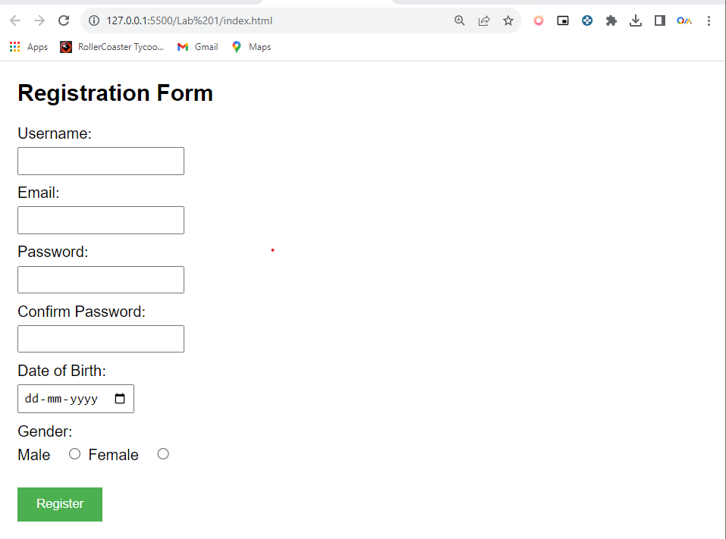

**Code Snippet:**

body {

font-family: Arial, sans-serif;

margin: 20px;

}

label {

display: block;

margin-bottom: 5px;

}

input {

margin-bottom: 10px;

padding: 5px;

}

input[type="submit"] {

padding: 10px 20px;

background-color: #4CAF50;

color: white;

border: none;

cursor: pointer;

}

input[type="submit"]:hover {

background-color: #45a049;

}

.gender-container label {

display: inline-block;

margin-right: 10px;

}