Practical 13:ImplementingaServerlessArchitecturewithAWSManaged Step 1:Search for S3 in services.

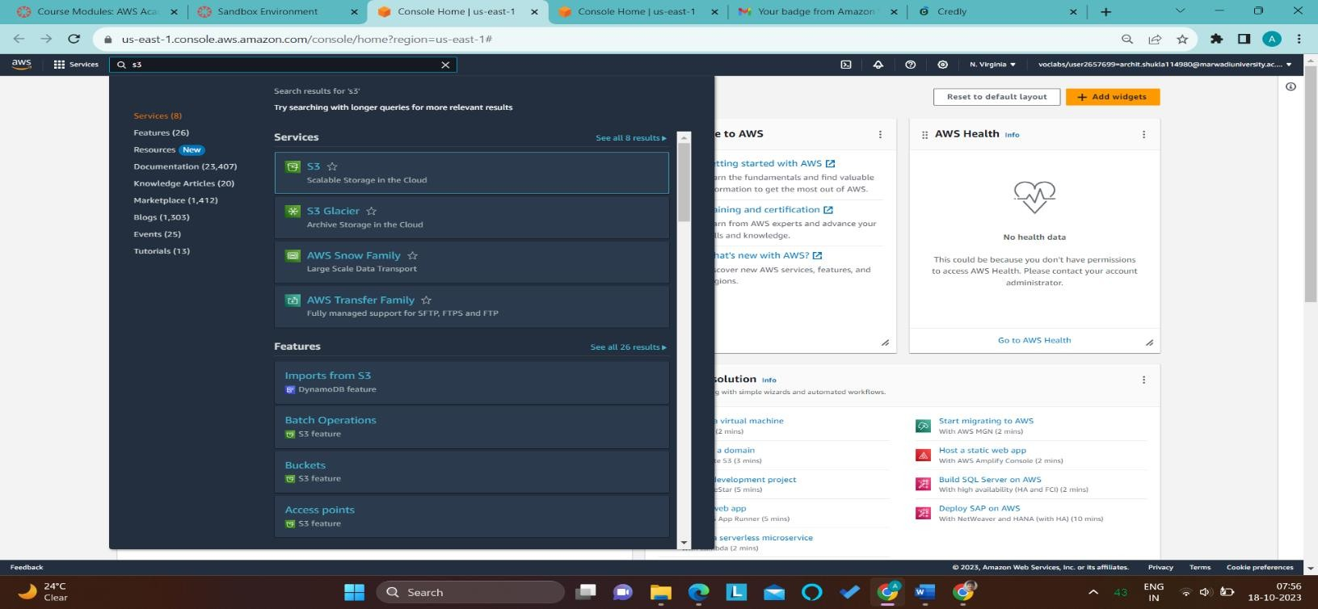

Step2:Thenwritedownbucketnameanduncheckblockpublicaccessandatlastclickoncreate bucket so bucket created.

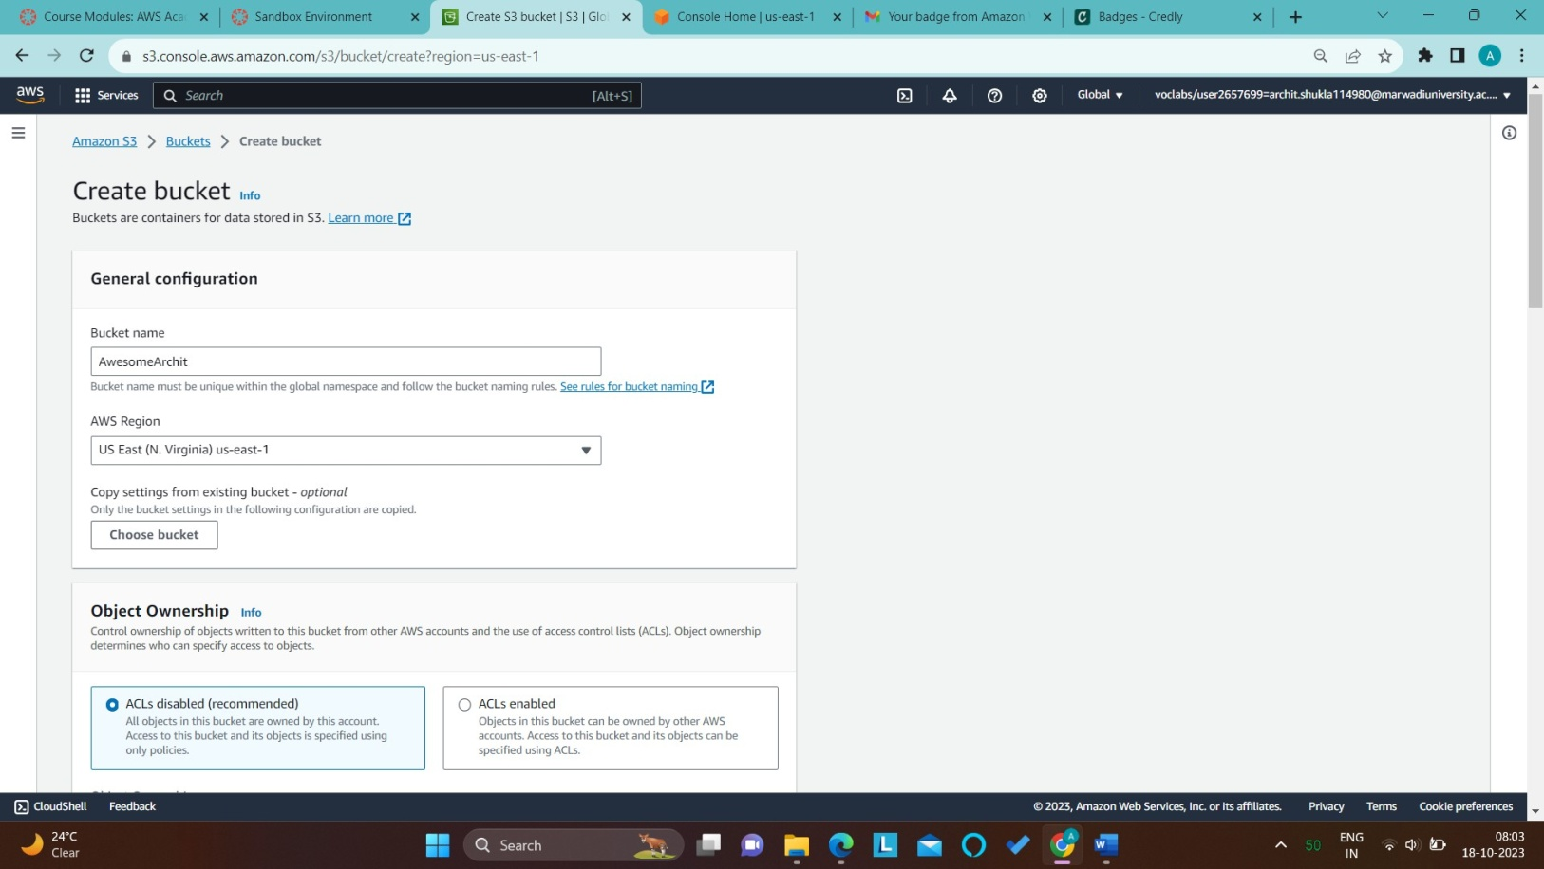

Step3:Nowmakeaonehtnmlstaticpage.Aftertheclickonbucketidsoopenobjecthomepagehere click on upload and upload your html file that you made.

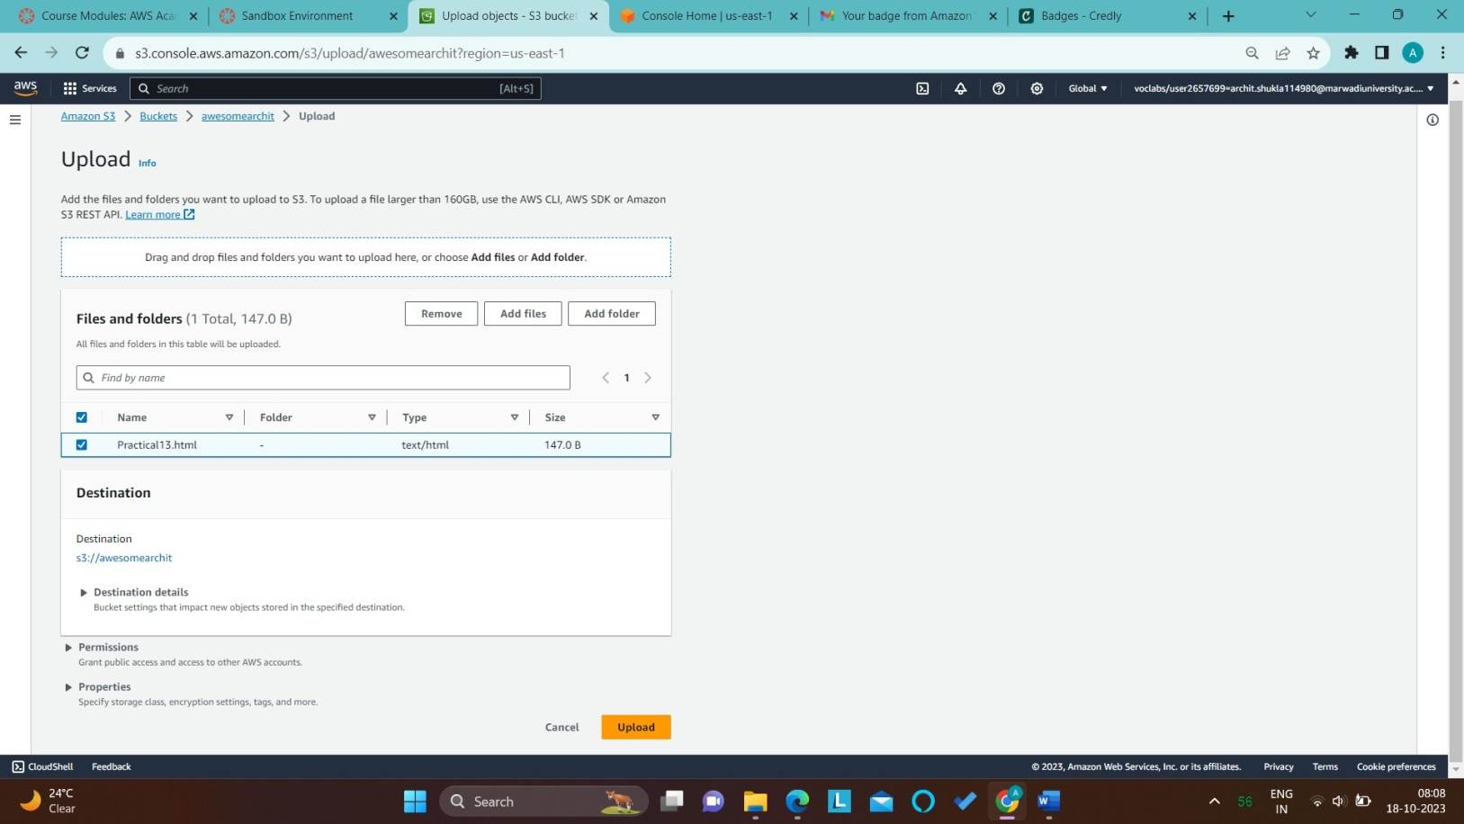

Step4:NextinpropertiesgotoStaticWebsitehostingandherewritedownyourhtmlfilenamein Object Index and then save that settings.

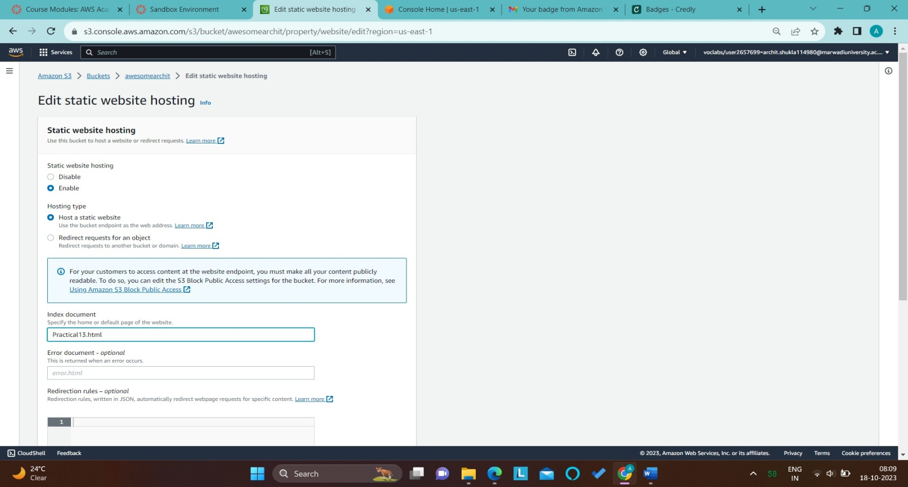

Step5:Nowinaobjectchooseyourhtmlfileandopenthatsoyouareabletoseethatobjecturland open it in a new web page. So currently that file is not working.

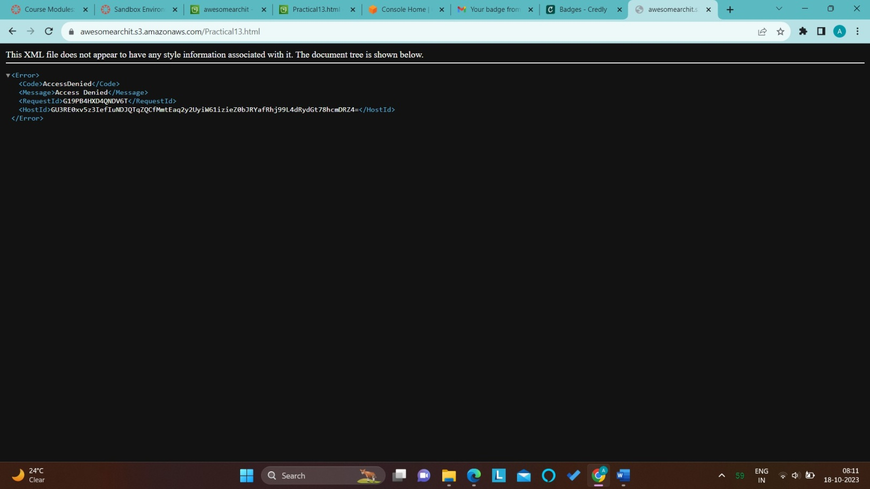

Step6:NextmovetopermissionandchooseObjectOwnershipandafterthatchooseACLEnableand save it.

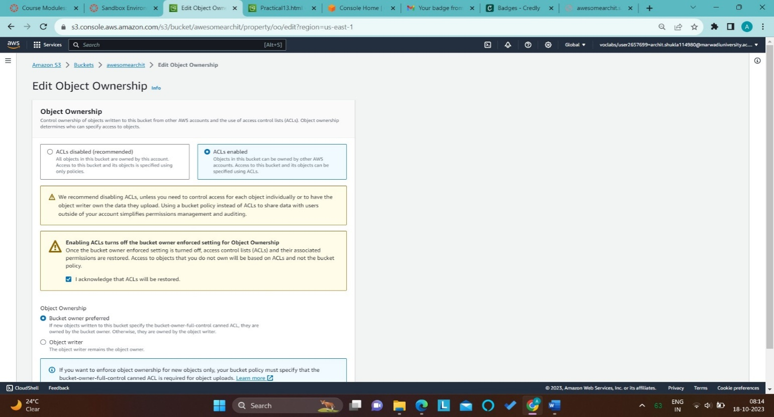

Step7:NowselectyourabjectandfromActionchooseMakepublicusingACLandsavedefaultsetting.

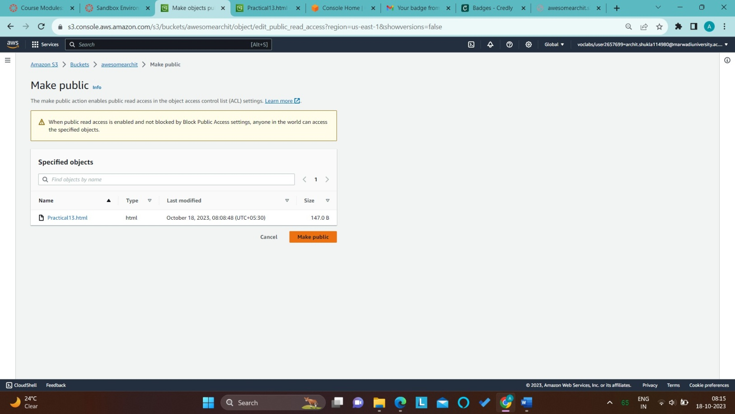

Step8:NowagainrefreshyouwebsiteURLsonowit'sworking.

