**Practical 14: Cloud monitoring and management tools -> AWS CloudWatch**

**Step 1: Click on start lab.**

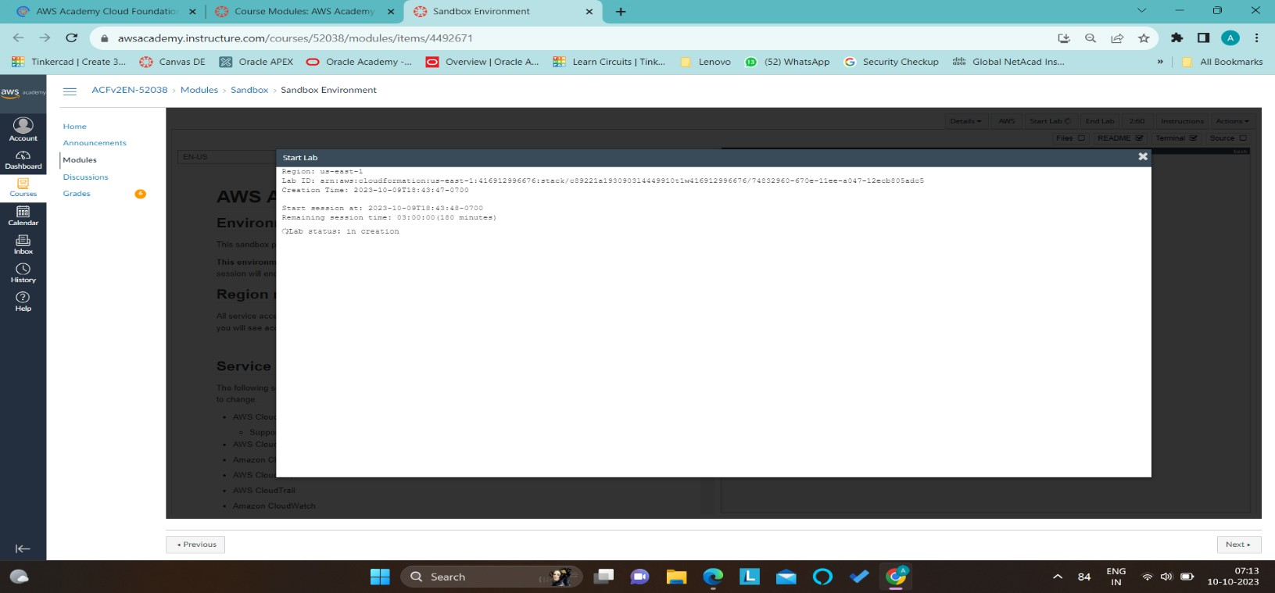

**Step 2: Click on services and in that click on CloudWatch.**

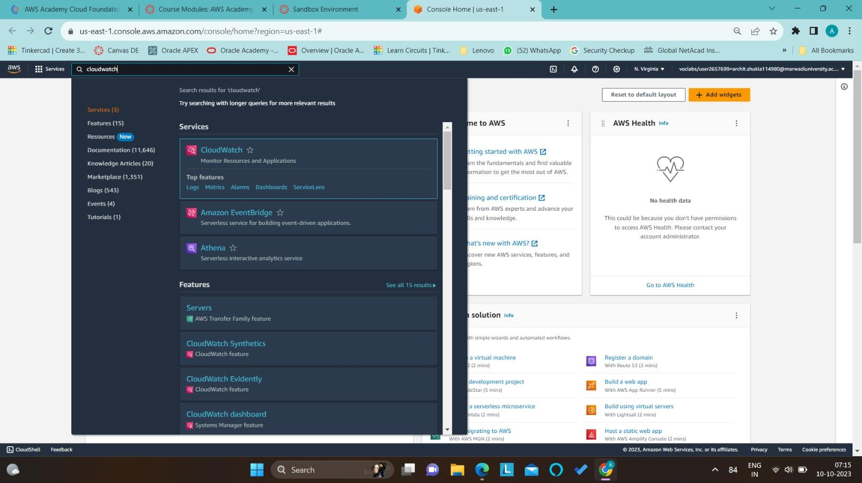

**Step 3: Click on Cloudwatch dashboards and click on create dashboard.**

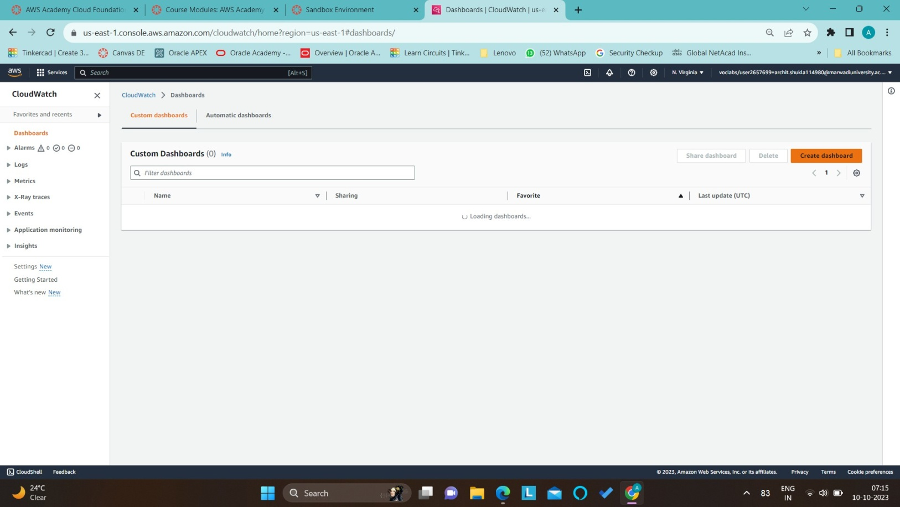

**Step 4: Now, Create new dashboard and give name to Archit, and click on create dashboard.**

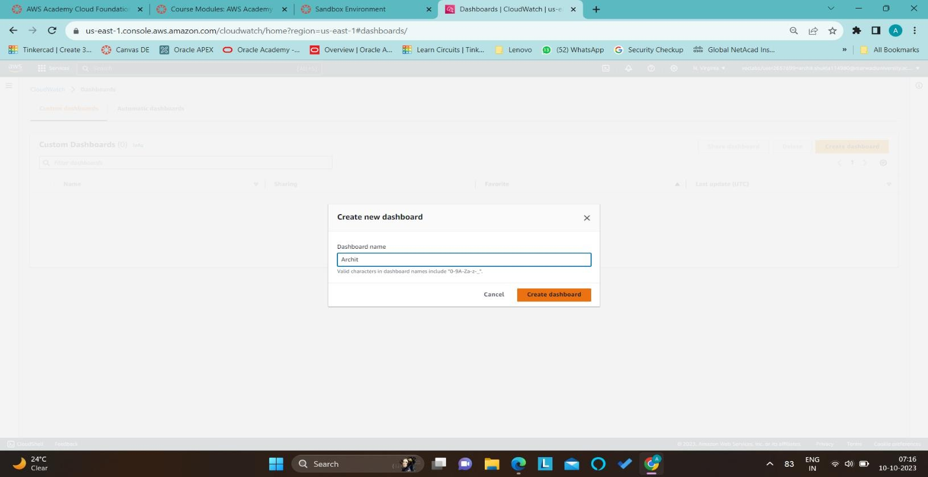

**Step 5: Now, click on Line and add widget and click next.**

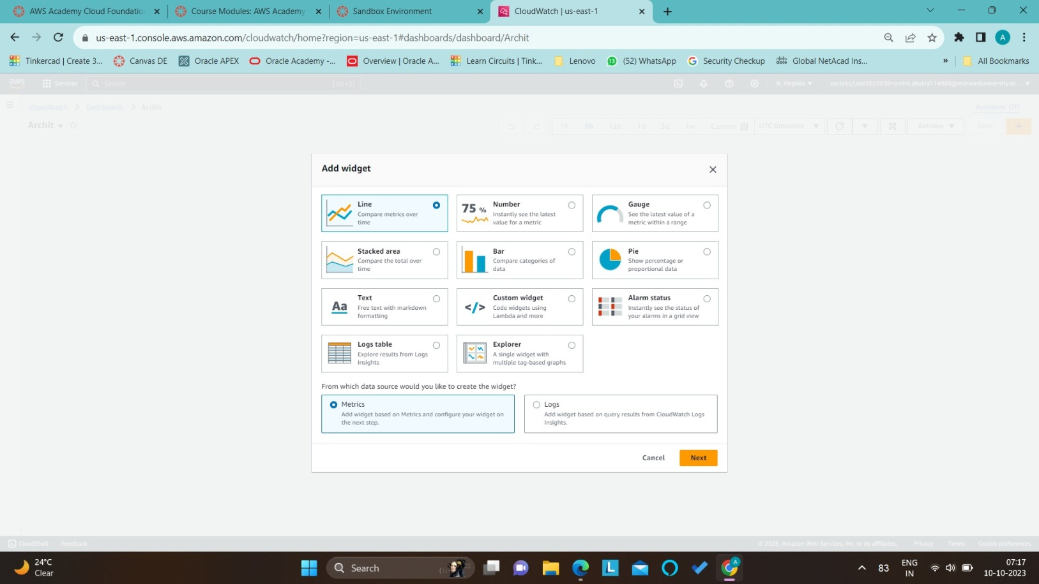

**Step 6: Now click on add math and select SQL query and select Top 10 EC2 instances by CPU.**

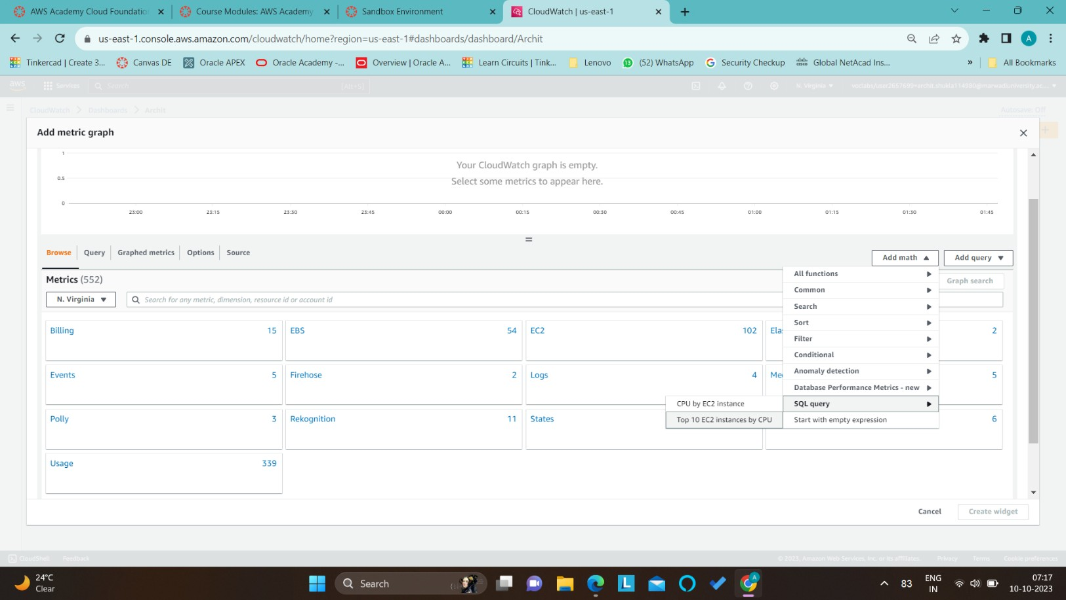

**Step 7: Now click on Add query and select EC2 and select Top 10 instances by highest CPU utilization.**

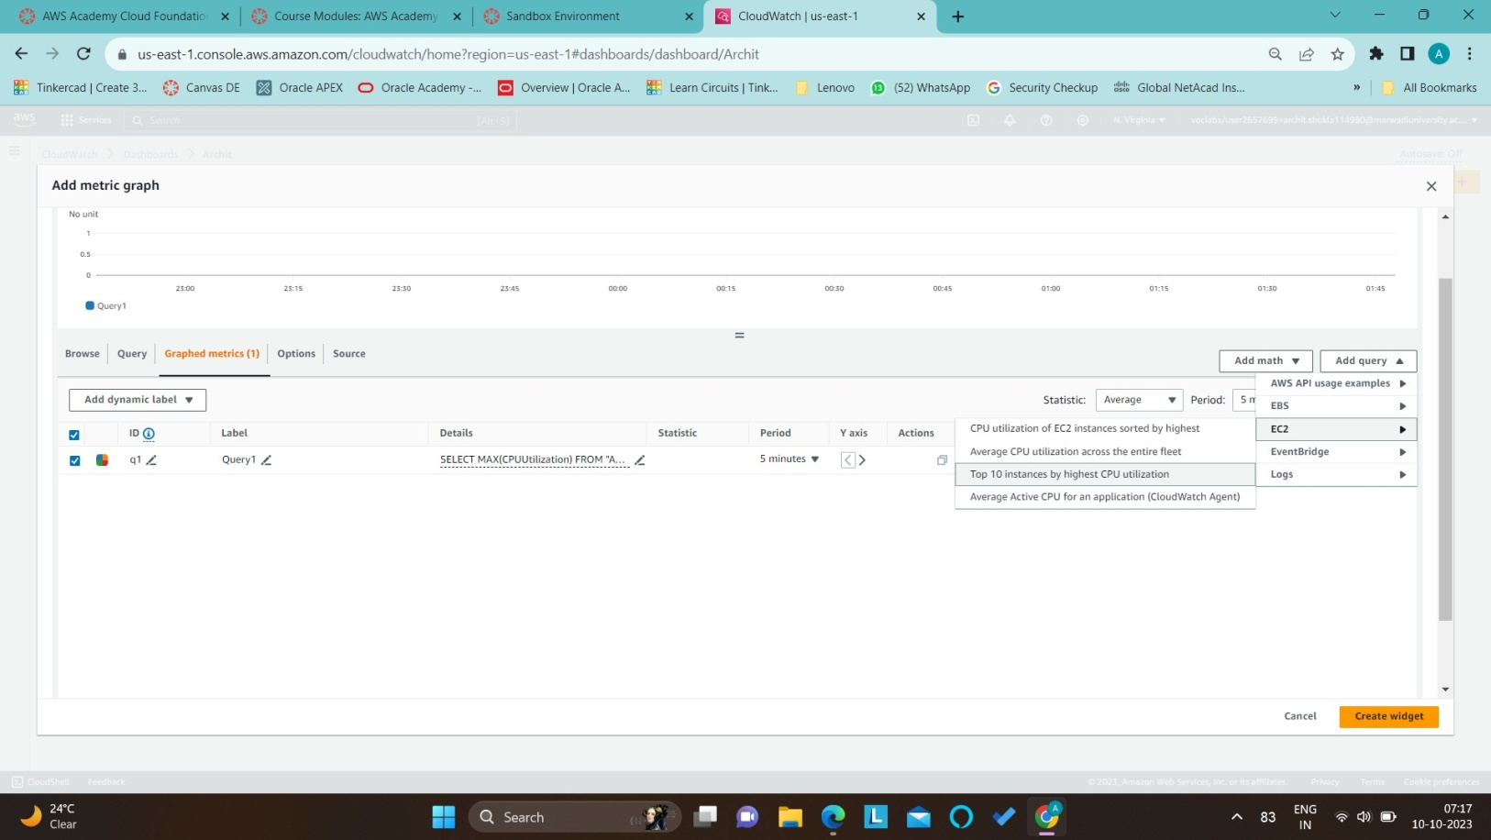

**Step 8: Now in Graphed metrics click on create widget.**

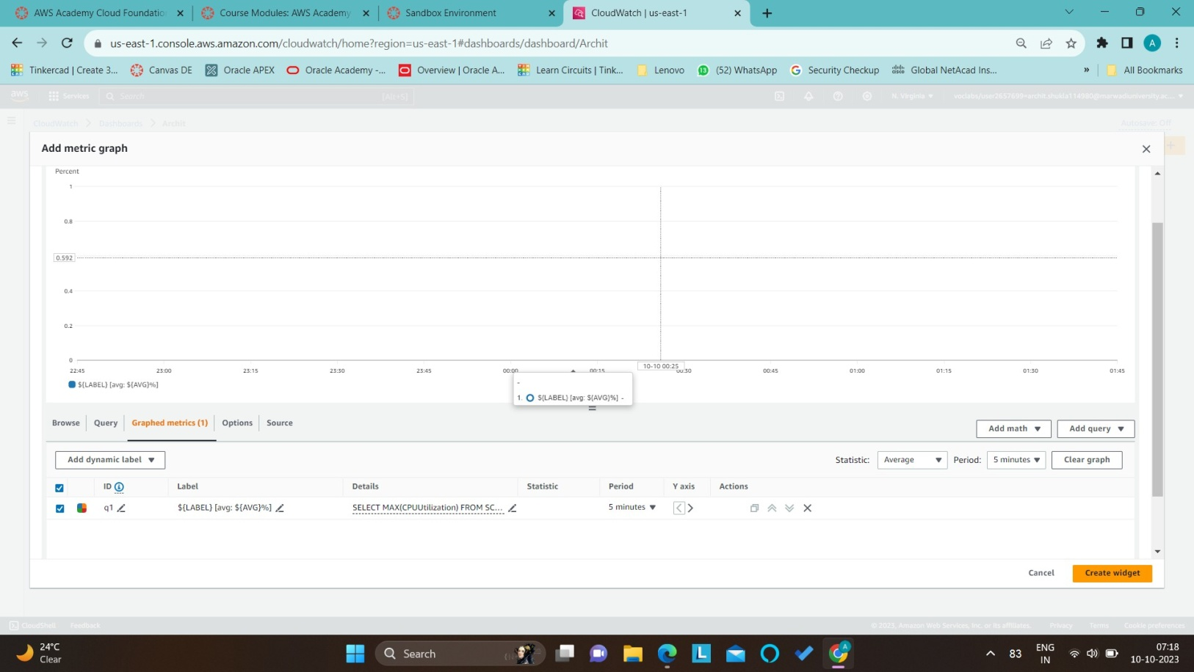

**Step 9: Now click on Archit, the dashboard that we have created.**

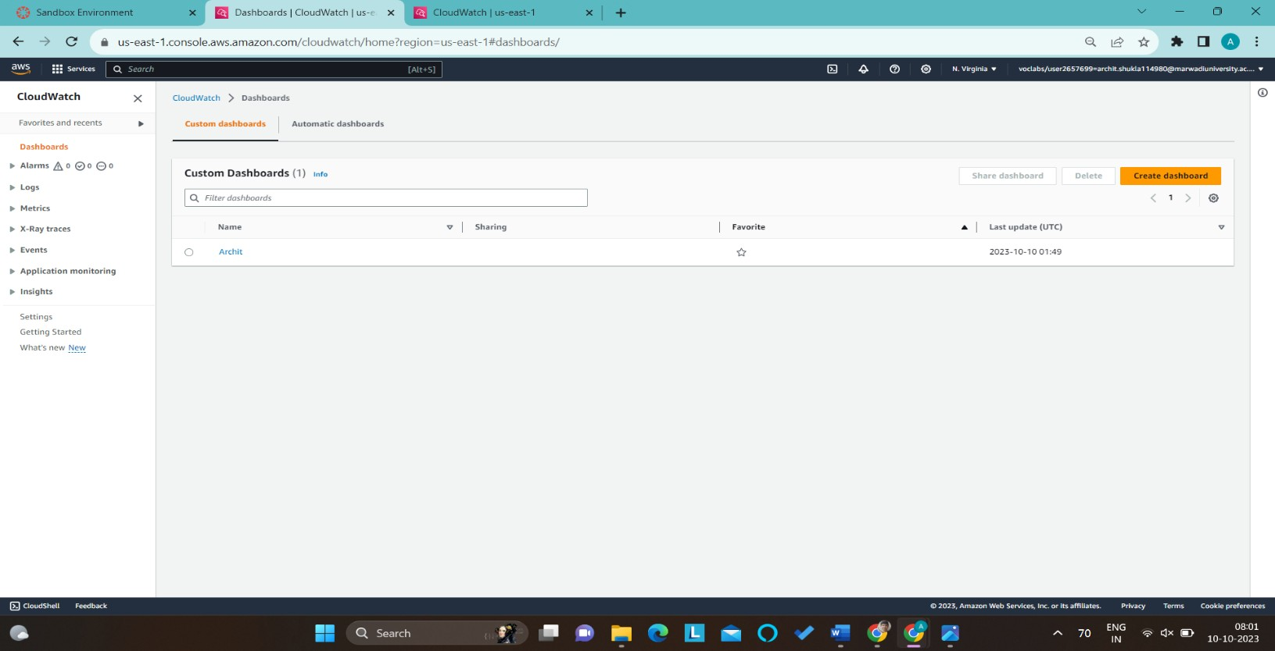

**Step 10: Now we can see this utilization of the CPU, then click on view in metrics**

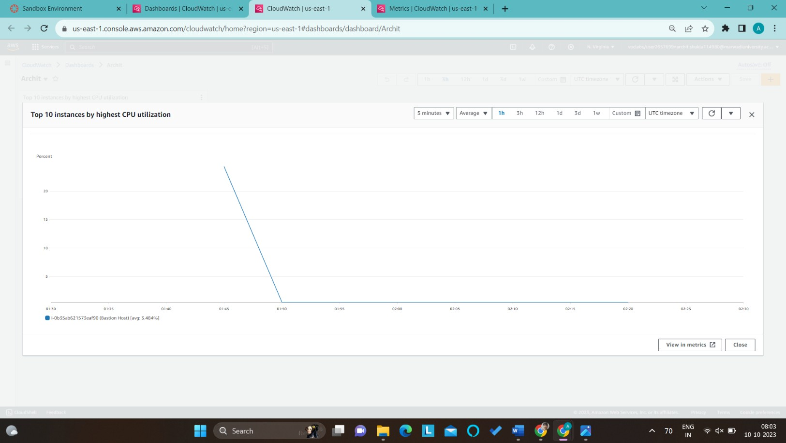

**Step 11: Now click on the instance what we need to monitor.**

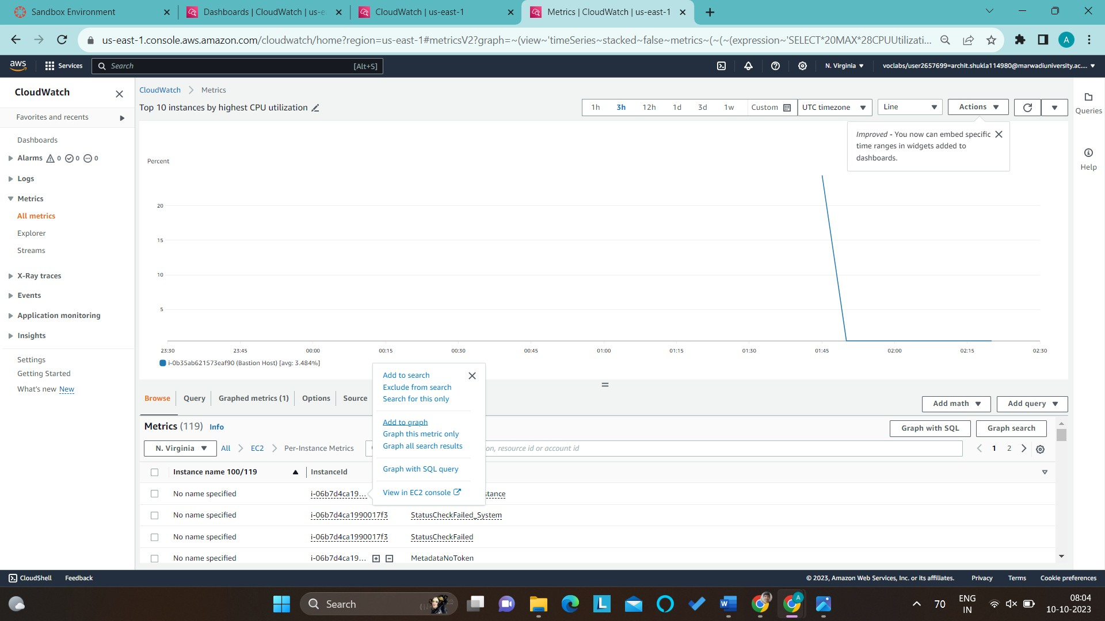

**Step 12: Now we can see the CPU utilization of that instance.**

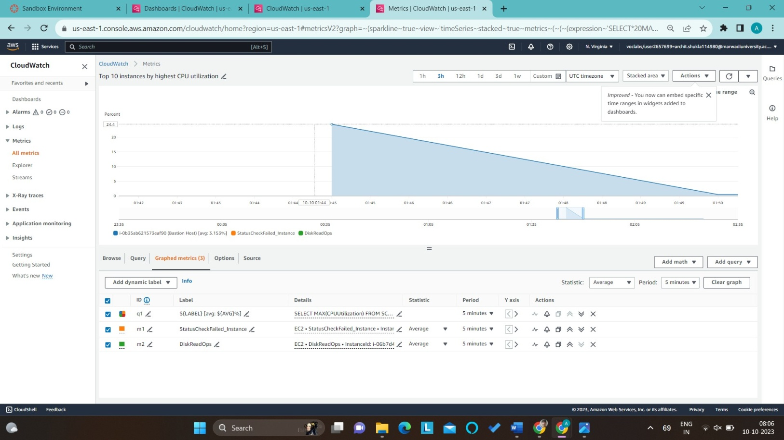

**Step 13: Click on Number and we can see the CPU utilization of that instance in number format and click on Graphed metrics.**

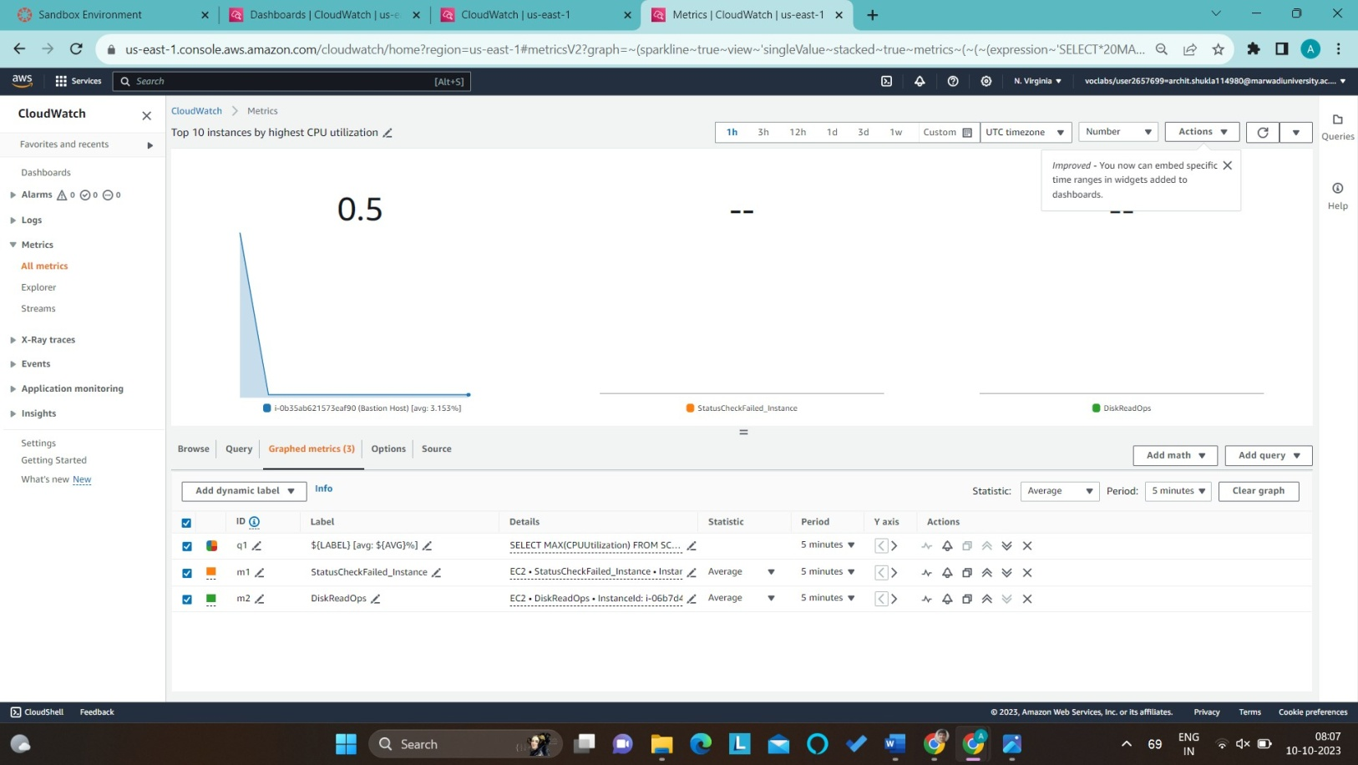

**Step 14: Click on create widget & Save the instance. Now we can monitor our resources for the selected instance.**

