**PRACTICAL-1**

**AIM:**

**a. Write a program to demonstrate all the basic data types in python.**

**Source Code:**

int_var = 10

float_var = 3.14

str_var = "Hello, World!"

bool_var = True

list_var = [1, 2, 3]

tuple_var = (4, 5, 6)

dict_var = {"name": "Om", "age": 20}

set_var = {7, 8, 9}

print(int_var, "typeof(int_var):", type(int_var))

print(float_var, "typeof(float_var):", type(float_var))

print(str_var, "typeof(str_var):", type(str_var))

print(bool_var, "typeof(bool_var):", type(bool_var))

print(list_var, "typeof(list_var):", type(list_var))

print(tuple_var, "typeof(tuple_var):", type(tuple_var))

print(dict_var, "typeof(dict_var):", type(dict_var))

print(set_var, "typeof(set_var):", type(set_var))

**Output:**

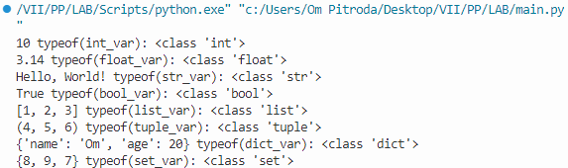

**b. Write a program that takes two numbers as command line arguments and prints its summation.**

**Source Code:**

import sys

num1 = float(sys.argv[1])

num2 = float(sys.argv[2])

result = num1 + num2

print(result)

**Output:**

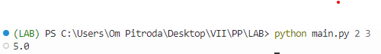

**c. Write a program to print the largest and smallest number of three numbers input from user with and without using library functions.**

**Source Code:**

num1 = float(input("Enter the first number: "))

num2 = float(input("Enter the second number: "))

num3 = float(input("Enter the third number: "))

if num1 >= num2 and num1 >= num3:

max_num = num1

elif num2 >= num1 and num2 >= num3:

max_num = num2

else:

max_num = num3

if num1 <= num2 and num1 <= num3:

min_num = num1

elif num2 <= num1 and num2 <= num3:

min_num = num2

else:

min_num = num3

print(f"Largest number: {max_num}")

print(f"Smallest number: {min_num}") num1 = float(input("Enter the first number: "))

num2 = float(input("Enter the second number: "))

num3 = float(input("Enter the third number: "))

if num1 >= num2 and num1 >= num3:

max_num = num1

elif num2 >= num1 and num2 >= num3:

max_num = num2

else:

max_num = num3

if num1 <= num2 and num1 <= num3:

min_num = num1

elif num2 <= num1 and num2 <= num3:

min_num = num2

else:

min_num = num3

print(f"Largest number: {max_num}")

print(f"Smallest number: {min_num}")

**Output:**

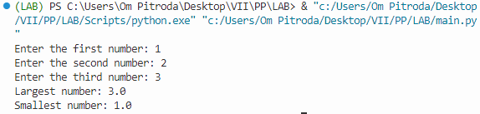

**d. Write a program to calculate GCD of two numbers.**

**Source Code:**

def find_gcd(x, y):

while(y):

x, y = y, x % y

return x

num1 = int(input("Enter the first number: "))

num2 = int(input("Enter the second number: "))

gcd = find_gcd(num1, num2)

print(f"GCD of {num1} and {num2} is {gcd}")

**Output:**

