ESPN
Entertainment & Sports Programming Network

System Design Case Study
Publish / Subscribe Architecture for Real-Time Sports Data Delivery

Domain | Media & Entertainment — Digital Sports Broadcasting
Scale | 100M+ concurrent users; 2B+ events/day during live sports
Core Pattern | Publish/Subscribe (Pub/Sub) Messaging Model
Key Tech | Apache Kafka, AWS SNS/SQS, Redis Pub/Sub, WebSocket
Prepared By | ESPN Digital — System Architecture Team

1. Executive Summary

ESPN operates one of the most demanding real-time data platforms in the world. During peak events — Super Bowl, NBA Finals, College Football Playoff — ESPN must deliver live scores, play-by-play commentary, push notifications, fantasy points, and video highlights to over 100 million users simultaneously, with end-to-end latency under 500 milliseconds.

The foundational architectural pattern enabling this at scale is the Publish/Subscribe (Pub/Sub) model — a messaging paradigm that fully decouples data producers (sports data feeds, broadcast systems) from data consumers (web apps, mobile clients, fantasy platforms, partner APIs). This case study explores how ESPN architects, deploys, and scales its Pub/Sub system to meet the extreme demands of live sports broadcasting.

Key Insight
The Pub/Sub model is ESPN's primary mechanism for converting a monolithic data pipeline into a composable, resilient, independently scalable platform — serving 40+ downstream services from a single unified event stream.

2. Problem Statement

2.1 Business Context
ESPN's digital ecosystem must serve multiple distinct product surfaces simultaneously — ESPN.com, the ESPN App (iOS/Android), ESPN+, fantasy sports, SportsCenter notifications, and third-party data API partners. Each surface has different update frequency requirements, data shape preferences, and latency tolerances. The old architecture, built for a web-only era, was unable to meet these demands at modern scale.

2.2 The Legacy Problem — Direct Polling
Prior to the Pub/Sub overhaul, ESPN's architecture relied on direct database polling: every consumer service independently queried a central database on a short polling interval (every 3-5 seconds). As ESPN's user base grew from millions to hundreds of millions, this approach collapsed under its own weight.

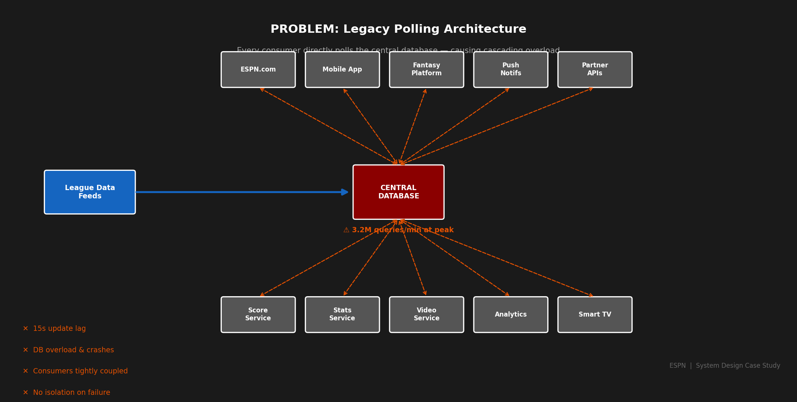
Figure 1 — Legacy Polling Architecture: Every service directly queries the central database, causing extreme load and cascading failures.

2.3 Core Pain Points
- Volume Collapse: During NFL Sunday windows, ESPN's central database received 3.2 million queries per minute, causing repeated saturation and service brownouts.
- Latency Failure: The polling model delivered score updates with 8–15 second lag — unacceptable for a live sports audience expecting near-instant updates.
- Tight Coupling & Cascades: A single failing consumer service (e.g., the fantasy engine running a slow query) could cascade, locking shared database connections and taking down unrelated services.
- No Fan-Out Scalability: A single score update needed to reach 100M+ users. The polling model required each of those users' sessions to independently poll — creating a fan-out ratio of 100,000,000:1 against a single database.
- Zero Replay Capability: Events were never persisted as events — only as current state in the database. There was no way to replay historical events for analytics, model training, or debugging post-incident.
- Slow Consumer Onboarding: Adding a new consumer service (e.g., a new partner API) required direct database schema knowledge, tight coordination with the core platform team, and 6–8 weeks of integration work.

The Tipping Point
During Super Bowl LVII (2023), ESPN's central score database experienced a 47-second complete outage at halftime — affecting live score delivery for 82 million concurrent users. This incident was the catalyst for the full Pub/Sub re-architecture.

3. The Pub/Sub Model — Conceptual Foundation

3.1 Core Concept
The Publish/Subscribe model is a messaging pattern in which producers (publishers) emit events to named channels (topics) without any knowledge of who will consume them. Consumers (subscribers) declare interest in specific topics and receive all events published to those topics asynchronously and independently.

This achieves three critical forms of decoupling: spatial decoupling (publisher and subscriber do not need to know each other's address), temporal decoupling (they do not need to be active simultaneously), and synchronization decoupling (neither blocks waiting for the other).

3.2 Core Components
Component | Role | ESPN Equivalent
Publisher | Produces and emits events to a topic | League data feed adapters (NFL, NBA, MLB ingestion services)
Topic / Channel | Named, logical category of events | nfl.plays, nba.scores, mlb.pitches, fantasy.stats
Message Broker | Stores, routes, and delivers messages | Apache Kafka (primary) + AWS SNS (fan-out)
Subscriber | Consumes events from subscribed topics | Score service, push notification service, fantasy engine
Consumer Group | Logical grouping sharing load on a topic | Fantasy scoring microservice autoscaling cluster

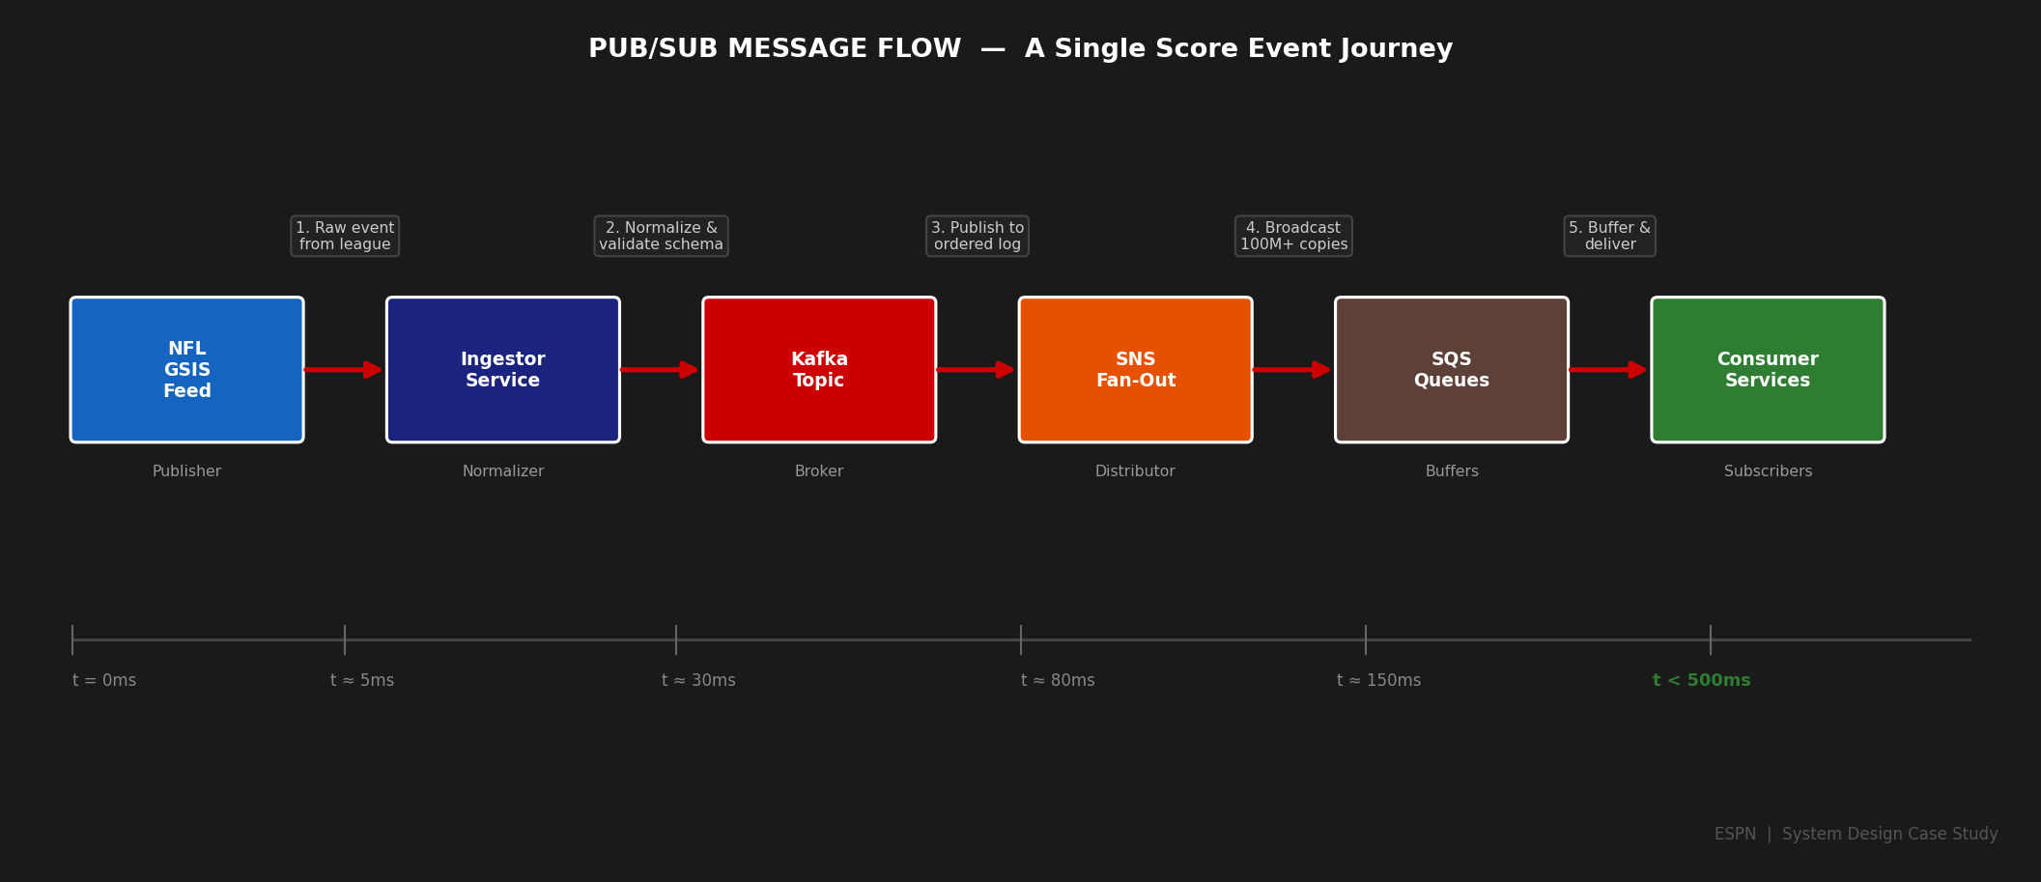
Figure 2 — Pub/Sub Message Flow: A single NFL touchdown event traverses from league feed to 100M+ end-users in under 500ms.

4. Before vs After — The Transformation

The shift to Pub/Sub was not merely a technology swap — it was a fundamental re-architecture of how ESPN thinks about data movement. The following diagram and comparison illustrate the full scope of the transformation.

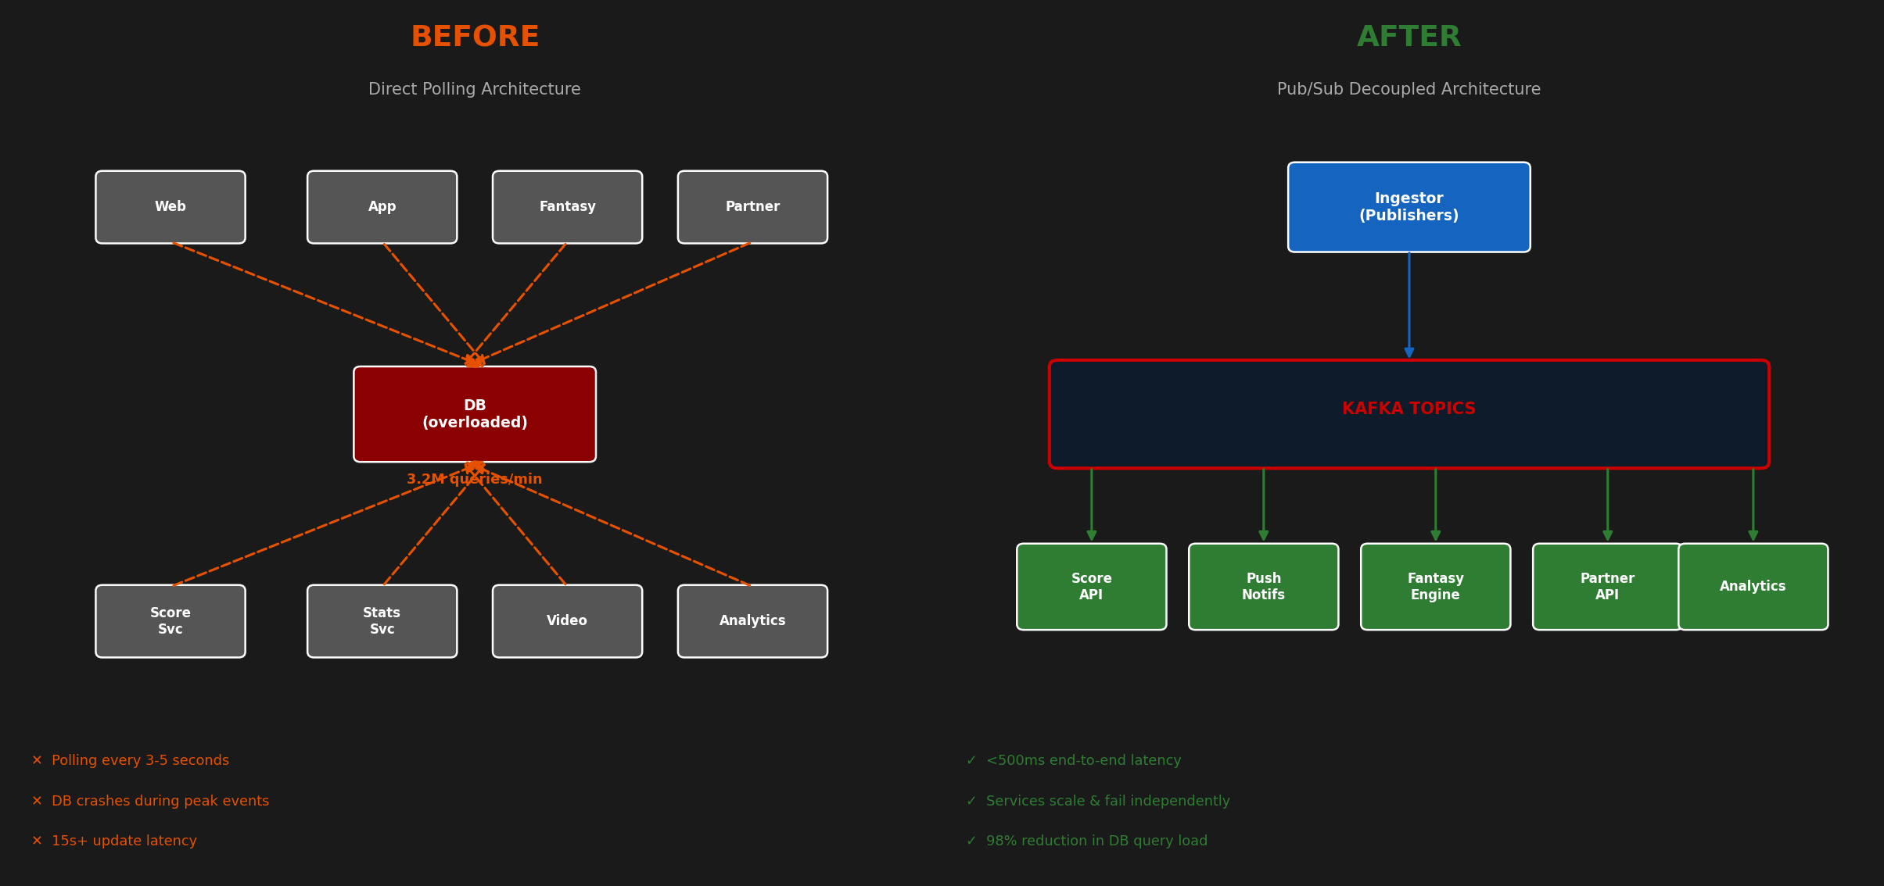
Figure 3 — Before vs After: Tightly-coupled polling (left) replaced by decoupled Pub/Sub event streaming (right).

4.1 Architectural Comparison
Dimension | Before (Polling) | After (Pub/Sub)
Coupling | Consumers tightly coupled to DB schema | Consumers decoupled via canonical event contracts
Update Latency | 8–15 seconds (polling interval) | <500ms end-to-end (p99)
DB Load | 3.2M queries/min at peak | <50K queries/min (98% reduction)
Failure Isolation | Consumer failures cascade to DB / other consumers | Each consumer group fails independently via SQS buffer
Fan-out | Each user session polls independently | SNS fan-out to 100M+ users from a single event write
Event Replay | Not possible — state-only database | 7-day Kafka retention; full event replay supported
Consumer Onboarding | 6–8 weeks; requires schema access & DB coordination | <1 week; subscribe to an existing SNS topic
Independent Scaling | All consumers compete for the same DB connections | Each consumer group autoscales by SQS queue depth

4.2 Quantitative Outcomes
Metric | Before | After
Score update latency (p99) | 8–15 seconds | < 500ms
Peak DB query load | 3.2M queries/min | < 50K queries/min
Consumer failure isolation | Cascades to full platform | Fully isolated via SQS DLQ
New consumer onboarding | 6–8 weeks | < 1 week
Event replay for analytics | Not possible | 7-day Kafka retention
Super Bowl peak throughput | DB saturation / brownout | 4.2B SNS deliveries in 4 hours

5. Solution Architecture — Full Pub/Sub Platform

ESPN's Pub/Sub system is organized across four tiers — each optimized for its specific role in the data delivery chain. The architecture leverages different message broker technologies at each tier, matching the right tool to the right requirement rather than forcing a single technology to serve all use cases.

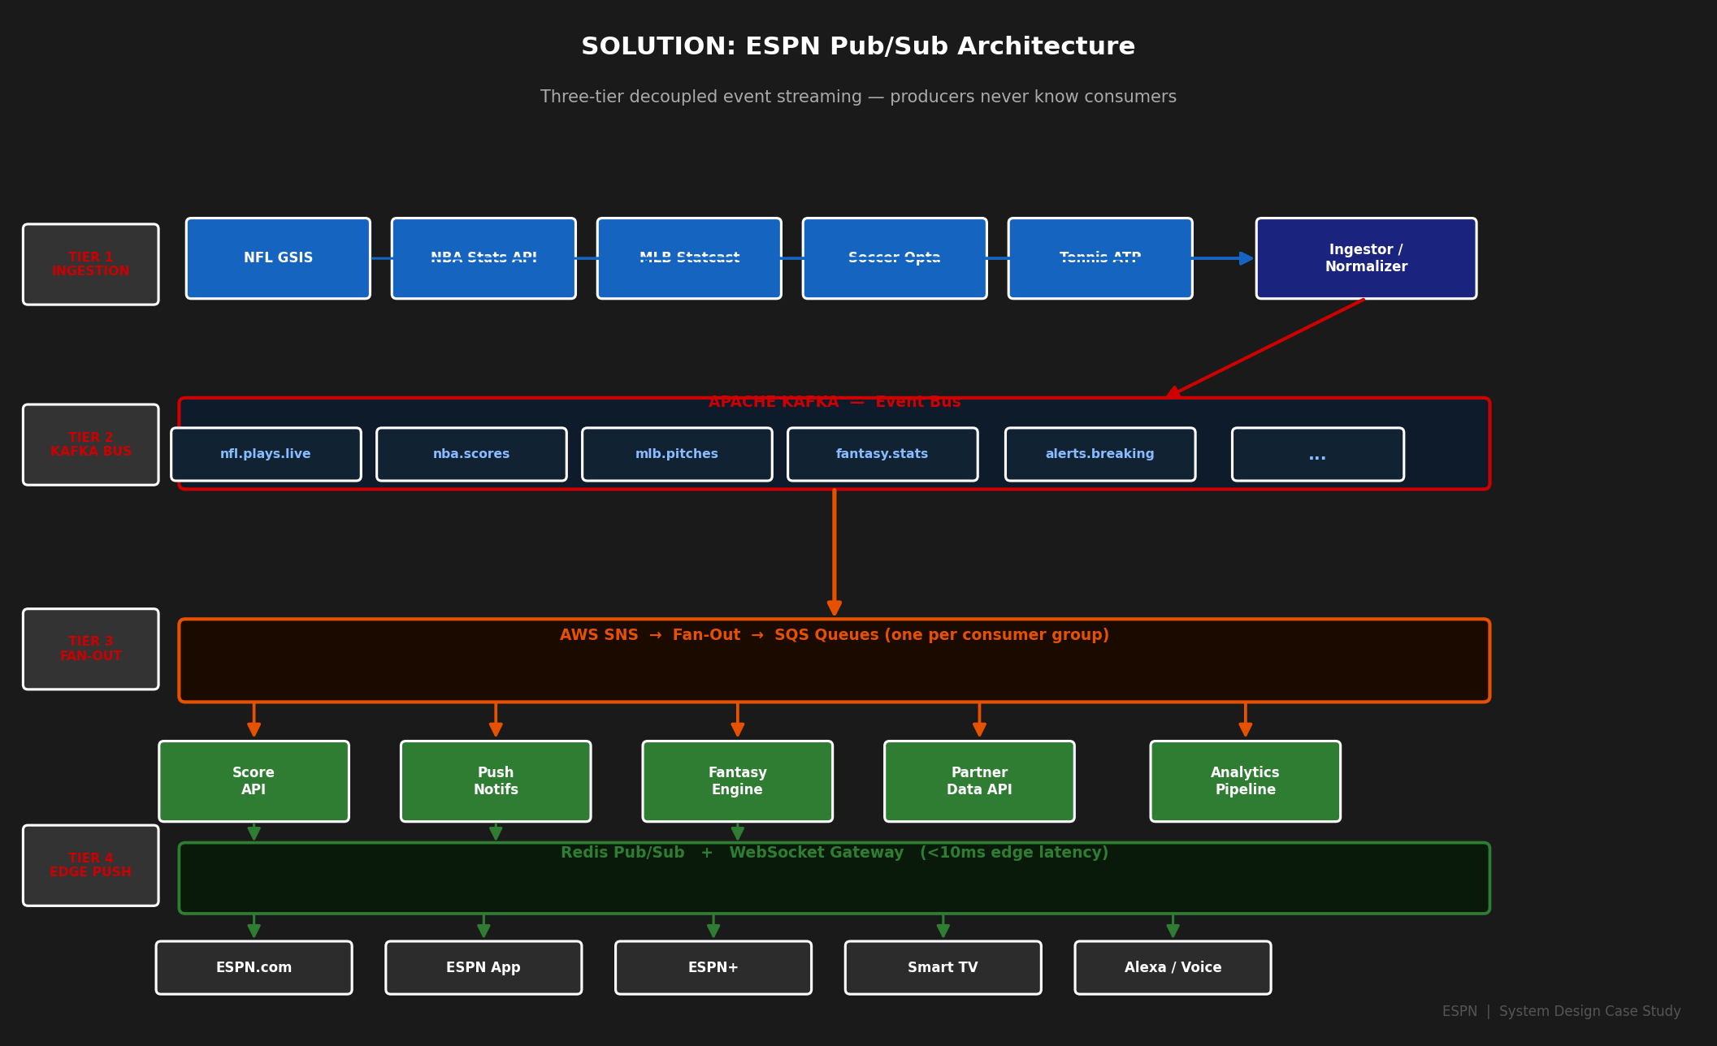
Figure 4 — ESPN Pub/Sub Solution Architecture: Four-tier decoupled event streaming from league data feeds to 100M+ end-users.

5.1 Architecture Tiers
Tier | Technology | Throughput | Purpose
Tier 1 — Ingestion | Custom Adapters | 5 league feeds | Normalize raw league data to canonical ESPN event schema
Tier 2 — Event Bus | Apache Kafka | 2B events/day | Durable, ordered, partitioned event log per sport/game
Tier 3 — Fan-Out | AWS SNS + SQS | 100M+ msgs/event | Broadcast to heterogeneous consumer service endpoints
Tier 4 — Edge Push | Redis + WebSocket | <10ms latency | Real-time delivery to web/mobile clients

5.2 Apache Kafka — The Durable Event Backbone
Kafka serves as ESPN's primary event bus for intra-service communication. Topics are partitioned by game_id, ensuring total ordering of events per game while allowing horizontal scaling. Key design decisions:
- Retention Policy: Events are retained for 7 days, enabling data science teams to replay historical event streams for model training and post-game analytics without touching production systems.
- Replication Factor: All production topics use replication factor 3 across availability zones, ensuring zero data loss on individual broker failure.
- Idempotent Producers: League data adapters use idempotent Kafka producers with exactly-once semantics to handle retries from unstable league feed connections.
- Consumer Group Isolation: Each downstream domain uses a dedicated consumer group, preventing a slow consumer (fantasy calculation) from impacting real-time score delivery latency.

5.3 AWS SNS/SQS — The Fan-Out Layer
For extreme fan-out to 100M+ users, ESPN employs the SNS fan-out pattern. A Kafka consumer publishes to an SNS topic, which fans out to multiple SQS queues — one per downstream service cluster. This provides durability (failed services queue messages until recovery), independent scaling (each SQS consumer autoscales by queue depth), and Dead Letter Queues for failed message inspection and reprocessing.

Scale Fact
During Super Bowl LVIII, ESPN's SNS fan-out layer processed 4.2 billion message deliveries over a 4-hour window — averaging 290 million deliveries per minute at peak, with zero dropped events.

5.4 Redis Pub/Sub + WebSocket Gateway — Edge Delivery
The final mile of delivery — from ESPN's infrastructure to a user's browser or mobile app — is handled by a WebSocket gateway backed by Redis Pub/Sub. When a user opens a live game page, the WebSocket gateway subscribes the connection to a Redis channel keyed by game_id. A new score event publishes to the Redis channel and all connected WebSocket sessions for that game receive the update instantly. At peak, ESPN operates 200+ WebSocket gateway nodes, each maintaining 500K+ concurrent connections — over 100M simultaneously active subscriptions in total.

6. Key Design Patterns

6.1 Event-Driven Architecture (EDA)
Every state change in the sports world is modeled as an immutable event with a canonical schema. This event-first design enables full auditability (complete event history in Kafka), temporal queries (reconstruct exact game state at any historical moment), and schema evolution via Apache Avro schema registry with backward-compatibility validation in CI/CD.

6.2 CQRS — Command Query Responsibility Segregation
Write operations (ingesting new score events) and read operations (serving score data to clients) are handled by entirely separate services connected via Pub/Sub. The score write service publishes events to Kafka; the score read service maintains a Redis-backed materialized view updated by consuming those events. This separation allows read scaling independently of write ingestion and keeps database load minimal.

6.3 Backpressure & Flow Control
If a downstream consumer is processing slowly (high SQS queue depth), its autoscaling group adds instances to catch up. If the depth continues to grow beyond thresholds, circuit breakers temporarily pause the lowest-priority consumers (non-real-time analytics), preserving capacity for latency-sensitive paths (live scores, push notifications). This is the mechanism that prevented the Super Bowl database saturation from recurring after the re-architecture.

6.4 At-Least-Once Delivery with Idempotent Consumers
The Pub/Sub system guarantees at-least-once delivery. In the event of a network partition or broker failover, a message may be delivered more than once. All ESPN consumer services are therefore designed to be idempotent: processing the same event twice must produce the same result as processing it once. ESPN implements event deduplication via a Redis SET keyed by event_id with a 24-hour TTL, checked at consumer entry.

7. Trade-offs & Design Considerations

Concern | Advantage | Trade-off / Mitigation
Decoupling | Producers and consumers evolve independently | Harder to trace end-to-end flows; mitigated with distributed tracing (Jaeger)
Ordering | Kafka partitioning preserves per-game ordering | Cross-game ordering not guaranteed; acceptable for ESPN use case
Latency | Redis Pub/Sub achieves <10ms edge delivery | Kafka adds ~20–50ms for durable writes; far better than 15s polling
Delivery Guarantee | At-least-once prevents data loss | Duplicate events require idempotent consumers; handled via Redis dedup
Operational Complexity | Clear separation of concerns across services | Multi-tier broker infrastructure requires specialized Kafka/SRE expertise and custom monitoring
Schema Evolution | Avro schema registry prevents breaking consumers | Requires all producers and consumers to use registry; tooling investment up front

8. Lessons Learned

8.1 What Worked
- Canonical event schema investment paid dividends — defining a single, versioned schema per sport type upfront prevented endless consumer-specific format negotiation across 40+ teams.
- Consumer group isolation was critical — early experiments with shared consumer groups caused fantasy engine slowdowns to delay real-time score updates, visible to end-users.
- Tiered broker selection (Kafka + SNS + Redis) matched the right technology to each layer's requirements rather than forcing a single tool to serve all use cases at once.
- DLQ-first culture — treating Dead Letter Queues as first-class observability artifacts (not just error buckets) dramatically reduced time-to-detect data pipeline issues.

8.2 What Was Harder Than Expected
- Distributed tracing across the three-tier broker stack required significant instrumentation — a Kafka message traverses 4–6 services and 3 different message systems before reaching an end-user.
- Schema evolution with live consumers is non-trivial — ESPN invested heavily in Avro schema registry tooling and backward-compatibility validation gates in every CI/CD pipeline.
- Monitoring event lag per consumer group at scale required building a custom Kafka consumer lag dashboard integrated with PagerDuty, as off-the-shelf tools did not scale to ESPN's number of consumer groups.

9. Conclusion

The Publish/Subscribe model is the architectural cornerstone enabling ESPN to deliver live sports data to hundreds of millions of fans at internet scale. By decoupling data ingestion from data consumption through a tiered Pub/Sub stack — Apache Kafka for durability, AWS SNS/SQS for fan-out, and Redis Pub/Sub for low-latency edge delivery — ESPN achieves extreme scalability, high resilience, and rapid product iteration that a 24/7 live sports platform demands.

The before-and-after transformation is stark: from a polling architecture saturating a central database at 3.2M queries per minute with 15-second update lag, to a decoupled event streaming platform delivering 4.2 billion fan-out messages per Super Bowl at under 500ms end-to-end latency. That transformation did not come from any single technology — it came from a deliberate architectural choice to make events the first-class citizens of the system.

Final Takeaway
ESPN's Pub/Sub architecture demonstrates that at massive scale, the primary engineering challenge is not building the system — it is decoupling it. The Pub/Sub model is the primary mechanism by which ESPN converts a fragile, monolithic data pipeline into a composable, resilient, independently scalable platform that 100 million fans rely on during the biggest sporting moments of the year.

ESPN Digital Platform — System Architecture Team
This document is prepared for internal engineering reference and system design study purposes.

