Coding Standards Checklist to be followed

1.Naming Convention as per following Standards.
2.Common Validations.
3.Common Methods.
4.Repository Pattern(If u are working on asp.net core)
5.Commenting.
6.Session State.
7.Encode Url.
8.Sql Injection.
9.Custom Errors.
10.Exception Handling.

Naming Convention
1. PascalCase
- PascalCase, the first letter of each word in the identifier is capitalized, including the very first letter.
- PascalCase is typically used for naming classes, methods, and properties.
2. camelCase
- In camelCase, the first letter of the first word is lowercase, and the first letter of each subsequent word is capitalized.
- camelCase is commonly used for naming variables and private or internal fields.
3. Interface Naming Convention
- Interface names should always start with the capital letter 'I'. This prefix stands for "Interface" and distinguishes the interface from other types such as classes, enums, and structs.
- Example: IEnumerable, IDisposable, Ilogger
- Avoiding Common Mistakes
- Do not include the word "Interface" in the name since the 'I' prefix already signifies that it is an interface.
  - Incorrect: ILoggerInterface
  - Correct: Ilogger
- Examples of Good Interface Names
- IShape
- IVehicle
- IRepository
- IService
- IUnitOfWork

4. Object Naming Convention
  - Using Hungarian notation, variable names begin with one or more lowercase letters that denote the variable type. For example: lblUserName

Common Validations
Create separate class or js file for common validation where you write the functions for validate the fields and everyone should use that common validation in their form if required by importing the class in their code.
Example
    - Validate Email
    - Validate Phone No
    - Validate Pan No
    - Validate Aadhar No
    - Validate Pincode
    - Validate Number
    - Validate Decimal
    - Validate Account No

Common Methods
- Identify Duplicates
Look for logic that is repeated in multiple places throughout your codebase.
- Extract to Helpers
Move the duplicated logic into a separate helper method or class that can be reused.

Repository Pattern
Repository pattern separates the data access logic and maps it to the business entities in the business logic. Communication between the data access logic and the business logic is done through interfaces.

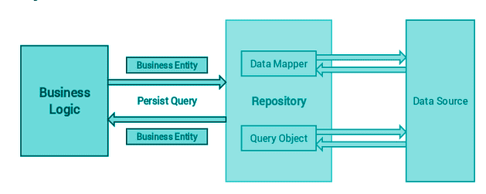

Commenting
Do the commenting in your code only for Logical part so other developer should understand the logic.
Session State
Clear your Page Session State at the time of Page Loading.
Encoding Url
Encode user data before including it in the URL.
Sql Injection
Use Stored procedures with parameterized with parameterized variable.
Custom Errors
If there is any error or exception occur, redirect to your page to a custom error page don’t show directly the error message in the browser.
Exception Handling
Always use try and catch block for Error or exception handling

