# OmPrakash Sirvi

## Database:

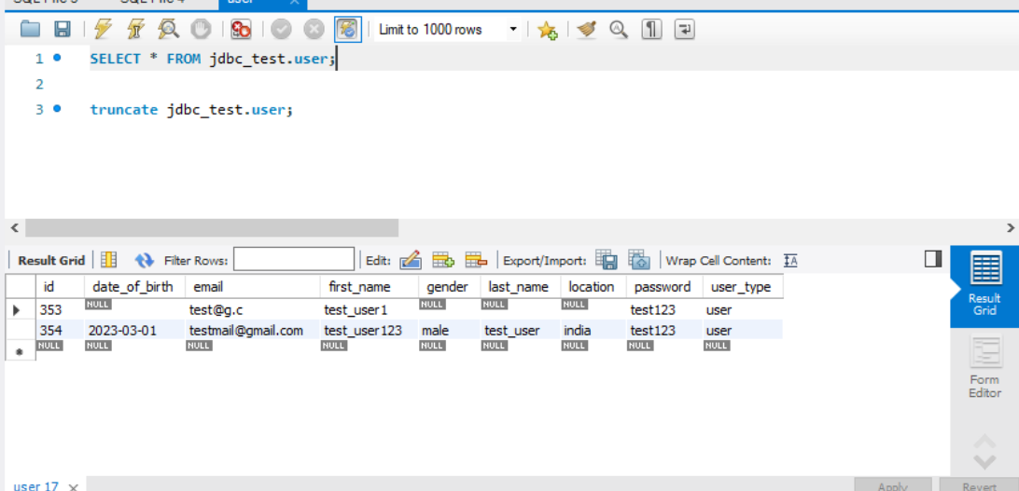

## Login:

## Login success :

## Register user;

## Register success :

