Karen Eddy  
Catalogue

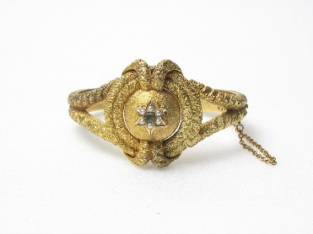

“**Duchess**”

Bracelet crafted in the Edwardian style, single emerald center with six 1ct diamond star surrounds.

AUD$44,500.00

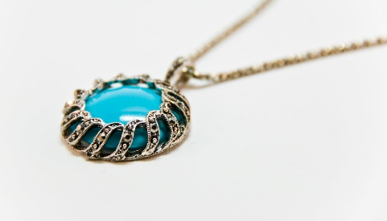

“**Oceania**”

Necklace, available in 12-16cm lengths, turquoise center cradled in pure silver.

AUD$12,500.00

“**Patricia**”

Broach, emerald center, six orbiting 1ct diamonds, gold support decoration.

$AUD 42,000.00

“**Broadway**”

Drops of natural Zircon; 2ct to 6ct, strung on pure silver necklace,

AUD$5,600.00

“**Gypsy Queen**”

Bracelet. Supernatural Green Moonstones captured by string of solid sterling silver alloyed with copper.

AUD$1,700.00

“**Delilah**”

Engagement Rings. Pure Silver or 18 Karat Gold.

AUD$ 2,500.00

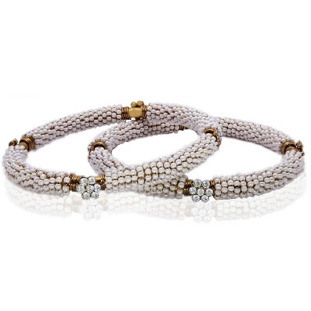“**Minuet**”

Bracelet. 6-7mm AA Quality Japanese Akoya Cultured Pearl Set, 18 Karat Gold, pure Silver, 1ct diamonds.

AUD$36,000.00 (ea)

“**Empress**”

Necklace. 18 Karat gold, pure silver, 1ct Alexandrite heroine and satellite gemstones.

AUD$ 19,000.00

“**Beatrice**”

Solid 18 Karat gold, trio of 1ct diamonds, sterling silver.

AUD$14,000.00