**Karen Eddy Jeweller**

Design Brief

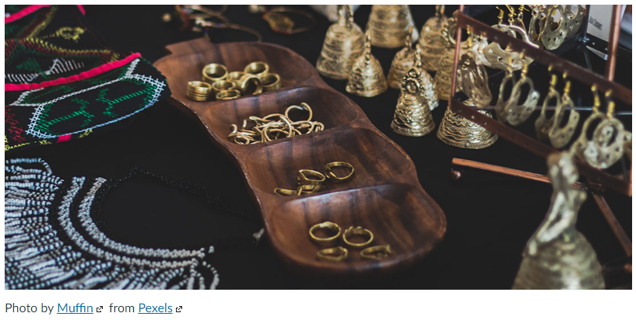

**Introduction | Business Profile**

An Australian-based home-based business, Karen Eddy Jeweller, creates and produces custom jewellery. They sell locally mostly but have plans to do a lot more commerce nationally and internationally. The business owner, Karen Eddy started the business 5 yrs. ago and it’s grown every year since.

Typically, customers get in touch via email or by in-person visits to their premises or by their stall at a local monthly outdoor market (seasonal; no market during 10 weeks over Winter).

There are two other craft fairs during the year they also sell from.

The business doesn't use eBay or Gumtree or Facebook Marketplace citing "a poor fit" for them and their product. They want to convey a sense of exclusivity and value.

Up to this point, their customers pay via credit card using Square or direct deposit.  They want this to continue but add more payment options such as PayPal, WeChat Pay and AfterPay.

Demand outstrips supply. Average turn-around per item is two weeks although some items may take 3-6 months depending on complexity, level of customisation and availability of raw materials.

Items range from $150AUD to $1500AUD excluding-GST / excluding-post. Annual income currently 32-35K AUD before tax.

**Future Growth**  
Karen wants to expand, employing a friend; another jeweller who works 50 km away.

Karen has identified a need for a website/ecommerce solution to grow the business and provide an easier and secure way to buy items and make the whole purchase process more formal. Karen has recognised that Facebook is an effective tool for creating "buzz" and communicating with customers but is a poor choice for representing the business profile in a structured, respected and distinctive way.

Karen is keen to minimise the effort required to maintain the site/ inventory management/ hosting overheads. She just wants to sell jewellery locally and internationally with as little effort and cost as possible.

**Technical Aptitude**

Karen is mobile phone, Facebook and Instagram-savvy and is also familiar with basic apps like email, MS Word and Photoshop.

**Branding**

The current logo:



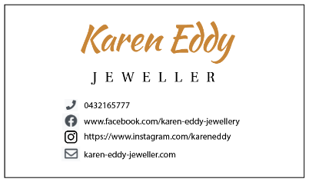Business Card (front / back)

.ico artwork



**The Website**

The current site needs attention. It’s a point-of-information web site with low-traffic that hasn’t been maintained for years. They get fewer than 10% of their referrals from the site. The site is not responsive and hard to use on a mobile phone.

Domain is registered as [www.kareneddy.com](http://www.kareneddy.com).au

Their hosting is due to expire soon. Karen is unhappy with her current hosting provider.

Karen is keen to implement a more reliable Customer Relationship Management system. Up until recently she used Facebook and a mailing list on her computer to maintain client contacts.

Historically they have lost the entire mailing list due to a hard-drive crash.

**The new site needs to include the following assets and functionality:**

Layout responds to mobile and desktop.

Site is SEO, accessible and a pleasure to use.

Site-wide navigation that responds to mobile and desktop.

Site-wide footer info features links to; privacy policy | socials| Copyright info.

**Entry page featuring three sections:**

**1. Business Profile**“Handcrafted in Underwood Tasmania using recycled gold, conflict-free diamonds and gemstones from around the world, Karen Eddy Jewellery creates timeless, desirable heirlooms.”

Add any meaningful artwork to help add personality and distinction to the layout.

**2. Latest Offering**Hero shot of feature product that changes every month or when a new item is released with accompanying product info.

Eg.

“Empress”

Necklace. 18 Karat gold, pure silver, 1ct Alexandrite heroine and satellite gemstones.

AUD$ 19,000.00

**3. Contact info.**

Contact info. (mob, email, socials)

**Product Gallery page**Showcasing max. nine products.  
Product photo, product info. & price. Photos featuring the products in their best light, in an appropriate context and with a compelling narrative.

For item details see companion file, **gallery-items.docx**

**Contact Form & Privacy Policy page**  
**Contact Form**  
Used by end-users to get in touch with the business. Form supported by a suitable Privacy Policy.

*example:*

Name: Joanne Bridges

Email: [jkbridges433@gmail.com](mailto:jkbridges433@gmail.com)

Mob: 0448 332 114

User query: Interested in the Opal / 22Kt gold bracelet but need it customised to suit.   
 Ready by Oct. 2022, sister’s wedding.

**Privacy Policy**See accompanying document for information to include **karen-eddy-privacy-policy.docx**