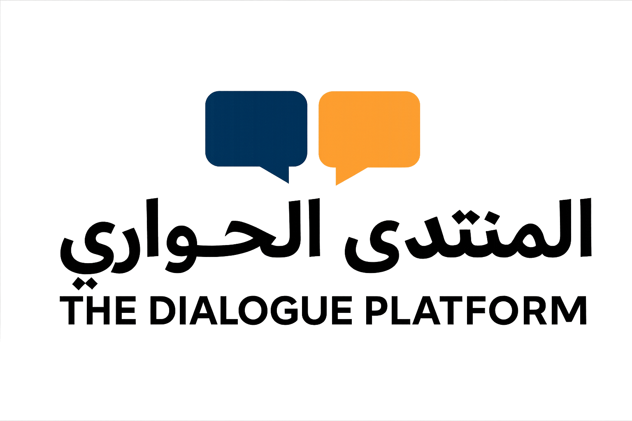 | PROJECT CONCEPT NOTE  Prepared for Fritt Ord
Dialogue Rooms Norway
Four public meetings for freedom of expression, trust and democratic participation
APPLICANT  The Dialogue Platform | PROPOSED PERIOD  February-June 2027 | LOCATIONS  Lillestrom and Oslo | FRITT ORD REQUEST  NOK 100,000

PURPOSE AND PUBLIC NEED  Public debate is increasingly shaped by polarization, distrust and unequal access to the spaces where opinions are formed. Minority, diaspora, youth and women voices are often discussed without being fully included. Dialogue Rooms Norway will create open, carefully moderated physical meetings where disagreement can be expressed safely, tested against other experiences and turned into democratic participation.  ACTIVITIES AND METHOD  The project will deliver four free public meetings, each designed for 60-100 participants. Every meeting combines a short factual framing, two or three invited perspectives, facilitated table dialogue and an open plenary. The method draws on structured exploration, exchange and reflection so participants listen actively, challenge assumptions and identify practical common ground.  - Freedom of expression across disagreement  - Belonging, identity and democratic participation  - Media, misinformation and the language of conflict  - From polarization to practical local cooperation  PUBLIC RELEVANCE AND ACCESSIBILITY  The meetings will be publicly announced and open without charge. Outreach will combine local associations, schools, municipal networks and The Dialogue Platform's digital channels. Moderation and interpretation will be adapted to participant needs. Representation across age, gender and background will be built into speaker selection, while photos or short clips will only be shared with consent.
  EXPECTED RESULTS
  - 4 moderated public dialogue meetings
  - 240-400 participants in total
  - 4 concise public event summaries
  - 1 final learning note with recommendations
  SUCCESS MEASURES
  - Attendance and participant diversity
  - At least 75% report greater understanding of another perspective
  - New collaborations or follow-up actions recorded after each meeting
  PROVISIONAL BUDGET
  Facilitation and moderation | 40,000
  Venue and technical delivery | 32,000
  Guest travel and honoraria | 24,000
  Interpretation and accessibility | 20,000
  Outreach and design | 18,000
  Documentation and evaluation | 16,000
  Administration and contingency | 10,000
  Total project cost: NOK 160,000
  Fritt Ord: NOK 100,000 | Own, volunteer and partner contribution: NOK 60,000
APPLICANT CAPACITY  The Dialogue Platform is an independent, non-profit initiative based in Lillestrom. It has organized seminars, workshops and public dialogues in cooperation with community actors, with approximately 380 direct participants across 11 activities and more than 40,000 combined online views reported to date. | CONTACT  Omran Adam  contact@thedialogueplatform.com  thedialogueplatform.com  Org. no. 935 674 220

