# Variables:

* + **Mainroad**: Whether the house is connected to the main road (Yes/No)
  + **Guestroom**: Whether the house has a guest room (Yes/No)
  + **Basement**: Whether the house has a basement (Yes/No)
  + **Hot water heating**: Whether the house has a hot water heating system (Yes/No)
  + **Airconditioning**: Whether the house has an air conditioning system (Yes/No)
  + **Prefarea**: Whether the house is in a preferred area (Yes/No)
  + **Furnishing status**: The furnishing status of the house (Fully Furnished, Semi-Furnished, Unfurnished)
  + **Price**: The price of the house
  + **Area**: The total area of the house in square feet
  + **Bedrooms**: The number of bedrooms in the house
  + **Bathrooms**: The number of bathrooms in the house
  + **Stories**: The number of stories in the house
  + **Parking**: The number of parking spaces available within the house

# Descriptive Statistics:

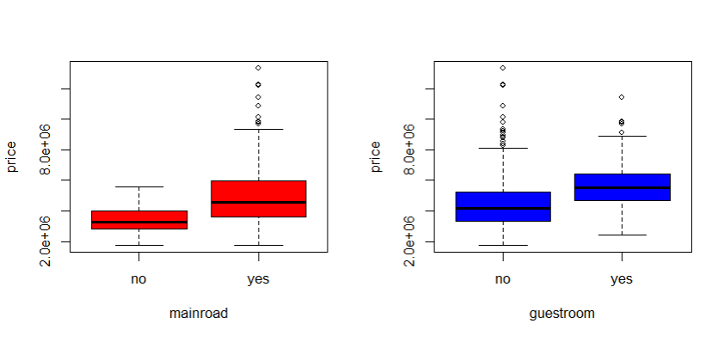

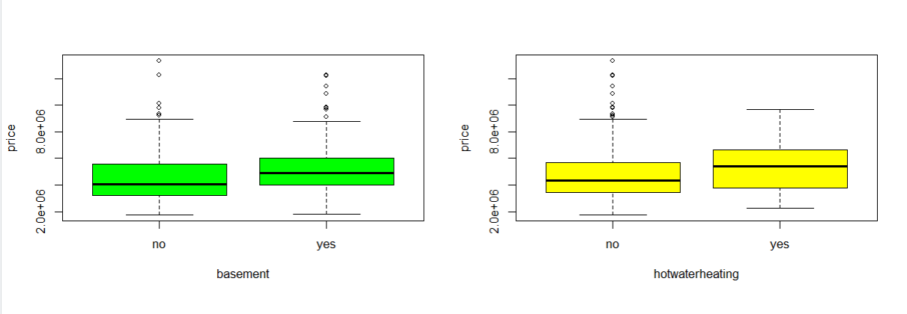

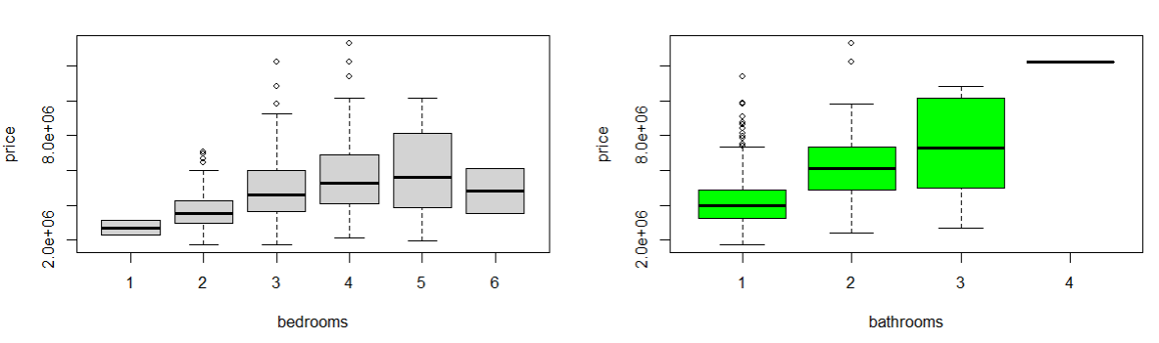

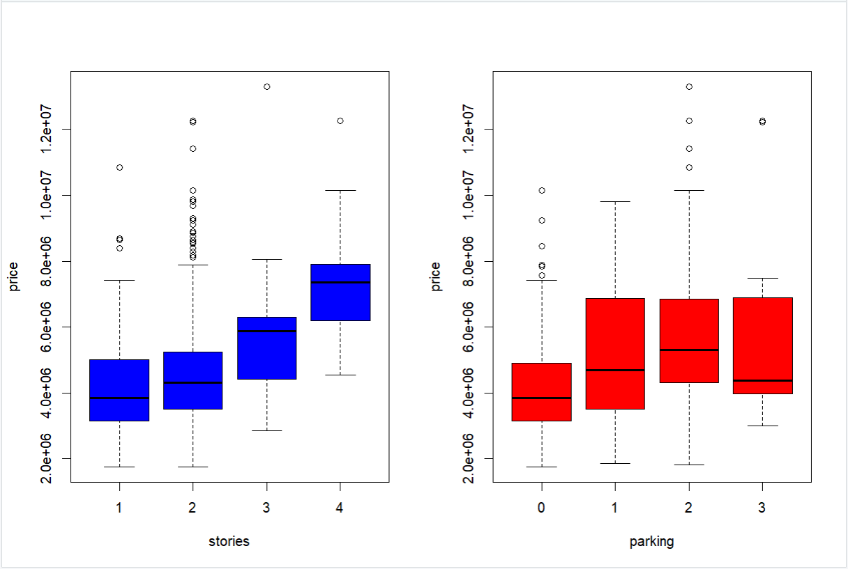

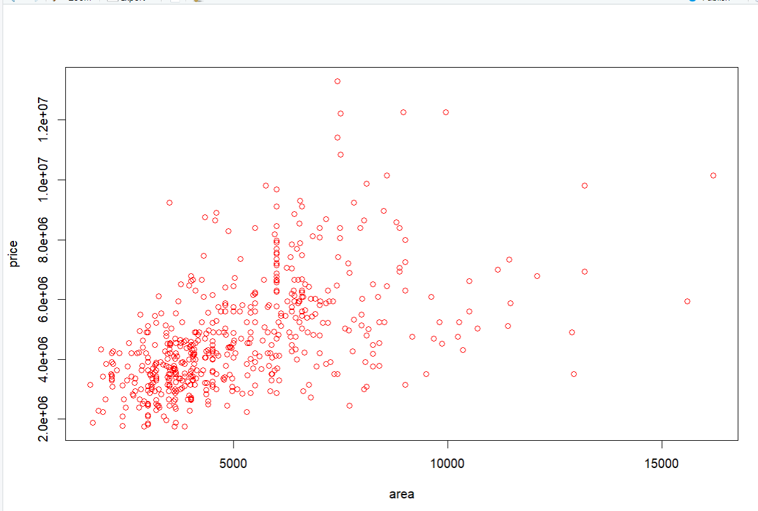

# Model Summary before removing outliers:

|  |  |  |
| --- | --- | --- |
| MODEL | NB OF PREDICTORS | ADJUSTED RSQUARED |
| M1 | 12 | 66.58 |
| M2 | 11 | 66.66 |
| M3 | 10 | 65.88 |
| M4 | 8 | 64.4 |

# Model Summary after removing the outliers:

|  |  |  |  |  |  |
| --- | --- | --- | --- | --- | --- |
| MODEL | MAPE | MAE | RMSE | NB OF PREDICTORS | ADJUSTED RSQUARED |
| M1 | 18.10517 | 864109.7 | 1136095 | 12 | 70.76 |
| M2 | 18.47509 | 865463.7 | 1136119 | 10 | 69.88 |
| M3 | 18.12907 | 863692.4 | 1137402 | 11 | 70.74 |

# Assumptions

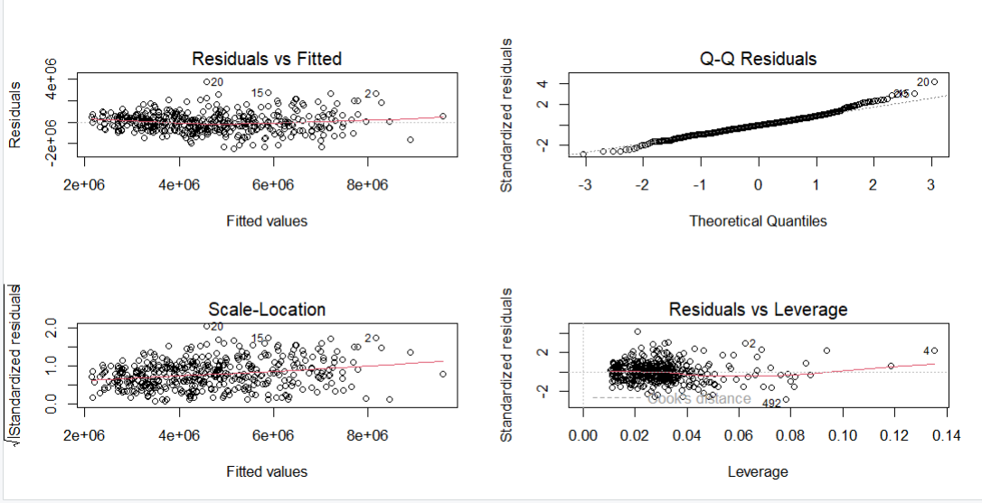

# Average Price increase:

|  |  |  |
| --- | --- | --- |
| Feature | Value | Average Increase Percentage |
| Bathroom | 1-2-3-4 | 0%->44%->75%->194% |
| Air Conditioning | No- Yes | 0%-> 41% |
| Hot Water Heating | No-Yes | 0%-> 17% |
| PrefArea | No-Yes | 0%->30% |
| Stories | 1-2-3-4 | 0%->11%->32%->72% |
| Main Road | No-Yes | 0%->44% |
| Basement | No-Yes | 0%->14% |
| Guest Room | No-Yes | 0%->29% |
| Parking Space | 0-1-2-3 | 0%->25%->36%->28% |
| Furnishing Status | Unfurnished-Semi furnished-Furnished | 0%->20%->33% |