***COREDUMP:***

phase one 1:

technique:

**V5**

technique_VALUES:

jump_dist : **-0x800**

sub sp,dx -> dx = 0x2B

call_amount = 0x9c

INT 87,86:

INT 86: ZOMBIE TAKEOVER USAGE, NON OFFENSIVE

INT 87: NONE

ZOMBIE technique:

V5, same as survivors values

phase two 2:

technique:

V5

technique_VALUES:

jump_dist : **-0x2000**

sub sp,BP -> BP = 0x2B

call_amount = 0xca

INT 87,86:

INT 86:

INT 87: rep movsw

push ds

push es

ZOMBIE technique:

same values

***DINOXORS:***

phase one 1:

technique:

V5

technique_VALUES:

jump_dist: ranadommmmm

add sp,bp: bp = 0x50

changing magic segment, dinoxors stupid.....

INT 87,86:

INT 86: ZOMBIE TAKEOVER USAGE, NON OFFENSIVE

INT 87: no int 87

ZOMBIE technique:

phase two 2:

technique:

technique_VALUES:

val1 :

val2 :

INT 87,86:

INT 86: ZOMBIE TAKEOVER USAGE, NON OFFENSIVE

INT 87: no int 87 -> they are stupid!

ZOMBIE technique:

***HEXELLENT (PAST "WHITE LOTUS"):***

phase one 1:

technique:

movsw shit -> copying

technique_VALUES:

doesn't matter

INT 87,86:

int 86: ax = 0x1fff, dx = 0x1000

int 87: a5,a5,a5,a5

ZOMBIE technique:

phase two 2:

technique:

silent and callfar

technique_VALUES:

callfar:

jump_dist : **-0x800**

call far is continious in arena:

they jump but dont change sp

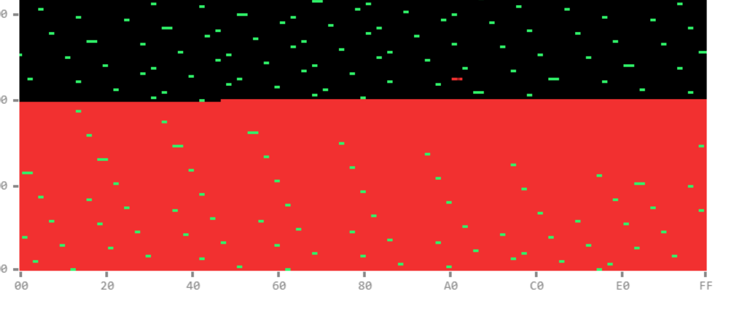

INT 87,86:

INT 86: no use of int86 stupid!

INT 87: extremley stupid bombing -> they are iq low

ZOMBIE technique: